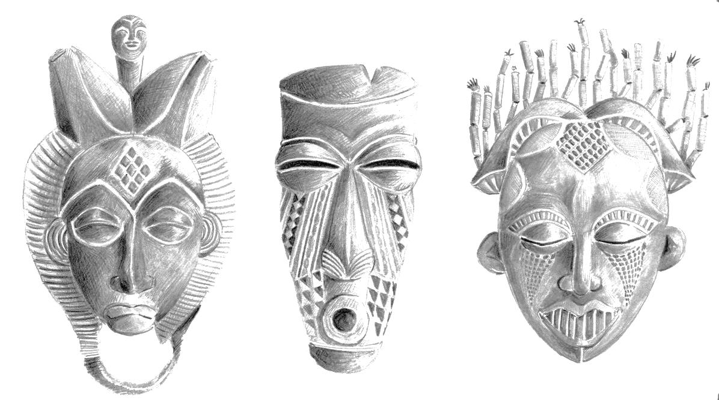

**TONAL DRAWING**

**Make a copy of one of these masks.**

**Start with an outline of the shape of**

**the mask.**

**Mark in where the eyes, nose and**

**mouth are – remember Symmetry**

**and think about Proportion.**

**Now draw the eyes, nose and mouth**

**and the Pattern used in the decoration.**

**Using the table on the left as a guide**

**add tone /shading to the Mask.**

**Use the attached Tonal shading sheets as a guide for Tonal shading techniques too.**

[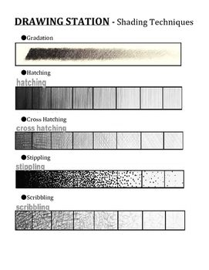](https://www.google.co.uk/url?sa=i&url=https://www.pinterest.com/pin/553309504202222657/&psig=AOvVaw3OaVJpcJQ-HbMDlrE2GbWV&ust=1587732827782000&source=images&cd=vfe&ved=0CAIQjRxqFwoTCJCnr_bL_ugCFQAAAAAdAAAAABAT)

**TONAL SHADING - EXAMPLES OF TECHNIQUES.**

[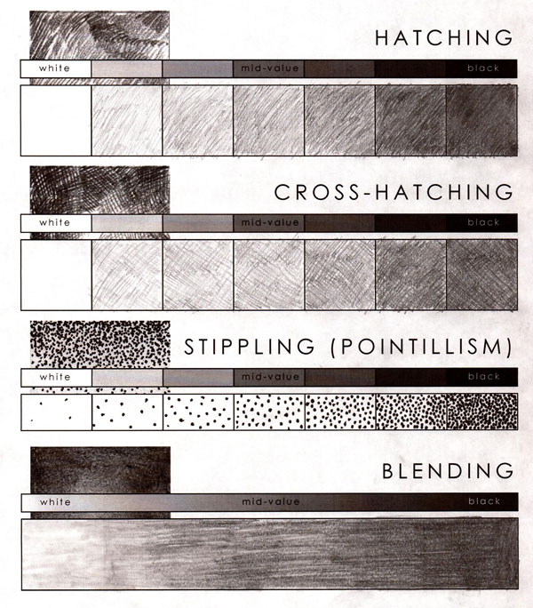](https://www.google.co.uk/url?sa=i&url=https://www.tes.com/lessons/F6LYn1qD7hdPkg/artist-hokusai&psig=AOvVaw3OaVJpcJQ-HbMDlrE2GbWV&ust=1587732827782000&source=images&cd=vfe&ved=0CAIQjRxqFwoTCJCnr_bL_ugCFQAAAAAdAAAAABAY)