This image can be drawn using any material, it could be produced using a pencil only. All year groups could work from this imagery.
Boulevard colour and tonal studies
This street scene shows a boulveard at night with a range of dark tones and vivid colours. The people walking around look blurred but they add to the relaxed mood of the scene.
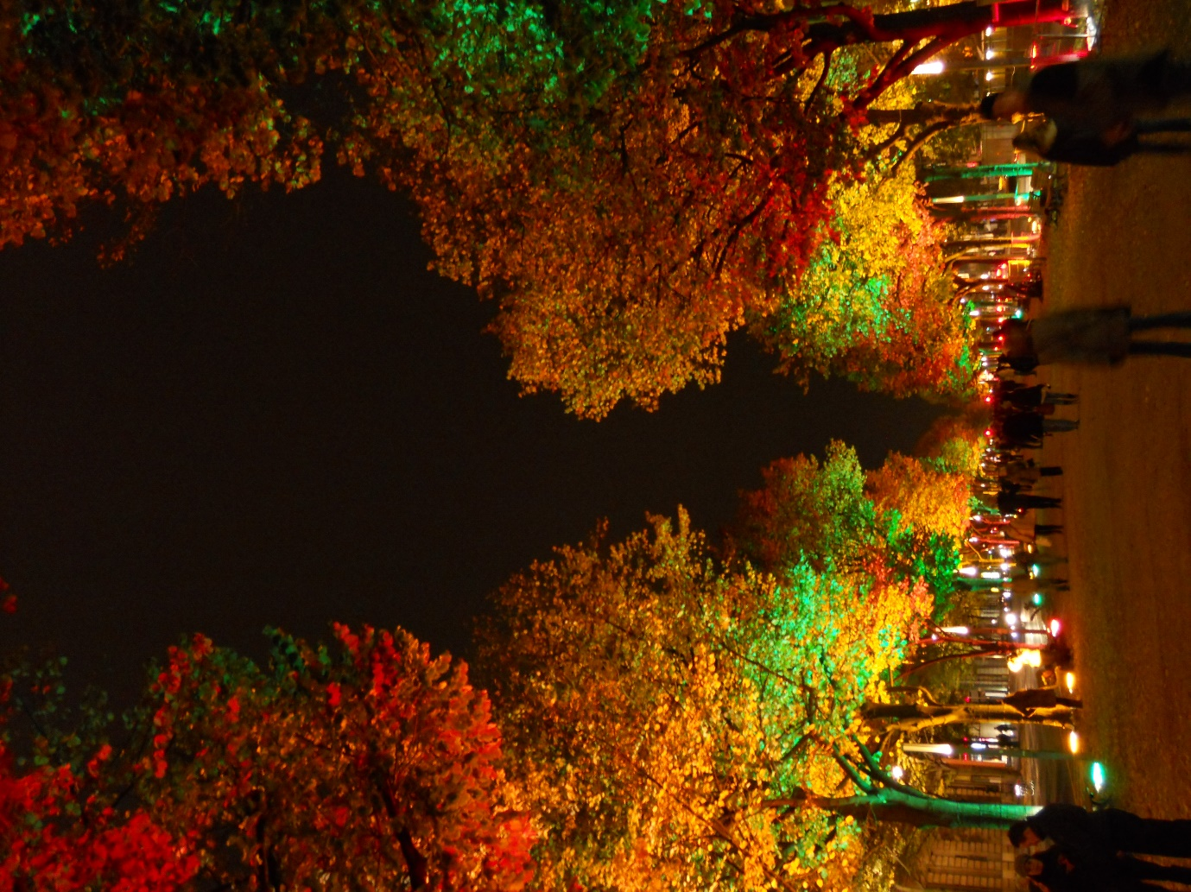
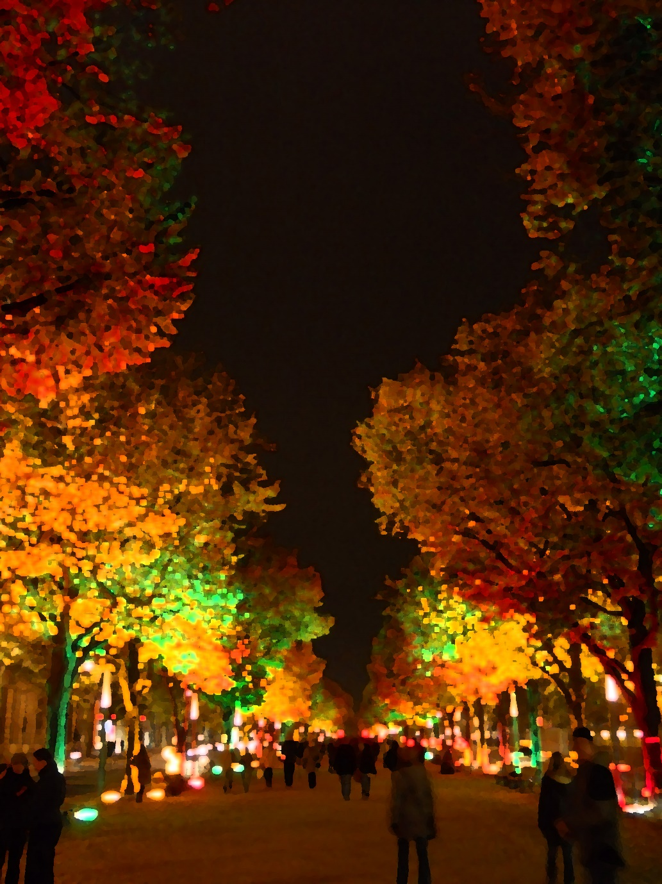
This version has been enhanced to look like it has been created with paint. Similar effects could be created using paint, felt tip pen, crayon or oil pastel. If the felt tip pens are water soluble, you could use a soft brush to create similar effects by painting over the marks you have already made with a thin brush.
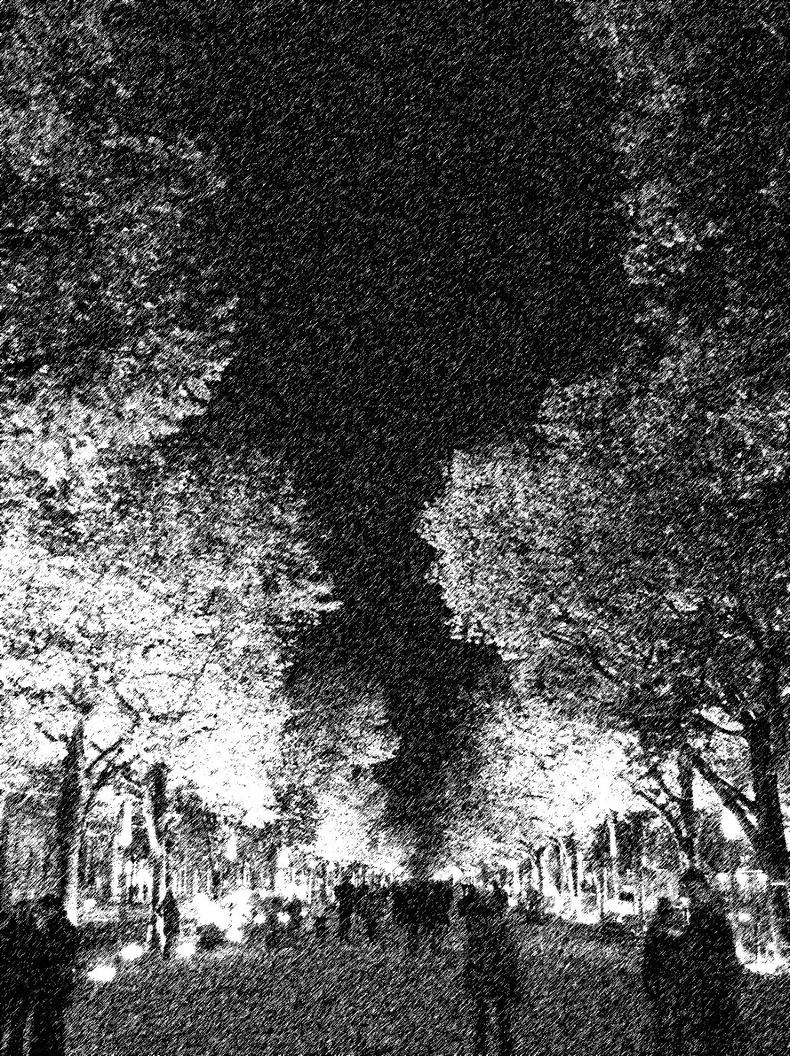

This last version has been enhanced to look a charcoal drawing. Similar effects could be created by using a graphite pencils or fine pens to create short marks going in different directions. Placing the marks closely will create dark areas of tone. Mid-tones can be created by spreading the marks out.

