This image can be drawn using any material, it could be produced using a pencil only. All year groups could work from this imagery.
Clydeside colour and tonal studies
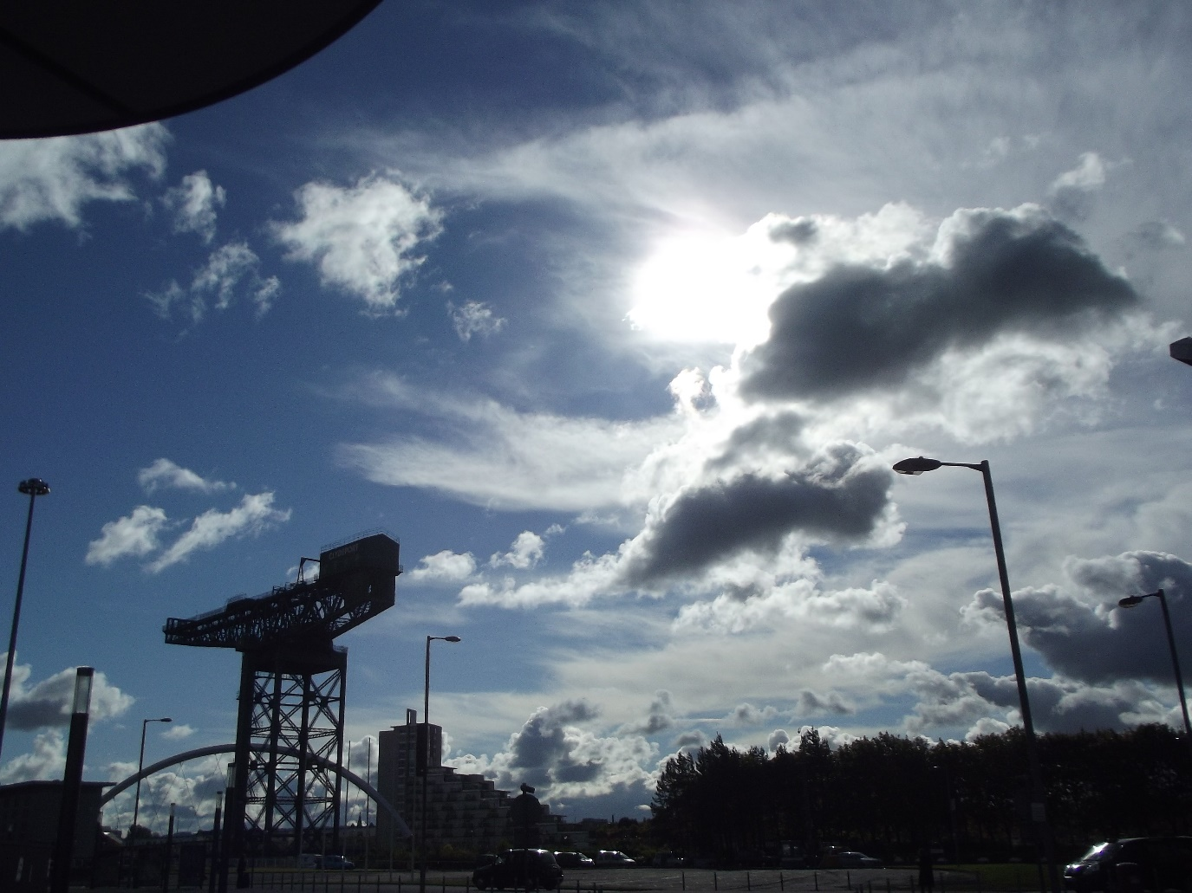

Pictured below the original photograph are two images which could be created using a range of materials.
The first would ideally be created with watercolour paint but you could use poster paints, oil pastels, crayons, colour pencils and pens.
The black and white image could be created using a range of pencils e.g. HB, B and 2B. You could also use fibre tip pens or ball point pens to achieve the effects that you are looking for.
Technique 1 – Watercolour painting
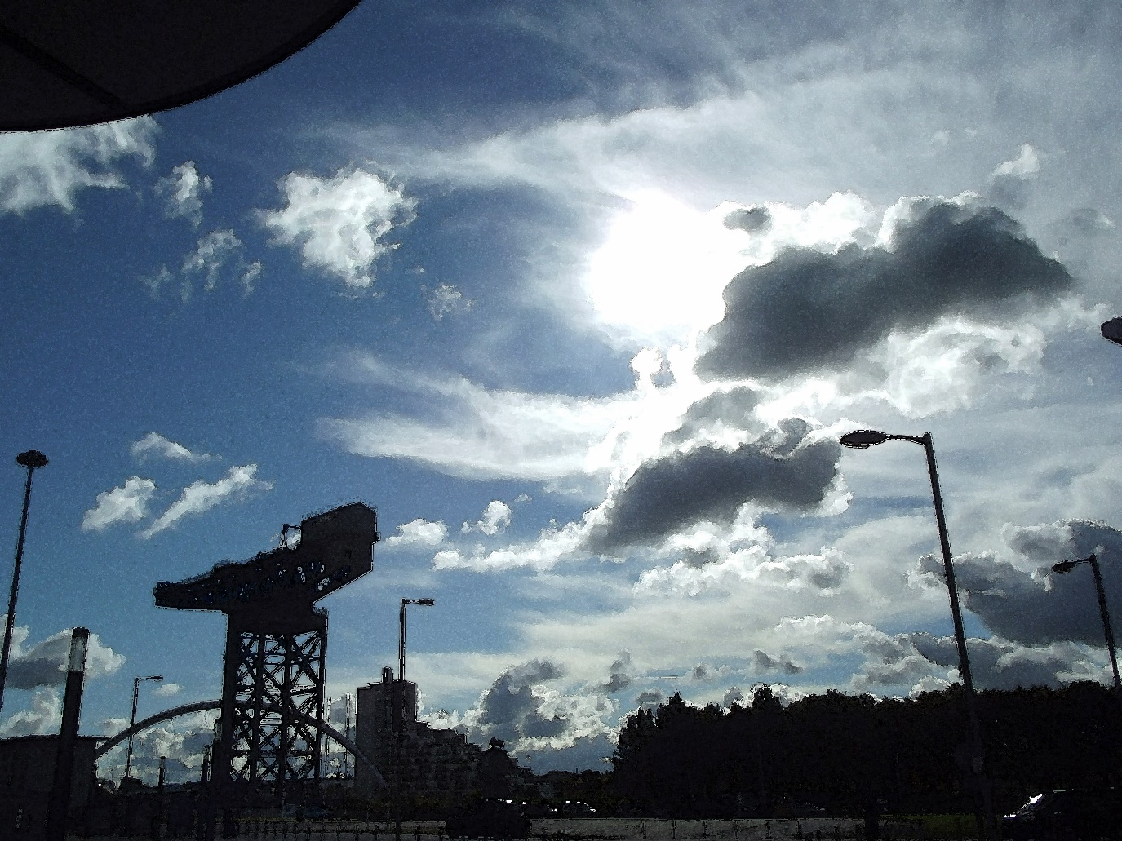

If paint is available, you would start this landscape by drawing out the basic shape of everything that you can see.
Softer brushes are more suitable for this technique as stiffer brushes are more likely to wear out the surface of the paper.
After doing this you would then start to paint the lighter shades of blue and grey.
The areas of white should be left as unpainted areas of paper.
Remember to add water to create pastel shades of colour rather than white paint if you want to create the softer appearance of watercolour paint.
This is because the paint will become transparent depending on how much water you use.
For the final stages of the painting, you should start to create the darker tones of colour throughout the painting. Use less water in the paint to do this and the colours will appear more intense.
Complete the painting by adding the areas of black to create the dark silhouettes of the crane and the buildings on the lower left of the composition.
Similar effects could be created with the other materials by adding the softer and lighter colours first before adding the darker colours and tones to complete.
Remember that some fibre tip pens are water soluble and can have water added to create a watercolour effect. You should only add water after using the pen and not the other way around as this could damage the pen.

Technique 2 – Tonal drawing
The mood of this picture is even more dramatic because of the strong areas of light and shade.
Using a softer grade pencil such as a 2B or even a 4B would ideal for this piece but a HB or a B grade pencil would also be suitable.
Avoid using a 2H pencil because this will only give very light shades and is more likely to tear the paper if you lean on the pencil heavily.
Ball point pens are also suitable for this technique but remember to sketch lightly at first because the pen will give you a more permanent mark which is more difficult to correct.

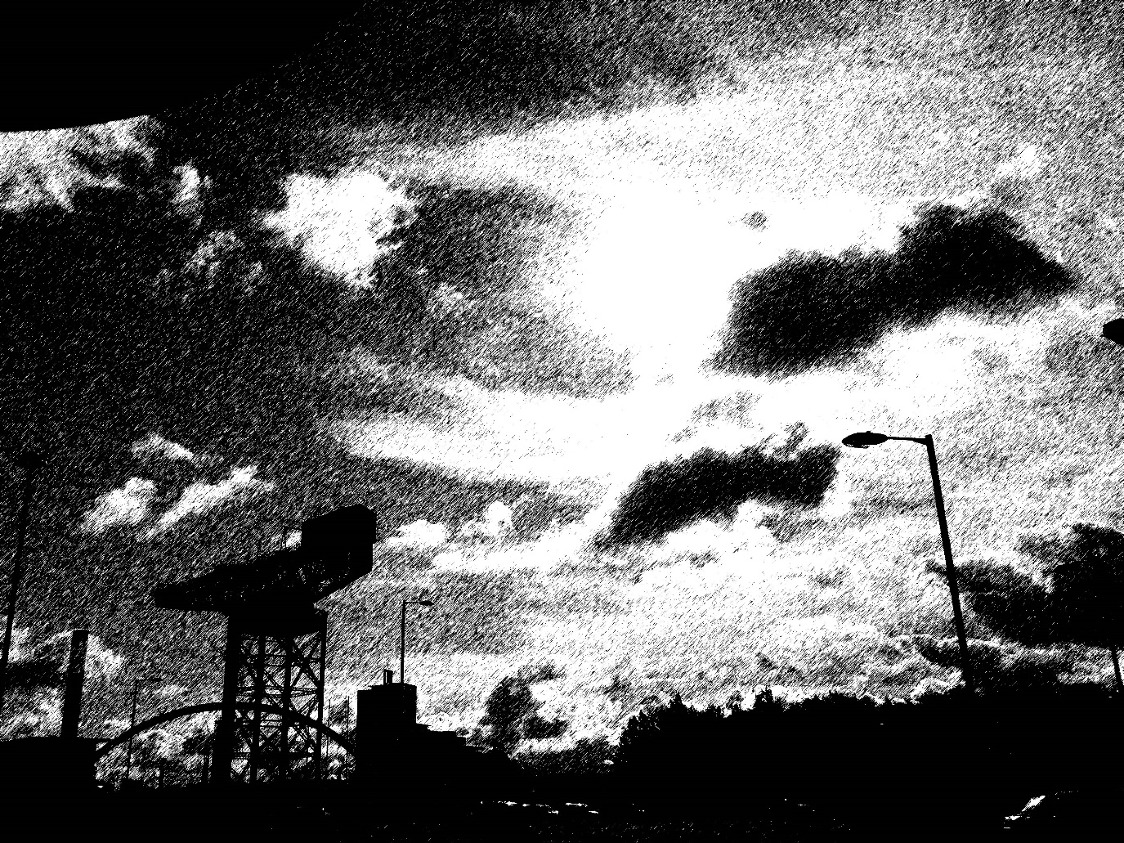
To create the dramatic effects of this image you would start by sketching out the different dark shapes that you can see.
The clouds should have rough edges and the bridge, crane and buildings will have smoother and more geometric outlines.
After sketching out the scene you should then start to create marks like the ones in the picture.
The first marks that you make should be quite light but as you become more confident in what you are doing, you should start to lean heavier on the pencil or pen to create a more permanent mark.
Remember to create the lighter tones by having more gaps between the marks.
To create the darker tones, you should place the marks closer together and allow these to overlap. This will give dense shadows and more definition to the bridge, crane and buildings.
You can also create more depth in your drawing by using different lengths and directions of mark.
Shorter marks will be useful for areas in the distance and longer marks will be suitable for areas closer to the viewer.

