
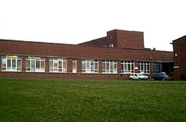

K
NORTH LANARKSHIRE COUNCIL

SHARP AVENUE
COATBRIDGE
ML5 5TJ
TEL: (01236) 632062
Website
www.blogscotland.org.uk/ni/oldmonklandps
E-Mail
ht@oldmonkland.n-lanark.sch.uk

www.blogscotland.org.uk/ni/oldmonklandps
E-MAIL:ht@oldmonkland.n-lanark.sch.uk
wwwwww

NLC Aims

Education and Families

- improving learning and teaching
- raising achievement and realising potential
- encouraging lifelong learning
- working with communities for a better future
- listening and learning together
- celebrating success
- respecting the dignity and value of all
- giving pupils and staff a safe, happy and attractive place to work




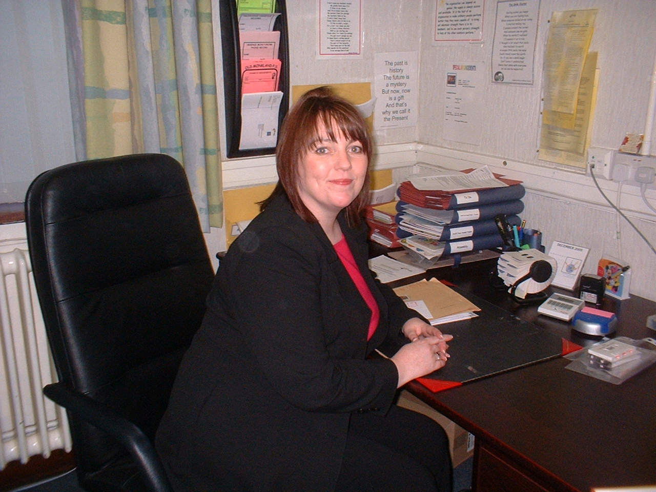

H.T INTRODUCTION

Dear Parents/Guardians,

Welcome to Old Monkland Primary School. Our school is situated in the heart of Kirkwood, Coatbridge. We have a Primary School, Nursery Class and Community Education Base. The Community Education base offers opportunities for adult learners and actively supports community priorities and family learning.

We are proud of our most successful Nursery Class, which provides a rich early level Curriculum for Excellence and encourages our youngest children to be happy, confident, independent learners.
In our Primary School we strive to ensure our Motto “Every Child is Special” is an every day reality for our children. We aim to provide a safe, secure learning environment, which challenges each individual pupil to achieve their full potential. We encourage our children to become responsible and respectful citizens enabling them to share and maximise the opportunities presented for them to become happy, successful and confident learners.

The whole staff aim to work in partnership with the parents to ensure needs of each child are fulfilled appropriately. Our whole staff team are committed to Nurture and Inclusion.

We encourage our children to understand and share the learning process and systems used to promote positive behaviour. We believe this promotes fairness, reasoning and fosters deeper understanding.
We want our pupils to enjoy their education and we are committed to fulfilling our role in enabling our children to make satisfying and successful choices for their futures.
We believe every child is special and we want them to believe it too.

Lynn McFadden
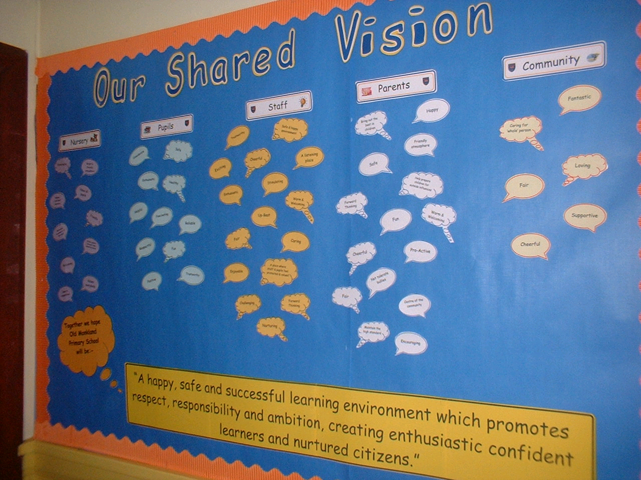

SCHOOL AIMS

As a Community School, to work in partnership with parents, professional agencies, and the wider community to provide, opportunities for the whole community.
- To make a difference, by providing a caring and stimulating learning environment for our pupils.
- To promote self esteem, creativity and intellectual development.
- To raise achievement by helping pupils to aim higher and fulfil their potential.
- To extend pupils’ abilities to communicate ideas and feelings in a variety of ways leading to their playing a full part as citizens in modern society.
- To help pupils develop skills which enable them to maximise opportunities and respond positively to change throughout their life.

OUR SHARED VISION

The following statement was compiled using feedback from pupils, staff, our nursery team, parents and our community links. They were asked what makes our school successful and what factors could work towards continual improvements.
Together we hope Old Monkland Primary School will be:-

“A happy, safe and successful learning environment which promotes respect, responsibility and ambition creating enthusiastic confident learners and nurtured citizens”

Our School Motto is ”Every Child Is Special”

SCHOOL INFORMATION

School Name Old Monkland Primary
Address Sharp Avenue
Kirkwood
Coatbridge
ML5 5TJ
Telephone No. 01236 632062

E-Mail Address ht@oldmonkland.n-lanark.sch.uk

Present Roll 125 School Pupils

Class Structure 7 classes from P1-P7

Nursery Structure Mixed Model
24 Full Time Term Time
24 AM Sessions 48 Weeks
24 PM Sessions 48 Weeks

Capacity of School Planning Capacity 239

Parents should note that the working capacity of the school will vary
dependent upon the number of pupils at each stage and the way in which classes are organised.

Stages covered P1 to P7 School
3-5 years Nursery

Teaching Staff School – 7.62 FTE
+ additionality
Status Non-Denominational and Co-Educational School & Nursery Class

Letting Facilities It is N.L.C. Council Policy that the school accommodation be made
available as far as possible out with school hours for use by the community. Such use by groups, clubs, etc will be in accordance with approved letting procedure and enquiries should be directed to either the Area Community Education Office or to the Area Office.

School Hours School Nursery
Start 9am Full Time term time: 8.45am-2.45pm
Interval 10.45am to 11am Morning session 48wk: 8.00am–12.45pm
Lunch 12.30pm to 1.15pm Afternoon session 48wk: 1.15pm-6.00pm
Close 3pm

School Hours During Covid Restrictions

Start (P1,2 and 3) - 9.00am till 3.00pm
(P4, 5, 6 and 7) - 8.45am till 2.45pm
Interval (P1,2 and 3) 10.30am – 10.45am
(P4, 5, 6 and 7) 10.45am – 11.00am

STAFF

SCHOOL

Head Teacher Miss Lynn McFadden
Principal Teacher Miss Amanda Grant

Class Teacher Primary 1 Ms Joanne Sharkey
Class Teacher Primary 2/3 Mrs Gillian Clark
Class Teacher Primary 3/4 Miss Emma Marchant
Class Teacher Primary 4 Miss Megan Davidson
Class Teacher Primary 5/6 Miss Bethany Jones/Miss Grant
Class Teacher Primary 6 Miss Alana Lochrie/Mr Scott Henderson
Class Teacher Primary 7 Mr Scott Henderson/Miss Danielle Flanagan
McCrone / Class Teacher Flexibility Miss Alana Lochrie/Miss Grant
Senior Clerical Assistant Mrs Caroline Bodie
Clerical Assistant Mrs Christelle Keenan
Classroom Assistant Mrs Karen McKenna
A.S.N. Assistants Mrs Maureen Henderson (0.5)
Mrs Theresa McGuigan (0.5)

NURSERY

Principal Leads: Miss Nicola Thompson
Mrs Marguerite Dick
Equity and Excellence Lead: Mrs Jennifer Maher
Early Learning Practitioners: Mrs Doris Gibbons
Mrs Margarete McLeod
Miss Arlene Rossi
Miss Jessica Simpson
Miss Gemma Doyle
Early Learning Support Workers: Mrs Denice Hughes
Mrs Lynsey Glen
Miss Yvonne Howe

COMMUNITY SERVICES

Janitor Mr Martin Power
Cleaners Mrs Josephine Cassidy
Mrs Donna Quinn
Mrs Helen Kearney
Catering Supervisor Mrs Anne Cunningham
Catering Assistants Mrs Linda Gillick
Mrs Irene Cameron


MONKLAND PRIMAR

SESSION 2020/2021
August 2020

In-service day: Tuesday 11th August 2020
In-service day: Wednesday 12th August 2020
Pupils return to school: Thursday 13th August 2020

September 2020

September weekend holidays: Friday 25 September 2020 to Monday 28 September 2020

October 2020

October break: Monday 12 October 2020 to Friday 16 October 2020

November 2020
In- Service day: Monday 16 November 2020
December 2020 - January 2021
Christmas and New Year Holidays: Wednesday 23 December 2020 - Tuesday 5 January 2021
February 2021
Mid-term break: Monday 8 February 2021 and Tuesday 9 February 2021
In Service Day: Wednesday 10 February 2021
March/April 2021
Spring break: Monday 1 April to Friday 16 April 2021 (inclusive)
Good Friday 2 April 2021 and Easter Monday 5 April 2021
May 2021
May day holiday: Monday 3 May 2021
In-Service day: Thursday 6 May 2021
Mid-term holiday: Friday 28 May 2021 and Monday 31 May 2021
June 2021 School closes: Thursday 24 June 2021

SESSION 2021/2022
August 2021 In-service day: Thursday 12 August 2021
In-service day: Tuesday 13 August 2021
Pupils return to school: Monday 16 August 2021
September 2021 September weekend holidays: Friday 24 September 2021 and Monday 27 September 2021
October 2021 October break: Monday 11 to Friday 15 October 2021 (inclusive)
November 2021 In- Service day: Monday 15 Nov 2021
December 2021 - January 2022 Christmas and New Year Holidays: Thursday 23 December 2021 to Friday 7 January 2022 (inclusive)
(School closes 2.30pm on Wednesday 22 December 2021)
February 2022 Mid-term break: Monday 14 February 2022 and Tuesday 15 February 2022
In Service Day: Wednesday 16 February 2022
April 2022 Spring break: Monday 4 April 2022 to Monday 18 April 2022 (inclusive) Schools close at 2.30pm on Friday1 April 2022
Good Friday 15 April 2022 and Easter Monday 18 April 2022
May 2022 May day holiday: Monday 2 May 2022
In-Service day: Thursday 5 May 2022
May weekend holiday: Friday 27 May 2022 and Monday 30 May 2022
June 2020 School closes: Wednesday 29 June 2022 at 1.00pm

TRANSITION STAGES

PRIMARY ENROLMENT

Enrolment of first entrants takes place in January each year; details of dates are intimated in local press, and also given to pupils presently attending the school. In Old Monkland we have a Pre-entrant programme in place, which provides parents and pre-entrant children with opportunities to get to know the school and class teacher.
Any parent wishing to enrol his/her child at any other time may do so by contacting the school by telephone or in person and are warmly invited to see round the school.

NURSERY ENROLMENT

Children who have had their second birthday may have their names placed on the waiting list by bringing in a completed application form along with copies of birth certificate and Council Tax proof of address to the school office.

TRANSFER TO SECONDARY

Pupils normally transfer between the ages of 11½ and 12½, so that they will have the opportunity to complete at least 4 years of secondary education. Parents will be informed of the arrangements no later than December of the year preceding the date of transfer at the start of the new session.

The secondary school which pupils will transfer to:



Coatbridge High School
17 Park Street
COATBRIDGE
ML5 3NA
Tel: 01236 794848

What is Curriculum for Excellence?
Curriculum for Excellence is Scotland’s national curriculum. It provides a coherent and inclusive curriculum from 3-18 years wherever learning is taking place, including early learning childhood centres, schools, colleges and community learning. It places children and young people at the heart of Scottish Education.

The purpose of the Curriculum for Excellence is encapsulated in the four capacities – to enable each child or young person to be

- a successful learner
- a confident individual
- a responsible citizen and
- an effective contributor

These four capacities govern the entire curriculum from age 3-18 and aim to raise the standards of achievement for all learners.
Curriculum for Excellence is underpinned by the values inscribed on the mace of the Scottish Parliament –
Wisdom, Justice, Compassion and Integrity.

Throughout Curriculum for Excellence there is a strong focus on literacy, numeracy and health and wellbeing across all aspects of learning and every teacher will support learners with development of these, including digital literacy skills.

Curriculum for Excellence is defined as:
The totality of all that is planned for children and young people throughout their education.

The opportunities for learning and teaching are governed by the Four Contexts for Learning, which ensure that the education your child received is informative, interesting, relevant and fun.

These contexts are:
Ethos and life of the school as a community
Curriculum areas and subjects
Interdisciplinary learning
Opportunities for personal achievement

What are the Curriculum for Excellence levels?
There are five levels and these are flexible depending on pupils’ needs and abilities (some children and young people may achieve these levels earlier or later dependent on ability):
- Early level pre-school to P1
- First level to the end of P4
- Second level to the end of P7
- Third and fourth levels S1 to S3
- Senior phase S4 to S6 and other forms of study
What is the Broad General Election?
The Broad General Election (BGE) is the first phase of two closely connected phases of education. The BGE phase stretches from age 3 until the end of S3 after which learners move into the Senior Phase which starts in S4.

Curriculum Areas and Subjects
The BGE is delivered via 8 curricular areas which, in secondary school cover years S1 to S3, and may be subdivided further into individual subjects.
The 8 curricular areas are:

- Expressive Arts
- Languages and Literacy
- Health and Well Being
- Mathematics and Numeracy
- Religious and Moral Education
- Sciences
- Social Studies
- Technologies

What are the curriculum areas in Curriculum for Excellence?
There are eight curriculum areas:-
Expressive Arts Religious and Moral Education
Health and Well Being Sciences
Languages (literacy) Social Studies
Mathematics (numeracy) Technologies
Importantly, literacy and numeracy are given added importance because these skills are so vital in everyday life. All teachers will have responsibility to teach literacy and numeracy.

Learning is divided into two phases
The Broad Education (BGE) is from Nursery to the end of Secondary School Year 3. Learning is divided into levels. The levels are as follows:-

LEVEL STAGE

Early the pre-school years and P1 or later for some

First to the end of P4 but earlier or later for some

Second to the end of P7, but earlier or later for some

Third and fourth S1-S3, but earlier for some

Senior Phase S4 – S6 and college or other means of study

How will my child’s learning be assessed?
In playrooms and classrooms staff will be using improved ways of assessing children’s learning taking account of national and local advice and guidance. Your child’s progress will be reported to you so that you know how well your child is doing.
Each year your nursery/school will let you know what is being done to implement Curriculum for Excellence so that you can be confident that your child is receiving a high quality education.

- National 4 and 5 qualifications were introduced in 2013/2014
- Access, Highers and Advanced Highers are being updated to
reflect Curriculum for Excellence
- New highers in most subjects were introduced in almost all
North Lanarkshire schools in August 2014

In OMPS every child has a Snapshot Jotter to share routine learning and standards throughout the year and to share out school achievements and interests. These are shared bi-annually with parents at progress appointments, where parents and pupils have the opportunity to comment on them.

CURRICULUM
Curriculum for Excellence
Currently our school is embracing the four capacities of Curriculum for Excellence – enabling children to be Responsible Citizens, Effective Contributors, Confident Individuals and ultimately Successful Learners.
We are working towards full implementation and assessment in line with Curriculum for Excellence outcomes
and school improvement planning priorities.

As a guide: Pupils in Nursery to P.1 Early Level Outcomes
P.2-4 First Level Outcomes
P.5-7 Second Level Outcomes
Our children will be working on Interdisciplinary Topics and themed weeks to involve them in planning their learning.


CURRICULAR AREAS
Literacy and English Numeracy and Mathematics



Social Subjects Science/Technology






Expressive Arts Religious and Moral Education



Health and Wellbeing I.C.T

Literacy and English

Our school implements NLC’s Active Literacy Programme
Early Years Department (P1-3)
In the Early Years Department reading resources include Storyworld, Heinemann Sunshine Spirals, Literacy Links, PM Books and Discovery World. The N.L.C. Active Literacy is used to support phonics, reading skills and spelling strategies.
Junior & Senior Department (P4-7)
Reading resources include skinny and full novels supplemented by Literacy Links, PM Books, Ginn Lighthouse and PM Benchmark reading resources. N.L.C. Reading and Writing programmes are used to ensure the children have a variety of approaches to literacy. Interactive Approaches to spelling are being developed in our Junior/Seniors too and we plan to communicate these strategies to parents in an Open Evening held annually.

MODERN LANGUAGES
In P1-7 pupils are given an opportunity to study introductory French from our staff who have relevant qualifications in Modern Languages. We intend to develop Spanish in P5-7 too in coming sessions as
part of modern language development in North Lanarkshire Council.

NUMERACY AND MATHEMATICS
The school follows the N.L.C. guidelines on Maths and Numeracy, using NLC Pathways, ‘Heinemann Maths’ and Teejay materials to support Active Learning.. Through practical experiences and applying maths in a context, pupils are led to an understanding of the Mathematical Processes of Number, Shape and Measurement, Problem Solving and Information Handling. Children participate in Interactive Maths activities daily and a variety of assessment approaches.

INTERDISCIPLINARY TOPICS

.
Throughout the school, Environmental Studies topics encompass Social Subjects, Technology and Science.
The children participate in a variety of Social Subject topics developing knowledge & skills relating to people in the past, people and place and people in society. In Science, skills are taught through investigations of living things and the processes of life, Energy and Forces and Earth and Space. Information Technology and Health and Wellbeing are also taught in all stages. Emphasis is laid on the children’s discoveries in their local environment, and they are encouraged to use all local sources in their research including home background information.
We are currently working towards becoming an Eco School and are committed to improving our school environment and making positive contributions to our and global community issues.

EXPRESSIVE ARTS
Whilst Dance, Music, Art and Drama may be integrated into class topics, children are also helped to develop skills in all four subjects in activities designed to extend and encourage a progression of skills.
N.L.C. Guidelines are implemented and evaluated to show progression and effort in all 4 areas in:-
- Using materials, techniques, skills and media
- Expressing feelings, ideas, thoughts and solutions
- Evaluating and appreciating
Some specific resources/activities are used to create a focus or enhance children’s appreciation e.g.
Music Silver Burdett / Kodaly/ ABC Music
Drama All 4 Expressive Art Areas are encompassed in our school performances, in class
assemblies, end of term services and School Shows. They have contributed to
our super reputation within the local community

HEALTH AND WELLBEING
Our school has an Active Schools Co-ordinator who supports us in extending our provision including Out Of School Hours Learning i.e. dance, football, tops games (P1-3), golf.
Old Monkland Primary School is a Health Promoting School.
We encourage our children and families to make healthy choices in diet, exercise and emotional well-being. Children follow N.L.C. guidelines on Health Education and skills and understanding are naturally extended
from P1-7.

ICT
Our children are trained in I.C.T. skills using Apple Mac and PC computers and i-books. They are given opportunities for skills reinforcement, and to develop knowledge and ability in using hardware and software.
Children use a variety of packages including Smart Learning, Success maker and Interactive Mental Maths. They have opportunities to use Interactive Whiteboards, digital cameras and remote control toys.
We are now delighted to have been able to fund the expansion of our ICT hardware to include
each class having its own smart board and a large screen and projector facility in our school hall.

HOMEWORK
Teachers will inform parents of the type and frequency of homework at the start of each session and parents are asked to sign/complete diary sheets to communicate regularly with staff.
Homework usually consists of reinforcement of skills taught in class e.g. spelling, sentence structure, number skills etc. On occasion children are asked to complete topic related tasks which may require some personal research.
Homework should take between 15-30 minutes daily and our pupils are encouraged to take responsibility for planning their homework completion through weekly tasks being set to prepare them for Secondary Education.




ASSESSMENT AND REPORTING

Assessment is an important part of the Curriculum for Excellence and, at all levels, pupils’ progress is closely monitored by teachers and staff.
In turn, teachers and staff work with pupils to reflect on their results, looking at their strengths and learning needs, agreeing next steps and action based on these. As they progress, pupils become more involved in this process, as they develop the skills to make effective judgments on their own learning, developing personal expertise that will be important to them throughout life. Assessment also helps teachers plan learning experiences which are motivating and challenging. Children who may have additional support needs will be assessed using methods best suited to their individual requirements.
Assessment is for Learning. In Old Monkland we use a variety of formative assessment strategies. These include … Peer/Self assessment, marking systems, traffic lights, setting targets, Reflecting on Our Learning and Learning Logs. Teachers, using their professional expertise are then able to make reports to parents about their children, usually an interim report in November, plus a written report once per year. Any test results or progress reports are of course given in confidence to the parent.
In Old Monkland Primary parents are invited to school twice per year to discuss in private, their child’s progress, but are welcome to consult with class teacher at other times if there is an issue which concerns them or they wish more information. (A telephone call or letter to arrange a mutually convenient time would be appreciated).

IMPROVEMENT PLAN SUMMARY
HOW ARE WE DOING?
Pupils continue to build on their strengths and successes from last session. Our School Management Team visit classes regularly and make time to regularly monitor children’s progress. Teachers use positive comments and symbols to praise children and enable them to improve their written work.
Teachers plan work for pupils in advance ensuring that individual needs are met in a realistic and motivating way.
At times, parents or class teachers express concern about an individual pupil’s progress in a particular area. In these circumstances pupils may be referred to other agencies e.g. Area Network Support, Speech & Language therapy, often through our Multi Agency meetings which are held in school. We follow guidelines laid out in the GIRFEC agenda to support individual needs and communicate with families and relevant agencies. A Parent Workshop is held annually to refresh parental knowledge of our SfL Systems.
National Assessment is in place and pupils sit the test for their level as soon as they are ready. Parents are then informed of results and share with us in the celebration of their child’s success.
In Session 2021/22 we will continue to drive forward these initiatives with Scottish Attainment Challenge priorities.

SIP Priorities 1921/22
CLUSTER PRIORITY
- Improve outcomes for children via implementation of the GIRFEC Pathway for Planning and Support refresh and the establishment of Integrated Cluster Wellbeing Teams and Bases.
PRIORITY 1
Enhance digital communication and learning across our whole school community
PRIORITY 2
To enable all stakeholders to recognise the importance of and use a variety of strategies to promote emotional wellbeing and partnerships in learning
PRIORITY 3
To raise attainment in Literacy through effective core and collaborative planning, teaching and assessment and effective support programmes for identified groups and individuals
PRIORITY 4
Delivering 1140 hours in a new Mixed Model Setting

SPIRITUAL, SOCIAL, MORAL AND CULTURAL VALUES
In Old Monkland Primary, we endeavour to develop self-esteem and respect for others. Our School Motto is Every Child Is Special. All religious beliefs are respected and parents can exercise their rights to withdraw their child from Religious Education or Observance, by writing to the Head Teacher. (This is in line with the council policy and national advice.) Any such pupil will not be placed at a disadvantage with respect to secular instruction.
Since Religious Education forms a part of the curriculum, it is taught in each primary stage, using a variety of resources. We aim to help pupils be aware of: beliefs, values, attitudes and practices in a range of religious faith, thus encouraging religious tolerance.
Weekly assemblies allow an opportunity for Religious Observance, others are led by classes – usually one per month. (Parents of children in the particular class are most warmly invited to that assembly). Assemblies also allow for whole school updates or launches of new initiatives.
At the end of term service, it is usual for all pupils to take part – e.g. choirs, and all parents’ family and friends are warmly invited.
Parents/Guardians from ethnic minority religious communities may request that their children be permitted to be absent from school in order to celebrate recognised religious events. Only written requests will be considered. Appropriate requests will be granted on not more than three occasions in any one-school session and the pupil noted as an authorised absentee in the register.

EQUAL OPPORTUNITIES AND SOCIAL JUSTICE
All pupils in Old Monkland Primary School, regardless of belief, race, culture, class and gender are provided with the same opportunities to enable them to reach their potential, following the council’s policy.
The school is committed to ensuring its policies and practices do not impact adversely on any particular group(s) of people and opportunities to promote equality are actively pursue

The Equality and Human Rights Commission’s Technical Guidance for Schools in Scotland outlines the essential requirements of the Equality Act 2010 for schools

Implementation of the Education and Families Equality Policy including The Equality and Human Rights Commission’s Technical Guidance for Schools in Scotland is the essential guide for the school community to promote equality. This can be accessed at https://www.equalityhumanrights.com/en/publication-download/technical-guidance-schools-scotland

RAISING ACHIEVEMENT FOR ALL
Raising Achievement for All forms the overarching strategy for the service. Subtitled ‘Experiences to Last a Lifetime’, this strategy aims to harness the combined forces of Learning and Leisure Services to provide a rich set of learning opportunities and experiences for young people and adults which begin in the classroom, nursery or learning centre and extend out into the community and the wider world beyond. In seeking to offer ‘Experiences to Last a Lifetime’, we will also look to draw upon ‘a lifetime of experiences’ already there in the communities which make up North Lanarkshire.

PUPIL COUNCIL
A Pupil Council is elected annually consisting of a Representative for each class stage, a secretary, a chairperson, a vice chairperson and a Staff Representative.
The pupil council reflect the pupils’ requests and suggestions and have previously taken responsibility for organising regular non-uniform days to raise school funds for particular events or charities nominated by our children.

SUPPORT FOR LEARNING
Many children at some time of their school career encounter some form of learning difficulty. Since it is our policy to allow each child to develop at his/her own pace, problems would be recognised, and the class teacher would respond accordingly. Since we are keen to work in partnership with parents, you would be informed of any such problem at an early stage, and invited to support your child in liaison with the class teacher.
Class Teachers, who know the variety of needs in their classes, plan programmes of work carefully, so that each pupil is supported.
This school also has regular sessions from the Area Network Support Teacher who works in the classroom with individuals/groups offering extra support. It is our policy not to withdraw individual children from the class, but rather to offer support alongside the class teacher when at all possible.
The services of the Speech Therapists and Psychologists may also be called upon as required. In this case parents will be fully consulted and involved in decision making.
Additional Support Plans (A.S.P’s) can be formulated to ensure a structured delivery of the recognised levels of support. Meetings with parents will be arranged to communicate these and copies of the IEP will be issued.

Additional Support for Learning
Old Monkland Primary School complies with the Education (Additional Support for Learning) (Scotland) Act 2004 as amended by the Education Additional Support for Learning (Scotland) Act 2009 and the Additional Support Learning: Statutory Guidance 2017.
North Lanarkshire Council’s policy is contained within “Support for Learning Policy into Practice 2”, a copy of which is available in the school. The school has a support for learning policy, available from the school on request which is consistent with North Lanarkshire Council guidelines.
N.B. Currently Old Monkland Primary is piloting a draft GIRFEC policy to outline the stages of support and intervention put into place to support our pupils,

Level 1 – Internal Support, where education staff identify that a child or young person needs support or
planning which can be met within the existing classroom or playroom setting.

Level 2 – Internal Support, where education staff identify that a child or young person needs support or
planning which can be met within the school or early years establishment.

Level 3 – External Support from within Learning & Leisure Services, where it is identified that the child or
young person requires support or planning from beyond the school or early years setting but within
educational services.

Level 4 – External support provided on a multiagency basis, where the child or young person’s needs are
identified as requiring support or planning from multiagency services and these support needs will last for
more than one year.

Looked after Children i.e. children who are cared for directly or whose care is supervised by the local authority are deemed to have Additional Support Needs unless assessment determines otherwise.

Parents are involved throughout the whole process of any support for learning strategies implemented and are asked to express their views and opinions regularly throughout.
As and when required, the school will seek additional support from our partner agencies e.g. English as an additional language.

Planning

Additional Support Plans (ASPs) enable staff to plan effectively for children and young people with Additional Support Needs.

Some children and young people may require significant support from education and at least one other agency, such as health, social work and/or voluntary agency to help them meet their learning targets. Where this support requires a high level of co-ordination the opening of a Co-ordinated Support Plan (CSP) may be considered.
A CSP may be initiated by the school or another agency.
Parents and young people can, if they wish, request that a CSP be considered and would be involved in the process. Parents will receive letters from the Education Authority throughout the CSP process. Parents and young people will be invited to take part in multi-agency meetings and their views will be recorded in the plan.

Dispute Resolution
North Lanarkshire Council is committed to resolving any differences of views through discussion, dialogue and building on common ground.

If the matter cannot be resolved with the Education Authority you have the right to request mediation. An independent mediation service is available to parents and young people through Resolve (see contact details at the back of this handbook). Mediation is free and independent of the Education Authority.

In the event that a disagreement cannot be resolved through mediation, then an application for Independent Adjudication (see contact details at the back of this handbook) can be made by parents free of charge. The Independent Adjudicator will make recommendations to the Education Authority about how the dispute should be resolved.
The Additional Support Needs Tribunal has been set up to hear appeals made by parents or young people on the decisions made by the Education Authority relating to
Co-ordinated Support Plans, placing requests and post school transition. If you disagree with any decision relating to your child’s Co-ordinated Support Plan, either the creation of a CSP, or the content of it, you may be entitled to refer to the Tribunal.



HOME SCHOOL LINKS
Partnership with Parents
In Old Monkland Primary we are very keen to forge links with parents; to work in partnership with them, in the education of our pupils. We positively encourage parental involvement (in a variety of ways):-
- Parent Helpers – in classroom, Playground Pals, outings, sports, behind the scenes preparation.
(we try to encourage and utilise the skills of our parents in a supportive way) Any amount of help & time given is appreciated.
*To ensure the Safety of our pupils, all parent helpers must obtain a valid disclosure check through
NLC
- Parental Communication - we like to keep the lines of communication open by talking/listening to parents, as well as sending letters/newsletters home on a regular basis, keeping parents well informed and up to date on current/future events in the school.
We communicate by – newsletters, information leaflets, parents notice board, certificates and phone calls.
- Open Door Policy - we hope that parents feel comfortable about visiting the school and we’re always pleased to see them – whether it’s on an informal visit to pick up a child or on a Parents’ Evening, when progress reports are given to parents. Parents’ Evenings take place twice per year and appointments are made for this. However, if at any time parents wish to discuss something relating to their child, they will be very welcome – though a telephone call first would be appreciated to arrange a convenient time for all parties.

TARGET 21
We want our school to be the very best it can be and for all pupils to maximise every opportunity for learning and development during their primary years. Therefore, we want to improve standards by implementing our school programme called ‘Target 21’ where children can achieve points for:
- Attendance
- Punctuality
- Wearing School Uniform
- Bringing PE kit on required days
- Returning homework timeously and to a satisfactory standard.
Pupils work towards termly Gold/Silver/Bronze rewards and targets are shared with parents weekly to enable us to work in partnership to ensure all pupils can achieve their reward for school readiness.

SCHOOL/COMMUNITY
The school plays an important part in the community. It is our policy to foster in the pupils an interest and pride in the school and the community which it serves. An awareness of the quality of life around them is encouraged.
A link has been established with Health Visitors, Police, Community Involvement, Community Education and a Kirkwood Parent Action for Safe Play Group. The Kirkwood/Kirkshaws Area Liaison Committee has been established which brings together officers of the Council, elected members and representatives of local organisations to look at needs, issues, and problems as they affect the community, with a view to working together to have some impact on the problems in the area.
We support Old Monkland Church and encourage community involvement in school issues through committee membership i.e. Health Promoting School Committee, Eco Council, P.T.A.

HOME/SCHOOL/COMMUNITY BASE
The school is very fortunate to have an excellent provision for parents in our Community Education Wing and support programmes led by our Community Learning and Development Worker. Many programmes of workshops are offered after our parents are consulted annually through questionnaires seeking their views on what their needs/ requirements are.
A variety of classes, including art, Nifty Fiftys and word processing are offered in the base.
The programme is constantly changing so please telephone Coatbridge 423358 for the latest up-date information.
COMMUNITY LEARNING AND DEVELOPMENT WORKER
Our Community Learning and Development Worker is Bernadette Newton. Bernadette can be contacted at Coatbridge CLD Locality Office, 9 Old Monkland Road. Coatbridge, ML5 5EA on 01236 638470, e-mail to
CLD-Coatbridge@northlan.gov.uk
She can support any issues concerning our parents, also she can offer a variety of activities for parents and their children, source information or support when required and is happy to offer any help he can.

PARENT FORUM

As a parent of a child at Old Monkland PS you are automatically a member of the Parent Forum. The Parent Forum is composed of all the parents and carers of children at the school.
As a member of the Parent Forum you can expect to:
- Get information about what your child is learning
- Get information about events and activities at the school
- Get advice/help on how you can support your child’s learning
- Be told about opportunities to be involved in the school
- Have a say in selecting a Parent Council to work on behalf of all parents at the school
- Be invited to identify issues for the Parent Council to work on with the school.

PARENT COUNCIL

Parent Councils came in to force on 1 August 2007.

The Parent Councils’ rights and duties include:
- supporting the work of the school;
- representing the views of parents;
- consulting with parents and reporting back to the Parent Forum on matters of interest;
- promoting contact between the school, parents, pupils, providers of nursery education and the wider community;
- fundraising;
- taking part in the selection of senior promoted staff;
- receiving reports from the head teacher and education authority; and
- receiving an annual budget for administration, training and other expenses.
- Improving home/school partnership and facilitating parental involvement.

Members of Parent Councils, on a voluntary basis, may also have an advisory role in decisions on placing requests by parents in respect of those situations where the number of placing requests for a particular school or for a particular stage in a particular school exceeds the number of places available.

Our first Parent Council was formed in October 2008.
In 2018/19 our office bearers are:

Debbie Docherty Chairperson
Deepika Majumder Parent Member
Lorna Richardson Treasurer
Fiona Lucas Co-opted Member
Martin Seel Parent Member
Karen Williams Parent Member
Shona Cope Parent Member

In the new Session we hope our Parent Council information will also be available in our GLOW blog.
ATTENDANCE AT SCHOOL

Section 30 of the 1980 Education Act places a duty on every parent of a child of ‘school age’ to ensure that their child attends school regularly. Attendance must be recorded twice per day. Morning and afternoon.
Regulation 7 of the Education (School and Placing Information) (Scotland) Amendment, etc. Regulations 1993 requires each child’s absence from school to be recorded in the school register as authorised or unauthorised. As defined by the Scottish Government.
Parents are asked to inform the school by letter or telephone if their child is likely to be absent for some time, and to give the child a note on his or her return confirming the reason for absence.
At the start of each school session, parents will be asked to provide contact details including at least one emergency contact number, including where possible, a number that will accept a text message. Parents are required to inform the school if these contact details change during the course of the year.

Attendance Monitoring
To ensure the safety of our children, the parents of any child with an unexplained absence will receive a call or text from the school to check on reason for absence. However, this is a large commitment on the workload of the office staff and therefore we ask all parents to notify us immediately of any absence if at all possible.
Every effort should be made to avoid family holidays during term time as this both disrupts the child’s education and reduces learning time. Parents/guardians should inform the school by letter of the dates, before going on holiday.
Absences will be classified as authorised only in exceptional circumstances. Such circumstances may include:
A family holiday judged to be important to the wellbeing and cohesion of the family, following serious or terminal illness, bereavement or other traumatic events.
A family holiday classified under the ‘authorised absence’ category will not include such reasons as:

- The availability of cheap holidays
- The availability of desired accommodation
- Poor weather experience during school holidays
- Holidays which overlap the beginning or end of term
- Parental difficulty obtaining leave (except in cases where evidence is provided by the employer that it cannot accommodate leave during school holidays without serious consequences)
Family holidays with the above similar characteristics will be classified as unauthorised absence. Where the head teacher’s prior agreement has not been sought the absence will automatically be classed as unauthorised.
Where most family holidays will be recorded as unauthorised absence (see above) extended leave with parental consent will not be considered the same as a family holiday. Leave in such circumstances will be authorised under circumstances such as:

- Extended overseas educational trips not organised by the school
- Short-term parental placement abroad
- Family returning to its country of origin (to care for a relative, or for cultural reasons
- Leave in relation to the children of travelling families
Parents may request permission for such leave in writing and the school may authorise such requests under the following circumstances:

- The period immediately after an accident or illness
- A period of serious or critical illness of a close relative
- A domestic crisis which causes serious disruption to the family home, causing temporary relocation.

It should be emphasised that the school investigates unexplained absence, and that the authority has the power to, interview or prosecute parents/carers, or to refer pupils to the Reporter of the Children’s Panel, if necessary. A statement of the school’s policy including procedures for the enforcement of attendance.

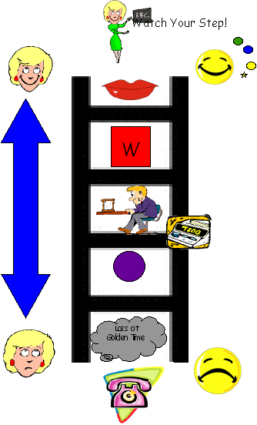
Verbal warning
Warning card issued
Stop & think time (in class)
Time out with Miss McFadden (purple counter given)
Loss of Golden Time – Parents informed
Staff are instructed to advise the Head Teacher of any concern they have about pupil absence, who will then send an Absence Enquiry letter. If your child has a dental or medical appointment during school hours, he/she should show an appointment card/letter to class teacher, in advance. Parents must arrange for their child to be collected from school on such occasions.

OUT OF SCHOOL HOURS LEARNING

We currently offer a range of extra curricular activities i.e. football, golf, choir and dance and have plans to extend this provision in the New Year.
With the increased levels of support from Parents & Active Schools Coach, we hope to present a varied, cross curricular programme in the future and organise alternative activities for intervals.

PROMOTING POSITIVE BEHAVIOUR
The relationship between pupils and teachers is similar to that between a child and his/her parents, requiring mutual consideration on both sides. In Old Monkland Primary we aim to encourage respect and responsibility for others by reinforcing positive behaviour. We implement a school policy on discipline ‘Happy Houses’ which has been presented to parents in a summary booklet.

Every child and members of un-promoted staff are placed in Houses to promote teamwork and encourage community spirit. Happy House Captains are elected annually and are trained in peer mediation skills to help support younger children in the playground. All classes participate in forming class rules. We encourage our children to follow the ‘Golden Rules’ and we do enforce some of these in order that the children are safe and well, e.g. playground behaviour. Every class in the school display a ‘Watch Your Step’ poster which allows the children to recognise the sanctions challenging behaviour merit and at all times children are encouraged to turn their behaviour around. This whole school approach promotes understanding, fairness and consistency.
Parents are informed of discipline sanctions applied to their children by telephone call or by letter, and we are grateful for the support and co-operation given by parents. Pupils are asked to reflect on their behaviour and how they could have approached things differently.
We give our anti-bullying programme a high priority, giving senior pupils an opportunity to discuss the various issues. Please inform the school staff of any incident of bullying affecting your child, since we deal with allegations of bullying very seriously. We have a policy statement on dealing with bullying.

N.B. At any time if a pupil is defiant or disobeys staff a purple counter will be immediately issued. Staff reinforce use of this ladder by encouraging children to turn around their behaviour and prevent small issues escalating.

SUPERVISION OF NON-CLASS TIMES

An adult presence is provided in playgrounds at break-times in terms of the Schools (Safety and Supervision of Pupils) (Scotland) Regulations 1990.
Support staff are available in the playground to encourage safe and harmonious play and we have purchased various playground resources.

CLOTHING AND UNIFORM
All North Lanarkshire schools must have a dress code, which encourages pupils to dress in a way which is appropriate to attendance at school. This dress code must not lead to direct or indirect discrimination on the grounds of race, religion, gender or disability. Prior to drawing up the dress code the parents, pupils and staff were fully consulted. It is the expectation of the education authority that parents will be keen to support the dress code and written agreement may be sought.
Clothing which is unacceptable in school under any circumstances includes items which:

could potentially, encourage faction (e.g.football colours)
could cause offence (e.g anti-religious symbolism or political slogans)
could cause health and safety difficulties, such as loose fitting clothing, dangling earrings and other potentially dangerous jewellery
are of flammable material which may be a danger in certain classes (e.g. shell suits)
could cause damage to flooring
carry advertising in particular for alcohol or tobacco
could be used to inflict injury to other pupils or to be used by others to do so.

Parents of Primary aged children in receipt of a clothing grant from the Council will be encouraged to purchase items, which are in accordance with the school dress code. Approval of any requests for such grants in other circumstances is at the discretion of the Assistant Chief Executive Education, Skills and Youth Employment. Information and application forms may be obtained from any school or First Stop Shop. Parents are entitled to receive a clothing grant if they are in receipt of any of the following benefits: Income Support, Job Seekers Allowance (income based), Employment & Support Allowance (income related), Univeral Credit, housing benefit and council tax rebate.
Whilst in general terms it would not normally be the policy of the authority to exclude a pupil from school solely on the basis of his/her dress, persistent refusal to respond to a reasonable dress code may be deemed to be a serious challenge to the Head Teacher’s authority and to be detrimental to the well being of the whole school community. In such circumstances a head teacher may justify the use of the school discipline procedure.

The council wishes to minimise claims arising from the loss of pupils’ clothing and/or personal belongings. Parents are asked to assist in this area by ensuring that valuable items and unnecessarily expensive items of clothing, jewellery etc. are not brought to school. Parents should note that any claims submitted to cover the loss of such items are likely to be met only where the authority can be shown to have been negligent.
If required, school ties and badges may be purchased from the school office.
Currently our items of uniform with badges are available from Scotcrest in Mackinnon Mills
Old Monkland Primary School Uniform:
Gold polo shirt with school badge or white shirt and school tie
Black or grey skirts, pinafores or trousers
Royal blue sweatshirt or tank top with school badge
Royal blue/yellow summer dresses
PE Kit
Black shorts
White t-shirts
Change of gym shoes/trainers
It is advisable to clearly label ALL personal belongings to avoid mix ups.

MEALS

Pupils can access their money card prior to 9 a.m. and during interval to put money on their card for Breakfast Club (free for P1-3 pupils/£1 per day for pupils, reduced cost if more than 1 sibling), Tuck or School Meals. Online payments are available for parents should they prefer. NB – During covid restrictions all monies have to be paid ONLINE.

The availability of special diets
Diets required as a result of a medical condition (a medically prescribed diet e.g. coeliac disease, diabetes, food allergy or intolerance) can be provided in school. A medically prescribed diet form must be completed by the child’s Registered Dietician or General Practitioner. Procedures and forms can be accessed from the child’s school or dietician, or from North Lanarkshire’s catering service. Occasionally, parents/carers may be asked to supply prescription foods or attend a meeting to discuss the child’s dietary requirements.
Some children with additional support needs may require food to be adapted to an appropriate texture and consistency. In this instance the child’s Registered Dietician or Speech and Language Therapist will liaise with Head Teacher and school catering service to ensure appropriate food provision.
Special diets required for ethical, religious or cultural reasons should be requested in writing to the head teacher, who will liaise with the school catering service.

Arrangements for those who bring packed lunches
Pupils can choose to bring a packed lunch and are seated with their classmates in the dining hall. We
request that no glass bottles are provided.

Arrangements for Nursery snacks
Our Nursery provides children with a healthy snack daily, milk and free access to water. Snacks are
purchased using donations from parents. Our Nursery also participates in loving lunches.

All P1-3 pupils are entitled to a free school meal.

From August 2020, all eligible two year olds and all children aged from 3 to those not yet attending primary school, that attend a North Lanarkshire Council Nursery or a Funded Provider (childminder or voluntary/private nursery), will be entitled to 1140 hours Early Learning and Childcare provision . Those children attending for four hours per day, or more, will receive a free meal as part of the Early Learning and Childcare entitlement
Early Years Provision
Early Years Provision – If your child is aged between 2 and 4 years and attends a North Lanarkshire Council or Partnership Provider Nursery, in the middle of the day for more that 4 hours per day, may be entitled to a free meal.
Parents must be in receipt of any of the qualifying benefits above or in receipt of State Pension Credit or Incapacity and Severe Disablement Allowance. Your child will also be entitled if they are or have been at any point since their second birthday looked after, the subject of a kinship care or guardianship order.
Information and application forms for free school meals may be obtained, from Schools, First Stop Shops and Municipal Buildings, Coatbridge.

Parents are entitled to receive a clothing grant if they are in receipt of any of the following benefits:
Income Support, Job Seekers Allowance (income based), Employment & Support Allowance (income related), Universal Credit, Housing Benefit, Council Tax Rebate.

Only primary school children who receive a free school meal are entitled to free milk. Milk may, however, be available for purchase in the school during the lunch period.

Nursery children are entitled to free milk.

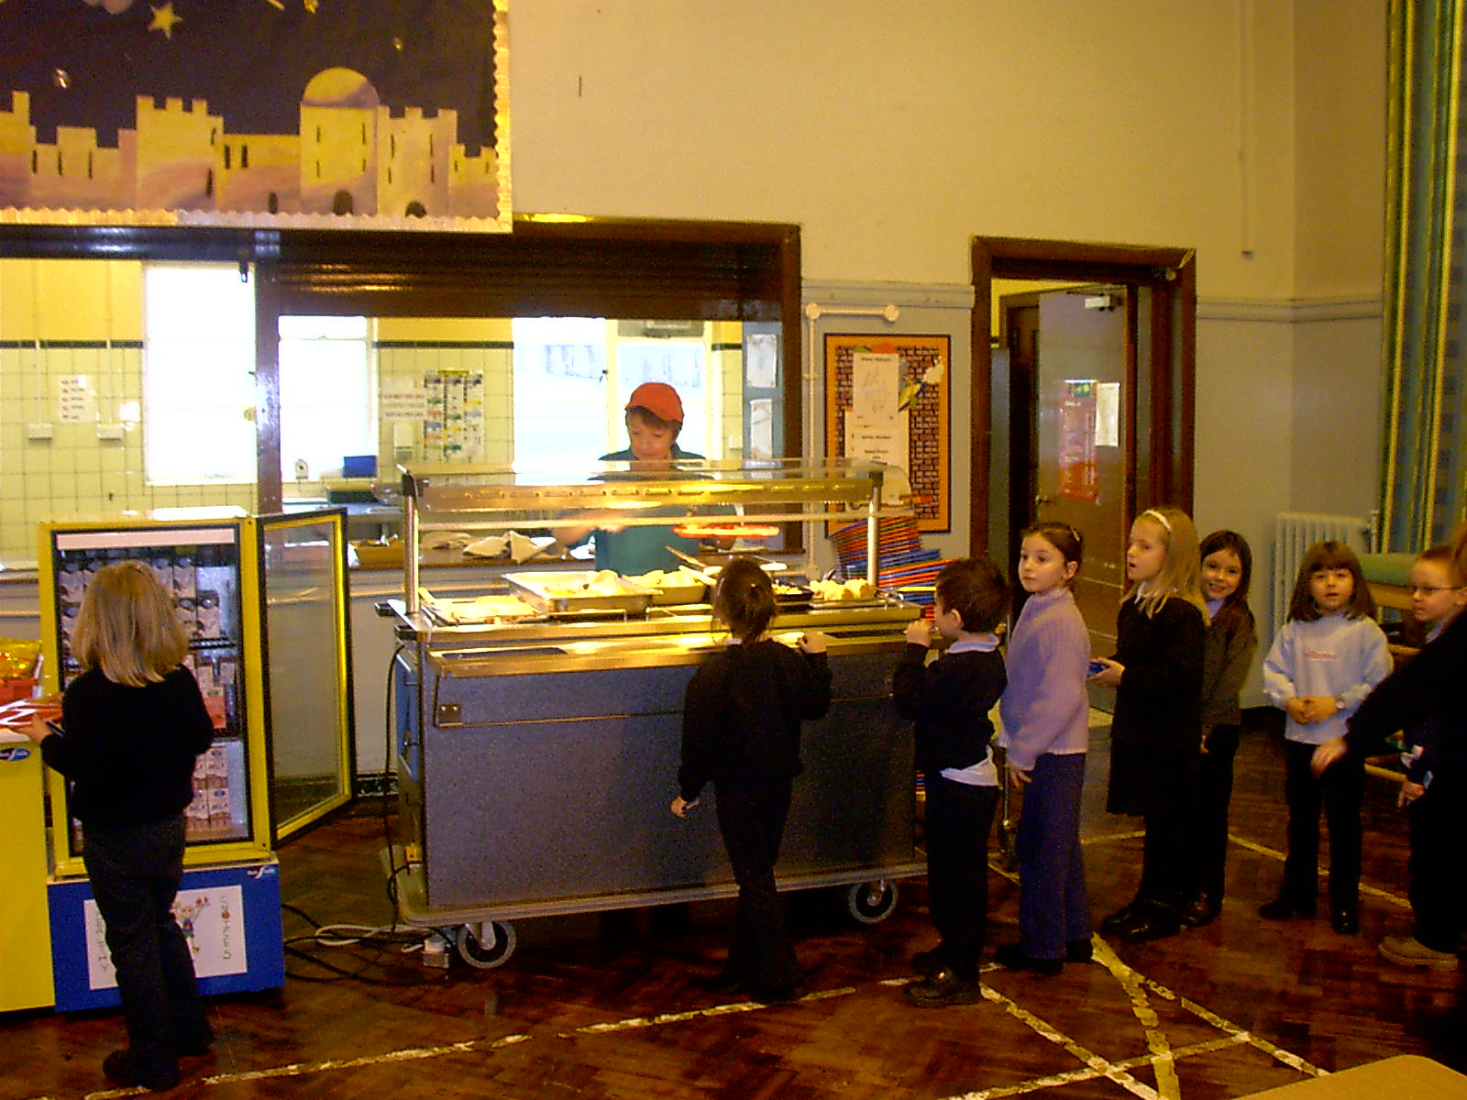

TRANSPORT

GENERAL
The Council has a policy of providing free transport to all primary pupils who live more than one mile from their local school by the shortest suitable walking route. This policy is more generous than the law requires. This means that the provision of transport could be reviewed at any time. Parents/carers who consider they are eligible should obtain an application form from the school or from Education and Families. These forms should be completed and returned before the end of February for those pupils beginning school in August, to enable the appropriate arrangements to be made.
Applications may be submitted at any time throughout the year but may be subject to delay whilst arrangements are made. There is discretion, in certain circumstances, to grant privilege transport for pupils to travel in transport provided by the Authority, where spare places are available and no additional costs are incurred.

PICK UP POINTS
While free transport is provided it may be necessary for pupils to walk a certain distance to the vehicle pick up point. Walking distance in total, including the distance from home to the pick up point and from the drop off point to the school in any one direction will not exceed the authority’s limits (see above paragraph). It is the parents/carers responsibility to ensure that their child arrives at the pick up point in time. It is also the parents/carers responsibility to ensure the child behaves in a safe and acceptable manner while boarding, travelling in and alighting from the vehicle. Misbehaviour could result in a loss of the right to free transport.

PLACING REQUESTS

The Council does not provide transport for those pupils in receipt of a placing request other than in exceptional circumstances. In the case of Early Entry requests, if the child is offered a place in the catchment area school, transport will be provided in accordance with council’s policy stated above.

You have the right to make a placing request for your child to be educated in a school
other than their local school. In December each year, the authority will
advertise its arrangements for placing requests.

There are sound educational reasons for trying to ensure that the transfer or
admission of children to a school takes place at the start of a school session. Other
than those who are moving home, to a new area, parents are advised to time any placing
requests so that they take effect from the beginning of the new school session.
Every effort will be made to try to meet the parental wishes, but you should note that
it is not always possible to grant every placing request to a particular school.

Placing requests to Primary School does not necessarily ensure that your child will have a direct entry into the associated secondary. Advice on this must be sought from the Primary School Head Teacher. Further information on placing requests and procedures is available from the school or the council’s website.

Parents/carers and Young People have a right under the Additional Support for Learning Act 2009 to make a placing request for their child or young person to attend a nursery (including partnership nursery), special school or, special class managed by the home authority. In the event of a successful placing request the authority are not required to provide transport. The Act also enables parents/carers and young people to make a placing request to attend a school/establishment belonging to another authority.

MEDICAL AND HEALTHCARE
The medical examination of children is undertaken during each child’s school life, normally in the first year of primary schooling and then at age 10/11 years by staff of Lanarkshire Health Board. Parents may refer their child at other times to the Clinical Medical Officer for examination or advice.
Dental inspections may also be carried out on a routine basis in primary schools and parents are offered any necessary treatment for their children, although they may choose, instead, to go to the family dentist.
If a child takes ill in school, or has an accident during school hours, the parents of the child will be contacted. As facilities for the care of sick children in school are very limited, it is essential that an Emergency Contact, who can be reached by telephone, is give to the school. It is particularly helpful if two contacts can be named.
- Parents should make the school aware of any particular medical requirements
relating to their child.
- Parents should also complete a form, obtainable from school office, if they wish staff to administer medicine at school.

- Children with specific, regular medical needs will have their information displayed at the office and in the classroom.

INFORMATION IN EMERGENCIES
We make every effort to maintain a full educational service, but on some occasions, circumstances arise which lead to disruption. For example schools may be affected by severe weather, temporary interruption of transport, power failures or difficulties of fuel supply. In such cases we shall do all we can to let you know about the details of closure and re-opening. We shall keep you in informed by using letters, notices in local shops and community centres, announcements in local churches and announcements in the press, on local radio and the North Lanarkshire Council’s website and twitter.
In the event of an emergency evacuation of the building, the children assemble at the far end of the playground away from the building. If this is deemed unsafe, our children would be escorted to:

St Monica’s P.S.
Playground or School Hall
dependant on weather

Staff would then contact a parent or emergency contact and ensure that all children would be safely collected.
FREEDOM OF INFORMATION
The Freedom of Information (Scotland) Act 2002 came into force in January 2005.
The Act allows anyone to ask for information held by the Council and imposes a time-scale of 20 working days for the Council to respond. To deal with Freedom of Information requests, this Council has appointed a Corporate Freedom of Information Officer with the support of an officer in each Service. The Freedom of Information and Records Management Officer can be contacted by telephone on 01698 302484.

CHILD PROTECTION
Every adult in Scotland has a role in ensuring all our children and young people are safe and protected from harm at all times. The Head Teacher is responsible for the schools actions in response to Child Protection concerns. If there are any Child Protection concerns the Head Teacher or the Child Protection Co-ordinator will follow North Lanarkshire Child Protection Procedures and Guidelines.
Child Protection Co-ordinator is: Miss Lynn McFadden Telephone Number: 01236 632062
ADULT PROTECTION
The Council has responsibility under the Adult Support and Protection (Scotland) Act 2007 for the protection and support of adults at risk of harm within North Lanarkshire. Its employees, therefore, have responsibility to ensure the welfare of all adults at risk of harm with whom they come into contact, as well as providing the highest possible standard of care for some of the most vulnerable members of our society. The Head Teacher is responsible for the schools actions in response to Adult Protection concerns. If there are any Adult Protection concerns, the Head Teacher or the Adult Protection Co-ordinator will follow North Lanarkshire Adult Protection Procedures and Guidelines.
Adult Protection Co-ordinator is: Miss Lynn McFadden Telephone Number: 01236 632062

DATA PROTECTION ACT
Information on parents and guardians is stored on a computer system and may be used for teaching, registration, assessment and other administrative duties. The information is protected by the Data Protection Acts and may only be disclosed in accordance with the codes of practice. For further information please contact the school.
The processing of your personal information by North Lanarkshire Council is carried out in accordance with the Data Protection Act 1998. The information you give is held securely, treated confidentially and only used for statutory educational purposes or to improve the quality of the service. Under the Data Protection Act 1998 you are entitled to access the information held. In terms of section 7 of the Act such requests should be sent to Freedom of Information and Records Management Officer.

Education authorities and the Scottish Government Education Portfolio (SGEP) exchange
data about pupils either on paper or electronically through the ScotXed programme.
The data collected and transferred covers areas such as date of birth, postcode, registration for free-school meals, whether a pupil is looked after by his/her local authority, additional support needs including disability, attendance, absence and exclusions from school. Pupil names and addresses are collected by the school and the council but they are not passed to SGEP. The postcode is the only part of the address that is transferred. Data is held securely and no information on individual pupils can be published by SGEP
Providing national identity and ethnic background data is entirely voluntary. You can choose the ‘not disclosed’ option if you do not want to provide this data. However, we hope that the explanations contained in this message and on our website will help you understand the importance of providing the data

Why do we need your data?
In order to make the best decisions about how to improve our education service, SGEP and education authorities need accurate, up-to-date data about our pupils. We are keen to help all our pupils do well in all aspects of school life and achieve better educational outcomes. Accurate and up-to-date data allows SGEP, education authorities and schools to:

plan and deliver better policies for the benefit of all pupils,
plan and deliver better policies for the benefit of specific groups of pupils,
better understand some of the factors that influence pupil attainment and achievement,
target resources better.

Your data protection rights
The collection, transfer, processing and sharing of ScotXed data is done in accordance with the Data Protection Act 1998. We also comply with the National Statistics Code of Practice requirements and other legislation related to safeguarding the confidentiality of data. The Data Protection Act gives you the right to know how we will use your data. This message can give only a brief description of how we use data. Fuller details of the uses of pupil data can be found on the ScotXed website (www.scotxed.net).

SGEP works with a range of partners including Education Scotland and the Scottish Qualifications Authority. On occasion, we will make individual data available to partners and also academic institutions to carry out research and statistical analysis. In addition, we will provide our partners with information they need in order to fulfil their official responsibilities. Any sharing of data will be done under the strict control and prior agreement of the Data Access Panel in SGEP, which will ensure that no subject specific data will be made public as a result of the data sharing and that such data will not be used to take any actions in respect of an individual.
Concerns
If you have any concerns about the ScotXed data collections you can email school.stats@scotland.gsi.gov.uk
or write to The ScotXed Support Office, SEGP, Area 1B, Victoria Quay, Leith, EH6 6QQ
Alternative versions of this page are available, on request from the ScotXed Support Office, in
other languages, audio tape, braille and large print.
Want more information?
Further details about ScotXed data exchanges are available on the ScotXed website, www.scotxed.net.

Privacy statement for enrolment of pupils in a North Lanarkshire school

What is this statement?
This statement explains when and why we collect personal information about you, your child or young person and how this information is used, the conditions under which it may be disclosed to others and how it is kept secure.

Who are we?
North Lanarkshire Council is a Local Authority established under the Local Government etc. (Scotland) Act 1994. Education and Families is located in Kildonan Street, Coatbridge ML5 3BT.

Why do we need your personal information and that of your child or young person?
The Council has a legal obligation to deliver an effective education service to all children and young people in North Lanarkshire. In order to do this we need to collect personal information about children, young people and their families so that we can help them to learn and keep them safe.

Legal basis for using your information
We provide this service as part of our statutory function as your Local Authority. Processing your personal information is necessary for the performance of a task carried out in the public interest by the Council. If the information we have asked for is not provided, then we will not be able to provide this service to your child or young person.

Your personal information
Education and Families uses the national IT system, SEEMiS, to store personal information electronically. We ask parents/carers during registration and enrolment to provide us with their child’s name, date of birth, gender, address, family contact details (phone/email). We will also ask you to update this information annually.

We may also ask you for information about medical conditions, additional support needs, religion, and ethnicity. We may also record information you might wish to provide about your family circumstances.
We require this information to ensure children and young people are educated appropriately, supported, and that we take account of their health and wellbeing.

During a child’s journey through education a pupil’s record is kept, this core record is mainly paper based and is stored securely in the child or young person’s establishment. If the establishment has requested assistance from educational staff out with the nursery or school, key staff from these services may also store information securely about your child or young person.

How will we use this information?
Your personal information will be used:
- to provide your child or young person with an appropriate education
- for teaching, enrolment and assessment purposes and to monitor educational progress of children and young people
- to support pupil learning, improve outcomes and identify where additional support is needed to help children and young people
- to provide appropriate pastoral care to support health and wellbeing of children and young people
- to keep children and young people safe
- to maintain records of attendance, absence and behaviour of children and young people (including exclusions)
- to support children and young people during transitions when moving on each year from nursery to primary, primary to secondary and when they move or leave school
- to enable schools and establishments to process personal data in support of SQA and Further Education
- to monitor and report on pupil attainment and achievement in relation to the national improvement framework issued by the Scottish Government
- to assure the quality of our education services in line with national expectations from Education Scotland.
Who do we share information with?
To support your child or young person’s access to appropriate education and meet our legal obligation, personal information may be shared internally between departments of the Council. From time to time, education staff may also need to share information about you, your child or young person with another person from another agency or service, e.g. Social Work, Health.

We also share information with Scottish Government and bodies such as Education Scotland, Scottish Qualifications Authority, Skills Development Scotland and other organisations that support children and young people’s learning.

When a child or young person moves or transfers to another school the Council has an obligation to pass on information with regards to pupil records to the new school.

Only identified staff and those who require to have the information to enable them to carry out their job, will have access to you, your child or young person’s information. We care about the information we hold in respect to the education of children and young people. We will keep this information safe and secure.

How long do we keep your information for?
We only keep personal information for the minimum period of time necessary. Sometimes this is set out in law, but in most cases it is based on what we need to fulfil our function. We maintain a ‘records retention and disposal schedule’ which sets out how long we hold different types of information for. You can view this on our website at http://www.northlanarkshire.gov.uk/index.aspx?articleid=15003 or you can request a hardcopy of this from Education and Families, Kildonan Street, Coatbridge ML5 3BT.

Your rights under data protection laws
You can:

- Request access to your information – you have the right to request a copy of the personal information that we hold about you, your child or young person. You can ask us to confirm what personal information is being used and with whom it has been shared with.
- Request a correction to your information – we want to make sure that all personal information is accurate, complete and up to date. Therefore you may ask us to correct any personal information that you believe does not meet these standards.
- Request the restriction of processing – this enables you to ask us to suspend the processing of personal information about you, your child or young person, for example if you want us to establish its accuracy or clarify the reason for processing it.
- Request the transfer – you can request the transfer of your information to another party.
- Deletion of your information – you have the right to ask us to delete personal information about you, your child or young person where:
- you think that we no longer need to hold the information for the purposes for which it was originally obtained
- you have a genuine objection to our use of personal information
- Or, use of personal information is contrary to law or our legal obligations.

If you wish to update any personal information, retrieve it, or have it removed from records please contact your child or young person’s head teacher or head of establishment in the first instance.

The Council’s Data Protection Officer
If you have any questions or are unhappy about the way that we use the personal information of your child, young person or yourself you can contact the Data Protection Officer.

Data Protection Officer (DPO)
Civic Centre,
Windmillhill Street,
Motherwell ML1 1AB
or by email to AITeam@northlan.gov.uk
The Information Commissioner

You also have the right to complain to the Information Commissioner about the way the Council has handled your rights, to enquire about any exercise of these rights or to complain about the way the Council has dealt with your rights (or any other aspect of data protection law).

Information Commissioner's Office,
45 Melville Street,
Edinburgh, EH3 7HL
or by e-mail to
casework@ico.org.uk
Useful Addresses

Education and Families
Municipal Buildings
Kildonan Street
COATBRIDGE ML5 3BT
Tel: 01236 812222

Area/Registration Office
Buchanan Centre
126 Main Street
COATBRIDGE ML5 3BJ
Tel: 01236 856430

Community Learning & Development
Coatbridge Community Centre
9 Old Monkland Road
COATBRIDGE
Tel: 01236 638470

Councillors whose ward covers part of the catchment area
Councillor Caroline Stephen Councillor Mary Gourley Councillor Kevin Docherty
Civic Centre Civic Centre Civic Centre
MOTHERWELL ML1 1TW MOTHERWELL ML1 1TW MOTHERWELL ML1 1TW
Tel: 01698 302645 Tel: 01698 302645 Tel. 01698 302645

Member of Parliament
Mr. Hugh Gaffney
Municipal Buildings
Kildonan Street
COATBRIDGE ML5 3BT
Tel: 01236434565

Member of Scottish Parliament
Mr. Fulton McGregor
Municipal Buildings
Kildonan Street
COATBRIDGE ML5 3BT
Tel: 01236 897540

Qualifying Statement
Although this information is accurate at time of printing, there could be changes affecting any of the matters dealt within the document:
- Before the commencement or during the course of the school year in question.
- In relation to subsequent school years.
Education Authorities by law are required to issue a copy of the school handbook to parents in December each year. It details the current policies and practices of both the Council and the school.

Contacts in relation to Support for Learning

Help and advice on any matters relating to Support for Learning can be obtained from

Coatbridge High School Cluster
Paula McGhee
McGheePa@northlan.gov.uk

Enquire – the Scottish Advice Service for additional support for learning. Operated by Children in Scotland, Enquire offers independent confidential advice and information on additional support for learning. Enquire also provide a range of factsheets,
0845 123 2303
info@enquire.org.uk
www.enquire.org.uk for parents and practitioners
www.enquireorg.uk/yp for children and young people

Resolve 0131 123 2303 (Independent Adjudicator)

Scottish Independent Advocacy Alliance
London House
20 – 22 East London Street
Edinburgh
EH7 4BQ
0131 524 1975
enquiry@siaa.org.uk www.siaa.org.uk

Reference to Additional Support Needs Tribunal (Scotland)
ASNTS
4th Floor
1 Atlantic Quay
45 Robertson Street
Glasgow G2 8JB
Helpline: 0141 302 5860

NHS Lanarkshire
Coatbridge Health Centre01236 432200

Social Work
Coatbridge
Municipal Buildings01236 622100
Coatbridge
ML5 3BT

