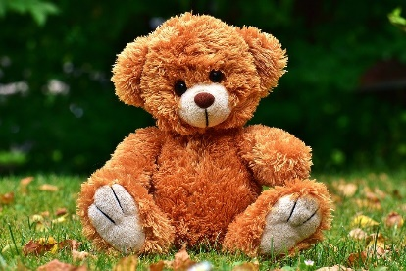
We’re going on a Bear Hunt!!

Let’s see if we can make our very own bear hunt around Kirkwood.
Place a teddy bear in your window and go on an adventure, how many can you find?
Upload a picture or photograph of your favourite to Glow.
Or you could make a chart of the different colours/types of bears you find.
Good Luck !!
