Spelling Game Ideas
Hangman
Play a game of Hangman with someone in your house using your spelling words.
How to play:
- Choose a spelling word
- Draw spaces to spell out the word eg. _ _ _ _ _ and draw the start of the Hangman

- Let your partner guess the letters to the word. If they get it right put the letter in the right part of the word. If they get it wrong start drawing a stick man
- If your partner gets the word before you are finished drawing the stick man then they win. If they do not get the word and the stick man is complete they lose.

Pairs – with a twist!
Have a go practising your spelling words by playing a game of pairs with someone in your house.
How to play:
- Write out your spelling words twice on a piece of paper.
- Cut up the piece of paper to make mini flashcards.
- Place all of the flashcards face down and start to find pairs with a partner.
- When you have found a pair you have 10 seconds to turn the cards away and spell the word. If you get it right you can keep the pair if you get it wrong you must put the pair back down and mix all of the cards around.
- The person with the most sets of pairs wins the game

Throw and catch
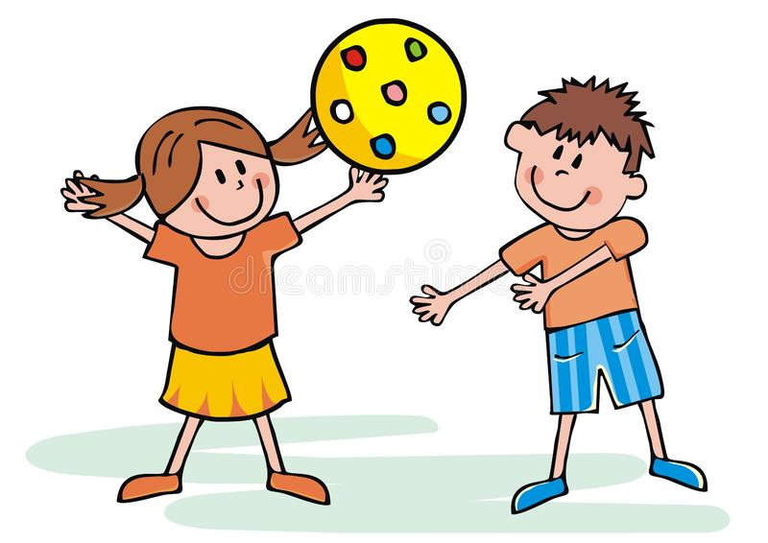
Spell your words out by throwing a small, safe object back and forwards to someone at home. For example if it was the word ‘dog’ you would say the letter d then throw the object to your partner and they have to say the next letter ‘o’. Keep throwing the object until you are finished spelling the full word.

Flashcards
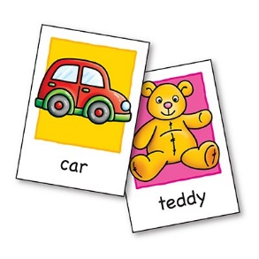
Make a set of flashcards for your spelling words. Write the word on one side and the meaning of the word on the other side. Get someone at home to hold up either the word side or the meaning side and you have to tell them what either the word means or guess and spell the word from the meaning.

Spelling Scramble
Get someone at home to write your spelling words all scrambled up. Once they have wrote all the scrambled words it is your job to unscramble them. You could time yourself to see how fast and accurate you are!
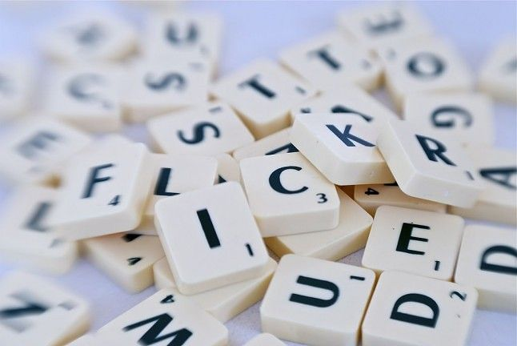

Water words
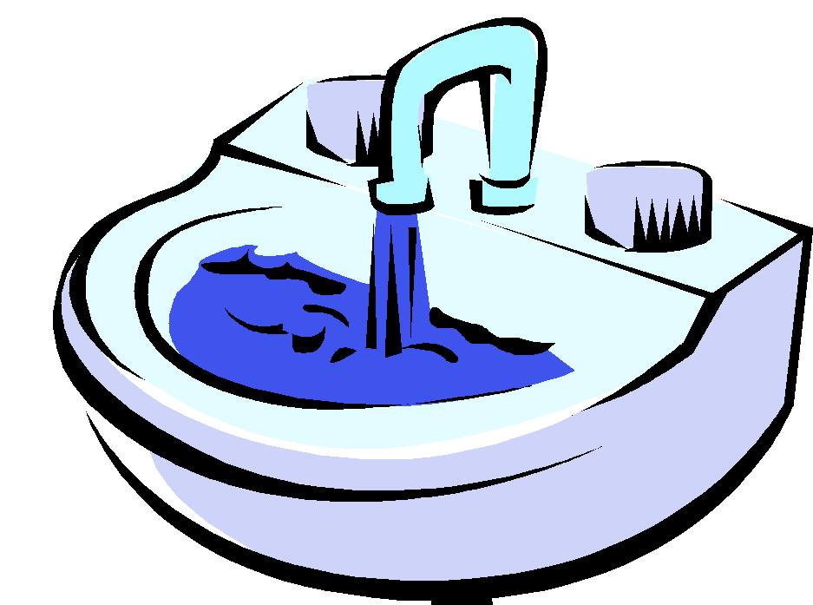
Fill up a bucket, the sink or even the bath with water. Trace your spelling words in the water and get someone at home to guess which word you traced. If they get it right you can move on to another word but if they get it wrong they have to spell out the word correctly out loud. Once you have finished it is your partners turn to test you!

Spelling Bingo
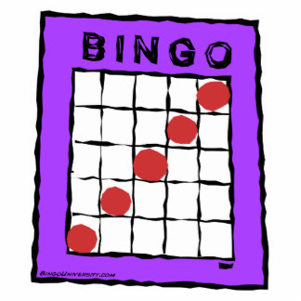
Draw your own Bingo board on a piece of paper (we know how to do this as we play bingo on our whiteboards for mental maths) and write your words on the board. Get someone at home to spell out the word and you have to listen and score it off. Remember when you have a full board to shout BINGO!

Skipping Rope Spelling
Skip and spell your words at the same time. With each jump say the next letter in your spelling word. How many times can you spell your words before you stop skipping?

