Microsoft Teams
Microsoft Teams is chat based tool that provides our classes with the ability to work together and share information via a virtual classroom. Teams can be accessed on a range of devices such as PC, Laptop, Mobile and Tablet. The following instructions will help you access Teams for the first time and visit your child’s virtual classroom environment.
To access Teams using a Laptop or PC
- Google Glow login: click on the RM Unify tab
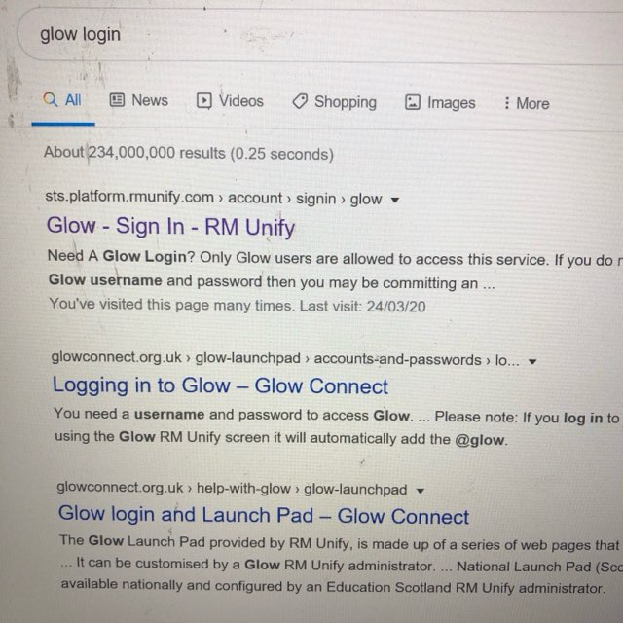

- This will bring you to the glow log in page.

- Your child’s log in details will be on the attached slip.
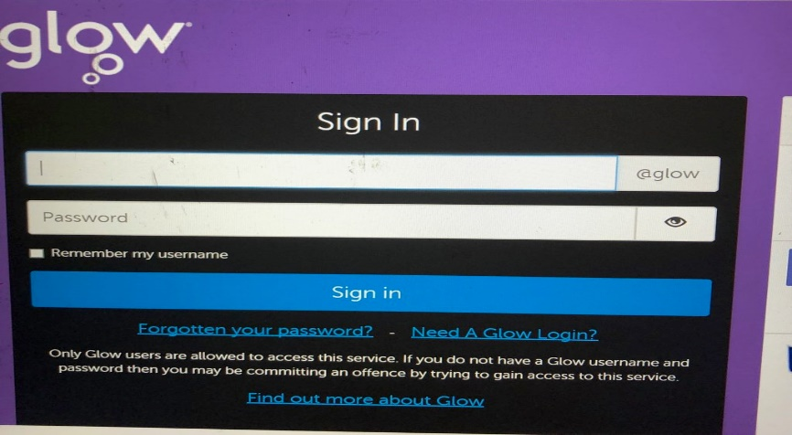

- This will take you to your launch pad. The person icon on the left hand side is your child’s personal launch pad. The house icon below is Old Monkland Primary and the one underneath is North Lanarkshire Council’s.
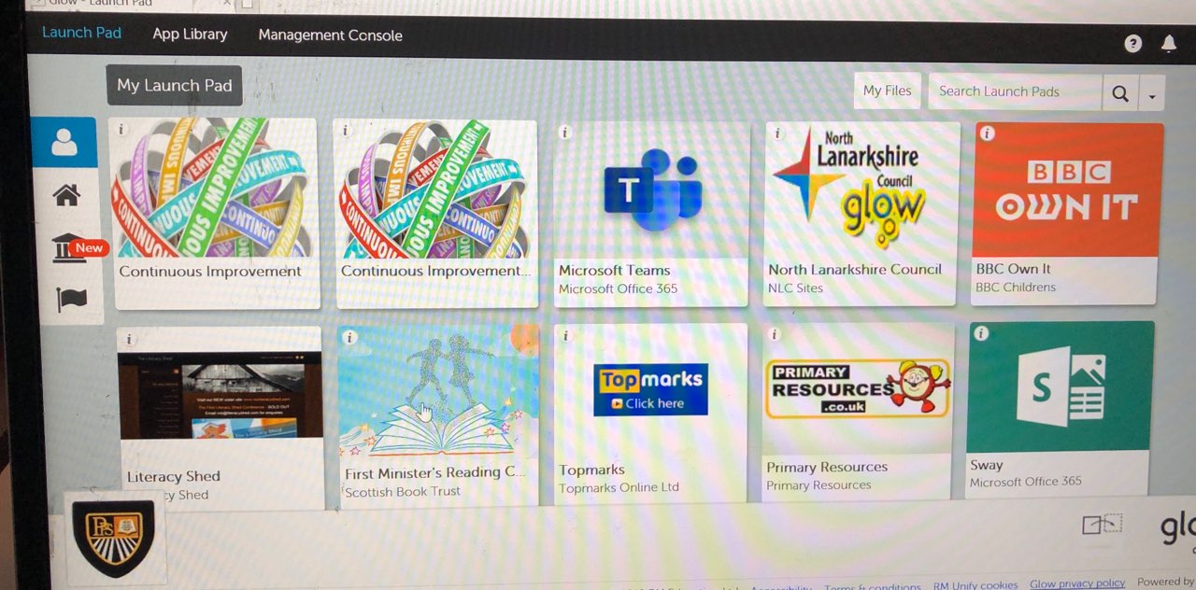

- Click on the ‘house’ icon and choose the square ‘Microsoft Teams’.

- You will be asked if you want to access Teams via the web or app. Downloading the app allows you to access Teams quicker and easier and you can save your log in details for the future. 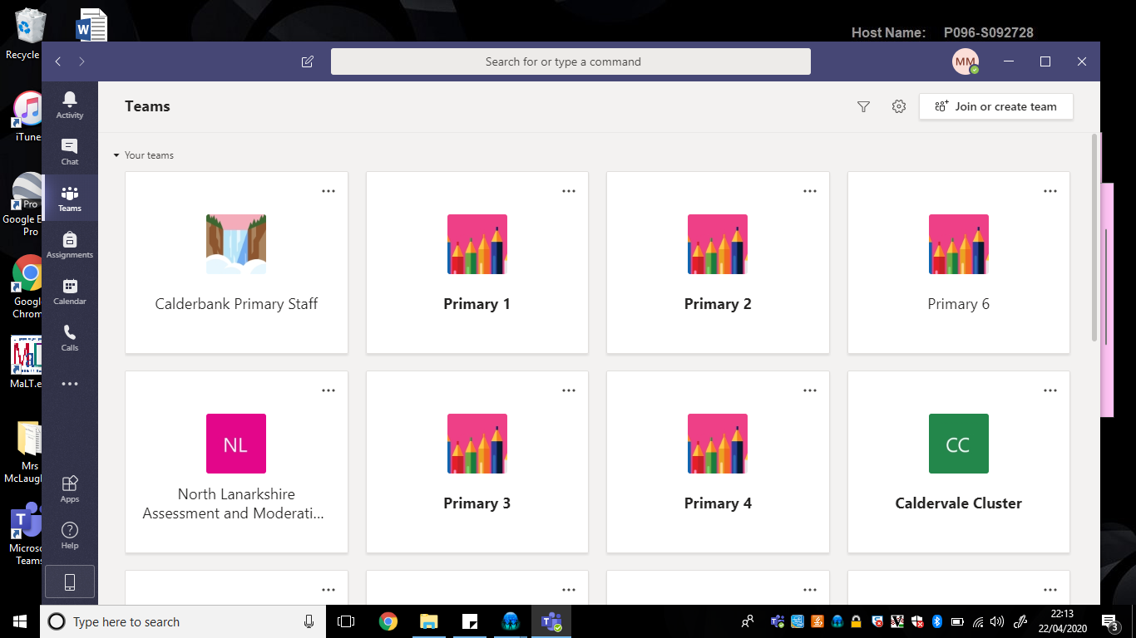

- You will now be able to see a square ‘tile’ for your child’s class. Click on the tile to enter your child’s class team.
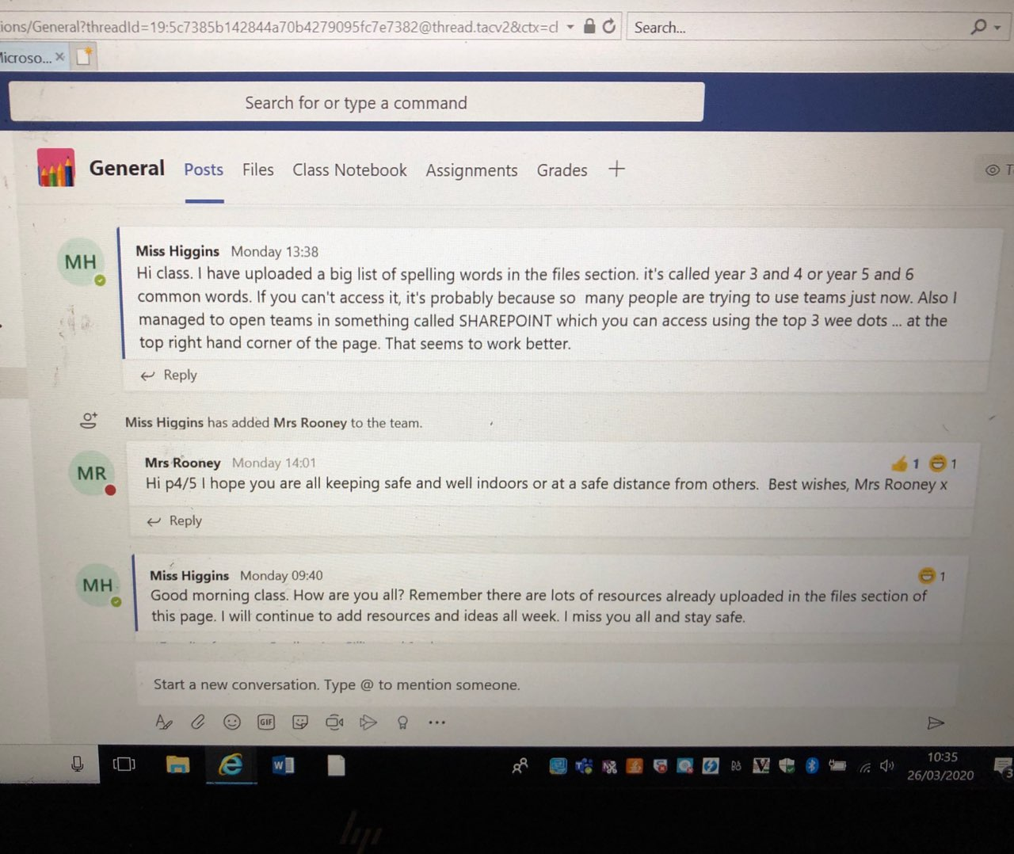

- The ‘Posts’ section is where your teacher will post comments and pupils can communicate back and forward with both the teacher and each other. Click on ‘start a new conversation’ at the bottom of the screen to post a comment.
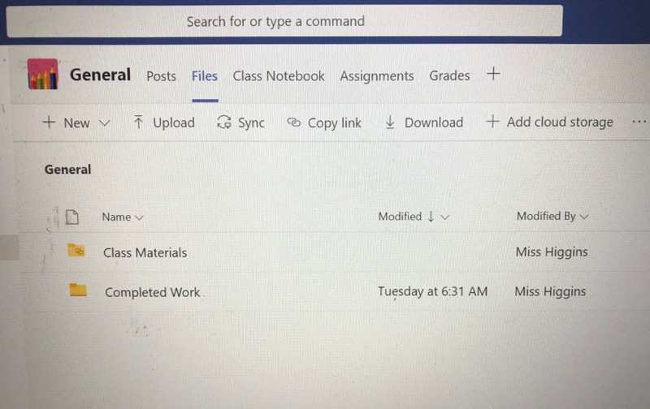
- If you click on the ‘Files’ tab, you will see folders of work which the teacher will post. The teacher will also create a folder for you to return any work back to them.

- Downloading the teams as a desktop app seems to make the Files section easier to access.
To do this, click on the screen icon on the bottom left.
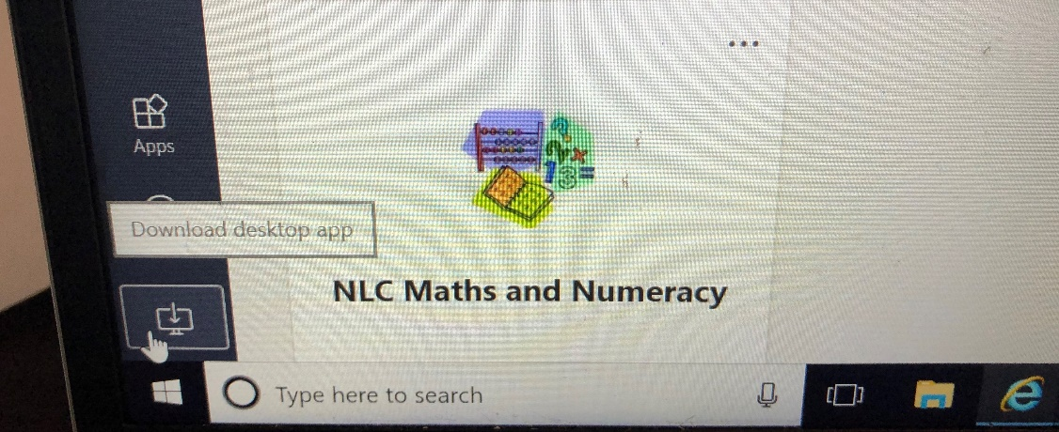
To Access Microsoft Teams from a Mobile or Tablet
- Open the app store and search for Microsoft Teams.
This is available in both Itunes and Android App stores.
- Download the teams app to your device.
- When logging into Teams on a mobile or Tablet you must add .sch.uk to the end of your username. This will allow teams to know you are accessing a school account. Your password will remain the same.
For example
gw10smithjohn@glow.sch.uk

