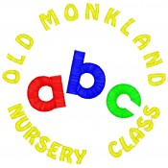

Dear Nursery Families,

Due to ongoing significant staffing shortage, Early Years have advised we remain on our reduced hours for the rest of this term and on return on the 6th January 2021 until we can review our staffing situation. We will notify you as soon as possible on return in January if we can increase hours.
Therefore sessions times will remain as follows:-
Term Time hours: 9 am to 12.10
48week Am hours 8.30am to 11.40 am
48week Pm hours 12.30 to 3.40 pm
Your support and understanding this term has been much appreciated.
We wish you and all of your families a safe and happy holiday.
Yours sincerely,

Miss L McFadden
Head Teacher
Old Monkland Primary & Nursery Class

