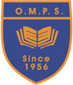
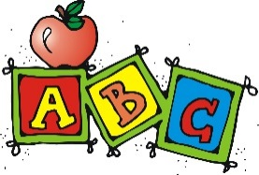 Welcome to Primary 1!

Welcome to Primary 1 with Miss Sharkey. Miss Lochrie will be your teacher on a Tuesday morning. We are very excited to work with you! Below is some information about your new class.
Homework
Information regarding homework will follow.
P.E.
P.E. days will be a Tuesday and a Thursday. Normally P.E. kit is a black pair of shorts, a plain white t-shirt and a pair of indoor shoes. Under the current circumstances we ask for children to come to school with their PE kit on as they can not get changed. Therefore, they can wear black/dark coloured joggers/leggings and a white t-shirt/polo shirt. They should also have trainers on as gym will take place poutside. No football tops are allowed in school. Jewellery should either be taken off/out by the pupils themselves before P.E. or not worn to school on P.E. days. Earrings that cannot be removed must be covered by plasters at home before coming to school.
Name Labels
Please could all names and class be put on ALL items of clothing/belongings (including jackets, P.E. kit, packed lunches, all items of clothes) so that belongings do not get lost.
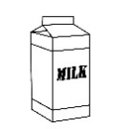
Water Bottles
Children are encouraged to drink water within class to keep them hydrated. If your child could bring their water bottle full at the start of the day as they can not be filled at the moment. Water bottles should have a sports cap so that if it is knocked over, it does not spill over jotters.

Regards

Miss Sharkey

