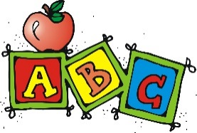 Welcome to Primary 3/4!

A big warm welcome to P3/4. My name is Miss Marchant and I will be your childs teacher this year. I am really looking forward to working with you and your child! Please see below some information about their new class.
Homework
Due to the current circumstances surrounding coronavirus, children will not be given homework to complete at home. This is to prevent the cross contamination between school and home. We will review this as a school throughout the year.
P.E.
At present, P.E will take place outdoors. This will be reviewed throughout the year and any changes to this will be communicated to you by letter or through the school app. Children should come to school dressed in their P.E kit on their P.E days. We ask that children wear joggers, a t-shirt or school polo and trainers for P.E. Our P.E days are a Tuesday and Thursday for now. If there are any changes to P.E days, this will be communicated to you by letter or via the school app.

Name Labels
Please could all names and class be put on ALL items of clothing/belongings (including jackets, P.E. kit, packed lunches, all items of clothes) so that these belongings do not get lost.
Money
All money for school should be paid online. Children should not bring any money with them to school. If you are having trouble accessing the online system then please phone the school office for further advice. There will be no milk available for children at present.
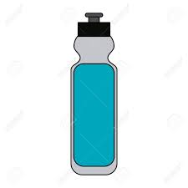
Water Bottles
Children are encouraged to drink water within class to keep them hydrated. Your child should bring their water bottle full at the start of the day as they will not be able to fill it up throughout the day for now. This is to prevent children from all using the same water cooler and leaving their class during class time. Water bottles should have a sports cap so that if it is knocked over, it does not spill over jotters.

Personal Property
Children can bring a bag to school if they wish however each child has their own set of resources to use in school. We ask that, where possible, children bring a small snack for playtime in a disposable bag. Children can bring a lunch bag to school if they are a packed lunch, however a disposable bag for their lunch is preferred. Children should not bring any personal things from home, for example, toys.
Finally, if you have any other questions or concerns during the year please do not hesitate to contact the school or myself by phone, letter or by making an appointment to speak to myself or a member of the senior management team.

It is so nice to have the children back after a long and uncertain time for many. We have missed them very much and will do our utmost to keep the children safe, happy and confident when in school.

Kind regards
Miss Marchant

