Health and Wellbeing Home Learning Grid
Stories of kindness  Listen to the Rainbow Fish story on Storyline Online. Think about a time when you were kind to someone.  - What did you do?  - What did you do that was kind?  - How did this make the other person feel?  - How did it make you feel.  Draw a picture of a time when you were kind to someone else. Or draw a picture of the Rainbow Fish and colour in his scales beautiful rainbow colours.  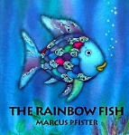 | Compliment List  In Primary 1/2 we love giving compliments to each other! When we give compliments to others it makes them feel special but it also makes us feel good too! Draw a picture of one person in your family and think of some compliments which you think describe them. Here are some words that might help you.  Beautiful Kind Good Friend Helpful Talented Funny | Get Moving!  Physical Exercise makes us feel good about ourselves. Choose a form of exercise from the list below. Or create your own obstacle course outdoors. I would love to see you post pictures in our Class Team of you exercising!  Joe Wicks P.E  Go Noodle  Cosmic Yoga  Outdoor physical activity cards ( in files)
Healthy Snacks  Healthy Snacks are very good for our bodies. Help prepare a healthy snack to eat today. What did you make? Upload a picture for me to see!  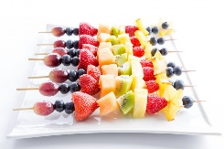 | Be helpful to others  Think of how you could be helpful to someone at home. You could tidy your room.  Help wash some dishes.  Feed your pet.  Play with siblings nicely.  Help prepare breakfast/lunch/dinner.  Help set the table. | Get Dancing  Music is very special and can make us feel lots of different emotions! Which songs make you feel happy? Which songs make you want to dance? Get dancing to your favourite songs.  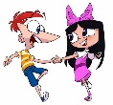
Leap Time !  The Infant boys and girls are always happy when they are going to LEAP time each Friday with Miss McFadden and Mrs McKenna. Think of some of your favourite games and play them with your family. Miss McFadden posted LEAP time games a few weeks ago, if you scroll down the posts you will  See them. | Nature Walk  When you go for a walk on your daily exercise – lets see how many colours you can find. You can either take a photo of the different colours you see. Or if you want to be creative, pick a few and make a bracelet or crown from cardboard and stick them on with double sided tape or sticky dots. Collect things with the same or different colours to decorate these. | Time for you  Spend time doing something that you love! For me this is going out for a long walk with my dog Marley. Spend some time today doing something you love to do! Drop me a post in our Class Team to tell me what you did.

