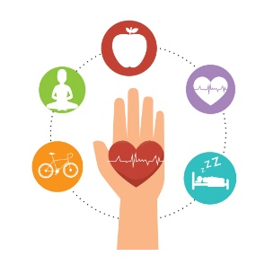
Health and Wellbeing Choice Activities

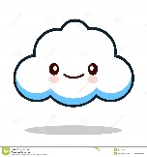  Check in with your feelings by filling in a ‘Feelings Cloud’ (see attached sheet). You could even made your own ‘Feelings cloud’ | 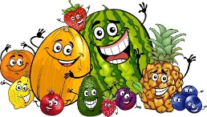  Be kind to your body by making a healthy snack. Take a picture and share on our Teams page. Miss Marchant will be posting her healthy snack to show you! | Write a kind note or maybe draw a nice picture. You could stick it on your window or tie it to a tree when you are out for some daily exercise. You never know who might need to hear some kind words!
Try some Mindfulness Meditation using this clip. Click here:  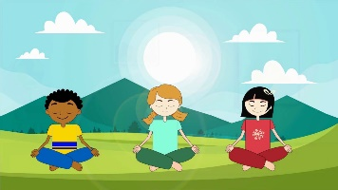  https://www.youtube.com/watch?v=Bk_qU7l-fcU | 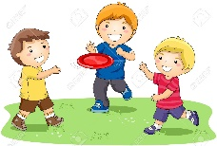  Keep your body healthy by playing an active game with someone in your house. Can you remember the ‘Opposites’ game we played with Mr Miller? Maybe you could try that out on someone at home! | Make your own ‘Positivity jar’ or a ‘Things to look forward to jar’. Fill it with things that you would like to do when we are back to normal or some things you can do to stay positive during lockdown. Miss Marchant will be sharing some things from her jar soon!  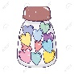
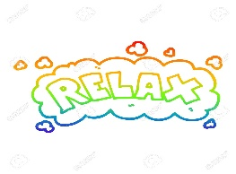  Take time out of your day to do something that makes you feel relaxed. Miss Marchant likes to read to relax. What do you like to do? | Make up an exercise routine or design your own obstacle course in your house or back garden. Get someone at home to try it out with you. Share how you got on with it on Teams. | Do something nice with your family one day or night. You could have a movie night, make a meal or bake, play a board game, have a picnic in the garden etc. Let me know what you decided to do by posting on Teams!

