Log into Oxford Owl
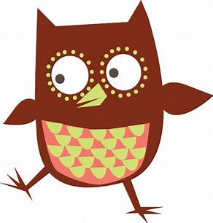

- Type Oxford Owl into your Browser.
- At the top of the Oxford Owl webpage you will see, My class login
- Click on this and you will be asked for My class name and password
My class name: Miss Sharkey
My class password: Primary 1/2
- You should now be able to access e books and a Parents section.

