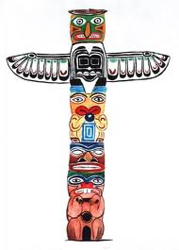
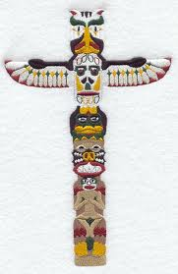
Totem poles:

Watch this short Youtube video

- A totem can be the symbol of a tribe, clan, family or individual. Native American tradition provides that each individual is connected with nine different animals that will accompany each person through life, acting as guides. Different animal guides come in and out of our lives depending on the direction that we are headed.
- Native Americans also believe that a totem animal, is one that is with you for life, both in the physical and spiritual world. Though people may identify with different animal guides throughout their lifetimes, it is this one totem animal that acts as the main guardian spirit.
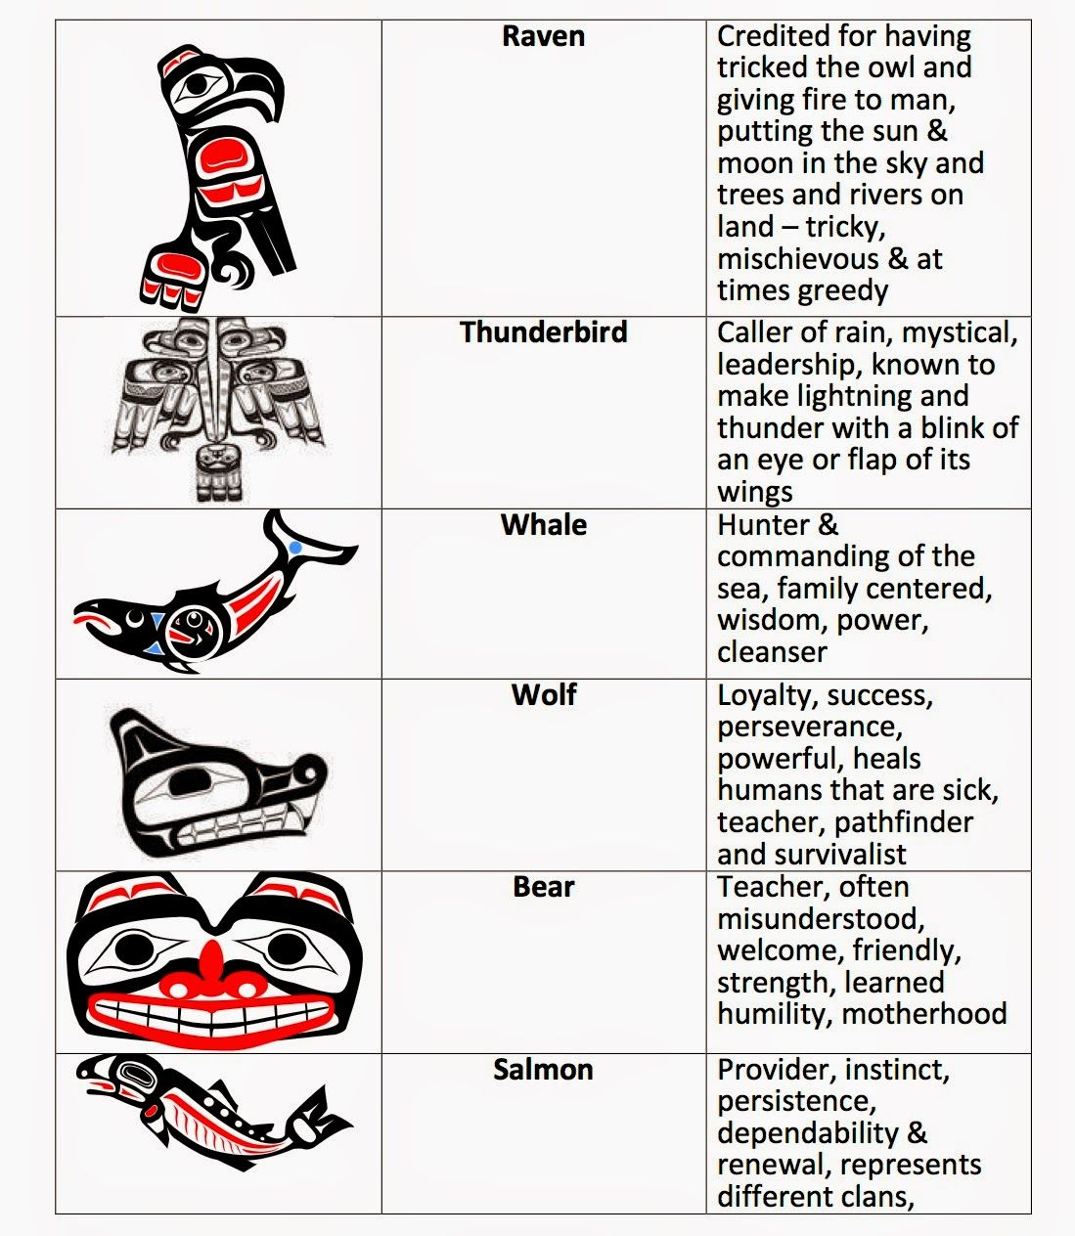

Totem Pole Activities

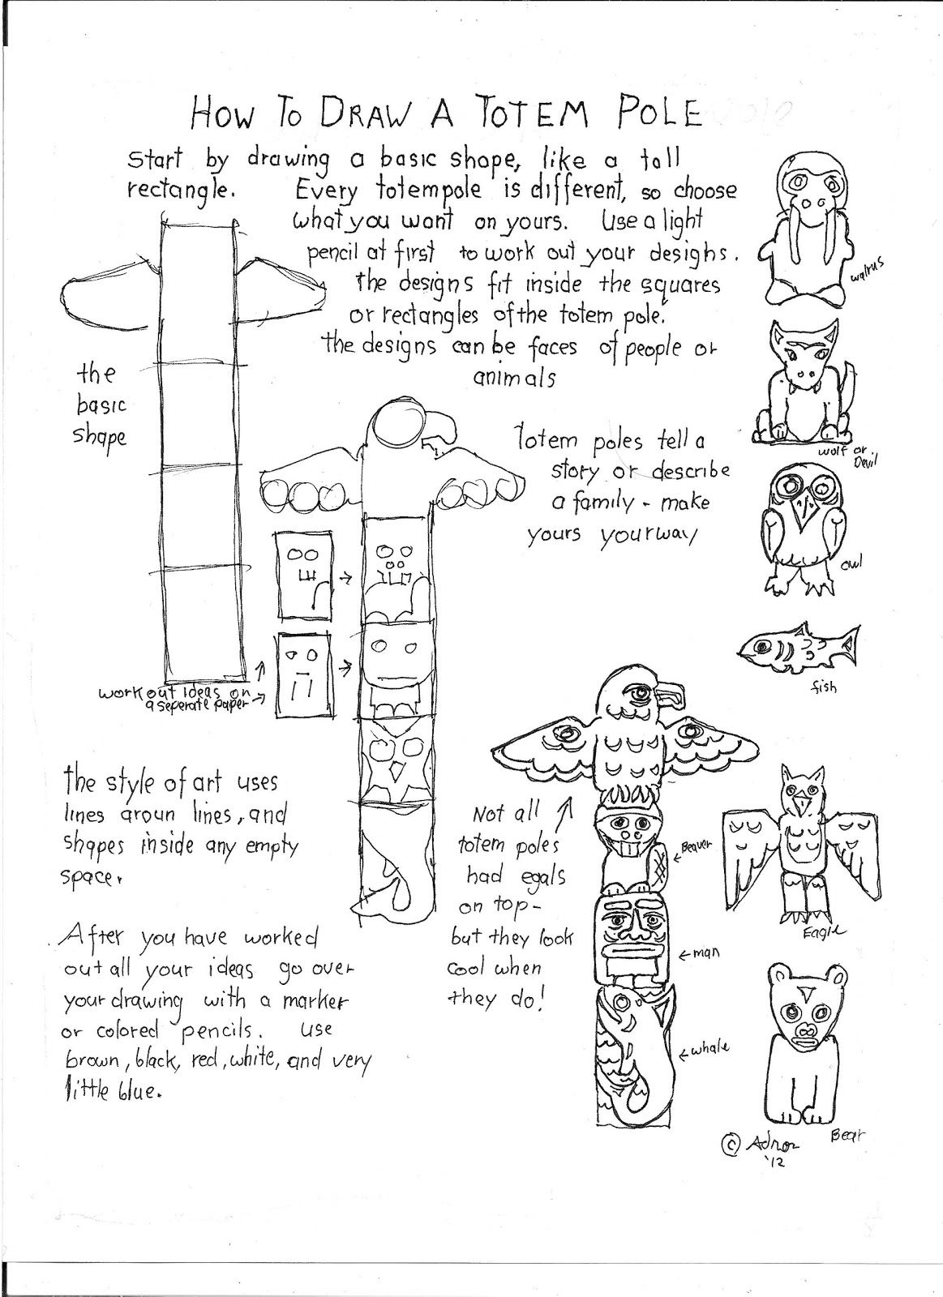
Activity one: Design your own totem pole.

Craft Activities:
https://www.cindyderosier.com/2016/08/totem-pole-craft.html
https://www.dltk-kids.com/canada/mtotem.html

