Spelling Activity Ideas
Bubble Writing
Write out your letters in bubble writing. Once you have finished you could colour your words in. Try to make each letter a different colour. You could even add some patterns to the letters.
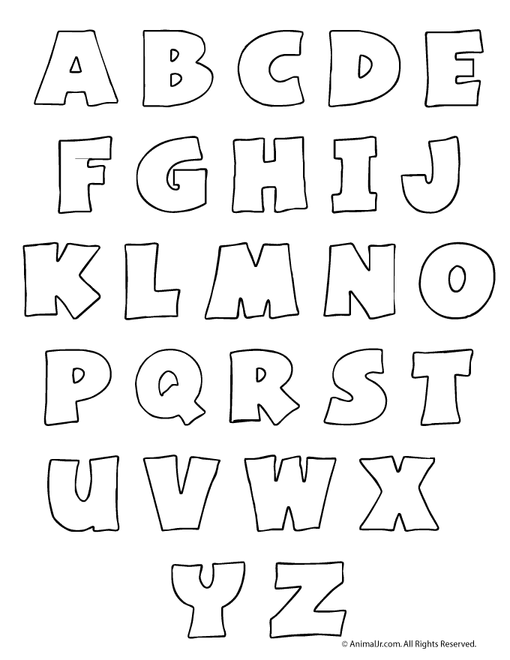

Dot to dot spelling
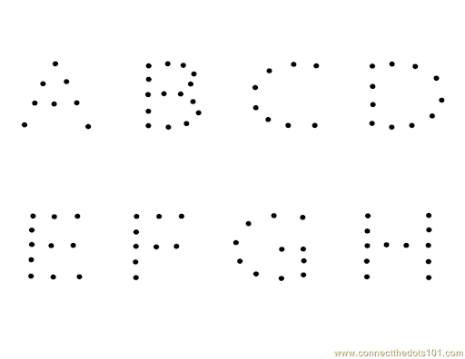
Spell each letter of your word out using dots. Once you have finished spelling the word connect the dots so you can see the word clearly

Back to back spelling
Spell out your words on someone’s back at home. Let them guess the word. If they get it right you can move on to the next word. If they get it wrong you have to tell them what word it was and then get them to spell it out correctly. Then switch and let someone at home try it on you.

Lego Spelling
Spell out your words using Lego at home. If you do not have Lego you could try spelling your words out with different things for example pasta, sweets, leaves and sticks.
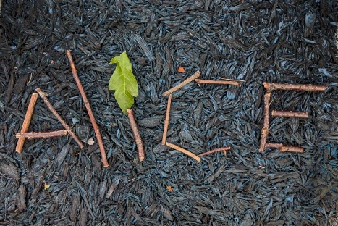
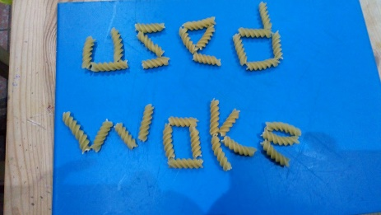
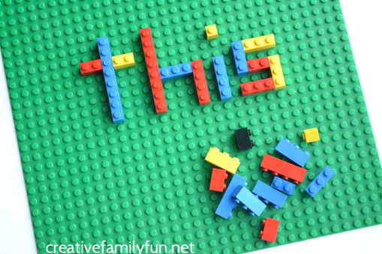

Fidget Spinner Spelling
If you have a fidget spinner at home spin it really fast and then see how many times you can write your spelling words out until it stops. You could do this for all the words or take one word at a time each time you spin the fidget spinner.
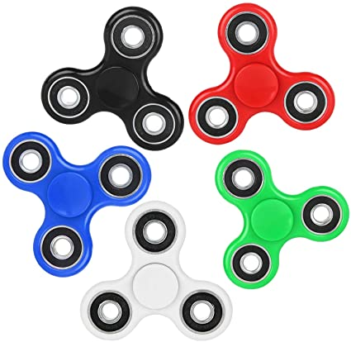

Type Spelling
Practise typing your spelling words on a computer, ipad, tablet or phone! If you do not have any of these devices you could draw out your own keyboard and practise typing the words out like we do in class!

Hidden Words!
You will need a white crayon and paint to do this. Write out your words with a white crayon on a piece of paper. Once you have wrote out the words paint over them with a colour of your choice. The words should show up on your paper!
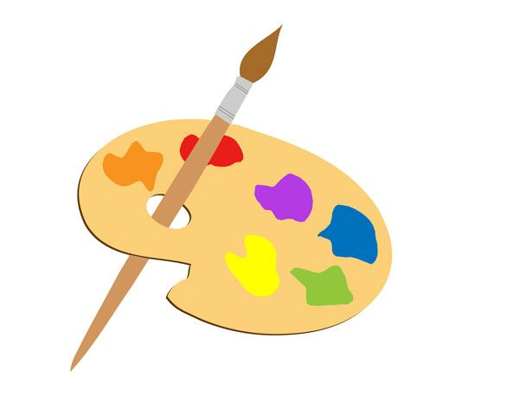
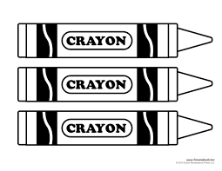
Magazine spelling
Spell out your words by cutting out different letters from old newspapers or magazines. Remember to ask your parents before you start to cut the words out of the magazines and newspapers!
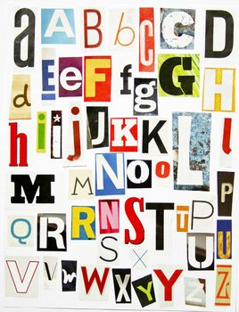

Word picture
Create a picture using your spelling words. Remember to use coloured pens or pencils to make your picture stand out!
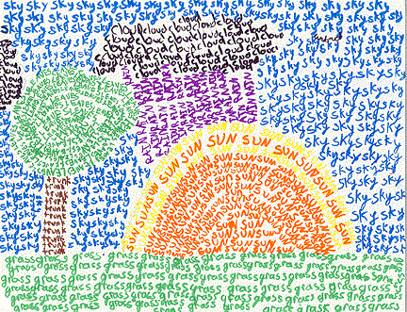

Wacky words
Write your spelling words in your jotter or on a sheet of paper in lots of different directions, filling up the whole sheet. Use different colours and types of writing for each word.

