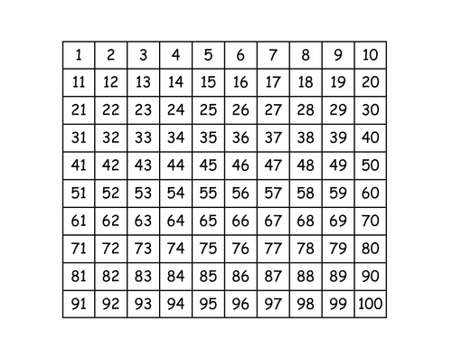
Hundred Square Activities
To do these activities you will need a hundred square. You could print the hundred square on this page or you might have a hundred square at home already.
Challenge: Make your own hundred square using a pencil and paper!

Odd or Even
Colour the odd numbers in red and the even numbers in blue. Write all of the numbers out. What do you notice?

One more, one less
Choose a number on the hundred square. Close your eyes and say the number before and after your chosen number. Write it down and get someone to check if you are correct.
Challenge: You could try saying 2 numbers before or after the number or 10 before the number after.

Place Value
Pick a number and write how many tens and ones it has.

Make the number (we do this in school)
Pick a number and write it in the middle of a piece of paper or in the middle of your jotter. Write the 4 operations around the number which are: + - x ÷ . Then write as many ways as you can using the symbols to make the number.
Example: If I picked the number 10 I could write these sums on my paper:
5 + 5 = 10 4+6 = 10 13-3=10 15-5=10 2x5 = 10 20 ÷ 2 =10
Your sheet would look like this:
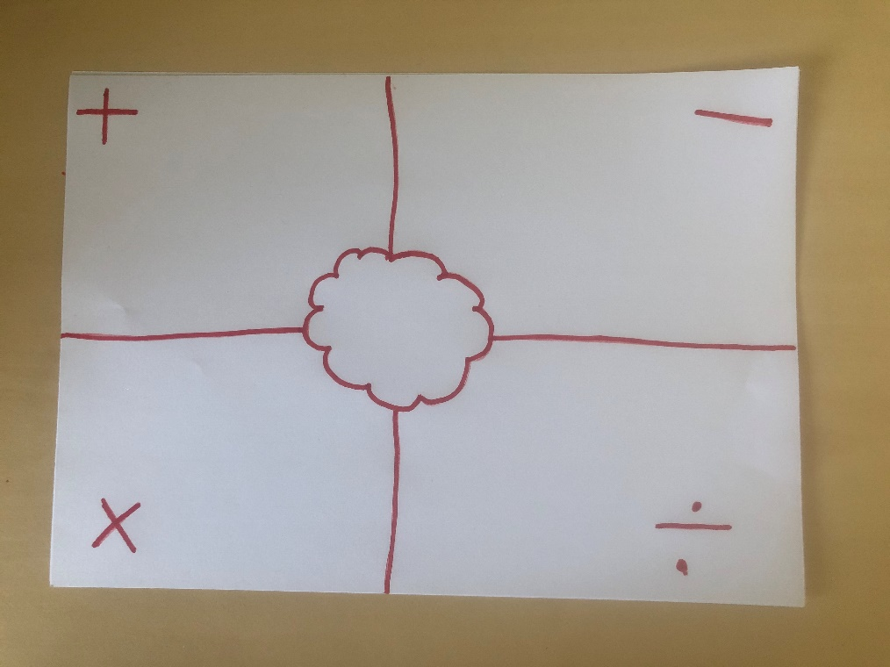

Times tables
Choose a times table you have been practising. Colour in all the numbers of that times table using the colour guide below:
2x table – light blue
3x table – green
4x table – red
5x table – orange
6x table – yellow
7x table – purple
8x table – pink
9x table – grey
10x table – dark blue
You might need to do this on separate hundred squares if you are doing more than one times table.

Mystery Number
Get someone at home to pick a number on the hundred square. They then have to give you clues to guess the number they have picked. For example, the number has 4 tens and 2 ones, or the number is 3x2 etc. You can swap and test someone at home too!

How far apart?
Pick a number on the hundred square mark it or put a coin, counter on it. Get someone at home to do the same but with a different number. You then have to work out how far apart from each other the numbers are. Do you count along the hundred square or could you do a sum??

Hundred chart puzzle
Print out this hundred chart or make your own. DO NOT use the hundred chart you have in the house. Cut out the hundred chart into strips (easy) or squares (tricky). Piece the hundred chart back together. Time yourself to see how fast you can go!

