Australia Questions
- What are Australian schools like? What age do you start Primary One?

Australian schools are a lot like Scottish schools. The biggest difference is probably the school uniform, because it always includes a sun hat!
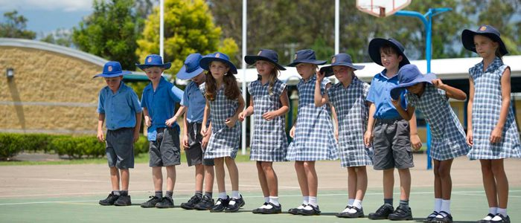

Australia has 6 states and 2 territories, and they each have their own laws about when children start school. In South Australia, children usually start Primary One when they are 6. They will usually have spent at least one year at pre-school, which is also called kindergarten in South Australia, before they start Primary One.

- What it is our Spring is it your Autumn?

Yes. When it is day in Scotland, it is night in Australia, and when it is Summer in Scotland, it is Winter in Australia. Some people in Australia like to celebrate Christmas in July, when it is the middle of Winter.

- What do Australian libraries look like?

Australian libraries look a lot like Scottish libraries. Here is a picture of the State Library of South Australia. The statue outside is of a very famous Scottish poet.
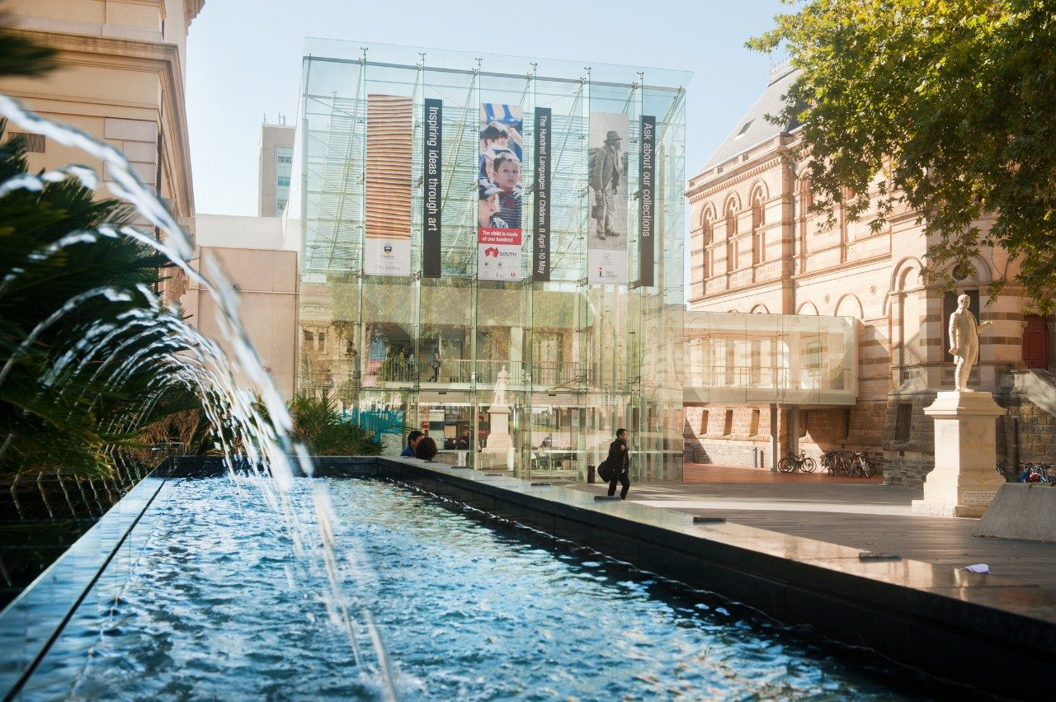

- What are Australian rollercoasters like?

Rollercoasters are too scary for me! I have never been on one! You will have to watch this video of the top 10 rollercoasters in Australia to see what they are like:
https://www.youtube.com/watch?v=-qeob4dFPV0

- What do Australian houses look like?

In city centres, there are lots of modern apartments and high-rise buildings, but most people live outside the city centre, in suburbs, and the houses are usually single story.

In Queensland, houses are quite often built on stilts, called stumps. Some parts of Queensland are not only very hot, but also very humid, so the stumps let the air move underneath the house, to help keep it cool.
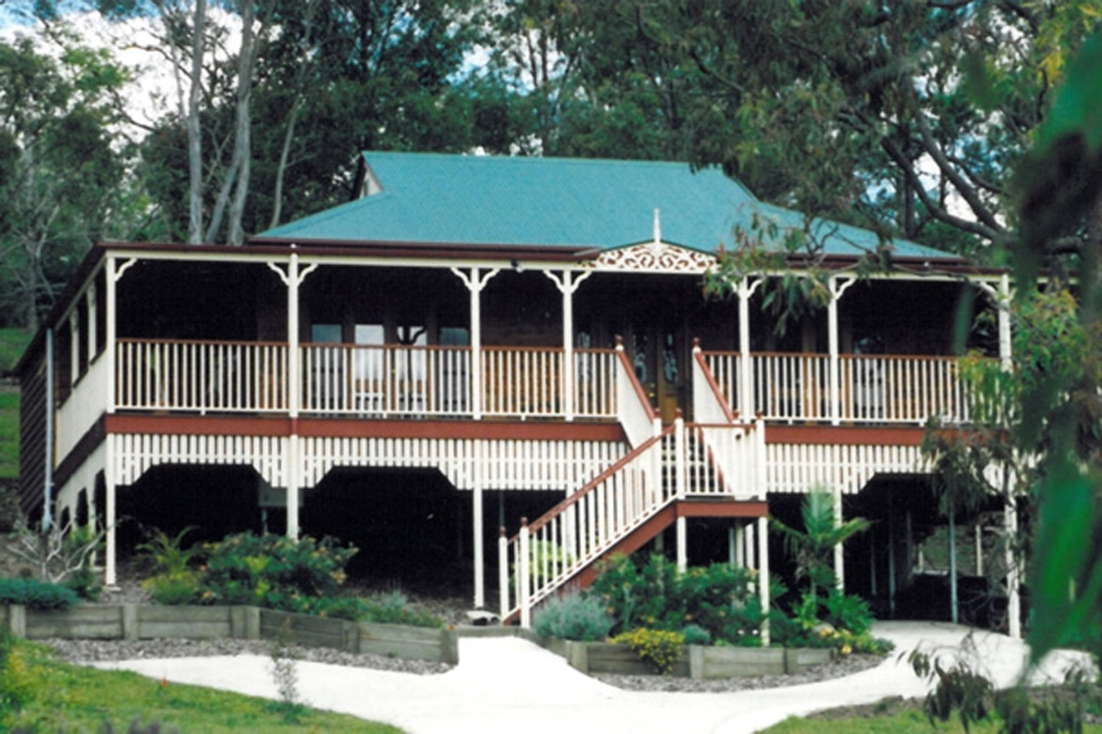

Australian houses, especially older ones, are often built from a blue-gray stone. This kind of house is called a ‘Bluestone’, and there are lots in South Australia.

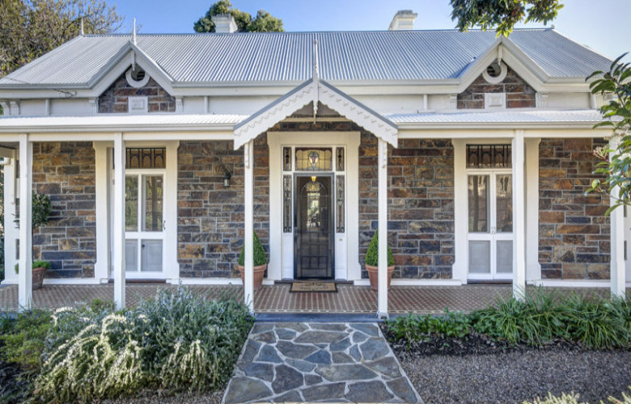

You will notice from the pictures that it is very usual to have a verandah at the front of a house. This is a nice shady place to sit on a sunny day.

- What religions do Australian people follow?

The main religion in Australia is Christianity, but there are lots of other religions here as well because so many different sorts of people from all over the world have come to live here.

- What types of shops do you get in Australia?

You will find many of the same shops here in Australia as you find in Scottish cities. The two main supermarkets are called Woolworths and Coles, and they are a lot like Tesco. There are also lots of markets for buying food and other things. Smaller towns usually have a street market once a month. All the big cities have a permanent market. The biggest one is the Queen Victoria Market in Melbourne. The oldest market in Adelaide is the Central Market.

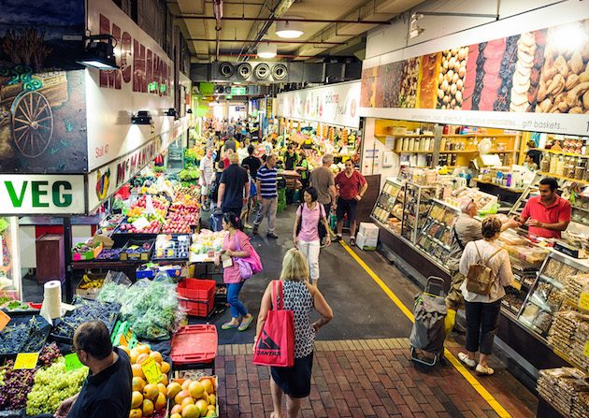

- What are some popular Australian sports?
Cricket, tennis, football, rugby, netball and surfing are all very popular sports in Australia, but the most popular sport is Australia’s own sport, which is called Australian Rules Football, or Aussie Rules for short. Aussie Rules uses an oval ball, and it is also played on an oval-shaped pitch.
Every town in Australia has its own ‘oval’, where cricket and Aussie Rules are played. Adelaide has two Australian Football League teams: Port Adelaide and the Adelaide Crows.
Aussie Rules is a very fast and exciting game. You can watch this video to see it being played and find out more about the rules:
https://www.afl.com.au/video/32869/what-is-afl-the-game-explained?videoId=32869&modal=true&type=video&publishFrom=1439424500001

- Are there aardvarks in Australia?

Sadly, there are no aardvarks in Australia, but there are lots of very special animals that are only found in Australia and nowhere else. Marsupials are one very famous kind of animal found only in Australia. Marsupials carry their babies, called ‘joeys’, in a pouch on their tummy. Kangaroos and koalas are marsupials. Here is a picture of Kevin, the koala who lives in our garden:
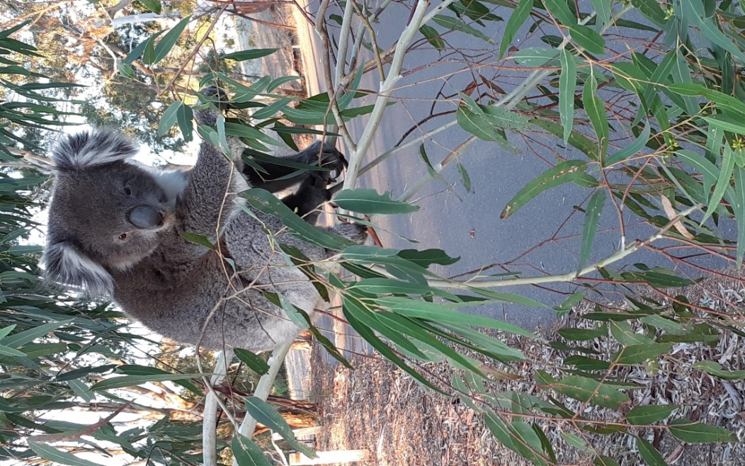

- What language do they speak in Australia?

Australians speak English, but they sound very different to English speakers in Scotland, and they have some words of their own. For example, sausages are sometimes called snags!
Even though the main language in Australia is English, you will hear many, many different languages spoken, because people have come here to live from all over the world.

- Where there ever dinosaurs in Australia?

Yes, there were! The National Museum of Australia has lots of information:
https://www.nma.gov.au/learn/kspace/prehistoric-australia-110-million-years-ago/kids

