Educational Psychology: Advice and support regarding children and young people (COVID-19)
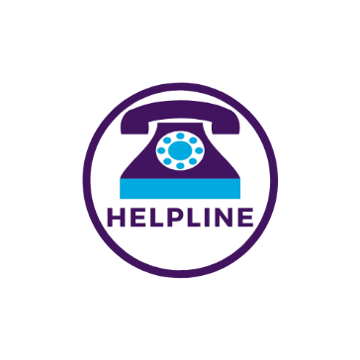
01236 812 380
Just to remind you that the Educational Psychology helpline is up and running
Who is it for?
School staff/other professionals, parents/carers and young people

What will it provide?
Advice/phone consultation support to help manage the stresses that can felt by children and young people at this difficult time.

How to get in contact:
Phone: 01236 812 380. 10am – 3pm Monday to Friday (Please leave a message and we will return your call)

