Home learning resource pack

Hi boys and girls,
We all hope that you are all well, staying home and keeping safe! We are missing you all very much.
We hope that you have all enjoyed the activity packs so far and we have a few more ideas to help keep you all busy.

Here is a nursery rhyme all about growing! Lets see if you can learn this rhyme!
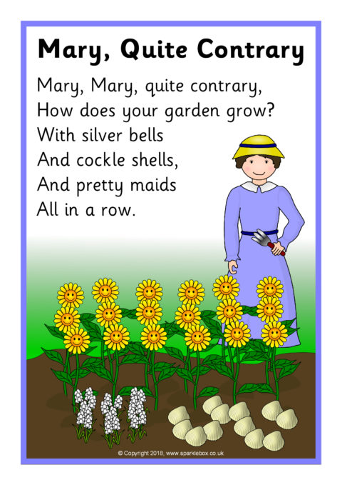

It is Spring time now and the weather is beginning to change. Can you make a weather diary by drawing and recording the weather of 5 different days. An adult at home could write all the things that you did as well and how you were feeling on each these days.

Now that Easter is over you might have some eggs left so why not have some fun in the kitchen and make some chocolate crispy cakes, you will need some cake cases, Rice Krispies or cornflakes, some chocolate to melt and maybe some chocolate buttons to decorate. Why not send us some pictures of you making them via email or the school app.

Some useful websites:

https://www.e-learningforkids.org/
https://famly.co/blog/inspiration/10-sensory-play-ideas-to-develop-motor-skills/

