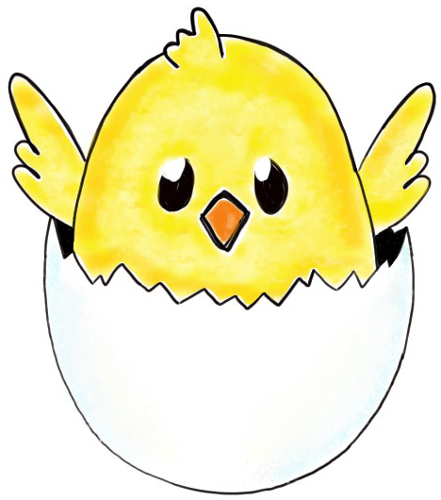
Primary 3/4 Spring and Easter Activities
Draw a picture of a butterfly then decorate it using different patterns. Make sure the patterns are symmetrical on each wing. | Decorate your own Easter Egg by using a spare egg in the house. When you have finished decorating it you could roll it in your garden to see if it cracks! | Create your own Minibeasts using pebbles or stones in your garden. Please find the instructions for this attached. Remember this is just a guide. | Make some Easter Crispy Cakes by following the recipe attached. Enjoy eating these with your family.
Ask your family to tell you what their favourite thing about Spring is. Write their answers down in your jotter. | Make an Easter card for someone in your house. Remember to write Happy Easter inside. | Look up the song ‘April Showers’ by Judy Garland on Youtube. Have a sing-a-long with your family! | Complete the Spring Flowers wordsearch with someone at home.
Draw a picture of your favourite spring flower. Some examples are: daffodil, tulip, bluebell | Create your own Easter chick using the instructions on the sheet attached (see Easter Chick Instructions). | Create your own Dried Petal picture. Please find the instructions for this attached. Remember this is just a guide. | Create your own Spring Wreath. Please find the instructions for this attached. Remember this is just a guide.

