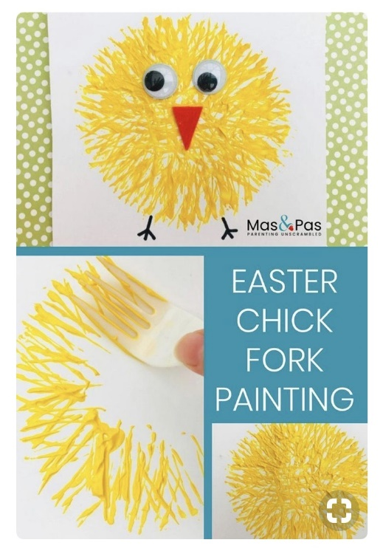
Easter Chick Instructions
You will need:
- Fork
- Plate
- Paper
- Yellow Paint
- Orange and black pens

Method:
- Squeeze some yellow paint onto a plate
- Take a fork and dip it in the yellow paint
- Use the fork to start printing onto the paper
- Keep repeating until you have a yellow chick shape
- Leave the paint to dry
- When it is dry use the black pen to add some eyes and legs to the chick
- Use the orange pen to draw a triangle to make the beak

