Early Level Speech and Language Home Activities

Think of as many words as you can which rhyme with:  Cat  Key  Ball  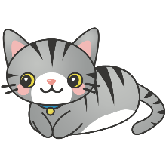  This means they sound the same at the end, e.g. cat-bat | How many syllables are there in these words?  Bunny  Teapot  Crocodile  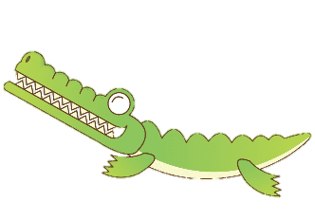  Can you clap them out? | Category Game - In one minute, name as many….  Animals  Fruit  Colours  …as you can think of | 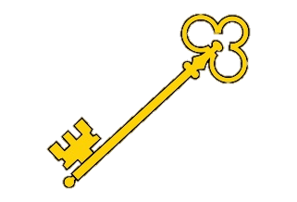  You have a Magic Key which opens a castle door. Describe what it might look, feel and smell like. Can you draw it?
Read a short story together. Now talk about:  Who was in the story?  Where was the story set?  What happened?  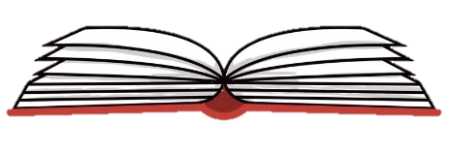  What happened at the end? | Can you solve these riddles?  Who uses a hose to put out fires?  Who has a red cape and can fly?  Who is pink with a curly tail?  Who wears a pointy hat and rides a broomstick? | How many doing words can you think of?  What do you do when you get up in the morning?  What do you do when you get home from school?  What do you do at the weekend? | Go around your house and collect a number of items:  What did you collect?  What does it look like?  (colour, shape)  What could you use it for?

