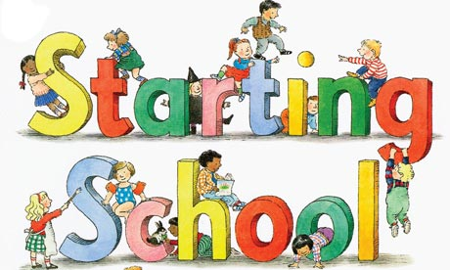

P.1 Old Monkland Primary
August 2020

We look forward to welcoming our brand new Primary 1 pupils when they start in August 2020 and we will invite all families by letter ,to participate in a programme of visits to school in April /May.
However, to begin the school enrolment process please visit for a short meeting to complete the initial enrolment paperwork.

Children who attain the age of 5 years between 1 March 2020 and 28 February 2021 should be registered during the week commencing Monday 13 January to Friday 17 January 2020.

NB Due to difficulties in the past, each child's birth certificate and proof of address in the form of the current council tax bill must be produced.
Please come into the main school reception on any of the following days/times during enrolment week to complete your enrolment form.
Monday 13th January 1.30- 3pm
Tuesday 14th January 9.15-11.30 – 1.30-3.30pm
Wednesday 15th January- 1.30-3pm
Thursday 16th January 9.15-11.30 – 1.30-3.30pm

We look forward to meeting you all then. Don’t forget to bring the required documents please.
Kind Regards
Miss L.McFadden (Head Teacher)

