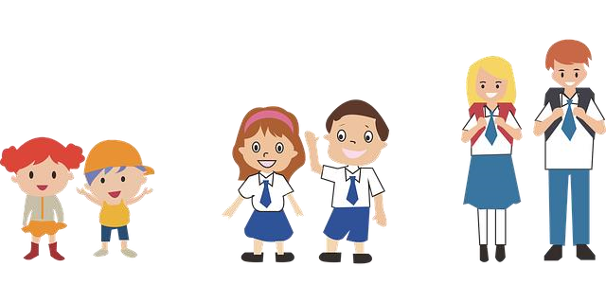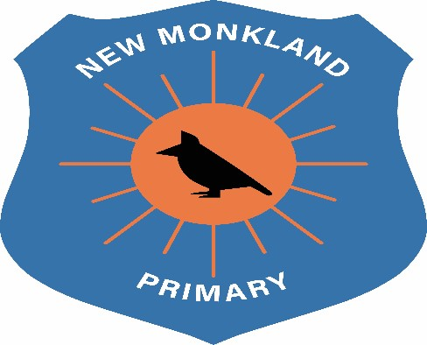

New Monkland Primary School

Uniform Policy

Written: June 2021

Review Date: August 2022

Uniform
At New Monkland Primary School, we pride ourselves in looking smart and presenting uniformity across the school. This encourages a whole school identity (Article 8, UNCRC).
Regarding COVID-19 safety measures, it is recommended that children attend school wearing fresh clothes each day. Clothing should be comfortable and suitable for all weathers.
Uniform consists of the following:

Girls | Boys
White polo shirt | White polo shirt
White school shirt | White school shirt
School tie | School tie
Navy school jumper | Navy school jumper
Navy cardigan | Navy sweater
Black school shoes | Black school shoes
Black trousers | Black trousers
Black skirt or pinafore
Tartan skirt or pinafore

Outdoor Learning
Weather appropriate clothing and footwear
Waterproofs, wellies, own casual clothing.
Children will be accessing outdoor learning in all weathers.

No football colours or logos are permitted in school at all, this includes clothing, bags, lunchboxes and stationery as this can encourage factions. This is also outlined in North Lanarkshire Council Policy.
Covid-19 Restrictions
As outlined above, children are encouraged to wear a fresh set of clothes each day they are attending school to avoid cross contamination. A school bag is permitted to be brought to carry a disposable water bottle and their snack. No other personal items are to be brought to school in line with the safety guidance. Until restrictions are lifted, children will not be changing for P.E. or outdoor learning, therefore it is recommended that uniform items worn are comfortable and appropriate for participation in these activities.

UNCRC Links
Article 8: You have the right to an identity – an official record of who you are .No one should take this away from you.
Article 28: You have the right to a good quality education. You should be encouraged to go to school to the highest level you can.

