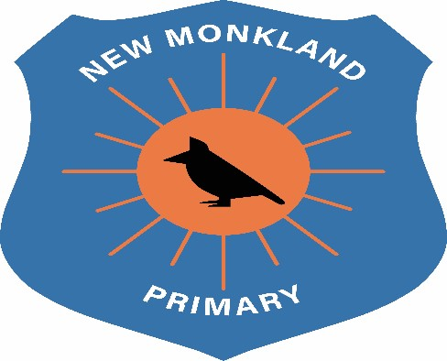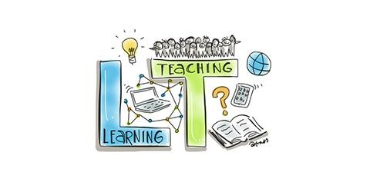

New Monkland Primary School

Teaching and Learning Policy

Written: June 2021

Review Date: August 2022

Teaching and Learning Policy

“Every child has the right to an education. Primary education must be free and different forms of secondary education must be available to every child. Discipline in schools must respect children’s dignity and their rights. Richer countries must help poorer countries achieve this.” Article 28 UN Convention on the Rights of the Child (UNCRC)
As a result of physical distancing measures now in place in response to COVID-19, teaching and learning will be implemented using a blended approach (see Home Learning Policy). This will consist of 10 hours of learning taking place within the school building and digital learning taking place at home.
Within New Monkland Primary school we have high expectations of all pupils in our care and have a progressive and responsive curriculum, in line with Article 3 of the UNCRC. We endeavour for our curriculum to be creative and derive from pupil choice, where appropriate. Staff regularly engage in continuing professional development in order to deliver the best learning and teaching for our pupils. Staff regularly work collaboratively in school in order to further develop their own skills and knowledge and witness best practice from other establishments.
In addition we have an inclusive and diverse Health and Wellbeing programme which underpins our curriculum and we truly believe for our children to achieve and be successful we must meet their Health and wellbeing needs firstly. Through GIRFEC – Getting it Right for Every Child and DYW - Developing the Young Workforce children are provided with a variety of opportunities to engage with meeting their individual needs.
We follow a variety of programmes of work for Literacy, Numeracy and Health and Wellbeing. We also have access to many resources that can support and challenge learners beyond these programmes of work. Programmes of work are tailored to meet the individual needs of all learners and staff use their own professional judgement and expertise to provide meaningful learning experiences. Staff, pupils and parents/carers are also supported by a range of external agencies who can provide a more specialist service.
Curriculum for Excellence expects our pupils to be challenged and have enjoyment through their learning and for our programmes of work to have breadth challenge and application where depth of learning is provided through coherent and relevant programmes of work. Pupil voice is encouraged and the children have a right and a say toward developing and improving their school. Please see the Curriculum for Excellence refresh using the following link https://scotlandscurriculum.scot/
It is vital that children access the Broad General Education and get the opportunity to showcase and develop their talents beyond the core subject areas of Literacy, Numeracy and Health and Wellbeing.
We use our outdoor environment to allow children to develop skills for life, learning and work.
Children can participate in walks in and beyond the local community and outdoor PE. We aim to encourage opportunities for personal achievement and this will be showcased through Twitter.
UNCRC Links
Article 3: All adults should do what is best for you. When adults make decisions, they should think about how their decisions will affect children.
Article 12: You have the right to give your opinion, and for adults to listen and take it seriously.
Article 17: You have the right to get information that is important to your well-being, from radio, newspaper, books, computers and other sources. Adults should make sure that the information you are getting is not harmful, and help you find and understand the information you need.
Article 23: You have the right to special education and care if you have a disability, as well as all the rights in this Convention, so that you can live a full life.
Article 28: You have the right to a good quality education. You should be encouraged to go to school to the highest level you can.
Article 29: Your education should help you use and develop your talents and abilities. It should also help you learn to live peacefully, protect the environment and respect other people

