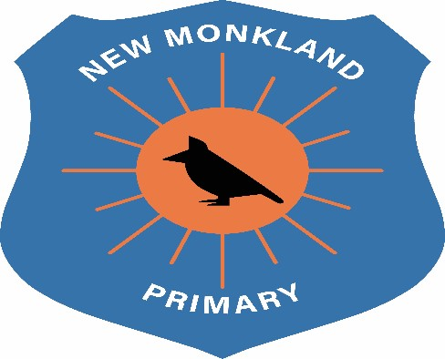

New Monkland Primary School

School Organisation Policy

Written: June 2021

Review Date: August 2022

School Organisation and Management

With COVID19 we have found ourselves in unprecedented and uncertain times. This has resulted in a massive shift in how we move and operate around the school.

No Stop and Talk Policy
A ‘No Stop and Talk’ Policy has been implemented. This means you are not permitted to stop and talk to any passing colleagues or children.

One Way System
There is a one way system in operation (where possible) throughout the school and the school grounds to help implement social distancing.
Prior to movement within the school, staff members will use Walkie-Talkies to inform others of their intended route.
Walkie-Talkies will also be used to inform members of staff when children require the toilet. This will allow designated staff to escort children to and from here (one child in each suite of toilets at a time).

Specific Areas
The office will have limited access. All photocopying will be given to a specific member of staff to carry out and help eliminate unnecessary traffic in the office space.
The Senior Clerical will operate using the “hatch” to speak to children who visit the office on instruction from their teacher. This will also be communicated via the Walkie-Talkie before movement.
The staff room has been organised to allow no more than three members of staff to convene at the one time, and to allow for social distancing. This will help facilitate staff breaks.

Doors
All fire doors are to remain closed. This ensures the health and safety of all staff and children in the building.
All classroom doors to remain open with a door stop, to help eliminate touch points and allow for easy access and exit of the classroom.

Cleaning Boxes
Cleaning boxes will be available in all rooms and throughout the school building. It is the staff member’s responsibility to clean down their area and any workstations before and after use.
It is the member of staff’s responsibility to inform the Senior Clerical when items run out so these can be replenished in a timely manner.

UNCRC Links
Article 3: All adults should do what is best for you. When adults make decisions, they should think about how their decisions will affect children.
Article 19: You have the right to be protected from being hurt and mistreated, in body or mind.
Article 28: You have the right to a good quality education. You should be encouraged to go to school to the highest level you can
Article 29: Your education should help you use and develop your talents and abilities. It should also help you learn to live peacefully, protect the environment and respect other people.

