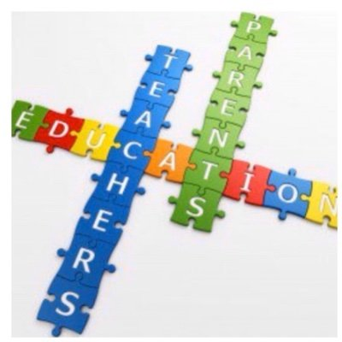
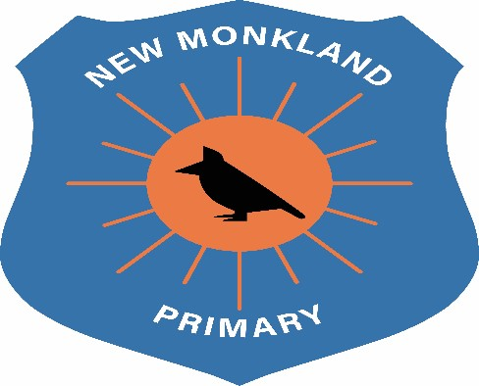

New Monkland Primary School

Parental Involvement Policy

Written: June 2021

Review Date: August 2022

Parental involvement includes parental representation in decision-making, collaboration between parents and educators in matters such as school improvement planning and communication between home and early learning and childcare setting and school. It is about the partnerships and links between home and school, and the opportunities for parents and families to get involved in activities in school or early learning and childcare setting. Education Scotland

Introduction
This policy outlines the important role that parents/carers play in their child’s education at New Monkland Primary School.
Children have two main educators in their lives – parents and their teachers. The school and parents all have crucial roles to play and the impact of learning is greater if parent and schools work together in partnership.

Parental involvement can be divided into two broad strands:
- Parents’ involvement in the life of the school.
- Parents’ involvement in the support of the individual child at home and at school.

Research and documents support that parental involvement is crucial to raising a child’s educational achievement and well-being.

The benefits of parental involvement for children:
- Accelerated development of oracy skills and pre-literacy skills
- Improved standards in Literacy and Numeracy
- Positive behaviour and attitudinal changes
- Enhanced confidence and self-esteem and awareness that learning is a normal activity through life
- Pleasure from collaborative learning

Aims:
It is our aim at New Monkland Primary to:
- Encourage parents/carers to participate in their children’s’ education and in the life of the school.
- Provide opportunities to enrich the learning experience of the child, bringing together the resources of home and school.
- Give parents/carers a sense of purpose and belonging, through a range of opportunities to become involved in the life of the school.
- Ensure that parents/carers are made to feel welcome in our school and are encouraged to work alongside the school.

Communication
At New Monkland Primary School, we aim to make school a welcoming place for parents/carers and visitors. Our main entrance is welcoming with notice boards placed to allow parents/carers access to information. We aim to build and develop a partnership between all families and the school and to build the ethos of being a Rights Respecting School with our local community.

Regular newsletters are sent to all families updating them of school events and school news, this is also posted on our school website and shared via Twitter. Our website is also regularly updated, and parents/carers can access this from home.

Parents are kept informed of their child’s progress at twice yearly Parent Consultation evenings, and staff are available throughout the year to discuss the progress of the child. Staff have a professional responsibility to make themselves available at a reasonable time and with reasonable notice to discuss concerns about a child’s development. Such meetings may be requested by parents or teachers. However, due to Covid-19 restrictions, meetings with staff members will be conducted by an appointment only system to allow for physical distancing measures to be adhered to.

Written reports are sent home once a year, and opportunities are provided for parents to discuss these with teachers.

Parents are kept informed of the coverage of work done within their child’s class through the use of a Snapshot jotter. This is sent home each term to allow families to get an insight into their child’s work. All class jotters are available to view during the Consultation evening. Due to Covid-19 safety measures in place, jotters will not be shared with families to limit opportunities of cross contamination until restrictions are lifted.

We have strong induction procedures throughout the school where procedures are in place which enable children and parents /carers to build up relationships with the school before joining. If children enter school part way through their school life then they are encouraged to visit the school with their parents/carer.

Parent/Carer Roles

As a Rights Respecting school, parents/carers views are vital to the smooth running of the school and we regularly ask for their opinion to help us drive forward positive change within our school community. We recognise the importance of listening to parent/carer views, needs and ideas. The views of our families, needs and ideas can be shared through the Parent Partnership group. We have an open door ethos where we welcome parents to approach the school themselves, phone to make an appointment or put their views in a letter. However, due to Covid-19 measures, this open door policy will cease until safety restrictions are lifted. We encourage all communication to come via telephone or by appointment.
Parents/carers of children who require GIRFME Plans, will be invited into school to consult on this plan and to discuss interventions and support systems for their child. This plan will be agreed upon by staff and the family members and reviewed at appropriate intervals.

UNCRC Links
Article 3: All adults should do what is best for you. When adults make decisions, they should think about how their decisions will affect children.
Article 12: You have the right to give your opinion, and for adults to listen and take it seriously.
Article 13: You have the right to find out things and share what you think with others, by talking, drawing, writing or in any other way unless it harms or offends other people.
Article 24: You have the right to the best health care possible, safe water to drink, nutritious food, a clean and safe environment, and information to help you stay well.

