New Monkland Primary School

**Mobile Phone**

**Policy**

Writte

n

:

June 2021

Review

:

August 2022

1

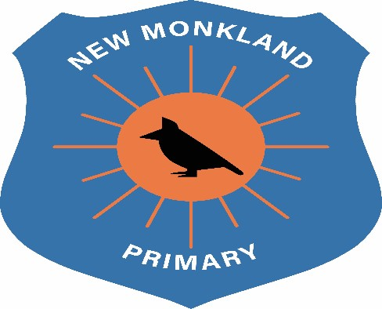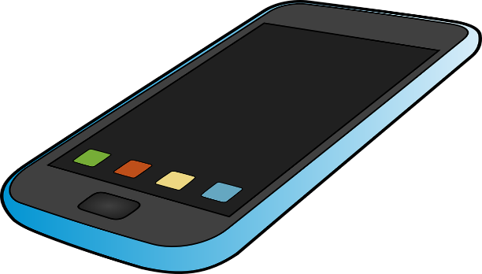

**Aim**

To **clarify** the **acceptable use** of mobile phones at New Monkland Primary School.

# Procedure

*“Under normal circumstances, pupils should not bring mobile phones to school and the use of mobile phones which involves bullying, the invasion of privacy or disruption to the work of the school is considered unacceptable.”*

*(North Lanarkshire Council: General Circular 024-07)*

Therefore, the following procedures should be followed at New Monkland Primary School:

* Mobile Free Zone - All areas of the school should be considered mobile free zones. This is for the safety of all pupils and to ensure learning and teaching is not disrupted.
* Mobile Free Time - At no time, should a pupil have access to a mobile phone. All mobile phones should be handed into the school office, before 8.55am and collected at 3pm.

Pupils not following these procedures will have their mobile phones taken from them and returned to them at the end of the day. Parents will be notified if this happens.

At New Monkland Primary School, we recognise that in some situations, some children may need access to a mobile phone travelling to and from school. The phone can be switched off and placed in a zip-lock bag, to stop cross contamination in line with Covid-19 safety measures, and put in the designated holding area within class. Any parent wishing to contact their child during the school can do so by telephoning the school.

# Disclaimer

New Monkland Primary School will not be responsible for the loss or damage of a mobile phone brought to school by a child.

## UNCRC Links

Article 3: All adults should do what is best for you. When adults make decisions, they should think about how their decisions will affect children.

Article 13: You have the right to find out things and share what you think with others, by talking, drawing, writing, or in any other way unless it harms or offends other people.

Article 17: You have the right to get information that is important to your well-being, from radio, newspaper, books, computers and other sources. Adults should make sure that the information you are getting is not harmful, and help you find and understand the information you need.