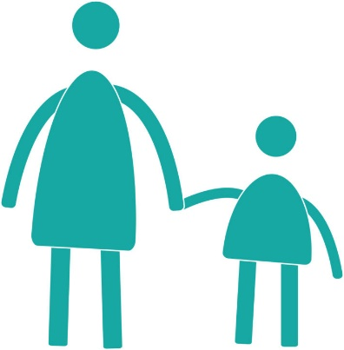
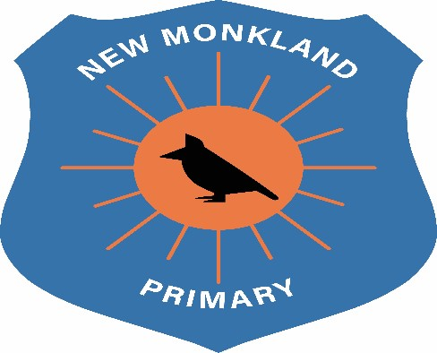

New Monkland Primary School

Intimate Care Policy

Written: June 2021

Review Date: August 2022

Intimate Care

At New Monkland Primary School we are committed to safeguarding and promoting the welfare of children and young people.
We are committed to ensuring that all staff responsible for intimate care of children and young people will undertake their duties in a professional manner at all times. We are committed to ensuring that children are treated with sensitivity and respect.
What is ‘Intimate Care’
Intimate care is defined as any care which involves washing, touching or carrying out an invasive procedure that most children and young people carry out for themselves, but which some are too young to or are unable to do.
Intimate care tasks are associated with bodily functions, body products and personal hygiene that demands direct or indirect contact with, or contact with intimate personal areas. Examples include support with dressing and undressing (underwear), changing incontinence pads and nappies, helping someone use the toilet or washing intimate parts of the body, cleaning a pupil who has soiled him/herself or vomited. It is also associated with other accidents that may require a child to remove their clothes. These include changes required as a result of water play, messy play, sickness and weather. Very young or pupils with additional need may be unable to meet their own care needs for a variety of reasons and will require regular support.
Practicalities
It is generally expected that most children will be toilet trained and out of nappies before they begin at school or nursery. However, we recognise that children will join New Monkland Primary school, having reached differing levels of independence and development in toileting and self-care. Therefore, it is inevitable that from time to time some children will have accidents and need to be attended to. A significant number of these pupils require adult assistance for their personal and intimate care needs. In order to help the children to become aware of their bodily needs and respond to them in time, those who wish to go to the toilet are always allowed to go.
Children in New Monkland Primary School have access to the toilet whenever they need to and are encouraged to be as independent as is age and developmentally appropriate. They are reminded at regular times to go to the toilet and are also encouraged to wash their hands after the toilet.
Role of New Monkland staff
School and nursery staff have access to a bathroom area with a toilet and hand basin with access to warm water. There is also a stock of baby wipes, plastic bags and disposable protective gloves for staff to use. In line with Covid-19 safety procedures, staff must wear PPE (Protective Personal Equipment) such as a mask, disposable gloves and apron to carry out this task. PPE items will be disposed of in a biohazard bag. If a child soils him/herself during school time, one member of the Nursery staff will help the child:
- Remove their soiled clothes
- Clean skin (this usually includes bottom, genitalia, legs, feet)
- Dress in the child’s own clothes or those provided by the school
- Wrap soiled clothes in plastic bags and give to parents to take home.
- All waste materials that need disposed of will be placed in a biohazard bag and disposed of accordingly.
At all times the member of staff pays attention to the level of distress and comfort of the child. If the child is ill the member of staff will telephone the parent/carer.
In the event a child is reluctant and finally refuses, the parent/carer will be contacted immediately.
Our intention is that the child will never be left in soiled clothing, but as soon as a member of staff is aware of the situation, she/he will clean the child. The member of staff responsible will check the child regularly and ensure that he/she is clean before leaving to go home.
It is intended that the child will not experience any negative disciplining, but only positive encouragement and praise for his/her endeavours to master this necessary skill. It is always our intention to avoid drawing attention to such events and positively to encourage the child in his/her efforts to gain these skills.
Guidance for intimate care needs over and above accidents.
The management of all children with intimate care needs will be carefully planned.
Where specialist equipment and facilities above that currently available in the school are required, every effort will be made to provide appropriate facilities in a timely fashion, following assessment by a Physiotherapist and/or Occupational Therapist.
There is careful communication with any pupil who requires intimate care in line with their preferred means of communication to discuss needs and preferences.
Staff will be supported to adapt their practice in relation to the needs of individual children taking into account developmental changes such as the onset of puberty and menstruation.
Pupils will be supported to achieve the highest level of independence possible, according to their individual condition and abilities
Careful consideration will be given to individual situations to determine how many adults should be present during intimate care procedures. Where possible, one pupil will be cared for by two adults.
Intimate care arrangements can be discussed with parents/carers.
The needs and wishes of children and parents will be taken into account wherever possible, within the constraints of staffing and equal opportunities legislation.
Child Protection
Child Protection and Multi-Agency Child Protection procedures will be adhered to at all times.
All members of staff carrying out intimate care procedures will have a PVG. Students should only do so under the supervision of a trained member of staff. It is not appropriate for volunteers to carry out intimate care procedures.
UNCRC Links
Article 3: All adults should do what is best for you. When adults make decisions, they should think about how their decisions will affect children.
Article 16: You have the right to privacy.
Article 27: You have the right to food, clothing, a safe place to live and to have your basic needs met. You should not be disadvantaged so that you can't do many of the things other kids can do.

