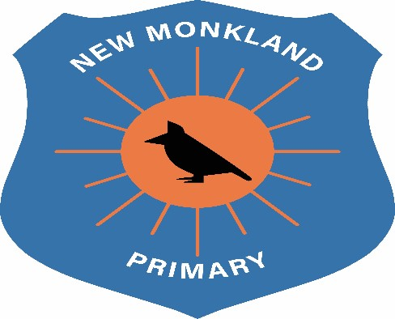

New Monkland Primary School

Home Learning Policy

Written: June 2021

Review Date: August 2022

Home Learning Policy

With COVID19 we have found ourselves in unprecedented and uncertain times. This has resulted in a massive shift in how we, as teachers deliver teaching, and how children access their learning.

All children have been offered a device and internet access to allow them the opportunities to engage in online learning.

Teachers and children are expected to participate in the new blended approach where they will experience in school teaching for part of the week, and digital learning the other part.

Teachers’ Expectations:

- Teachers will use their creativity to engage your child in online learning
- Provide activities to support your child’s learning

Children’s Expectations:

- Access their online activities by the given date
- Complete their online activities by the given date
- Engage and participate in timetabled lessons

Parental Involvement
- Parents/carers will support children by encouraging them to access their set home learning through their Team page

UNCRC Links
Article 3: All adults should do what is best for you. When adults make decisions, they should think about how their decisions will affect children.
Article 16: You have the right to privacy.
Article 17: You have the right to get information that is important to your well-being, from radio, newspaper, books, computers and other sources. Adults should make sure that the information you are getting is not harmful, and help you find and understand the information you need.
Article 28: You have the right to a good quality education. You should be encouraged to go to school to the highest level you can
Article 29: Your education should help you use and develop your talents and abilities. It should also help you learn to live peacefully, protect the environment and respect other people.

