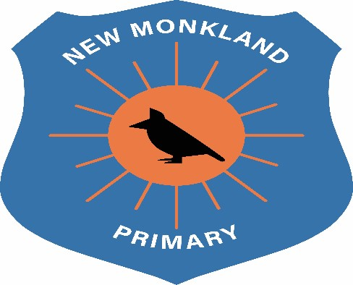
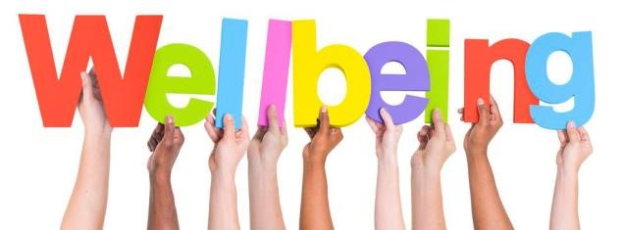

New Monkland
Primary School

Health and Wellbeing

Policy

Written
:

June

2021

Review: August 2022

Rationale

The positive health and wellbeing of children is fundamental to their development. Working in partnership with our parents, carers and wider school community, we hope to encourage lifelong healthy habits. As a school, we will ensure children have access to a safe and appropriate place to learn, achieve and succeed.

As a result of Covid-19, we have put in place all recommended safety measures from NLC and Government guidelines to ensure that all of our children and staff are safe.

Aims

- To incorporate a healthy lifestyle message into our daily activities by promoting the importance of hygiene, diet, exercise, sun safety, rest, general wellbeing and personal safety.
- To work in partnership with parents, carers other agencies and the wider community to reinforce all aspects of a healthy lifestyle.

Role of the Staff

- Staff will provide learning opportunities which will provide children with a broad range of experiences to develop knowledge and understanding encompassing the Health and Wellbeing experiences and outcomes.
- Staff will provide a variety of opportunities for children to experience all aspects of a healthy lifestyle in a fun, engaging and expressive way.
- Staff will be sensitive to the individual needs of each child and provide opportunities for pupil voice and choice.

Health and Wellbeing Teaching & Learning

New Monkland Primary School offers our children two hours of learning within the Health and Wellbeing curriculum. To support staff in effectively implementing this, we follow the Healthy Schools progressive framework to ensure, breadth, balance and depth of learning. This framework supports and explores the SHANARRI wellbeing indicators.

Healthy Schools

This frame work brings together all of the Health & Wellbeing Experiences and Outcomes into groups and aligns them with the SHANARRI wellbeing indicators. Each child’s journey can be followed over a school year through the Health and wellbeing topics of Food and Health, Physical education, Physical Activity and Sport (PEPAS) and Healthy Lifestyles containing:
- Mental, social, emotional and physical wellbeing
- Planning for choices and changes
- Relationships, sexual health and parenthood
- Substance misuse
The framework supports co-ordination across the school and progression throughout the learner’s journey from Nursery though to Primary 7.

SHANARRI, GIRFEC and GIRFME

At New Monkland Primary School we ensure that children’s wellbeing is the best it can be. What we mean by wellbeing is that your child will be Safe, Healthy, Achieving, Nurtured, Active, Respected, Responsible and Included. The main aim of GIRFEC is to improve outcomes for all children and young people when additional help is needed to help develop children’s wellbeing.

Where additional support has been identified by school staff, a Getting it right for me plan (GIRFME plan) allows staff to record strategies, resources, interventions from the earliest point to prevent difficulties escalating. If a child needs specific learning objectives to support their wellbeing these can also be recorded in their GIRFME plan. The child and their parents/carers will be involved in the GIRFME plan and will be asked for comments and ideas to support the plan.

Physical Education, Health and Fitness

The recommendation is that children receive two hours of Physical Education lessons per week built around progressive learning experiences created using the CfE experiences and outcomes. Experiences are carried out within our gym hall, outdoor space or in the local community. However due to the blended approach to learning in light of Covid-19, this time recommendation will be altered.

Due to Covid-19 restrictions, lessons will need to adhere to the strict physical distancing recommendations set out by NLC and the Scottish government in regards to physical distancing and use of equipment.

Oral Hygiene Initiative

New Monkland Primary School is an active participant in the Oral Hygiene Initiative known as Childsmile. Each child is given the opportunity to take part in this. Those taking part are given their own toothbrush to use and are shown how to correctly brush their teeth. The oral hygienist visits regularly to support the implementation of this. Twice yearly, children will also have the option of having a fluoride varnish applied to their teeth. Parents are asked to consent to this and the varnish is applied by the Childsmile team.

Due to Covid-19 health and safety restrictions, the Childsmile programme will not be implemented until it is safe to do so.

Nutrition

In partnership with NLC Catering Direct, all children have the option to choose a healthy lunch from the school cafeteria. Children who are bringing snacks or a packed lunch are encouraged to bring healthy, nutritious foods. Foods containing traces of nuts are not permitted to protect children and staff who have nut allergies.

Recommendations from the safety guidance in respect to Covid-19, it that it is recommended that children who are bringing a packed lunch to school do so in a disposable bag that can be thrown away after use. This is to limit the possible transition of infection.

Sun Safety

Children’s skin needs special care when they are in the sun and it is important that we support them to protect themselves from sun damage by encouraging them to apply sun screen and wearing a sun hat.

UNCRC Links

Article 3: All adults should do what is best for you. When adults make decisions, they should think about how their decisions will affect children.

Article 17: You have the right to get information that is important to your well-being, from radio, newspaper, books, computers and other sources. Adults should make sure that the information you are getting is not harmful, and help you find and understand the information you need.

Article 24: You have the right to the best health care possible, safe water to drink, nutritious food, a clean and safe environment, and information to help you stay well.

Article 31: You have the right to play and rest.

Article 39: You have the right to help if you've been hurt, neglected or badly treated.

