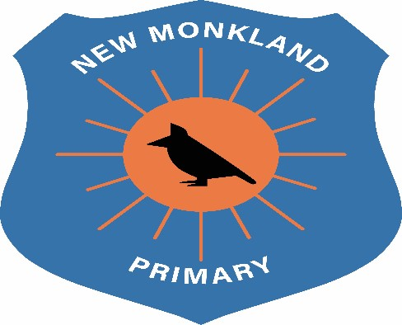
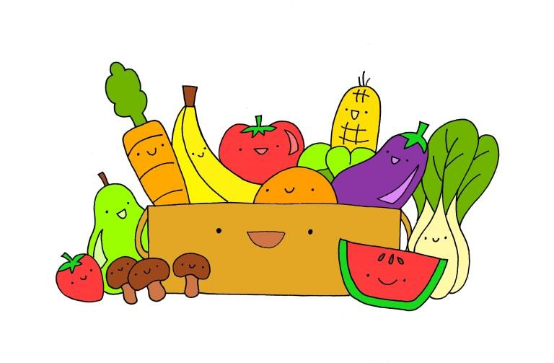

New Monkland
Primary School

Food Storage & Preparation

Policy

Written:
:

June

2021

Review: August 2022

Rational
This policy has been devised to comply with Health and Safety legislation and
practice and taking into account the latest safety advice in relation to Covid-19. . It is essential this policy is put into practice and all staff act consistently when following procedures outlined within.

Food Storage
- Fridges to be cleaned every week and this is logged by a staff member and recorded in the relevant folder.
- Fridge temperatures should be checked on a daily basis. The temperature should be 5° or under. This is logged on a form and stored in the same folder as cleaning form.
- Fridges must be kept clean at all times, with particular attention paid to the seal area around the door.
- Dates on milk cartons to be checked and use oldest dates first. Milk to be taken out fridge just before use.
- All fruit and vegetables must be removed from their plastic bags, as the goods will sweat.
- Vegetables should be stored at the bottom of the fridge and fruit in the baskets.
- Items such as bread, pancakes and bagels, and so on should be stored appropriately with attention paid to sell-by dates.
- A common sense approach to using food and storing food should be followed, i.e. do not leave out too many items that could go to waste.
- Sell-by dates regularly checked on all food packages.
- Open packages will be dated and consumed as soon as possible.
- All food waste to be disposed of into food bin and emptied daily.

Food Preparation
- Staff must ensure that they have washed their hands following NHS and Covid-19 recommendations before handling or preparing food.
- Staff must be familiar with any specific dietary requirements and/ or allergies. A record of these is contained in a notebook in the snack area.
- All surfaces at snack, including the table, worktop and sink area, should be kept clean and hygienic at all times.
- Bacterial spray should be used before and after each session.
- Detox wipes/ Antibacterial spray bottles should be clearly labelled and instructions followed by the cleaning supervisor.
- Aprons must be worn at all times during food preparation.
- A brush, mop and small brush and pan should also be available at all times as spillages should be cleaned immediately.
- Paper towels and paper rolls must be kept fully stocked.
- No metal items prone to rust should be put in the dishwasher.
- Fruit and vegetables should be washed under running water before being offered to the children. Sink is clearly labelled.
- Children should wash their hands before eating or working with food.
- All hot food must be tested with a food probe and have reached the required safe temperature - 75° - as highlighted in the Food Hygiene Handbook. The food must be cooked to the manufacturer’s requirements and be eaten within 20 minutes of cooking.
- Coloured chopping boards should be used in line with guidance displayed in the kitchen area.

The following procedures must be followed when using the cooker, microwave and induction hob within school kitchen area.

Due to Covid-19 restrictions, the use of the school cooking kitchen is not permitted.

- The cooker /I.H. / Microwave should only be used if there is more than one adult in the playroom.
- The cooker /I.H. / Microwave should never be left unattended.
- The cooker should have a visible warning sign (words/ images) to highlight ‘Hot’ and ‘Danger’.
- Each time the cooker /I.H. / Microwave is in use safety issues must be highlighted and discussed with children.
- The area surrounding the cooker should be sectioned off with no children working/ playing near the cooker.
- The cooker /I.H. / Microwave must be cleaned before and after use.
- Oven gloves must be worn by staff.
- Staff should ensure no wires are hanging near the cooker /I.H. / Microwave.
- Fire extinguishers are located in each playroom. This is serviced annually by Chubb.
- A fire blanket is located next to cooking areas.
- The oven only should be used. No rings should be used due to the high temperature and necessary cooling down period. (playroom)
- Microwave will be used following guidelines on food packages.
- All cooking utensils will be checked regularly for any defects and replaced accordingly.

Food Standards Agency Guidance: www. Food.gov.uk/foodindustry/regulation

UNCRC Links

Article 3: All adults should do what is best for you. When adults make decisions, they should think about how their decisions will affect children.
Article 24: You have the right to the best health care possible, safe water to drink, nutritious food, a clean and safe environment, and information to help you stay well.
Article 27: You have the right to food, clothing, a safe place to live and to have your basic needs met. You should not be disadvantaged so that you can't do many of the things other kids can do.

