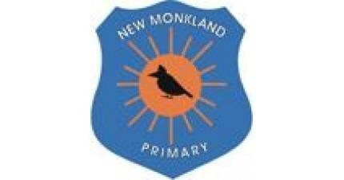
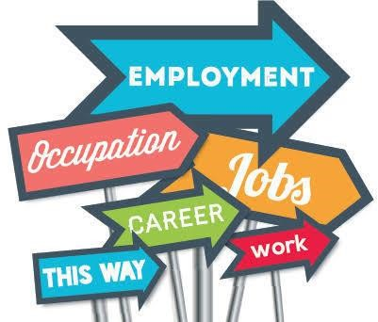
New Monkland Primary School

Developing the

Young Workforce

Policy

New Monkland
Primary

School DYW Vision

Written: June 2021

Review Date: August 2022

Developing the Young Workforce
All children and young people in Scotland have an entitlement to a curriculum which will support them in developing their values and beliefs and enable them to:
- Achieve the highest possible levels of Literacy and Numeracy and cognitive skills.
- Develop skills for life and skills for work.
- Develop knowledge and understanding of society, the world and Scotland’s place in it.
- Experience challenge and success.
Children should be equipped with the skills needed for planning their future lives and careers. There should be positive destinations for all regardless of background and circumstance.
‘The career education standard recognises the journeys that children and young people make as they progress from age 3-18 and the potential and role of key influencers in these journeys. It recognises that all young people will not progress in the same way and that not all face the same challenges and will require appropriate support and interventions as required’
Developing the Young Workforce: Career Education Standard (3-18)

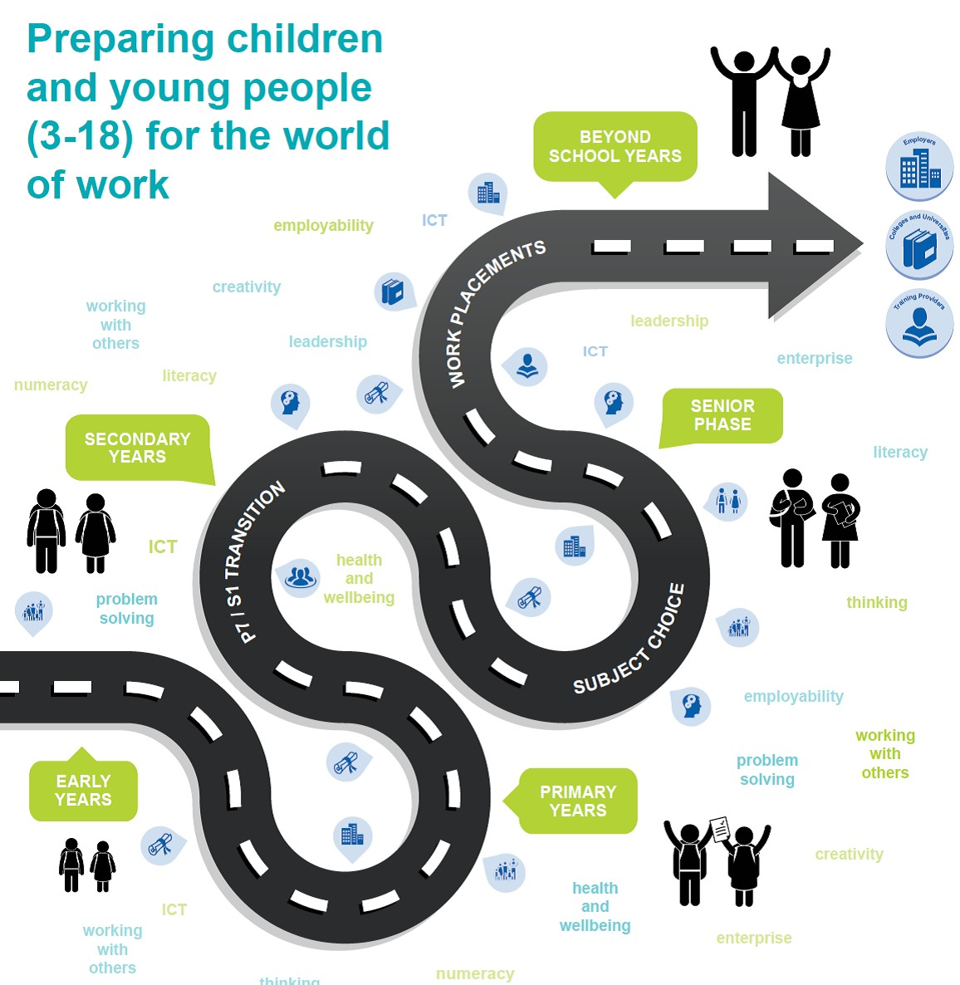

Career Education Standard 3-18 identifies entitlements children and young people are entitled to:

Expectations - children will:
- Experience a curriculum through which they learn about the world of work and job possibilities and which makes clear the strengths and skills needed to take advantage of these opportunities.
- Develop skills for learning, life and work as an integral part of their education and be clear about how all their achievements relate to these.
Expectations - teacher/practitioners will:
- Virtually work with a range of partners including parents/carers, employers and other practitioners to design and deliver an appropriate personalised curriculum that’s takes account of: - the individual needs of children and young people; and – genuinely equips them for learning, life and work in all settings including colleges and other learning providers.
- Develop children and young people’s understanding pf the responsibilities and duties placed on employees and employers.

‘Children and young people are entitled to opportunities for developing skills for learning, life and work.’
Building the Curriculum 4

UNCRC Links

Article 2: All children have these rights, no matter who they are, where they live, what their parents do, what language they speak, what their religion is, whether they are a boy or girl, what their culture is, whether they have a disability, whether they are rich or poor. No child should be treated unfairly on any basis.
Article 4: The government has a responsibility to make sure your rights are protected. They must help your family to protect your rights and create an environment where you can grow and reach your potential.
Article 13: You have the right to find out things and share what you think with others, by talking, drawing, writing, or in any other way unless it harms or offends other people.
Article 17: You have the right to get information that is important to your well-being, from radio, newspaper, books, computers and other sources. Adults should make sure that the information you are getting is not harmful, and help you find and understand the information you need.
Article 29: Your education should help you use and develop your talents and abilities. It should also help you learn to live peacefully, protect the environment and respect other people.
Article 32: You have the right to protection from work that harms you, and is bad for your health and education. If you work, you have the right to be safe and paid fairly.

