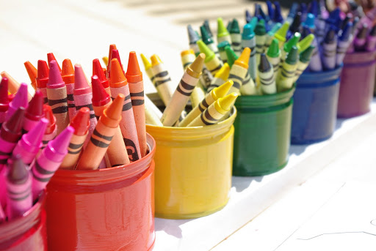
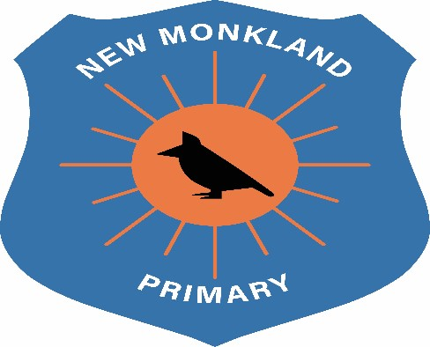

New Monkland Primary School

Classroom Organisation Policy

Written: June 2021

Review Date: August 2022

Classroom Organisation and Management

With COVID19 we have found ourselves in unprecedented and uncertain times. This has resulted in a massive shift in how we move and operate and manage the classroom.

Classroom Furniture
All excess furniture must be left out of classrooms until you are notified otherwise.
There must be a 2m distance maintained at all times between chairs.
Your own workstations must be cleaned before and after use, for eg, the teacher’s table.

Trays
Pupil trays and contents must be cleaned after the two days in school before group change over.

Doors & Windows
All classroom doors to remain open with a door stop, to help eliminate touch points and allow for easy access and exit of the classroom. Windows should remain open (where reasonable) to allow air to flow.

Blinds
Blinds should be kept in the one position where possible. If they need to be adjusted, then the member of staff must thoroughly clean the pole after use.

Resources
All resources must be kept in designated cupboards or areas; these should not be kept in classrooms. When resources are being used, they must be cleaned thoroughly between uses. This will help eliminate the spread of COVID19.

Cleaning Boxes
Cleaning boxes will be available in all rooms and throughout the school building. It is the staff member’s responsibility to clean down their area and any workstations before and after use.
It is the member of staff’s responsibility to inform the Senior Clerical when items run out so these can be replenished in a timely manner.

UNCRC Links
Article 3: All adults should do what is best for you. When adults make decisions, they should think about how their decisions will affect children.
Article 19: You have the right to be protected from being hurt and mistreated, in body or mind.
Article 28: You have the right to a good quality education. You should be encouraged to go to school to the highest level you can
Article 29: Your education should help you use and develop your talents and abilities. It should also help you learn to live peacefully, protect the environment and respect other people.

