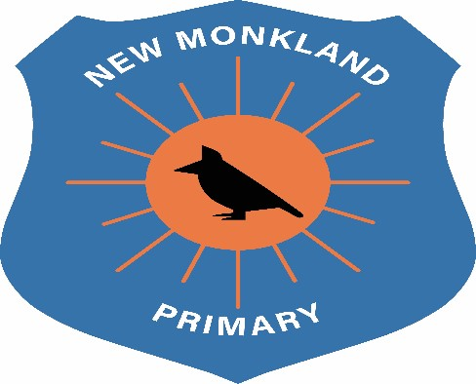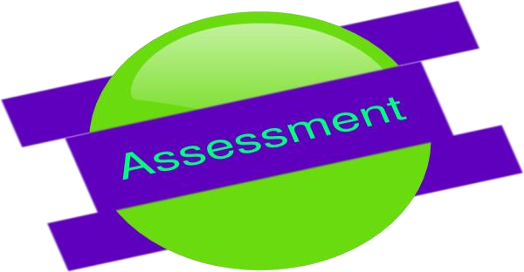

New Monkland Primary School

Assessment Policy

Written: June 2021

Review Date: August 2022

Assessment
Children will be assessed regularly to ensure teaching and learning is pitched appropriately through classroom observations of learners.
Assessment feedback will support teachers to plan appropriate next steps for your child.
Through feedback and discussion, your child will identify their next steps in their learning. Children will have significant input in deciding and actioning next steps. Article 12 of the UNCRC highlights the importance of this in a child’s life.
Teachers will track and monitor your child’s progress across a level. Teachers will use their professional judgement using the benchmarks around the achievement of a level by gathering observational evidence, using strategies such as: verbal feedback, self-assessment, etc. This will inform sound teacher judgement. Furthermore, targeted interventions will be put in place so that every child has the same opportunities to succeed no matter their barriers to learning.
Teachers will engage in ongoing professional dialogue through collaborative professionalism where they will be empowered to share and discuss data (the story of a child’s learning journey) to highlight the progress children are making and if needed, correct, timely and targeted interventions will be put in place to sustain such progress.
UNCRC Links
Article 12: You have the right to give your opinion, and for adults to listen and take it seriously.
Article 28: You have the right to a good quality education. You should be encouraged to go to school to the highest level you can.
Article 29: Your education should help you use and develop your talents and abilities. It should also help you learn to live peacefully, protect the environment and respect other people.

