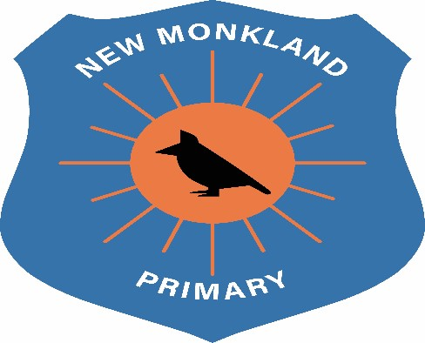

New Monkland
Primary School

Administration of Medicines

Policy

Written: June 2021
Review: August 2022

Administration of Medication Policy

This policy outlines the procedures relating to the administration and storage of medication, prescribed and non-prescribed, for children whilst attending school and also when off the premises on visits/outings.

Medication Required In School

- No child is permitted to carry any medication on their person or in their bag whilst in the building or on visits/outings and must be handed into school on arrival by a parent or carer.
- Medication will not be accepted without a completed “Administration of Medication” form (Med 1). A separate form should be used for each type of medication. This double –sided form is available from either the school office, or may be downloaded from the school website www.newmonkland.nlanark.sch.uk Completed forms will be held in a folder which will be stored in the locked medication cabinet in the office. Once the course of medication is completed, the Med1 form will be filed in the child’s PPR folder which is held in the office.
- All medication should be clearly labelled and will only be administered if it is in a pharmacy dispensed container or box, with dispensing label, the child’s name, date of birth, frequency of administration and date/time first dosage was administered by parent/guardian, or other responsible adult nominated by the parent/guardian. Where a child requires two or more items of medication then these should be provided in one sealed container and labelled as above. It is good practice to have the dosage and administration witnessed by a second adult and, wherever possible, this should take place.
- For health and safety reasons, a child’s parent/guardian, or other responsible adult nominated by the parent/guardian, must always administer the first dosage of any medication before depositing medication with a member of staff in case of allergic reaction.
- Children will be assisted by a member of staff, wearing PPE when physical distancing cannot be maintained in line with Covid-19 guidance, when medication requires to be administered. Children will then be monitored by the member of staff for a minimum of 10 minutes after receiving medication before being permitted to resume activities. If staff become aware of any side effects as detailed in patient information leaflet, the member of staff should complete section B of the Med 1 form.
- All medication will be stored in a locked cabinet in the office for the duration of the required period.
- The parent/guardian, or other responsible adult nominated by the parent/guardian should:
  - complete the appropriate section of the Administration of Medication form when long term medication is no longer required and
  - collect any leftover medication once the course the course of treatment is complete.
- No medication should remain in school over the summer holiday period.
- Medication required over an extended period of time.eg inhalers, will have the expiry date checked on a monthly basis by nursery staff to determine if still current. Parent/guardian will be advised when medication is approaching the use by date. Parent/guardian, or other responsible adult nominated by parent/guardian. Should collect out of date medication for safe disposal.
- Refusal of medication. If a child or young person refuses to take medication, staff should not force them to do so. A staff member must inform parents/carers and a record should be kept where medication is refused. (Section B)
- In line with the General Data Protection Act (2018), all forms containing personal information and relating to the Administration of Medicines must contain a privacy notice. This privacy notice is attached to the electronic copies of the forms.
- Staff to keep informed of any changes/updates and implement these as necessary.

Medication Required on Visits/Outings

- No child is permitted to carry any medication on their person or in their bag while on visits/outings.
- All medication required by children when off the school premises or on visits/outings will be the responsibility of the class teacher.
- Staff members, should monitor the child for a minimum period of 10 minutes after the child has received their medication before permitting the child to resume activities. The member of staff should complete section B of the Med1 form.

UNCRC Links

Article 2: All children have these rights, no matter who they are, where they live, what their parents do, what language they speak, what their religion is, whether they are a boy or girl, what their culture is, whether they have a disability, whether they are rich or poor. No child should be treated unfairly on any basis.

Article 3: All adults should do what is best for you. When adults make decisions, they should think about how their decisions will affect children.

Article 19: You have the right to be protected from being hurt and mistreated, in body or mind.

Article 24: You have the right to the best health care possible, safe water to drink, nutritious food, a clean and safe environment, and information to help you stay well.

Article 27: You have the right to food, clothing, a safe place to live and to have your basic needs met. You should not be disadvantaged so that you can't do many of the things other kids can do.

Article 39: You have the right to help if you've been hurt, neglected or badly treated.

