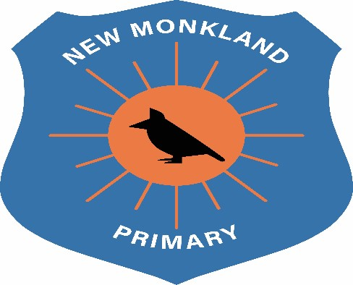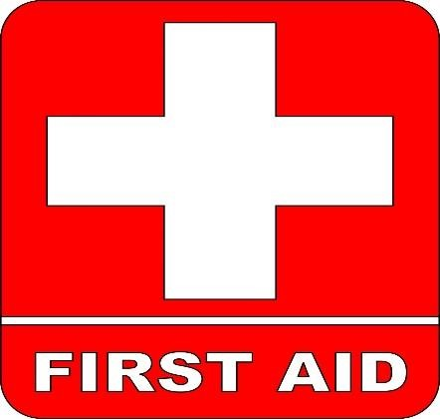

New Monkland Primary School

Accident & Incident Policy

Written: June 2021

Review Date: August 2021
2
Accident and Incident Policy
To maintain safety within New Monkland Primary School, and to ensure children receive the best care, as in line with Article 24 of the UNCRC, staff will adhere to the following protocols:

Head Injuries
Children who experience head injuries, such as bumps, will always be seen by a named First Aider. Parents/Carers will be notified of any head injuries immediately.

Minor Cuts and Sprains
Children presenting with scratches, scrapes and minor cuts will be inspected and wounds will be cleaned thoroughly. In line with COVID-19 safety guidance, the assisting adult may wear PPE (Personal Protective Equipment).
Sprains will be seen by a named First Aider.

Recording Injuries
Accidents and injuries will be recorded by members of staff, and parents will be notified about any noticeable marks visible on the child. All this information is included on the recording sheet.

UNCRC Links
Article 3: All adults should do what is best for you. When adults make decisions, they should think about how their decisions will affect children.
Article 19: You have the right to be protected from being hurt and mistreated, in body or mind.
Article 24: You have the right to the best health care possible, safe water to drink, nutritious food, a clean and safe environment, and information to help you stay well.
Article 27: You have the right to food, clothing, a safe place to live and to have your basic needs met. You should not be disadvantaged so that you can't do many of the things other kids can do.
Article 39: You have the right to help if you've been hurt, neglected or badly treated.

