NLL Registration Form EMAIL:
Please complete all the information below to provide us with the necessary details required for your child to safely participate with us. Once completed please return to reception.
Personal Details
Child Name: D.O.B: / /
Address:
Postcode:
Telephone:
Emergency Contact Information
- Name: Relationship:
Telephone: Mobile:

- Name: Relationship:
Telephone: Mobile:
Photography Consent
As your child is under 16 years of age we require your consent to their participation in a photo call. The photographs may be sent to newspapers and used within NL publications for promotional purposes. The photograph and its copyright will remain within the ownership of North Lanarkshire Council.
I agree to allow pictures to be taken of my child during photo calls for North Lanarkshire Leisure or Council: Yes / No
Medical Information
Does your child suffer from any illness or have any special needs/requirements: Yes / No
If yes please give details:
Does your child suffer from any of the following?:
Diabetes: Yes / No Epilepsy: Yes / No Asthma: Yes / No
Allergy: Yes / No If Yes please give details:

Please sign below to confirm all sections of the form have been completed:
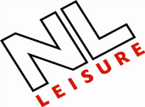
Signed Date

