Information Leaflet

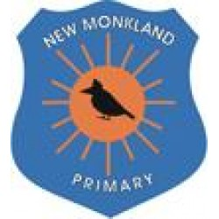

New Monkland Primary School and Nursery Class

What is a Rights Respecting School?

Where are we in the process?

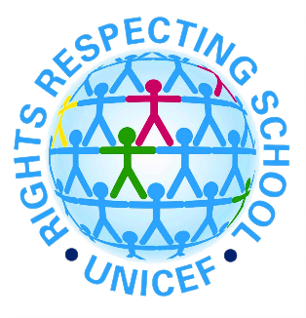

Our Rights Respecting School Committee members are:

Pupils
Elley Logan
Kieran Stewart
Mackenzie Gault
Sophie Reid
Abbie Tobin
Annabel Currie
Andrew Henderson
Teighan Gault
Harry Brady
Georgia Levett
Alix Greene
Lucy McDougall
Abi Dempsey
Romeo Grieve
Holly Walsh
Josh Hill
Skye Paterson
Danny McNaughton
Orla James
Isla Currie
Evie-May McInnes
Blair Murdoch

Parent Members
Helen Mitchell
Lorraine Ewing
Leanne More
Gillian Blair
Amanda Findlay
Lesley Stevenson

Staff Members
Miss D McLaughlin
Miss A Saleem
Mrs K Hanson

For more information on UNCRC and Rights Respecting School please feel free to get in touch with our members and also visit: www.unicef.org/rrsa

Look out for more updates on the school website and twitter page:

http://blogs.glowscotland.org.uk/nl/newmonklandps/

Twitter: @newmonklandPS
How can parents/carers support what the children are learning about in school with regards to the Convention and Rights?

- Take the time to ask your child what he/she has learned recently regarding children’s rights.
- Discuss ideas he/she is learning in class and try to think of examples of your own experiences or from the media of rights being respected or denied.
- Ask your child’s opinion on children’s rights.
- Become involved in children’s rights activities that the school do.
- Share your own ideas and thoughts about children’s rights and how we can continue to improve as a Rights Respecting School.
- Foster the aims and values of the school with your child to help promote children’s rights throughout the whole school community.
- Promote the school values by talking about them.

By being involved in your child’s learning with regards to UNCRC and children’s rights we can work together to foster tolerance, empathy, understanding and love throughout the whole school community, in turn creating responsible citizens and a generation fighting for change, equality and fairness.

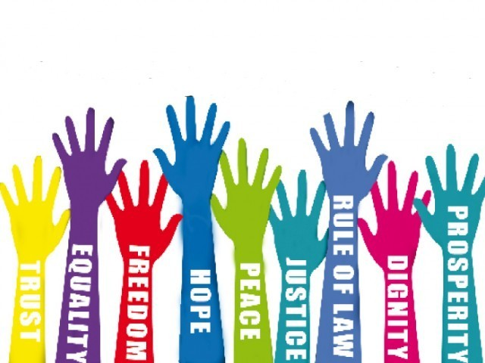

What is a Rights Respecting School?

“A Rights Respecting School is a place where we can all feel confident with ourselves and it encourages us to use our voice. It has helped me build my confidence. It has helped me raise awareness of injustice in the world.”
A PUPIL FROM A RIGHTS RESPECTING PRIMARY SCHOOL

Over 1.5 million children in the UK go to a Rights Respecting School and more than 4,500 schools up and down the country are working through the Award. Our school is on a journey and is fully committed to becoming a fully Rights Respecting School.
A Rights Respecting School works with UNICEF to help ‘create safe and inspiring places to learn, where children are respected, their talents are nurtured and they are able to thrive’. The Rights Respecting Schools Award aims to embed these values in daily school life and help to develop happy, healthy, responsible and active citizens.
Our school values of respect for self, others and property, empathy and tolerance, honesty and pride in our self and our school are all promoted and embedded within our Rights Respecting School. The school values will continue to develop and shine through as we continue on our journey.

Using the UN Convention on the Rights of the Child (UNCRC) ALL staff and children are developing their knowledge and understanding of children’s rights, the articles, how to respect these rights and how these rights can be denied. The staff and children are working towards ensuring that these rights are put into practice every day.
‘The Award recognises a school’s achievement in putting the United Nations Convention on the Rights of the Child into practice within the school and beyond.’

Within a Rights Respecting School, children and adults are developing an ethos and language of rights and respect around the school. Rights and principles of the Convention are used to put moral situations into perspective and consider rights-respecting solutions. Children begin to get involved in raising awareness about social justice issues, both at home and abroad. They become ambassadors for rights and take part in campaigns and activities to help to bring about change. The difference that a Rights Respecting School makes goes beyond the school gates, making a positive impact on the whole community.
What it means to be a Rights Respecting School……

‘We are respecting each other’s rights.’ Kemro P2

‘It means we can be listened to.’ Katie P3

‘Trying to make the school a better place.’ Kieran P7

‘We know that everyone has these rights and we need to protect them.’ Calum P4

‘Rights Respecting School gives us rights and helps us to know that others’ rights aren’t always protected.’ Zach P4

‘Helps us to make more friends because we show kindness, are helpful and look after each other.’ McKenzie P5

‘It means a lot as it means everyone can be happy because everyone is respecting each other’s rights.’ Ellie P5

Where are we in the process of becoming a Rights Respecting School?

Since May 2017, New Monkland Primary School and Nursery Class have made a positive start to working towards becoming a Rights Respecting School. We recognise that we are at the beginning of our journey and we believe that we must take the time needed to develop and deeply embed the aims and values of Rights Respecting School in our establishment and whole school community, as well as make and promote the links with our school values. We wish to continue to make Rights Respecting Schools meaningful and part of our everyday school lives.

The whole school and nursery have set up and established classroom, school, dinner hall and playground charters all developed in line with the UNCRC articles and created with the children. The children and adults are incorporating the language into our everyday interactions and noticing the impact this is having. We aim for this to continue to develop year upon year.

The whole school and nursery have all been learning about UNCRC, the articles and children’s rights in a variety of different topics and contexts. Many children and classes have brought their rights knowledge and understanding into their everyday learning. The articles and rights are incorporated into the school and nursery planning and curriculum and this is helping to develop our understanding of the UNCRC and children’s rights.

Our next steps are to further involve parents and the whole school community and encourage us all to work together to further develop our Rights Respecting School status. We aim to ensure that the whole school community knows and understands what the school wishes to achieve and to help and support one another in the next stages of our journey.

We all look forward to working together to support, respect and understand the rights of everyone within our school, our community, and throughout the wider world.

