Newmains Family Learning Centre
April-June 2019 Newsletter
Language Land
Lorraine, Julie Boyle & Clare will be introducing our next block of ‘Language Land’ in April, to the children in the Sunshine Room.
This is a fun and interactive group which helps support children’s language and communication skills. If your child has been chosen to take part in our next group, then they will receive a letter regarding this in the near future.

Little Learners
The children in the Little Learners Playroom have been continuing to show an interest in various sensory experiences, such as exploring paint, sand, brushes and making and tasting new foods. We also have lots of children who are developing skills in toilet training and who are learing to become more independent in this routine.
Staff are beginning to introduce the children to the balance bikes and this in turn will teach them how to balance on and ride a bike when we introduce them to our ‘Play on Pedals’ programme.

Sunshine Room
We have recently celebrated ‘World Book Day’ and the children have been learning about various characters in stories, role playing, and also the different ways to tell stories and act them out.
Over the coming weeks, the children will learn about Easter.
Following on from Easter, the staff will consult with the children on future learning.
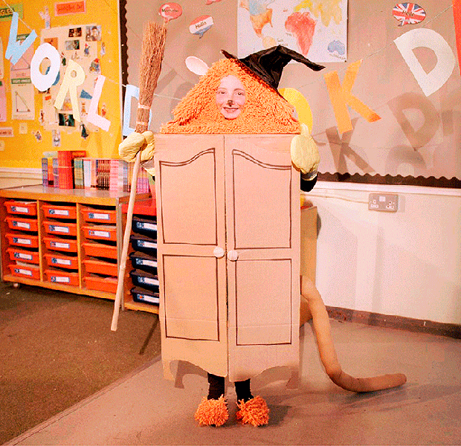

Staff News
We would like to congratulate Clare on her recent engagement to Jamie!
Also, congratulations to Anne who became a gran for the first time to baby Blair. Congratulations!

Tumble Time
Tumble Time has been a huge success with the children and the feedback from parents has been positive with regards to the cost, health benefits and motivation of the children.
We have therefore secured another block of Tumble Time with Julie, every Friday morning and afternoon commencing after the Easter holidays.
We would like to pass on a gentle reminder to everyone that we depend on your contribution of £1.50 per week to enable us to continue with this invaluable experience. Thank you very much!

Displays
The staff spend valuable time creating displays within the playrooms and corridors, to allow families to see what the children have been learning and also to pass on and share information.
We would kindly ask that you encourage your child not to remove any blue tack from the displays, as this spoils the display.
Thank you for your support in this matter.

Sunshine Room – Parent Consultations
Please make an appointment with your child’s keyworker on the appropriate date, in order for us to share your child’s progress & learning.
Red Group: Thursday 16/05/19 (Gillian)
Purple Group: Monday 20/05/19 (Anne)
Red Group: Tuesday 21/05/19 (Emma Jane)
Orange Group: Wednesday 22/05/19 (Clare)
Purple Group: Thursday 23/05/19 (Julie)
Green Group: Wednesday 29/05/19 (Shirley)
Pink Group: Thursday 30/05/19 (Karen)
Yellow Group: Monday 10/06/19 (Charlene)
Blue Group: Tuesday 11/06/19 (Julie)

Fun Day
Our annual Fun Day will take place on Thursday 27th June from 10.00 am – 2.00 pm and all children (from both the morning & afternoon sessions) are invited to attend at this time. We will have our usual bouncy castle, bake sale, face painting, etc. so please come along and join the fun (hopefully in the sunshine)
There will be a small charge for admission to the Fun Day and all children must be accompanied by an adult.

All Playrooms
The nursery is not insured to have children enter the playrooms without a member of staff being present. We would therefore ask that parents wait for staff to open the door to the playroom both at the beginning and end of each session. Thank you!

Transition to School
In the near future, you will receive a programme of transition visits from the school where you child has been registered.
Please take a note of the dates and ensure your child attends when required. It parent’s own responsibility and not that of nursery staff to take your child to and from theses visits, unless staff have arranged any additional visits themselves.
Thank you!

In-Service/Public Holidays
19/04/19 Public Holiday (nursery closed)
22/04/19 Public Holiday (nursery closed)
06/05/19 Public Holiday (nursery closed)
07/05/19 In-service Day (nursery closed)
24/05/19 Public Holiday (nursery closed)
27/05/19 Public Holiday (nursery closed)

Forest Kindergarten Graduation
Two adults (per child) are invited to come along to our Forest Kindergarten Graduation on the following dates:
AM Children Wednesday 01/05/19 PM Children Thursday 02/05/19
This will take place during normal session times.

Sandra’s Retirement
Sandra will be retiring in July this year and would like to invite you along to a celebration on Thursday 20th June from 11.00 am – 12.00 pm and also 3.00 pm – 4.00 pm.
Light refreshments will be available!

Keep Scotland Beautiful
We are supporting the ‘Keep Scotland Beautiful’ campaign and will be arranging a ‘Spring Clean Litter Pick’ in May. More details will follow shortly regarding this.
We will also be arranging our annual ‘Garden Week’ and will notify you of dates as soon as these have been arranged.

Nursery Graduation/Returners Party
The Graduation Ceremony for the children who are going to school, will take place on Wednesday 26th June 2019 during the morning session. All children who are graduating (both AM & PM children) will graduate at this time.
All returning children will attend nursery during the afternoon session on Wednesday 26th June, to celebrate their end of term party.
As space is limited, tickets will be issued for the graduation ceremony and these will be distributed in due course.

Afternoon Sessions
It has been brought to our attention that the actions of a few of our children, have resulted in other children getting hurt in the corridor between the hours of 12.55 pm & 1.00 pm.
We would like to reiterate that it is your responsibility as a parent to ensure that your child is supervised during this time and this will help reduce the amount of incidents occurring, thus allowing children to come into nursery for the start of their session, calmly and happily.
The main entrance is opened at 12.55 pm each day and as we are now at full capacity, we would remind parents that you if you wish, you may arrive at 1.00 pm or shortly after in order to ease the congestion in the corridor.
The situation is being closely monitored and if there is no improvement, then we may consider opening the entrance at 1.00 pm and not before. Thank you for your assistance in this matter!

Sports Day
The Sunshine Room will be holding a Sports Day on Wednesday 5th June 2019.
More details to follow!

Dates for Your Diary
Friday 19/04/19 Public Holiday (nursery closed)
Monday 22/04/19 Public Holiday (nursery closed)
Thursday 02/05/19 Public Holiday (nursery closed)
Monday 06/05/19 Public Holiday (nursery closed)
Tuesday 07/05/19 In-service Day (nursery closed)
Thursday 16/05/19 Red Group (Gillian) Parent Consultations
Monday 20/05/19 Purple Group (Anne) Parent Consultations
Tuesday 21/05/19 Red Group (Emma Jane) Parent Consultations
Wednesday 22/05/19 Orange Group (Clare) Parent Consultations
Thursday 23/05/19 Purple Group (Julie) Parent Consultations
Friday 24/05/19 Public Holiday (nursery closed)
Monday 27/05/19 Public Holiday (nursery closed)
Wednesday 29/05/19 Green Group (Shirley) Parent Consultations
Thursday 30/05/19 Pink Group (Karen) Parent Consultations
Wednesday 05/06/19 Sunshine Room Sports Day
Monday 10/06/19 Yellow Group (Charlene) Parent Consultations
Tuesday 11/06/19 Blue Group (Julie) Parent Consultations
Thursday 20/06/19 Sandra’s Retirement Celebration
Wednesday 26/06/19 AM- Graduation Ceremony
PM – Returners “End of Term” party
Thursday 27/06/19 Nursery Fun Day
Friday 28/06/19 Last Day of Term

