Newmains Family Learning Centre
January-March 2019 Newsletter
Sunshine Room

We are currently learning about “Sid and Shanarri” who are characters that visit the Wellbeing Wood. This is an initiative which promotes children becoming aware of their wellbeing and feelings in line with GIRFEC (Getting it Right for Every Child) legislation.
The children have been learning how to be safe and what things make them feel safe.
We are also encouraing the children to become involved in auditing our learning envirornment through the use of sticker systems and graphs.

Little Learners
The children in the Little Learners playroom have been exploring using their movement skills, as they investigate our new soft play resources.
The children have also been provided with lots of sensory opportunities such as porridge oats, shaving foam, sand, paint, massage brushes and textured mats. This has enabled the children to develop their curiosity, enquiry & creative skills.

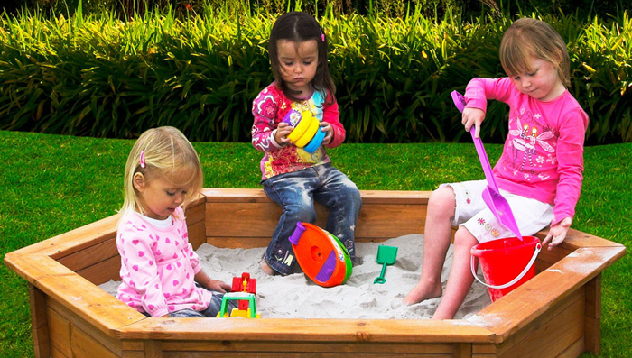

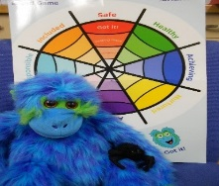

Speech & Language

We would like to welcome Nicole Sneddon (Speech & Language Therpay Student) who will be working alongside Kathleen every Thursday.
Welcome to the Team!

Mini Kickers

We have been fortunate enough to be allocated free “Mini Kickers” sessions over the next few weeks.
The staff involved will not only promote healthy eating and exercise with the children, but also encourage them to balance and co-ordinate their motor skills.
We look forward to being part of this initiative.

Care Inspectorate

We would like to thank all of our parents and carers for their valued contribution during our recent care inspection.
Eileen, our inspector, was very impressed and we are very happy and pleased with the outcome.
We will notify you all when the report is available online.

Bikes Wanted

We are looking for donations of 12” bikes for our “Play on Pedals” programme. The bikes do not need to have stabilisers.
Please speak to a member of staff if you are able to make a donation.
Many thanks!

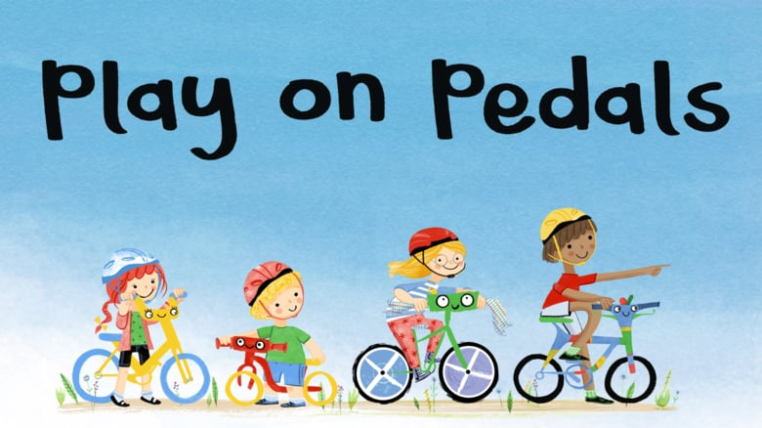

UNCRC Bronze Award

The meaning of UNCRC is the
“UN Convention on the Rights of the Child”
We are seeking training on applying for our “Rights Respecting Schools Bronze Award” and will be encourating the children to learn what their rights are in the coming months, as we progress through the bronze award.
More information will follow in due course.

Stay & Play Dates

Stay, Play & Learn with your child on the following dates:
Yellow Group – Monday 28th January
Pink Group - Wednesday 30th January
Purple Group – Thursday 31st January
Orange Group – Friday 1st February
Blue Group – Monday 14th February
Green Group – Tuesday 5th February
Red Group – Wednesday 6th February

You can stay for as long or short an amount of time as you would like. This is a great insight into how your child learns through play.

Loose Parts Play

We recently distributed information to all parents/carers requesting donations for loose parts play.
We will begin to introduce this to the children in the next couple of weeks, so if you have any items to donate, please do so now.
Thank you!

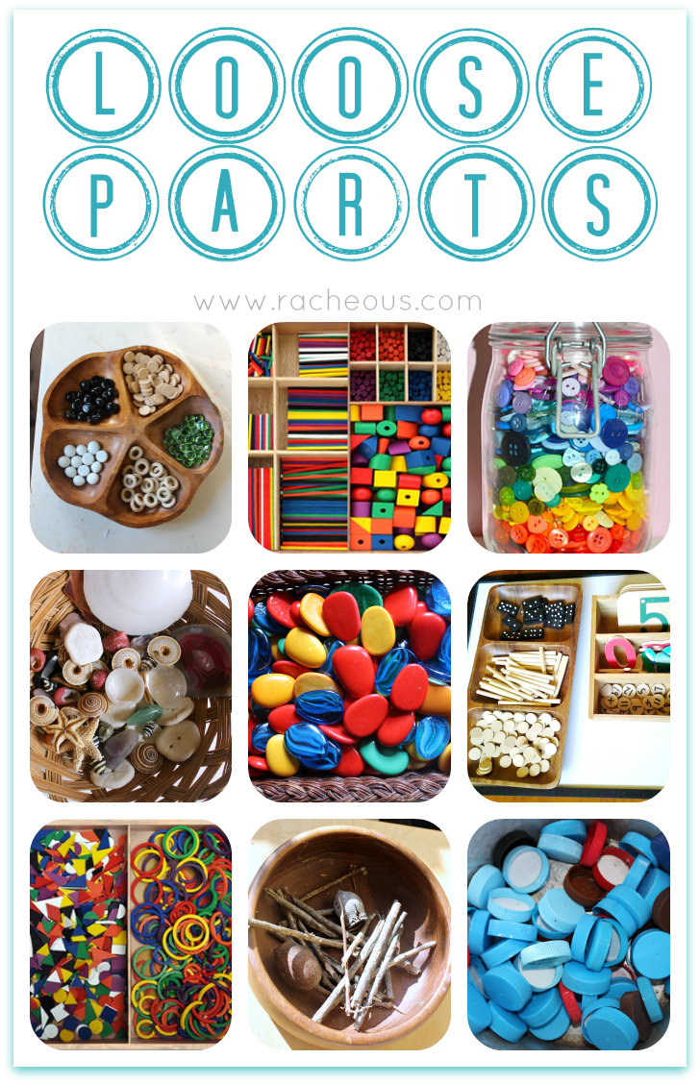

Tumble Time

We recently consulted with our parents and the overall consensus was that we should continue with our “Tumble Time” gymnastics which will be held every Friday for the next 11 weeks.
Due to the overall cost, we would require parents to contribute £1.50 per session (a significantly reduced rate) towards the cost of this and this will be collected by either Sandra or Karen every Friday.
Thank you for your support regarding “Tumble Time.” The children are very eager to participate and are very enthusiastic during the course of the session.

Forest Kindergarten  Another block of Forest Kindergarten will be commencing in the coming weeks.  Karen and Lorraine will lead the children and they are hoping to organise a few “parents only” sessions in the near future in order to share their skills.  If you would like to assist us by becoming a Forest Kindergarten Helper, then please let us know. “Forest Family Fun Bags” are available to borrow at anytime! | Solihull Sessions  A new Solihull “Understanding Your Child” course is due to begin on Friday 22nd March during the morning session. The course will be delivered by Jen (Community Link Development Worker) and a member for our staff team.  The nursery practices the nurturing values of Solihull daily and would therefore like as many parents as possible to become involved in this course.  If you require further information, please speak to Sandra or your child’s keyworker.

Sports Day

Our Sunshine Room Sports Day will take place on Wednesday 5th June (weather permitting). Everyone is welcome to come along and spectate and possibly even become involved!
More information will follow shortly!

In-Service Days/Holidays

Monday 11th February - Holiday (3-5’s only)
Tuesday 12th February - Holiday (3-5’s only)
Wednesday 13th February – In-service Day (nursery closed to all children)

Library Visits  The Sunshine Room children will be visiting the library at the NCT Centre every week. Staff will accompany the children in their individual groups and may possibly ask for parent helpers to assist with this.  Please help us if you can! | World Book Day  World Book Day takes place on Thursday 7th March.  We would like the children to join in this celebration and would therefore invite your child to dress up as their favourite character from a book.  We look forward to seeing them all!

Big Chef, Little Chef

Jen, our Community Link Development Worker, has organised a 3 week block of “Big Chef, Little Chef” where you can come along and cook healthy foods with your child. This will take place during the course of your child’s nursery session within the ICT Suite, Newmains Primary School.
Sessions are as follows:
AM Children – Friday 25th January, Friday 1st February & Friday 8th February (10.00am – 11.30am)
PM Children – Friday 15th February, Friday 22nd February & Friday 1st March (1.30pm – 3.00pm)

If you would like to participate along with your child, then please let us know.
Thank you!

Dates for your Diary

25/01/19 “Big Chef, Little Chef” commences for a 3 week block
(AM children)

28/01/19 Yellow Group Stay & Play Day

30/01/19 Pink Group Stay & Play Day

31/01/19 Purple Group Stay & Play Day

01/02/19 Orange Group Stay & Play Day

04/02/19 Blue Group Stay & Play Day

05/02/19 Green Group Stay & Play Day

06/02/19 Red Group Stay & Play Day

11/02/19 – 12/02/19 Mid Term Holiday (3-5’s only)

13/02/19 In-service Day (nursery closed)

15/02/19 “Big Chef, Little Chef” commences for a 3 week block
(PM children)

07/03/19 World Book Day

22/03/19 Solihull Course commences

01/04/19 – 12/04/19 Easter Holidays (3-5’s only)

19/04/19 – 22/04/19 Public Holidays (Good Friday/Easter Monday) - nursery closed

06/05/19 Public Holiday (nursery closed)

07/05/19 In-service Day (nursery closed)

24/05/19 – 27/05/19 Public Holidays (nursery closed)

05/06/19 Sunshine Room Sports Day

26/06/19 Sunshine Room Graduation (AM)
Returners Party (PM)

28/06/19 Nursery closes

