


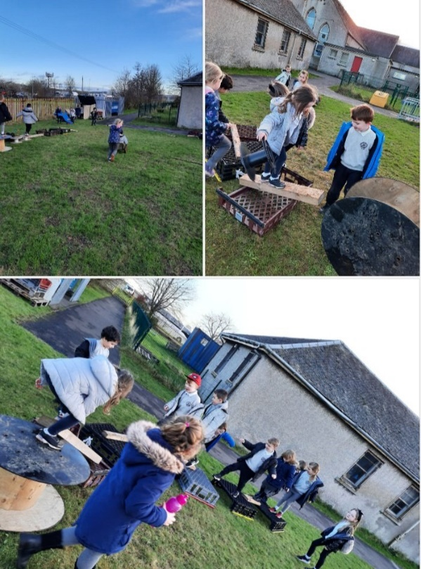

Newmains community hub
Loose Parts Play Policy
Contents
Section 1- Loose parts
What is Loose Parts Play? Page 2
The benefits of loose parts Page 3
Loose Parts Play at Newmains Hub Page 4
Section 2 – Facilitating Play
Types of play Page 5
The Adults Role Page 6
Open ended questioning Page 7
Section 3 - Risk assessments
Risk/Benefit analysis of activities Page 10

Section 1
What is loose parts play?
Loose parts provide limitless play opportunities, giving the children the resources they need to play in whichever way they choose, individually or with others. Loose parts allow children to manipulate their own environment, allowing them to play creatively, to invent, construct and evaluate.
Loose parts materials can be natural or manmade and should be open ended play materials that can be used in a variety of ways. Loose parts can be large parts or can be small world parts.
Some examples of loose parts are:
- Tyres
- Planks of woods
- Pallets
- Crates
- Cable reels
- Pipes
- Guttering
- Tree slices
- Shells
- Rocks
- Pinecones

Play is “essential to the health and well-being of children and promotes the development of creativity, imagination, self-confidence, self-efficacy, as well as physical, social, cognitive and emotional strength and skills.” (Committee on the rights of a child, 2013)

Nicholson’s Theory of Loose Parts  The term “loose parts” came into use in 1971, after an architect, Simon Nicholson, published a paper called “The Theory of Loose Parts”. Nicolson described loose parts as “variables” and provided examples such as materials and shapes; smells and other physical phenomena, such as electricity, magnetism and gravity; media such as gases and fluids; sounds, music, motion; chemical interactions, cooking and fire; and other humans, and animals, plants, words, concepts and ideas. With all these things all children love to play, experiment, discover and invent and have fun. | Affordance Theory  When children play in a space or with an object they experience it in a unique way. Rather than its intended purpose, they may view it in terms of its ‘affordances’. American psychologist James J. Gibson (1979) suggested that environments and objects within them have values and meanings that are unique to the person perceiving them. The ‘affordances’ of an object or space are all the things it has the potential to do or be. For example, a brick wall may be built to make a clear boundary between a pavement and a garden but for many children, it would offer a place to sit, walk along, balance, hide behind and jump of

The Benefits of Loose Parts Play
There is a growing body of evidence (Hyndman, Benson, Ullah and Telford, 2014) of the benefits of playing with loose parts including:
• Increasing levels of creative and imaginative play
• Children play co-operatively and socialise more
• Children are physically more active
• Curriculum outcomes occur through informal play with loose parts (Wagland, 2015)
• Loose parts facilitate communication and negotiation skills when added to an outdoor space (Maxwell, Mitchell and Evans, 2008)

There is also evidence about the benefits of playing with naturally occurring loose parts. This includes:
- Improvements in young children’s physical coordination (Fjortoft & Sageie, 2000)
- Children feeling better able to focus and it enhances cognitive abilities (Wells, 2000)

There is also evidence that introducing loose parts creates more active play:
Cheap items like crates and buckets encourage children to be more active and creative than expensive play equipment, researchers have found. The findings are the result of a long term study into the play differences of primary school children with access to different playgrounds. Introducing simple, everyday objects during recess and lunchtime can cut sedentary behaviour by half, improve creativity and boost social and problem-solving skills. (Science Daily, 2014)
In summary, providing loose parts play in the playground can:
• Improve social skills
• Improve concentration
• Develop imagination
• Develop problem solving skills
• Develop risk management
• Develop gross motor skills
• Increase physical activity

Loose Parts at Newmains Community Hub
At Newmains Hub we are developing the following skills through play:
- Resilience
- Determination
- Perseverance
- Co-operation
- Team work
- Independence
- Creativity
- Communication skills

Section 2 – Facilitating Play
Types of Play
At Newmains, we take a holistic approach to child development and our aim is that we will meet the development needs of our children through loose parts play. We have looked at the 10 characteristics of play according to Aistear (Learning and Developing through play- Aistear: the early Childhood Curriculum Framework 2009). We have been able to identify how these characteristics are developed through our loose parts play:

1. Active: Children are active during loose parts play in body and mind when they are interacting with the loose parts and each other. They more active as they chase tyres, lift and carry materials and will develop core muscles by balancing and climbing. Children are active in mind as they problem solve, create and imagine whilst playing with loose materials.
2. Adventurous and Risky: Loose parts provide an opportunity for adventurous play with the children having access to open ended materials that can be used in a variety of ways. Children are given the opportunity to take risks where safety measures are in place. The children are encouraged to risk assess along with adults and explore new concepts.
3. Communicative: Communication skills are developed as the children work together to build and create with loose materials, tell stories and share information about the play materials. They talk to each other about their discoveries and share their pride in the achievements they have made. Loose parts also provide a new way for children to communicate with adults, sharing achievements and explaining their ideas.
4. Enjoyable: Loose parts provide enjoyment as the materials can be manipulated, played with and shared in the ways that the children choose.
5. Involved: Children are involved in their play with loose parts as they concentrate on what they are doing and actively think and problem solve during play on their own or with others. Children are busy exploring and using materials, thinking about how they are going to achieve what they have set out to do.
6. Meaningful: Loose parts provide meaningful play as the children are using materials that they encounter in everyday life. They are often familiar and the children will be aware of their use in everyday life. They may choose to recreate their original use through their play.
7. Sociable: Loose parts provide the opportunity for children to be sociable in their play as they interact with other children and adults in the playground. They share their ideas and discoveries as they interact; building relationships, practising negotiation skills and sharing.
8. Symbolic: Loose parts allow children to recreate what they have experienced in everyday life. They will act out their feelings, ideas and roles.
9. Therapeutic: Loose parts play can allow children to express their feelings and build resilience.
10. Voluntary: loose parts play is child centred, where the adult’s role is to scaffold learning and to provide ideas and materials. The children take lead of their own activity and are free to change and alter what they are playing as they choose. The play is spontaneous and based on the child’s own interests.

The Adults Role
Our playground is supervised by adults at playtimes and lunchtimes to ensure the children are safe and to support the children in their play. As loose parts play involves an element of risk it is important that we allow the children to explore risky play and support them to evaluate and manage risk on their own. This is a vital life skill and develops confidence and self-worth in the children. Our adults will work through the Stop, Think and Act procedure when supporting children with their play.
Stop   | Stop yourself before you respond to or interrupt children’s play. Let children work it out on their own. If there is an argument see if they can work it out, try not to step in too soon. Look and listen to what is happening.
Think   | Are the children managing risks? How could you help them manage the risk?  Are the children working well together? How could you support them to listen to each other?
Act   | Now you can respond in a thoughtful way. Support the children to identify and manage risks by asking open ended questions like: what do you think would happen if…? Support children to settle arguments by using methods like playing rock, paper, scissors.

Open Ended Questioning
It is important that the adults in the playground use open ended questioning to support the children as they play with loose parts. It allows for the children to think through the risk assessment process and solve problems for themselves. Asking a child to ‘be careful’ can be meaningless to a child as they need to know what they have to do to manage the risk.
Instead of “Be Careful!” our adults will say things like:
- Notice how… that plank is thin, the tyre is slippery, that crate is strong.
- Do you see… the trip hazard, your friends nearby?
- Try moving… your feet slowly, carefully, quickly, strongly.
- Try using your… hands, feet, arms, legs.
- Can you hear… the rushing water, the singing birds, the wind?
- Do you feel… stable on that rock, like that could break?
- Are you feeling… scared, excited, tired, safe?

It’s important that we let our children engage in risky or challenging play because it’s a great way for them to practice problem solving skills. Our adults will help them out by asking things like:
- What’s your plan… if you climb that pile of tyres, cross that plank?
- What can you use… to get across, for your assault course?
- Where will you… put that stick, roll that tyre, put that crate?
- How will you…. get down, go up, get across?
- Who will… be with you, go with you, help you if?

We will improve our children’s social skills, improve interactions with their peers and promote resilience by using questioning to allow children to manage their interactions with others. Our adults will support social skills by asking questions like:

- Look around you…..is there space, will someone get hurt if
- How do you think they feel if…… you take that, knock that down, shake that?
- How could you…..share, take turns, use that together?
- Does everyone…..feel safe, like that, want to take part?

Section 3- Risk Assessments
Risks Benefit Analysis
We have looked at the risk/benefit analysis of the play activities that may take place in our playground to ensure that we are taking steps to reduce that risk in our playground and that the benefits outweigh the risks. The risk assessments look at the benefits of the play activities and show how we are minimising the risk.
Activity:
Tyre Play
Benefits of Experience/Activity:
Development of gross motor skills, Physical activity
Development of problem solving and creativity

Activity/Experience steps | Risk | Risk Level | Control Actions | New level
Lifting Tyres  Stacking Tyres  Rolling Tyres  Rolling inside a tyre | Bumps, soft tissue/ muscle damage  Bumps, scrapes, soft tissue/ muscle damage Head injury  Bumps, scrapes, soft tissue/ muscle damage  Bumps, scrapes, soft tissue/ muscle damage, Head or neck injury | Medium  High  Medium  High | If children want to lift a tyre they should do this with another child (in pairs)  Encourage children to roll a tyre if they want to move it from one place to another.  Tyres should not be stacked above the child’s waist height.  Encourage children to check for a clear path before rolling a tyre  Children should have a partner to ‘spot’ them when rolling inside a tyre, children should be encouraged to think about if the tyre is the right size for them to roll in so that they do not get stuck. | Low  Low  Low  Low
Activity:
Den Building
Benefits of Experience/Activity:
Imagination and creativity, predicting and problem solving, discovering how materials can be used, working co-operatively and sharing ideas, developing fine and gross motor control, exploring spaces and increasing spatial awareness, developing vocabulary, fantasy play

Activity/Experience steps | Risk | Risk Level | Control Actions | New level
Gathering loose parts available  Building materials up on top of one another  Building materials above head height | Bumps, scrapes, soft tissue/ muscle damage  Bumps, scrapes, soft tissue/ muscle damage  Bumps, scrapes, soft tissue/ muscle damage  head injury | Medium  Medium  High | Encourage the children to work in pairs to lift heavy items, support the children to transport materials without lifting them.  Support the children to think about the stability of their den as they build and help them think of ways to secure materials.  Any materials that are above the child’s head height should be fully secured. | Low  Low  Low

Activity:
Pallet/ Wooden plank Play
Benefits of Experience/Activity:
Imagination and creativity, predicting and problem solving, discovering how materials can be used, working co-operatively and sharing ideas, developing gross motor control and balance, exploring spaces and increasing spatial awareness, developing vocabulary, fantasy play

Activity/Experience steps | Risk | Risk Level | Control Actions | New level
Lifting/moving pallets or planks  Building materials up on top of each other  Walking/ balancing on planks and pallets | Scrapes, bumps, splinters or cuts  Bumps, tissue damage  Falls, bumps, tissue damage, sprains | Medium  Medium  Medium | Encourage the children to work in pairs to lift heavy items, support the children to transport materials without lifting them.  Check all wood for nails or rough wood, sand down any rough areas.  Support the children to think about the stability of their materials and to secure anything to be climbed on.  Check planks and pallets regularly for broken parts, encourage children to test if something will hold their weight before walking on it. Supervise the children to ensure that planks and pallets are stable before they climb or walk on it, | Low  Low  Low
Activity:
Assault Course Building
Benefits of Experience/Activity:
Imagination and creativity, predicting and problem solving, discovering how materials can be used, working co-operatively and sharing ideas, developing fine and gross motor control, exploring spaces and increasing spatial awareness, physical play
Activity/Experience steps | Risk | Risk Level | Control Actions | New level
Gathering loose parts available  Building materials up on top of one another  Walking on and balancing on materials | Bumps, scrapes, soft tissue/ muscle damage  Bumps, scrapes, soft tissue/ muscle damage head injury  Bumps, scrapes, soft tissue/ muscle damage | Medium  High  Medium | Encourage the children to work in pairs to lift heavy items, support the children to transport materials without lifting them.  Support the children to think about the stability of their materials and they should not be built above head height  Encourage children to test if something will hold their weight before walking on it. Supervise the children to ensure that planks and pallets are stable before they climb or walk on it, | Low  Low  Low

