5.
Why do we want to be a
Rights Respecting School?

A Rights Respecting School means children feel safe.

Through knowing about the UNCRC, children are able to think about how they and others are treated and challenge what they see as unfair.

A Rights Respecting School
means children play an active
part in school life.

Throughout the reward journey, children and young people are involved in decisions being made about their learning and their well-being.

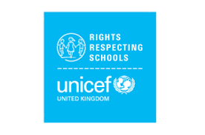

6.
A Rights Respecting School means promoting Global Citizenship.
Through the areas studied, children and young people are involved in raising awareness about social justice issues, at home and abroad.
They become ambassadors for equity and rights and take part in campaigns and activities to help to bring about change.

There are so many great reasons for us to become a Rights Respecting School!
Please support us in our journey to becoming a GOLD Rights Respecting School.
Talk to your children about what they know and are learning about the UNCRC.
Ask how you can help and be part of our school community as we work together to achieve our GOLD Rights Respecting Award.

Further information can be found on UNICEF UK’s
Website:

https://www.unicef.org.uk/rights-respecting-schools/

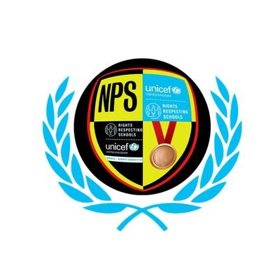
1.

Newmains Primary School

What is a Rights
Respecting School?

Parent/Carer Guide

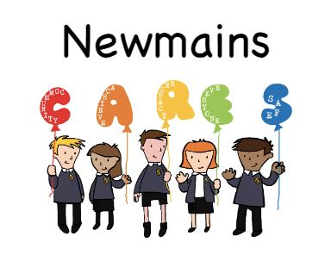

2.
What is a Rights Respecting School?

Rights Respecting Schools is an initiative
run by UNICEF UK based on the UN convention
on the Rights of the Child (UNCRC)

It is a serious of awards that schools can word towards achieving:

BRONZE, SILVER and GOLD
Together adults, children and the school community learn about children’s rights and put them into practice every day.

Newmains Primary currently have a SILVER
Award and are working towards GOLD.

What is the UN Convention on the Rights of the Child?

The United Nations Convention on the Rights of the Child is a statement of children’s rights.

It has 54 articles that cover all areas of a child’s life and it sets out the political, civil, economic, social and cultural rights that all children are entitled to.

The Convention came into force in the UK in 1992.
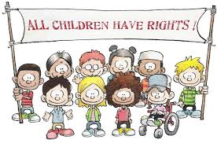

3.
What do schools have to do to become a
Rights Respecting School?

Achieving any of the Rights Respecting School awards is not just about proving that as a school we have completed a task or covered a set criteria.

In Newmains Primary, we are commitment to placing the rights of the child at the centre of everything we do throughout the school and in all areas of school life.

In Rights Respecting Schools, children’s rights are promoted and realised. Adults and children work towards this goal together.

The journey to receiving the Gold award can take three to four years.
UNICEF UK will work with our school as we work towards becoming Rights Respecting.
UNICEF UK helps teachers work with children throughout the school on issues facing the world today.
Topics might include the plight of refugees, the environment and climate change.

UNICEF UK will also assess the school when it is ready for each award

.
4.
What happens when we achieve
Rights Respecting status?

Once a school has been awarded Silver and Gold accreditations these have to be reviewed after three years to ensure schools are still putting children and young people’s rights first in their school’s practice and ethos.
Why do we want to be a
Rights Respecting School?

A Rights Respecting School means better relationships.

In a Rights Respecting School, relationships are based on mutual respect; everyone is equal, and everyone’s opinion is valued.

A Rights Respecting School means happier children.

By actively promoting the values of respect, dignity and non-discrimination, that are at the heart of the UNCRC, children’s self-esteem and wellbeing is strengthened.

