Cl
yde Valley High School
Handbook

2021

-

2022

Education
& Families

Handbook 2021/2022

CVHS CAPTAINS
2021/22

SCHOOL CAPTAINS
Duncan Richards
Callum Kyle
Rebecca Smith

CURRAN House
Tamara Achomere
Mark Kerr
Lucy Jane Hassan
Jasmine Pearce

SNEDDON House
Carly McCabe
Eva Purcell
Taylor Porteous
Aarran Paterson

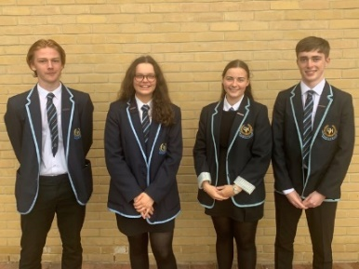
HOULDSWORTH House
Jack McManus
Ellie Smillie
Louise Davidson
Jan Svoboda

HEAD TEACHER’S INTRODUCTION……………………………

Dear Parent,

It gives me great pleasure in presenting the Clyde Valley High School Handbook for session 2021/2022. It contains a wide range of information, which I hope you will find useful and interesting.

Clyde Valley High School moved into a new £27 million building on January 28th 2016 and can now boast, first class facilities. A significant investment was also made in new technology which is evident in every classroom. Strong academic performance in recent years allied to the new school and resources gives cause for optimism of new levels of success to come.

We aim to provide a meaningful and effective education for all our pupils by creating a caring, and tolerant teaching and learning environment where staff can deliver a curriculum which is responsive both to the need of individual pupils and to those of a changing society. A curriculum which will enable our young people to become successful learners, effective contributors, responsible citizens and confident individuals. Central to this is a strong partnership between staff, pupils, parents and the wider community.
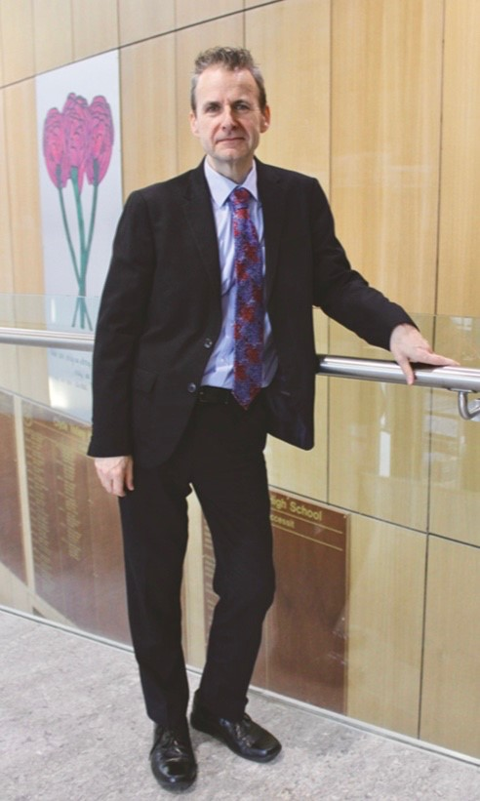
We strive to ensure our young people leave Clyde Valley High School with a well-developed sense of their local community, and are fully prepared and equipped to take their place within it.
No handbook in itself can fully or adequately describe a school. Why not visit our website www.clydevalley.n-lanark.sch.uk , follow us on Twitter @ClydeValleyHS https://twitter.com/ClydeValleyHS or download our school app from iTunes or google play.

If you wish to view our school, hear more about it, or discuss some aspect of our work, then please feel free to telephone, write or arrange a visit. Parents and guardians are particularly welcome. We look forward to working with you to support, guide and motivate your young people throughout their education in Clyde Valley High School, in turn preparing them for life beyond school.

Nick Quail

Head Teacher

THE AIMS OF THE SCHOOL………………………………………..

The principal aim of Clyde Valley High School is to ensure that each pupil in the school, by participating in a full and comprehensive course of education, is able to gain the maximum benefit from his/her time in the school. In so doing the school hopes to prepare pupils for the wider world of adult life.

Formal courses, prepared and taught by well-qualified and interested members of staff, are presented for the intellectual development of the pupils. Equally importantly, the school provides an opportunity for pupils to enhance their talents in, and their appreciation of, the physical and aesthetic areas of human experience. Religious and moral development, without which no person is complete, are given a high priority in the life of the school.

Recognition is given in the school planning to the fact that leisure now plays a greater part in our lives than ever before. A number of clubs and activities are available to pupils to prepare them for using leisure time in a positive fashion.

The majority of school pupils respond well to the provision in the school of an environment which encourages them to develop self-discipline. High priority is given in school planning to providing conditions in which good order and discipline can be maintained at all times.

Clyde Valley High School hopes to stimulate in its pupils a degree of sensitivity towards the needs of the community. The school has a community involvement programme in which pupils participate and from which they gain a wider view of the needs and aspirations of the community.

In pursuing these aims the school sees itself as being in partnership with parents in a joint venture to prepare pupils for their future. Only with full parental co-operation can the aims of the school be translated into something fruitful and meaningful.

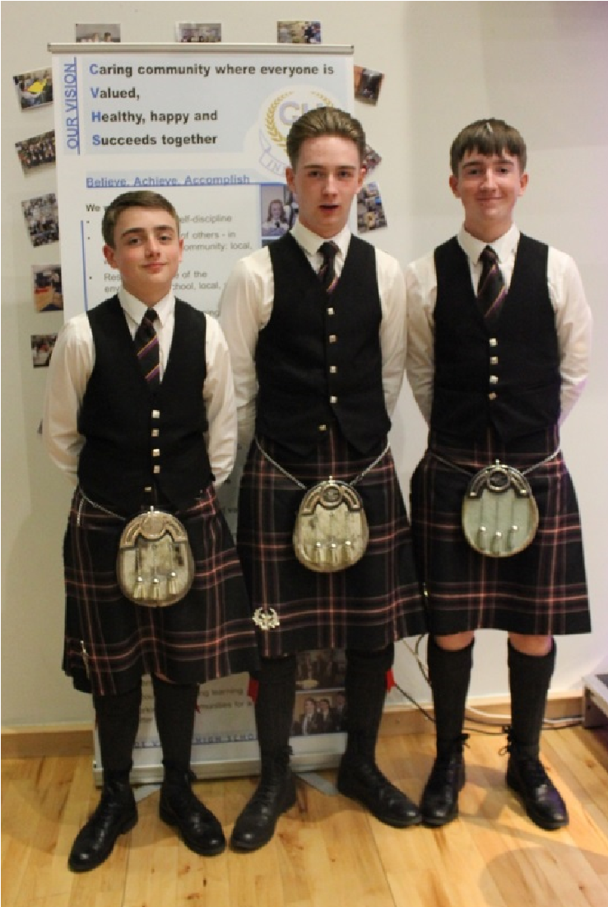

Clyde Valley High School
A Growth Mindset School

“Everyone can learn.”

At Clyde Valley High School we believe that all parents and teachers can support our pupils to become exceptional learners and to help do this we promote the culture of growth mindset in our school. This underpins our school ethos that we are “Raising Achievement for All”
For the past 12 months Clyde Valley High School has been working with the Winning Scotland Foundation, and using the work of, Carol Dweck from Stanford University to help Develop a “Growth Mindset” attitude in our school Community.

What is ‘Growth Mindset’?

Carol Dweck's research into children's
Self-Theories shows how their Mindset on intelligence affects their motivation to learn and their aspiration to achieve. A Growth Mindset means a child will be open to challenge and welcome feedback, whereas a Fixed Mindset gives them a view that nothing will change their "fixed" intelligence.
Carol Dweck has written two major books about how our Mindset affects our aspirations and achievement. The first book ‘Self-Theories: Their Role in Motivation, Personality and Development’ describes her research with children, which shows how those who have a fixed mindset tend to limit their aspirations and wilt when the work gets difficult, whereas those with a growth mindset are not afraid of failure and are much more resilient when faced with tough problems.
The second book ‘Mindset: The New Psychology of Success’ relates this research not only to children's progress at school, but also to adults' progress in the fields of sport, business, management and even relationships.
For more information on Growth Mindset visit our school website.
www.clydevalleyhighschool.org.uk or simply Google “Clyde Valley High School”
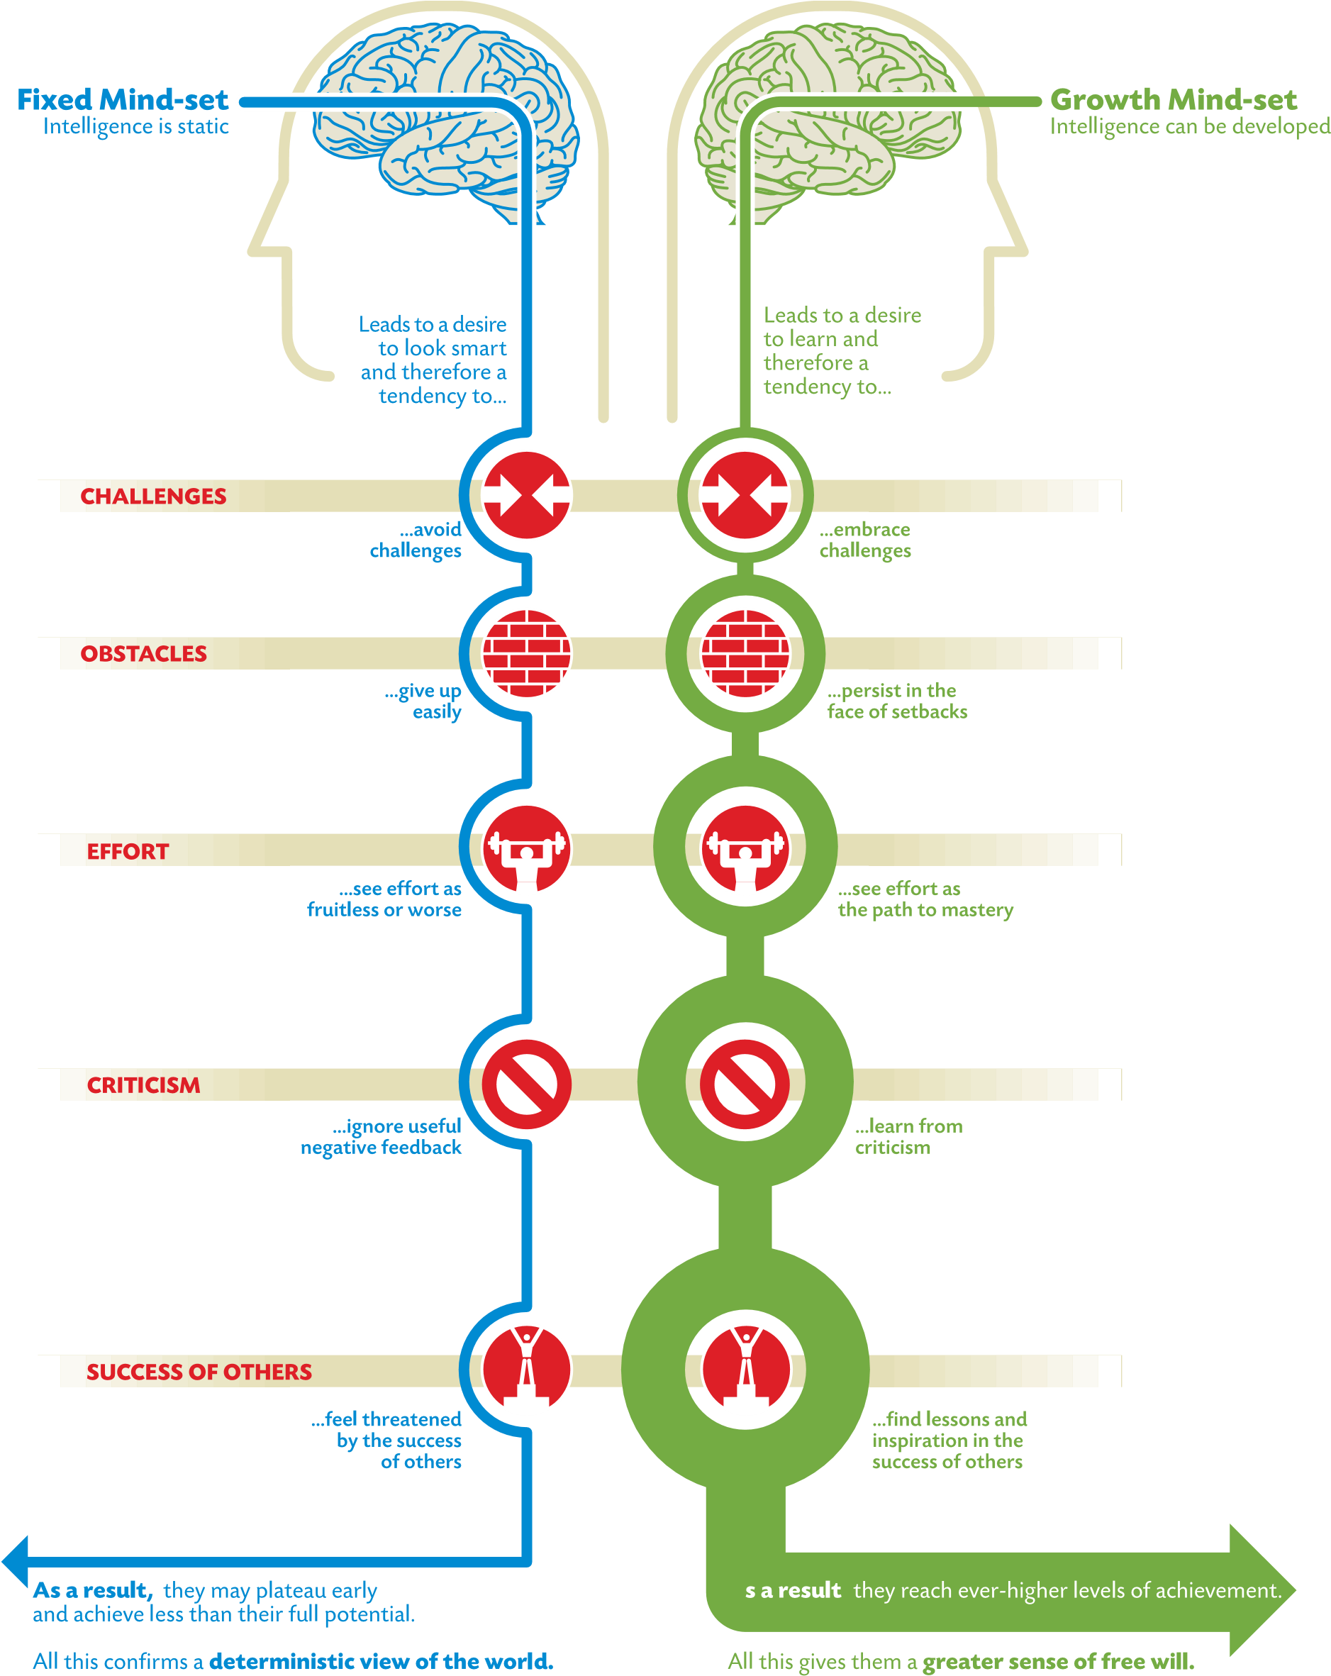
GRAPHIC BY NIGEL HOLMES

SCHOOL INFORMATION…………………………………….

How to contact the school:

Clyde Valley High School,
Castlehill Road,
Wishaw.
ML2 0LB

Tel: 01698 274950

E-mail: enquiries-at-clydevalley@northlan.org.uk

Web: www.clydevalleyhighschool.org.uk

Follow us on Twitter: @ClydeValleyHS

Clyde Valley High School is a six year co-educational and non-denominational comprehensive school with a capacity of 903.

The current roll is 841: S1 205 S2 159 S3 178

S4 137 S5 101 S6 61

January 2016 saw the completion of the new Clyde Valley Campus that sees Clyde Valley High School share facilities with Orchard primary school.

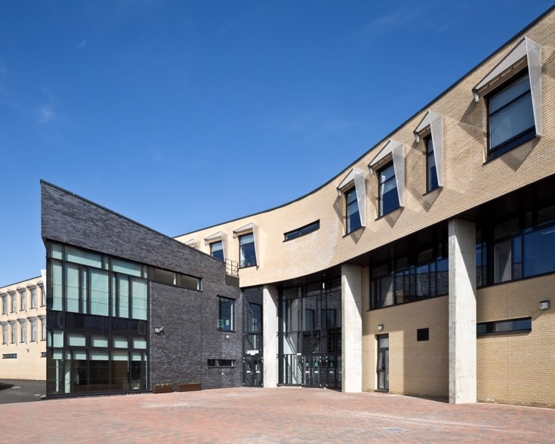
The buildings are a striking example of modern 21st century architecture and occupy a beautiful green-field site on the outskirts of Wishaw adjacent to the valley of the River Clyde.
The building is formed over three floors comprising a well-stocked Library Resource Centre (incorporating a computer suite and an S6 study area), a recording studio, photography studio and together with a variety of well-equipped classrooms, provides ideal teaching and learning facilities. Purpose-built computer suites support the delivery of ICT, Music, Graphics and Art.

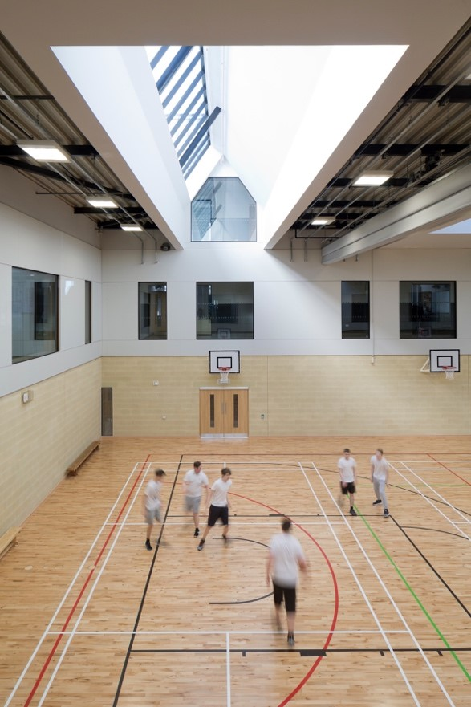
Facilities in the Physical Education Department are excellent. The PE Department has the use of a multipurpose Games Hall which can be divided to form three Gymnasia, together with a fully equipped fitness room. The extensive playing fields accommodate a full-size synthetic 4G football park with floodlighting and a smaller synthetic hockey/five a side football park, also with floodlighting. A large flat grass area can also be used for hockey, rugby and athletics.

The teaching of Home Economics and Science is carried out on the top floor of the building above the primary school. Laboratories and classrooms provide pupils with every opportunity to develop their skills in science and nutrition.

The Technology Department has a specialist suite of 20 PCs, all equipped with industry-standard design software. The ICT Department has 3 suites of PCs. The entire campus benefits from integrated super-fast Wi-Fi.

In partnership with New College Lanarkshire the school facilitates courses in Construction, Early Years Child Care and Hairdressing.

The school is equipped to support young people with disabilities for example lifts and special toilet accommodation. The school has a Sport Scotland Gold status and became a community sports Hub in 2017.

SCHOOL Day………………………………………………………………………………………

Monday - Thursday Friday
Period 1 | 08.55 – 09.45 |  | Period 1 | 08.55 – 09.45
Period 2 | 09.45 – 10.35 |  | Period 2 | 09.45 – 10.35
Interval | 10.35 – 10.50 |  | Interval | 10.35 – 10.50
Period 3 | 10.50 – 11.40 |  | Period 3 | 10.50 – 11.40
Period 4 | 11.40 – 12.30 |  | Period 4 | 11.40 – 12.30
Lunch | 12.30 – 13.15
Period 5 | 13.15 – 14.05
Period 6 | 14.05 – 14.55
Period 7 | 14.55 – 15.45

Parents are asked to ensure that pupils are not late for school. Late-coming is not simply a minor inconvenience. It seriously disrupts the work of classes. Every effort will be made, with parental cooperation, to encourage pupils to be punctual.

THE SCHOOL YEAR - SESSION 2021/2022 …………………………………………................
The Education Committee has agreed the school calendar and holiday arrangements for session 2021/2022. These arrangements apply to pupils and teaching staff.

August 2021
In-service day: Thursday 12 August, In-service day: Friday 13 August.
Pupils return to school: Monday 16 August

September 2021
September weekend: Friday 24 September- Monday 27 September

October 20201
October break: Monday 11 October to Friday 15 October

November 2021
In-service day: Monday 15 November

December 2021 – January 2022
Christmas holiday: Thursday 23 December- Friday 7 January (inclusive)

February 2022
Mid-term break: Monday 14 February-Tuesday 15 February,
In-service Day: Wednesday 16 February

April 2022
Spring break: Friday 1 April - Monday 18 April (inclusive)

May 2022
May Day holiday: Monday 2 May, In-service day: Tuesday 3 May,
May weekend holiday: Friday 27 May and Monday 30 May

June 2022 School closes: Wednesday 29th @ 1pm
STAFF 2021/2022………………………………………………………...

Head Teacher – Mr N. Quail.

The Depute Head Teachers have particular responsibilities as noted below:

Mrs Y McKenna, Improvement in children and young people’s health and wellbeing, Ensuring Wellbeing, Equality and Inclusion, Houldsworth House, Inclusion Team, Primary transitions, S1-S3 Curriculum (BGE), Parental Engagement, Parents Evening (S1-S3), School Fund, Inclusion Base/staff, Equal Opportunities, Partnership, Safeguarding

Mr V Lanagan, Improvement in employability skills and sustained, positive school leaver destinations for all young people, Learning, teaching and assessment, Curran House, Teaching & Learning, DYW, S4-S6 Curriculum, EMA/Focus West/UCAS, Parents Evening (S4-S6), Senior Options, Probationers/Student, SQA Exams & Admin.

Mrs C McNaughton, Raising Attainment & Achievement, Sneddon House, CLPL Programme, Performance Information Wider Achievement, Absence Cover, Timetable, CVHS Campus.

Mr C. Glover, Pupil Equity Fund

Acting DHT Mr C. McDonald, Digital Learning, Self-Evaluation, Staff Development, ICT/Website/Twitter, GLOW, Transport, Prize Giving awards, OSHL/Easter School, HASAW.

Each member contributes to the operation of the Senior Leadership Team whose prime concern will be the effective management of the school for the benefit of pupils and staff. Our main priority is the educational and social development of our pupils and we shall encourage them to have a positive attitude towards themselves and the school.
General Responsibilities.

Each member of the Senior Leadership Team is expected to:

- Contribute to the formulation of school aims and policies.
- Engage in whole school development planning.
- Promote effective two-way communication with parents, pupils, staff, the Authority, external agencies and the local community.
- Ensure that resources, physical, financial and human, are managed efficiently to promote effective teaching and learning.
- Work with all staff, teaching and non-teaching, to develop an ethos in which effective teaching and learning can prosper.
- Ensure that administrative procedures are effective and contribute to the efficient management and organisation of the school.
- Contribute to the supervisory duties of the Senior Leadership Team.

2021/2022 DEPARTMENT FACILTIES
Claire Ferrie | ENGLISH/FRENCH | LANGUAGES P.T.
Vincent Lanagan | ENGLISH | LANGUAGES D.H.T.
Rachel Carroll | ENGLISH | LANGUAGES P.T. PEF
Rachel Clements | ENGLISH | LANGUAGES
Gemma Close | ENGLISH | LANGUAGES
Louise Smith | ENGLISH | LANGUAGES 0.6
Heather Donaldson | ENGLISH | LANGUAGES
Max Ellis | ENGLISH | LANGUAGES
Joanne Bateman | ENGLISH/SFL | SUPPORT FOR LEARNING & INCLUSION
Yvonne McKenna | MODERN LANGUAGES | LANGUAGES D.H.T.
Helen Whitelaw | MODERN LANGUAGES | LANGUAGES P.T.PEF
Cathy Black | MODERN LANGUAGES | LANGUAGES
Adriana Jacobo Martos | MODERN LANGUAGES | LANGUAGES
Alistair Russell | MATHS | NUMERACY ACTING P.T.
John Fitzpatrick | MATHS | NUMERACY
Christina Hanlon | MATHS | NUMERACY
Elaine Jopling | MATHS | NUMERACY P.T.PEF
David Farrell | MATHS | NUMERACY
Leanne Lennox | MATHS | NUMERACY
Nicole Kerr | MATHS | NUMERACY PROBATINER
Grant McNaughton | MATHS | NUMERACY
May Mackenzie | SOCIAL SUBJECTS | HUMANITIES P.T.
Lynsay Ashton | SOCIAL SUBJECTS | HUMANITIES P.T. PEF
Nikki Heeps | SOCIAL SUBJECTS | HUMANITIES
Greg Hamilton | SOCIAL SUBJECTS | HUMANITIES
Paul Warnock | SOCIAL SUBJECTS | HUMANITIES PROBATIONER
Robert Mckie | SOCIAL SUBJECTS | HUMANITIES
John Ferrie | RE | HUMANITIES P.T.P.I.
Craig Mcdonald | TECHNICAL | TECHNOLOGIES P.T.
Colin Glover | TECHNICAL | TECHNOLOGIES D.H.T. P.E.F.
Pamela Ferry | TECHNICAL | TECHNOLOGIES P.T.P.I.
Graeme Brown | TECHNICAL | TECHNOLOGIES
Gillian Davidson | TECHNICAL | TECHNOLOGIES PROBATIONER
Caroline Ashmore | BUSINESS & ICT | TECHNOLOGIES
Stephen Conway | COMPUTING | TECHNOLOGIES
Craig Thomson | COMPUTING | TECHNOLOGIES
Jen Brown | PE | HEALTH & WELLBEING ACTING P.T.
Renee McNaughton | PE | HEALTH & WELLBEING D.H.T.
David Somerville | PE | HEALTH & WELLBEING P.T.P.I
Graham Lang | PE | HEALTH & WELLBEING P.T.F.F.
Sophie Morrison | PE | HEALTH & WELLBEING P.T.PEF
Dorothea McInness | PE | HEALTH & WELLBEING
Lisa Thomson | HE | HEALTH & WELLBEING P.T. PEF
Louise Barrett | HE | HEALTH & WELLBEING
AnneTraynor | MUSIC | EXPRESSIVE ARTS P.T.
Clare Brown | MUSIC | EXPRESSIVE ARTS P.T.P.I.
Stefanie Chalmers | MUSIC | EXPRESSIVE ARTS P.T. PEF
Debbie Taylor | MUSIC | EXPRESSIVE ARTS
Valerie Livingston | DRAMA | EXPRESSIVE ARTS 0.6
Sarah Fallon | DRAMA | EXPRESSIVE ARTS PROBATIONER
Wendy Mckenna | ART | EXPRESSIVE ARTS
Lynsay Gibson | ART | EXPRESSIVE ARTS
Julie Menzies | ART | EXPRESSIVE ARTS 0.4
Shona Kumar | ART | EXPRESSIVE ARTS 0.6 P.T.PEF
Colin Wright | SCIENCE | SCIENCE P.T.
Nicholas Quinn | SCIENCE | SCIENCE
Jimmy Burns | SCIENCE | SCIENCE
David Gavin | SCIENCE | SCIENCE
Anushi Pathmanathan | SCIENCE | SCIENCE
Christina Smith | SCIENCE | SCIENCE 0.6
Emma Harris | SCIENCE | SCIENCE
Mark Gallagher | SCIENCE | SCIENCE
Jack Inglis | SCIENCE | SCIENCE
Andrew Keating | SUPPORT FOR LEARNING | P.T.P.I.

SUPPORT STAFF …………………………………………………………………………

OFFICE STAFF: Mrs McMullen AFA
Mrs S. Hamilton Office Manager
Mrs A Dougal
Mrs P Graham
Mrs A Wright

ASN Assistant: Mrs L Falconer
Mrs C McLeod
Mrs D McKenna
Mrs M Russell

JANITORS: Mr S Jeffrey
Mr C McNicol

TECHNICIANS: Mrs M McKee
Mr J Bajgar
Mr A Martin

PARTNERSHIP OFFICER: Ms E Craig Wednesday - Friday

LIBRARIAN: Ms G Jenks

KITCHEN SUPERVISOR: Mr D Muir

CLEANING SUPERVISOR: Mrs A Clark

SUPPORT FOR INCLUSION.………………………

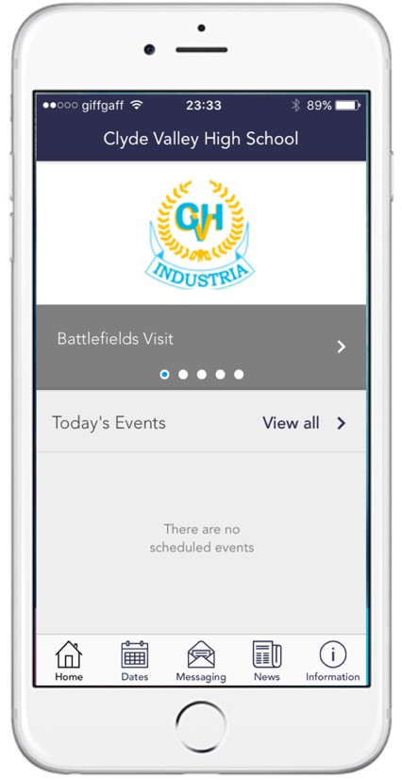
The Pupil Inclusion structure was established to look after the curricular, personal and vocational interests of all the pupils in school. The Pupil Inclusion structure in Clyde Valley High School comprises three houses.

CURRAN HOUSE
Mr D Somerville P.T.

HOULDSWORTH HOUSE
Ms C Brown P.T.

SNEDDON HOUSE
Miss P Ferry P.T.

- To help the Pupil Support teachers to fulfil their role they will individually interview each pupil on a regular basis
- be the main school contacts with the home
- provide reports to parents on the progress of their child
- help pupils and parents with important educational decisions
e.g. personalisation of choice in S2.

It is important that parents should feel free to contact the Pupil Inclusion teacher regarding their child. They may do so by arranging an appointment which avoids interrupting the teacher’s class commitment.
To augment the work of the Pupil Inclusion Teachers, a programme of Personal, Social and Health Education is organised and run within the school timetable. The Pupil Inclusion Teachers co-ordinate the keeping of academic and social records. They organise social activities both in and out of school. They also maintain regular contact with the various caring agencies:

Social Work Department
North Lanarkshire Psychological Services
Community Support Services
Community Policing, Police Scotland
Lanarkshire Health Board
Medical Officer
Network Support Team Language Support Unit
Inclusion Support

As part of the programme of PSHE provided for each individual, S.D.S supports the school with an excellent back-up service. A programme of careers guidance is undertaken in class from S1 to S6 and is designed to meet the needs of the youngster at each stage. S.D.S Adviser talks to groups/classes in S2, S3 and S4 to help them with such matters as subject choice. Individual interviews are given for pupils in S4, S5 and S6. Skills Development Scotland provide Further and Higher Education displays/conventions/counselling to which our pupils are invited. Our S4, S5 and S6 students are given the opportunity to attend numerous ‘Open Days’ and ‘Consultation Meetings’ at Colleges and Universities.

ENROLMENT …………………………………………………………….

In the case of Primary – Secondary transfer parents are issued with information by their child’s primary school, usually in December of the transfer year, and asked to indicate the secondary school of their choice. This information is then forwarded to the Education Department who contact Clyde Valley High School sometime in April with a list of our new intake. In the case of a placing request as soon as the school is made aware of the pupils transferring you will receive a letter from the school telling you of the two day visit and the parents’ evening which follows. This will either come to your home or be sent via your child’s primary school. Usually, it will be just after the Easter holiday period.
Within the school, Primary – Secondary transfer is organised by Mrs McKenna, Depute Head Teacher. For all other enrolments, parents should arrange an appointment with the Mr Lanagan, Depute Head Teacher. It is helpful to bring details of the pupil’s address, previous school record and subjects being studied are brought to the meeting.

CHILD PROTECTION…………………………………………………………..

Every adult in Scotland has a role in ensuring all our children and young people are safe and protected from harm at all times and in all situations.

The Head Teacher is responsible for the schools’ actions in response to Child Protection concerns.

If there are any Child Protection concerns the Headteacher or the Child Protection Co-ordinator will follow North Lanarkshire Child Protection Procedures and Guidelines.

The Council has responsibility under the Adult Support and Protection (Scotland) Act 2007 for the protection and support of adults at risk of harm within North Lanarkshire. Its employees therefore have the responsibility to ensure the welfare of all adults at risk of harm with whom they come into contact, as well as providing the highest possible standard of care for some of the most vulnerable members of our society. If there are any Adult Protection concerns the Head Teacher or the Adult Protection Co-ordinator will follow North Lanarkshire Adult Protection Procedures and Guidelines

Child/Adult Protection Co-ordinator is Mrs Y McKenna
Telephone number: 01698 274950

LEARNING SUPPORT………………………………………………………….

Learning Support is concerned with assisting in the learning and teaching process on behalf of a wide range of pupils. Pupils differ in their pace of learning and, when these differences become extreme, the Learning Support Department becomes involved. Such specialist assistance has an important and wider contribution to make too. This could involve working co-operatively with teachers in their classrooms, advising teachers, and assisting in curricular development. In this way the needs of all children can be more closely matched.

The Learning Support Department encourages parents to become involved in their children’s learning in an active way. Parents are encouraged to visit the school to discuss these matters and seek advice. It may be that there should be an agreed and individualised programme of work which the pupil should follow, or it may be that advice and support in day-to-day subject work is needed.

ADVICE TO PARENTS
- Children learn by listening, thinking, talking, reading, writing and doing.
- In talking, a child may well be searching for his or her own meaning. Encourage your child to explain things and to talk things out. Ask questions if the explanation does not make sense.
- One of the most important things which you can give your child is time.
- Give your child time to explain, to describe and to think aloud.
- Try to find time to follow up your child’s interest.

ASSISTANCE FOR PUPILS
- A Learning Support Teacher might go into a subject class to support pupils, alongside the subject teacher.
- Two subject teachers might also work like this to support pupils who experience difficulties in their day-to-day work. This team approach is the main kind of help provided.
- A pupil might be given individual teaching by a Learning Support Teacher.
- Parents may be invited to participate in the Home Reading or Structured Spelling programme. Both actively involve parents in their children’s learning.

For more information contact Mrs Y McKenna, DHT, Telephone 01698 274950

ADDITIONAL SUPPORT NEEDS
Staged intervention is a process which is used to identify, assess and support the learning needs of the pupils in our school. It provides:
- A record of intervention and achievement for individual children as they progress through school.
- An inclusive approach which involves parents, pupils, relevant staff and support services.
- Agreed learning and support plans which record the needs of individual pupils and the strategies used to meet those needs.
- A solution focused approach to resolving issues early and at the least level of intrusive intervention.
- A structured monitoring and review cycle.

Clyde Valley High School complies with the Additional Support for Learning (Scotland) Act 2004 as amended by the Additional Support for Learning (Scotland) Act 2009 and the Additional Support for Learning: Statutory Guidance 2017.

North Lanarkshire Council Policy is contained within “Support for Learning Policy into Practice 2”, a copy of which is available in the school. The school has a Support for Learning Policy, available from the school on request, which is consistent with North Lanarkshire Council guidelines.

Pupils are identified as having Additional Support Needs through the assessment processes described below and either via transition information from primary/ previous school or via a referral to the school’s multi-agency meetings. Referrals to the multi-agency meetings will either be made by a DHT following a weekly House meeting. Looked after children i.e. children who are cared for directly or whose care is supervised by the Local Authority are deemed to have Additional Support Needs unless assessment determines otherwise.

Level 1 - A pupil is identified as having additional support needs. Looked After Children are deemed to have Additional Support Needs unless assessment determines otherwise.
Following appropriate evaluation processes, it is agreed that these needs can be met within the resources of the classroom, for example, differentiation or a particular teaching style. The class teacher, liaising closely with the Pupil Support Team will plan for, monitor and provide evidence of this intervention.

Level 2 - A pupil is identified as having additional support needs.
Following appropriate evaluation processes, it is agreed that these needs can be met within the resources of the school, using interventions which are not normally found in the classroom, for example, support for learning teacher, behaviour support groups, ASN Assistant, HSPO, Youth Counsellor, School Nurse, special equipment or resources.
The class teacher or member of the Pupil Inclusion Team, in consultation with others, will plan for, monitor and provide evidence for this intervention. In some cases, these interventions are intensive, and enduring and essential to allow access to the curriculum and in some cases, the curriculum needs to be elaborated, reinforced, or extended in some way. In S1 & S2, additional support for literacy and numeracy is provided in the Learning Support Department for certain pupils who are withdrawn from Modern Languages. An additional support plan (ASP) will be written in these circumstances. This plan is drawn up by a designated teacher (PT Pupil Support or PT Learning Support), who will also write or co-ordinate any long-term and short-term targets that are agreed. The DHT (Pupil Inclusion) will have an overview of these.

Level 3 - At this stage other services within education but out with the school are involved in the pupil’s plan, for example, Sensory Support services, Psychological Services, Behaviour Support Teams, Bilingual Support and the Support & Microtechnology Team. In most cases at this level, an Additional Support Plan will be drawn up by a designated teacher who will also write or co-ordinate the long-term and short-term targets. The DHT (Pupil Inclusion) will have an overview of these.

Level 4 - At this stage it is recognised that a young person may require additional support from services out with education, for example, Speech & Language Therapy, Social Work, Occupational Therapy. Parents and pupils are an essential part of the assessment, planning and review processes and your views will be actively sought. Parents and young people can request of the authority to establish whether a child has additional support needs. They can also request an assessment at any time.

PLANNING ……………………………………………………………………………………………………

Getting it Right for Me (GIRFMe) plans enable staff to plan effectively for children and young people when interventions are requires supporting their learning a improve outcomes. Parents/carers and pupils are an essential part of the assessment; planning and review processes and their views will be actively sought.

Some children and young people may require significant support from education and at least one other agency, such as health, social work and/or voluntary agency to help them meet their learning targets. Where this support requires a high level or co-ordination the opening of a Co-ordinated Support Plan (CSP) may be considered. A CSP may be initiated by the school or another agency. Parents/carers and young people can, if they wish, request that a CSP be considered and would be involved in the process.

Parents/carers will receive letters from the Education Authority throughout the CSP process. Parents/carers and young people will be invited to take part in multiagency meetings and their views will be recorded in the plan.

Where more intensive support for a child or young person needs to be planned for, usually when a number of agencies are involved in supporting their wellbeing then a Child’s Plan may be developed. The plan will tell you what actions need to be taken and who will help with each action. It will usually be someone called a ‘Lead Professional’ who will have the job of making sure that the actions outlined in the plan take place and things get better for the child or young person.

DISPUTE RESOLUTION…………………………………………………………….………………………

North Lanarkshire Council is committed to resolving any differences of views through discussion, dialogue and building on common ground.

If the matter cannot be resolved with the Education Authority you have the right to request mediation. An independent mediation service is available to parents and young people through Resolve (see contact details at the back of this handbook). Mediation is free and independent of the Education Authority.

In the event that a disagreement cannot be resolved through mediation, then an application for Independent Adjudication (see contact details at the back of this handbook) can be made by parents free of charge. The Independent Adjudicator will make recommendations to the Education Authority about how the dispute should be resolved.

The Additional Support Needs Tribunal has been set up to hear appeals made by parents/carers or young people on the decisions made by the Education Authority relating to Co- ordinated Support Plans, placing requests and post school transition. If you disagree with any decision
relating to your child’s Co-ordinated Support Plan, either the creation of a CSP, or the content of it, you may be entitled to refer to the Tribunal.

SCHOOL DRESS CODE……………………………………………………….

All pupils in Clyde Valley High School must come to school dressed according to our Dress Code. The Dress Code carries the full support of the Parent Council.

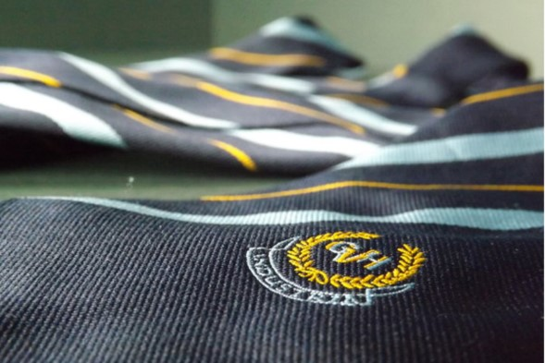
We have ensured that pupils can choose from a range of attractive and comfortable garments. We believe that having our pupils dressed fully in uniform has many positive effects on the life of the school by:

¨ Creating an atmosphere that encourages learning
¨ Developing a sense of community
¨ Removing unhealthy competition between pupils
¨ Helping security – possible intruders can be easily spotted.

The School colours are navy, gold, pale blue and white.

The school’s dress code for all pupils is:

¨ A navy blazer, complete with an embroidered school crest.
¨ A white shirt with school tie.
¨ Black trousers or skirt.
¨ Appropriate plain black footwear preferably shoes, or black trainers, only.

Pupils will be allowed to wear plain black, navy or grey sweaters and cardigans.

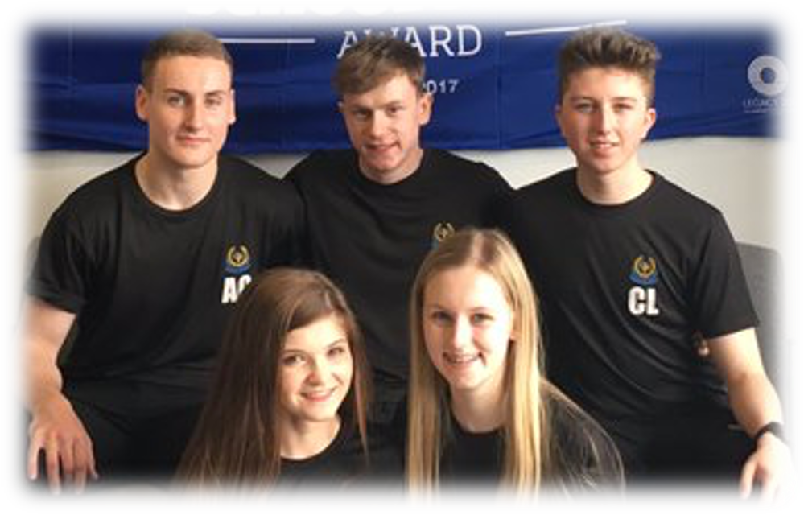
For Physical Education pupils are asked to wear dark shorts and a black (T-shirt) with embroidered school logo for indoor activities, the T-shirt costs £7 and are available from the school office. For outdoor work, pupils can also wear a black Hoodie with embroidered school logo, the Hoodie costs £12 and is also available from the school office. Water Bottles can also be purchased from the school Office for £3. Football strips associated with any team are not acceptable. Trainers are regarded as acceptable footwear.

In doors, once outdoor clothing has been removed, pupils must be wearing the school blazer.
Shell suits, tracksuits, jogging bottoms and jeans must not be worn.

SCHOOL DRESS CODE - NORTH LANARKSHIRE POLICY…………….

All North Lanarkshire schools have a dress code which encourages pupils to dress in a way which is appropriate to attendance at school. This dress code must not lead to direct or indirect discrimination on the grounds of race, religion, gender or disability. Prior to drawing up the dress code, the parents, pupils and staff were fully consulted. It is the expectation of Learning and Leisure Services that parents will be keen to support the dress code and written agreement may be sought.

Clothing which is unacceptable in school under any circumstances. Includes items which:

¨ could potentially, encourage factions (e.g. football colours)

¨ could cause offence (e.g. anti-religious symbolism or political slogans)

¨ could cause health and safety difficulties such as loose fitting clothing, dangling earrings and other potentially dangerous jewellery

¨ are of flammable materials which may be a danger in certain classes (e.g. shell suits)

¨ could cause damage to flooring

¨ carry advertising, particularly for alcohol or tobacco

¨ could be used to inflict damage on other pupils or to be used by others to do so

Parents in receipt of a clothing grant from the Council will be encouraged to purchase items which are in accordance with the school dress code. Approval of any requests for such grants in other circumstances is at the discretion of the Executive Director of Learning and Leisure Services. Information and application forms may be obtained from any school or First Stop Shop.

Parents are entitled to receive a clothing grant if they are in receipt of any of the following benefits: income support, job seeker’s allowance (income based), Employment and Support Allowance (income based), housing benefit, council tax rebate.

Whilst in general terms it would not normally be the policy of the authority to exclude a pupil from school solely on the basis of his/her dress persistent refusal to respond to a reasonable dress code might be deemed to be a serious challenge to the Head Teacher’s authority and be detrimental to the wellbeing of the whole school community. In such circumstances a Head Teacher could justify the use of the school discipline procedure.

The Council wishes to minimise claims arising from the loss of pupils’ clothing and/or personal belongings. Parents/Guardians are asked to assist in this area by ensuring that valuable items and unnecessarily expensive items of clothing are not brought to school. Parents should note that any claims submitted to cover the loss of such things are likely to be met only where the authority can be shown to have been negligent.

CURRICULUM FOR EXCELLENCE……………………….……………………

What is Curriculum for Excellence?
Curriculum for Excellence is Scotland’s national curriculum. It provides a coherent and inclusive curriculum from 3-18 years wherever learning is taking place, including early learning childhood centres, schools, colleges and community learning. It places children and young people at the heart of Scottish Education.

All schools and nurseries in North Lanarkshire are working hard to raise standards so that children and young people will develop all of the skills necessary to continue to be successful when leaving school and entering the world of higher education, training or work. Curriculum for Excellence is underpinned by the values inscribed on the mace of the Scottish Parliament – wisdom, justice, compassion and integrity.

The purpose of Curriculum for Excellence is encapsulated in the four capacities – to enable each child or young person to be a successful learner, a confident individual, a responsible citizen and an effective contributor. These four capacities govern the entire curriculum from age 3 to 18 and aim to raise the standards of achievement for all learners.

What are the curriculum areas in Curriculum for Excellence?
There are eight curriculum areas:-
Expressive Arts | Religious and Moral Education
Health and Well Being | Sciences
Languages (literacy) | Social Studies
Mathematics (numeracy) | Technologies

Importantly, literacy and numeracy are given added importance because these skills are so vital in everyday life. All teachers will have responsibility to teach literacy and numeracy. Learning is divided into two phases.

The Broad General Education (BGE) is from nursery to the end of Secondary School Year 3.
Learning is divided into levels:
The levels are as follow:

LEVEL |  | STAGE
Early |  | the pre-school years and P1 or later for some
First |  | to the end of P4 but earlier or later for some
Second |  | to the end of P7, but earlier or later for some
Third and fourth |  | S1-S3, but earlier for some
Senior Phase |  | S4 – S6 and college or other means of study

How will my child’s learning be assessed?

There will be new ways of assessing each child’s progress to make sure that potential is achieved.
National 4 and 5 qualifications were introduced in 2013/2014. Access, Highers and Advanced Highers have been updated to reflect Curriculum for Excellence. New Highers in most subjects were introduced in almost all North Lanarkshire schools in August 2014.
In playrooms and classrooms staff will be using improved ways of assessing children’s learning taking account of national and local advice and guidance. Your child’s progress will be reported to you so that you know how well your child is doing. Each year your nursery/school will let you know what is being done to implement Curriculum for Excellence so that you can be confident that your child is receiving a high-quality education.

In Clyde Valley there will be a greater focus on projects between departments - inter disciplinary learning. There will also be occasions when normal timetable will be suspended to allow all pupils to come together for a learning activity, like our ‘Celebration of Scotland’.
Curriculum for Excellence will encourage our pupils to play a more active part in classroom work, including helping to evaluate their own work and that of their fellow pupils.

BROAD GENERAL EDUCATION (S1-S3) ……………………………….

In their first and second years, pupils follow a common course:
English |  | Mathematics
History |  | Geography
Modern Studies |  | French & Spanish
Science |  | Home Economics
Technical Education |  | Physical Education
Art & Design |  | Music
Social Education |  | Religious & Moral Education

Pupils are normally taught in mixed-ability classes - classes containing pupils with a wide range of abilities and aptitudes. Teaching methods are varied, and include individualised learning, group work and class teaching. Class periods are 50 minutes each and normally the same teacher takes pupils for the whole of their time in each subject.

In some subjects co-operative teaching takes place. This means that the class teacher is assisted by another teacher, usually in the same classroom, in order to provide additional help for pupils. Pupils have access to their Pupil Support teacher who is ready to provide necessary advice or assistance.

In their second-year pupils continue the studies undertaken in the first year. During second year, pupils may be broadly grouped according to ability in some subjects.

THE SENIOR PHASE…………………………………………………………...

The following subjects are normally on offer:

English Administration | History
Mathematics Computer Studies | Geography
Travel & Tourism Hospitality | Cake Craft
PE Studies Modern Studies | Human Biology
Art & Design Graphic Communication | Chemistry
French Drama | Physics
Spanish Woodworking Skills | Business Administration
Design and Manufacture Music | Home Economics
Leadership Media Technology

Pupils who are currently in S4 follow most courses at National 4 or National 5 level. Pupils follow courses from the following seven modes, or areas, of study: English and other languages; Mathematics; Science (Biology, Chemistry or Physics); Social Subjects (History, Geography, Modern Studies); Creative and Aesthetic Studies (Art, Music, etc.); Technological Studies
(Computing, Craft and Design, etc.); Physical Activity and Leisure; and Religious and Moral Studies.

A number of vocational courses are also offered. These are delivered in school, by staff from New College Lanarkshire. Vocational courses which have been offered include child care, make up artistry and hairdressing. The provision of vocational education is subject to change.
North Lanarkshire Council has authorised schools to offer curricular structures they feel are best suited to the needs of their pupils. However, in Clyde Valley High School we always advise that pupils endeavour to choose a broad range of subjects. In compiling their courses, therefore, pupils have a wide choice of subjects, with some discretion about the time they wish to spend in each area of study. Specific advice is given to parents and pupils on this.
In addition, all pupils in S4 are offered the opportunity of a work experience placement. The school will endeavour to provide full progression routes from courses in S4 into the senior school.

Supporting all children to realise their full potential

Supporting all children to realise their full potential forms the overarching strategy for the service. This strategy aims to harness the combined forces of Education & Families to provide a rich set of learning opportunities and experiences for young people and adults which begin in the classroom, nursery or learning centre and extend out into the community and the wider world beyond.

THE WIDER CURRICULUM ……………………………………………………………….

The school has a very active and informal curriculum with a wide variety of sports activities and clubs in the school, involving large numbers of pupils and staff. Many members of staff and senior pupils are involved in the local community life, and the school actively encourages pupils to take advantage of the services provided by the many local organisations which exist.

Details of these activities are announced via daily Tannoy, at assemblies, promoted in departments and at House Time and are indicated on school noticeboards. Pupils are warmly invited to take part in these activities.

Extra-curricular activities are a vital constituent element in the personal and social development of young people and parents are asked to encourage their children to participate in events after school. Pupils requiring special transport arrangements are asked to inform the staff who are in charge of the after-school activities. Transport should not be seen as a problem for pupils joining extracurricular clubs.

CELEBRATING SUCCESS ……………………………………………………

As a school, we try to keep parents and the local community informed about what is happening in the school.
This means we use the local press regularly and produce our own publications like this handbook and our Yearbook. We are developing and updating our own website. Very importantly, we also like to celebrate the successes of our pupils by giving them public recognition in these ways. We always try to include photographs whenever possible. Parents have always commented very favourably on our efforts to recognise the work of our pupils, and the school generally. If, however, you would prefer your child not to be included by name, or to have his/her photograph appear in any of these features, we would, of course, respect your wishes.
Please simply inform us at the school if you would prefer your child not to be included in our publications
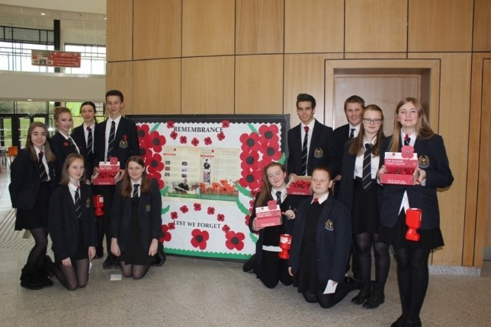
HOME SCHOOL COMMUNITY PARTNERSHIP……………………………

Working in partnership with Community Learning and Development Section, Clyde Valley has a Partnership Officer appointed to the school.

The Partnership Officer works alongside teaching staff, parents and pupils to provide support and purposeful learning opportunities out with the traditional classroom setting.

A broad and diverse range of learning programmes and activities have been designed and selected to enable all participants from S1-S6 to achieve their potential. These include courses in: confidence building, anger management, making positive life choices, working with others, peer learning, developing citizenship skills and improving motivation levels – all with a focus on celebrating success.

Pupils involved in these areas have had their work recognised and celebrated both locally and nationally, through award schemes such as Saltire Awards, at national education conferences and within national teaching and learning publications. All work is designed to improve teamwork, communication and raise confidence levels.

The work of the Partnership Officer extends to the home and families of our pupils, and individual and group work support is available to parents. Courses and learning programmes offered within Clyde Valley have included: Parenting Skills, Healthy Lifestyles, Handling Stress and Computing for Beginners.

TRANSPORT…………………………………………………………

The Council has a policy of providing free transport to secondary pupils who live more than two miles from their local school by the shortest suitable walking route. This policy has been more generous than the law requires. This provision may be reviewed at any time. Parents who consider they are eligible should obtain an application form from the school or from Education & Families Services.

These forms should be completed and returned before the end of February for those pupils beginning the school in August to enable the appropriate arrangements to be made. Applications may be submitted throughout the year but may be subject to delay whilst arrangements are being made.

There is discretion in certain circumstances to grant privilege transport for pupils to travel in transport provided by the Authority, where spare places are available and no additional costs are incurred.

Where free transport is provided it may be necessary for pupils to walk a certain distance to the vehicle pick-up point. Walking distance in total, including the distance from home to the pick-up point and from the drop-off point to the school in any one direction, will not exceed the Authority’s limits (see above paragraph).

It is the parent/carer’s responsibility to ensure their child arrives at the pickup point on time. It is also the parent/carer’s responsibility to ensure the child behaves in a safe and acceptable manner while boarding, travelling in and alighting from the vehicle.

Misbehaviour could result in a loss of the right to free transport.

PLACING REQUESTS
The Council does not provide transport for those pupils in receipt of a placing request other than in exceptional circumstances.

CONSORTIUM ARRANGEMENTS
Transport arrangements are made for pupils travelling to New College Lanarkshire or to other schools in the local area.

SUPERVISION
An adult presence is provided in playgrounds at break times in terms of the school (Safety and Supervision of Pupils) (Scotland) Regulations 1990.

ADVERSE CONDITIONS
We make every effort to maintain a full educational service, but on some occasions circumstances arise which lead to disruption. For example, schools may be affected by severe weather, temporary interruption of transport, power failures or difficulties of fuel supply. In such cases we shall do all we can to let you know about the details of closure or re-opening. We shall keep you informed by using letters, notices in local shops and community centres, announcements in local churches and in the press, on local radio, on the NLC website and on Twitter.

FREEDOM OF INFORMATION ……………………………………………………………

Freedom of Information (Scotland) Act 2002 came into force in 2005. The Act allows anyone to ask for information held by the Council and imposes a time-scale of 20 working days for the Council to respond. To deal with Freedom of Information requests, the Council has appointed a Corporate Freedom of Information Officer with the support of an officer in each Service. The Freedom of
Information Coordinator can be contacted by telephone on 01698 302484

General Data Protection Regulations (GDPR) Statement for Education

What is this statement?

This statement explains when and why we collect personal information about you, your child or young person and how this information is used, the conditions under which it may be disclosed to others and how it is kept secure.

Who are we?

North Lanarkshire Council is a Local Authority established under the Local Government etc. (Scotland) Act 1994. Education, and Families is located Civic Centre Motherwell ML1 1AB.

Why do we need your personal information and that of your child or young person?

The Council has a legal obligation to deliver an effective education service to all children and young people in North Lanarkshire. In order to do this we need to collect personal information about children, young people and their families so that we can help them to learn and keep them safe.

Legal basis for using your information

We provide this service as part of our statutory function as your Local Authority. Processing your personal information is necessary for the performance of a task carried out in the public interest by the Council. If the information we have asked for is not provided, then we will not be able to provide this service to your child or young person.

Your personal information

Education uses the national IT system, SEEMIS, to store personal information electronically. We ask parents/carers during registration and enrolment to provide us with their child’s name, date of birth, gender, address, family contact details (phone/email). We will also ask you to update this information annually.

We may also ask you for information about medical conditions, additional support needs, religion, and ethnicity. We may also record information you might wish to provide about your family circumstances.

We require this information to ensure children and young people are educated appropriately, supported, and that we take account of their health and wellbeing.

During a child’s journey through education a pupil’s record is kept, this core record is mainly paper based and is stored securely in the child or young person’s establishment. If the establishment has requested assistance from educational staff out with the nursery or school, key staff from these services may also store information securely about your child or young person.

How will we use this information?

Your personal information will be used:
- to enrol your child or young person in nursery or school
- to provide your child or young person with an appropriate education
- for teaching, assessment and planning purposes and to monitor educational progress of children and young people
- to support pupil learning, improve outcomes and identify where additional support is needed to help children and young people
- to provide appropriate pastoral care to support health and wellbeing of children and young people
- to keep children and young people safe
- to maintain records e.g. of attendance, absence, attainment and behaviour of children and young people (including exclusions)
- to support children and young people during transitions when moving on each year from nursery to primary, primary to secondary and when they move or leave school
- to enable schools and establishments to process personal data in support of SQA and Further Education
- to allow us to process Education Maintenance Allowance (EMA) applications
- to monitor and report on pupil attainment and achievement in relation to the national improvement framework issued by the Scottish Government
- to assure the quality of our education services in line with national expectations from Education Scotland
- when we require to contact you by post, email, telephone or text.

Who do we share information with?

To support your child or young person’s access to appropriate education and meet our legal obligations, personal information may be shared internally between Services of the Council. From time to time, education staff may also need to share information about you, your child or young person with another person from another agency or service, e.g. Social Work, Health.

We also share information with Scottish Government and bodies such as Education Scotland, Scottish Qualifications Authority, Skills Development Scotland and other organisations that support children and young people’s learning.

When a child or young person moves or transfers to another school the Council has an obligation to pass on information with regards to pupil records to the new school.

Only identified staff and those who require to have the information to enable them to carry out their job, will have access to you, your child or young person’s information. We care about the information we hold in respect to the education of children and young people. We will keep this information safe and secure.

How long do we keep your information for?
We only keep personal information for the minimum period of time necessary. Sometimes this is set out in law, but in most cases it is based on what we need to fulfil our function. We maintain a ‘records retention and disposal schedule’ which sets out how long we hold different types of information for. You can
View this on our website at http://www.northlanarkshire.gov.uk/index.aspx?articleid=15003 or you can request a hardcopy of this from: Education, and Families, Civic Centre, Motherwell ML1 1AB

Your rights under GDPR
You can:
- Request access to your information – you have the right to request a copy of the personal information that we hold about you, your child or young person. You can ask us to confirm what personal information is being used and with whom it has been shared with.
- Request a correction to your information – we want to make sure that all personal information is accurate, complete and up to date. Therefore you may ask us to correct any personal information that you believe does not meet these standards.
- Request the restriction of processing – this enables you to ask us to suspend the processing of personal information about you, your child or young person, for example if you want us to establish its accuracy or clarify the reason for processing it.
- Request the transfer – you can request the transfer of your information to another party.
- Deletion of your information – you have the right to ask us to delete personal information about you, your child or young person where:
- you think that we no longer need to hold the information for the purposes for which it was originally obtained
- you have a genuine objection to our use of personal information.
- Or use of personal information is contrary to law or our legal obligations.

If you wish to update any personal information, retrieve it, or have it removed from records please contact your child or young person’s head teacher or head of establishment in the first instance.

The Council’s Data Protection Officer

If you have any questions or are unhappy about the way that we use the personal information of your child, young person or yourself you can contact the Data Protection Officer:
Data Protection Officer (DPO)
Civic Centre,
Windmillhill Street,
Motherwell
ML1 1AB

The Information Commissioner
You also have the right to complain to the Information Commissioner about the way the Council has handled your rights, to enquire about any exercise of these rights or to complain about the way the Council has dealt with your rights (or any other aspect of data protection law).
Information Commissioner's Office,
45 Melville Street
Edinburgh
EH3 7HL
Transferring Educational Data about Pupils
Education Portfolio (SGEP) exchange data about pupils either on paper or electronically through the ScotXed programme.
The data collected and transferred covers areas such as date of birth, postcode, registration for freeschool meals, whether a pupil is looked after by his/her local authority, additional support needs including disability, attendance, absence and exclusions from school. Pupil names and addresses are collected by the school and the council but they are not passed to SGEP. The postcode is the only part of the address that is transferred. Data is held securely and no information on individual pupils can be published by SGEP
Providing national identity and ethnic background data is entirely voluntary. You can choose the ‘not disclosed’ option if you do not want to provide this data. However, we hope that the explanations contained in this message and on our website will help you understand the importance of providing the data.

Why do we need your data?
In order to make the best decisions about how to improve our education service, SGEP and education authorities need accurate, up-to-date data about our pupils. We are keen to help all our pupils do well in all aspects of school life and achieve better educational outcomes. Accurate and up-to-date data allows SGEP, education authorities and schools to:
- plan and deliver better policies for the benefit of all pupils,
- plan and deliver better policies for the benefit of specific groups of pupils,
- better understand some of the factors that influence pupil attainment and achievement,
- target resources better.

Your GDPR rights
The collection, transfer, processing and sharing of ScotXed data is done in accordance with the GDPR. We also comply with the National Statistics Code of Practice requirements and other legislation related to safeguarding the confidentiality of data. GDPR gives you the right to know how we will use your data. This message can give only a brief description of how we use data. Fuller details of the uses of pupil data can be found on the ScotXed website (www.scotxed.net).
SGEP works with a range of partners including Education Scotland and the Scottish Qualifications Authority. On occasion, we will make individual data available to partners and also academic institutions to carry out research and statistical analysis. In addition, we will provide our partners with information they need in order to fulfil their official responsibilities. Any sharing of data will be done under the strict control and prior agreement of the Data Access Panel in SGEP, which will ensure that no subject specific data will be made public as a result of the data sharing and that such data will not be used to take any actions in respect of an individual.
Further details are available on
https://www2.gov.scot/Topics/Statistics/ScotXed/PrivacyInformation

Concerns
If you have any concerns about the ScotXed data collections you can email school.stats@scotland.gsi.gov.uk or write to: The ScotXed Support Office, SEGP, Area 1B, Victoria Quay, Leith, EH6 6QQ. Alternative versions of this page are available, on request from the ScotXed Support Office, in other languages, audio tape, braille and large print.
Want more information?
Further details about ScotXed data exchanges are available on the ScotXed website, http://www.scotxed.net.

EQUAL OPPORTUNITIES………………………………………………………………………………

Clyde Valley High School is United Nations Rights Respecting School committed to the principal of Equal Opportunities and the promotion of social justice for all, regardless of gender, gender identity, race, sexual orientation, disability or social and economic status.

We aim to support individuals or groups who experience discrimination and allow them to achieve their full potential in education.

The school is committed to ensuring its policies and practices do not impact adversely on any particular group(s) of people and opportunities to promote equality are actively pursued.

All those associated with the life of Clyde Valley are treated as being of equal value and it is our aim to respond sensitively and professionally to their individual differences and needs. We aim to create an ethos which is friendly, supportive and secure.

The school has an Equal Opportunities Policy and Mrs McKenna, Depute Head Teacher, carries responsibility for monitoring all Equal Opportunities issues.
http://www.equalityhumanrights.com/publication/technical-guidance-schools-scotland

SCHOOL LIBRARY/RESOURCE CENTRE………………………..

The School boasts a beautiful Library and Resource Centre. It occupies a strategic position on the upper first floor. As a centre of learning and information technology, it provides a vital service to the extension of teaching and learning across all the departments.

The LRC has 30 desktop PCs which can be booked for classes and used by senior pupils for study. The LRC also hosts an S6 study zone and a primary section.

The general lay-out of the stock includes both books and non-book material. The book stock includes a wide selection of fiction and non-fiction together with an extensive range of general reference material. Information files provide news cuttings and pamphlets for the study of contemporary issues.

The library provides support for classroom work, study, homework and research. Junior pupils are given an introductory talk on the service and lay-out of the library/resource centre.

LINKS WITH PARTNERSHIP PRIMARY SCHOOLS……………..

Clyde Valley has established extensive links with its eight partnership primary schools. We aim to prepare pupils, and parents, for a smooth transition between primary and secondary and to provide the young people with a continuity of learning. Mrs McKenna, the Depute Head Teacher (Junior Phase), links closely with all the Primary Head Teachers. They have monthly meetings to discuss all curricular matters and the transition programme.

As parents of children from our associated primaries you will be offered a place for your child at Clyde Valley High School. In November of Primary 7 your child has a half-day visit which allows the pupils to experience a typical secondary lesson. They are also given the opportunity to question the Head Teacher about many aspects of secondary school: How do you become a captain? What clubs can I join? When can I pick my subjects? Will I get lost? What should I do? The parents’ opportunity for questions comes in the evening either at an open night or an information night. In October, if we have a school show, primary 7 are invited to a matinee performance.

There are also many opportunities for activities held in Clyde Valley: football, netball, public speaking, maths challenge, the list goes on and is always being enhanced and developed.

The final preparatory visit is in June when we welcome our incoming first year for a two day visit. The children are in their S1 classes, they have a timetable and they have guides, who themselves went through this process the year before. Inclusion Support, in conjunction with the Primary 7 teachers, prepare profiles on the pupils. This ensures that pupils are kept together with some friends and any special needs are met. By the time the pupils leave primary, Clyde Valley has gathered a wealth of information on each individual. As a result of our liaison programme, it is our experience that pupils settle very quickly into first year. For the few who find the transition difficult our Inclusion Support Team and Partnership Officer are on hand to offer guidance, and any extra support required.

REPORTS TO PARENTS ……………………………………………

In the BGE (S1 – S3) pupils are issued with 4 reports per year which give an indication of how a pupil is progressing and whether he/she is showing evidence of the necessary application

In the Senior phase (S4 – S6) Pupils have 3 reports which give an indication of how a pupil is progressing and whether he/she is showing evidence of the necessary application

Parents are encouraged to return a response sheet and pupils are now asked to complete a written statement about their progress. In addition to the reports each year group has a formal interview evenings when parents have the chance to speak with teachers. The timing of these meetings is carefully planned to maximise the benefit to parents and students.

KEY DATES FOR PARENTS’ EVENINGS AND REPORTS (SESSION 2021/2022):

BGE S1-S3: September, December, February, April

Senior’s: October, January, March, May

THE SENIOR PHASE (FOURTH, FIFTH AND SIXTH YEARS) …………………

Pupils in the senior phase generally prepare for Scottish Qualification Authority (SQA) Certificates.

The senior phase curriculum follows a young person's broad general education, building firmly on the experiences and outcomes they will have experienced and achieved by the end of S3. It enables them to extend and deepen their learning and continue to develop skills for learning, life and work, through qualifications and also through a range of opportunities for personal development such as awards and wider achievements. It is designed to support young people in moving on to positive sustained destinations, whether that is college, university, training or employment. In the Senior Phase, schools and their partners (such as colleges, employers or community learning and development providers) now have flexibility to offer a range of pathways that meet the needs and raise the attainment levels of all learners – including pupils who might previously have become disengaged from education.

As with all secondary schools Clyde Valley High School offers courses within the framework of National Qualifications. These courses are currently available at National 4, National 5, Higher and Advanced Higher levels.

By offering this range of courses we have ensured that pupils in Clyde Valley High School can receive a progressive and relevant curriculum. It is worth emphasising that all pupils receive careful advice on what are the most suitable courses for them to study. In particular, there is extensive written information available about courses for both pupils and parents. As Curriculum for Excellence continues to become increasingly embedded in Scottish schools, Clyde Valley High School will continue to develop curriculum courses to suit the new qualifications.

Further courses can be made available through Clyde Valley High School’s links with the following centres:
Coltness High School |  | Dalziel High School |  | Braidhurst High School
Calderhead High School |  | Our Lady’s High School |  | Taylor High School
St Aidan’s High School |  | Brannock High School |  | New College Lanarkshire

Clyde Valley pupils who make use of these links will have travel costs paid by the Authority.

During the senior phase we hope that ‘pupils’ will develop into ‘students’ who will be encouraged to take responsibility for their choice of courses. They are urged to organise their study time themselves. Parents are, however, kept fully informed and are always consulted.
In selecting their courses of study for 4th, 5th and 6th year senior pupils make their choices after being individually interviewed and advised. Their course choice comes from the Option Blocks shown in the Option Sheet. The selections are made from each block, with a balanced programme being devised.

S5 students generally have a full timetable with a small number having one period of private study. S6 students are allowed to leave one column free and are responsible for using this time productively. All pupils in S5 and S6 are expected to agree to our Upper School Contract.

A typical option form is shown overleaf indicating the available subjects both in CVHS and in the wider consortium.

Clyde Valley High School – Senior School Options 2021

Name: ______________________ House Class: __________ P.S. Signature: ___________________
A (6 periods) |  | B (6 periods) |  | C (6 periods) |  | D (6 periods) |  | E (6 periods)
Art (All levels) |  | Art (All levels) |  | Biology (AH) |  | Chemistry (H/N5 |  | Administration (H/N5)
English (AH) |  | French (All levels) |  | Human Biology (H) |  | Geography (H/N5) |  | Biology (N5)
English (H) |  | Health and Food Tech. (H/N5) |  | Biology (N5) |  | Graphics (N5/H) |  | Human Biology (H)
English (N.5) |  | App. Of Maths (H) |  | Computing (H/N5) |  | Drama (H/N5) |  | History (H/N5)
Leadership (P.E.) |  | Mathematics (H) |  | English (N5) |  | Hospitality (N5) |  | P.E. (N5)
Practical Woodwork (N.5) |  | Mathematics (N5) |  | English (H) |  | Applications of Maths (N5) |  | PE (H)
Psychology (H) |  | Media (N5) |  | Modern Studies (H/N5) |  | Mathematics (N5) |  | Peer Education (S6 only)
Volunteering (Saltire Award) |  | Music (All levels) |  | Music (All Levels) |  | Mathematics (H) |  | Photography (H)
 |  | Peer Education (S6 only) |  | Peer Education (S6 only) |  | PE (H) |  | Physics (N5)
 |  | Travel and Tourism (N5) |  | Volunteering (Saltire Award) |  | Psychology (H) |  | Physics (H)
 |  | Volunteering (Saltire Award) |  |  |  |  |  | Psychology (H)
Study (S6 only) |  | Study (S6 only) |  | Study (S6 only) |  | Study (S6 only) |  | Study (S6 only)

- If you will be in S5 next year, you must select five subjects (one in each column). S6 pupils are only allowed a column of study periods if they are sitting at least 4 Highers or at least one Advanced Higher.
- The availability of all classes is dependent on there being sufficient pupil uptake and staffing.
- Possible college courses and Foundation Apprenticeships are available overleaf, subject to availability. Pupils who are interested in a college/vocational option must also pick a school-based course on this side of the sheet.
- Other subjects will be available at local schools. If you wish to pursue a subject at another school, write the subject in the space at the bottom of the relevant column.
35

SCHOOL CAPTAINS…………………………………………………………………………….

Up to four S6 students are appointed to the posts of Captain of the school. Each House also has four Captains appointed who are normally drawn from S6. The involvement of the senior students is largely co-ordinated through these groups.

LEAVING SCHOOL………………………………………………………………………………

Support for pupils leaving school including career guidance, financial advice, further education, post 16+ learning choices. How to access further information locally e.g. Jobcentre.
Skills Development Scotland – My World of Work. My World of Work is a web service for people to plan, build and direct their career throughout their lives. Customers can see jobs in action; build their CVs, search for vacancies and explore training opportunities in a way that’s personal to them. There are video clips of people explaining their job roles and a news magazine cover with up-to-the-minute tips on how to get a job or train for one. Delivered by SDS, it provides information on the jobs market as well as offering help with things like tackling tough interview questions. My World of Work compliments SDS’s current face to face and telephone services, as well as those provided by partners, so customers have access to a range of channels depending on the level of support they need. To explore My World of Work and the help on offer, visit www.myworldofwork.co.uk

EDUCATIONAL MAINTENANCE ALLOWANCE ……………………………….…………….

Students who have reached the statutory school leaving age of 16 may be eligible for an Education Maintenance Allowance (EMA) to allow them to remain at school. In session 2021-2022, students who are born before 1 March 2006 will be eligible to apply for an EMA.

The EMA guidelines explain the criteria which must be met in order to be eligible for an EMA and the rules which must be adhered to for the EMA to be paid throughout the year.

The following notes will be helpful in giving information about the EMA Guidelines.

- Eligibility
All applications are individually assessed. Students must attend a school within North Lanarkshire Council, regardless of where he or she is resident.

The income used as the basis of the assessment is the gross household income for the preceding financial year.

The income thresholds used in assessing applications in session 2019/2020 are as shown below. These levels may be subject to change in session 2020/2021.
For applicants in single student households - £30 per week is paid where the income is up to £24,421; Where the income is above that level no award will be made.
For applicants in multiple student households - £30 per week is paid where the income is up to £26,884; where the income is above that level no award will be made.

- Attendance
Students in receipt of an EMA must attain 100% attendance in any week to receive payment for that week. Where the student is absent through illness a medical certificate must be submitted. In addition, self-certification forms are accepted for a maximum of 5 days sickness absence in the academic session. Any illness which would take the pupil over the 5 days self-certification would continue to require submission of a medical certificate.
- Application forms
A letter will be sent to the parent or carer of all students who are in the eligible age-band to apply for EMA in May each year, providing details of the main eligibility criteria.

Application forms and guidance documents are sent to all secondary schools and special schools in North Lanarkshire in June each year. The school is also given a number of posters publicising the scheme and advertising the availability of forms. Students who may be eligible should obtain an application form and guidance document from the school. Applications forms and guidance notes are available from Schools, Council Offices, Kildonan Street and First Stop Shops or they may be downloaded from the North Lanarkshire Council website.

Students who are eligible for EMA for the full academic session should apply as early as possible. Students, who are eligible for EMA from January to June, should apply from November.

Any student who is unsure whether they meet the EMA criteria should contact the EMA Section for advice.

ASSESSMENT………………………………………………………………………………………………..

In line with the policy of North Lanarkshire Council, all subject departments use a system of continuous assessment. This will enable them to identify the strengths and weaknesses of individual pupils, to go on to consolidate the strengths and to work on the weaknesses, with a view to eradicating the latter. This allows individual pupils to progress at their own pace.

The first decision to be made with regard to personalisation and choice towards the end of the second year. Having received their second-year report, pupils are asked to decide which subjects they wish to study in S3. There is a special evening set aside when parents may visit the school to speak to any teacher whose advice or opinion they may want to canvass. Another evening is set aside to give parents the opportunity to hear about the structure for courses in S3 and S4. Similar evenings are offered for course selection at the end of S4 and S5.

From S1 onwards, pupils have their progress constantly monitored and selected pieces of corrected work are regularly sent home for parental perusal and signature. By this method parents are provided with a running commentary on pupil progress. In some subjects these pieces of work are collected in a folio and illustrate progress and application throughout the session.

Pupils are required to complete some of these folio pieces in formal examination conditions in order to be thoroughly prepared for the discipline and environment of the SQA Examinations. Summary reports are sent to all parents detailing pupils’ performance. Upon receipt of this report parents are invited to indicate whether they wish to discuss any matter with a member of staff.

RELIGIOUS & MORAL EDUCATION (RME)………………………

All pupils from S1 to S4 will have RME as part of their course.

While no attempt is made to instruct pupils in a particular faith with a view to eventual adoption of that faith as their own, the core of Religious Education will be concerned with Christianity.

Religious observance will be practised through regular school assemblies. These are taken on a planned basis by one of the School Chaplain: Rev Terry Moran

Following the instruction contained within the Scottish Office Education Department circular 6/91 and within the terms of the Education (Scotland) Act 1980, parents have the right to withdraw their children from Religious Education or Religious Observance. Parents should contact the Head Teacher in this instance.

Parents/carers from ethnic minority religious communities may request that their children be permitted to be absent from school in order to celebrate recognised religious events. Only written requests detailing the proposed arrangements will be considered. Appropriate requests will be granted on not more than three occasions in any one school session and the pupil noted as an authorised absentee in the register.

HOMEWORK ……………………………………

All homework is on TEAMS

SUPPORTED STUDY SCHEME …………………

The school operates a very successful Supported Study Scheme. Students in S4, S5 and S6 are given the opportunity to remain after school on agreed days to attend “Homework” classes. These are supervised by teachers. The scheme has proved to be very popular, with many seniors who have remained behind after normal school hours to take advantage of this opportunity to improve on study habits.

DEVELOPMENT PLANNING…………………….

Each year the school produces a School Improvement Plan, which outlines the development work that will be undertaken during the following session.

The areas of priority contained within the Improvement Plan are in accordance with the priorities of North Lanarkshire Council and the Scottish Government.

THE FIVE PRIORITY AREAS FOR OUR WORK IN 2021-22 ARE:

Priority 1: |  | Self-evaluation for self-Improvement
Priority 2: |  | Improvement in pupils’ health and wellbeing
Priority 3: |  | Improvement in pupil employability skills and sustained, positive school leaver destinations for all young people
Priority 4: |  | Improvement in pupils’ attainment. (Particularly in literacy and numeracy)
Priority 5: |  | Closing the attainment gap between the most and least disadvantaged pupils

These 5 priorities will simply be the main areas for our attention.
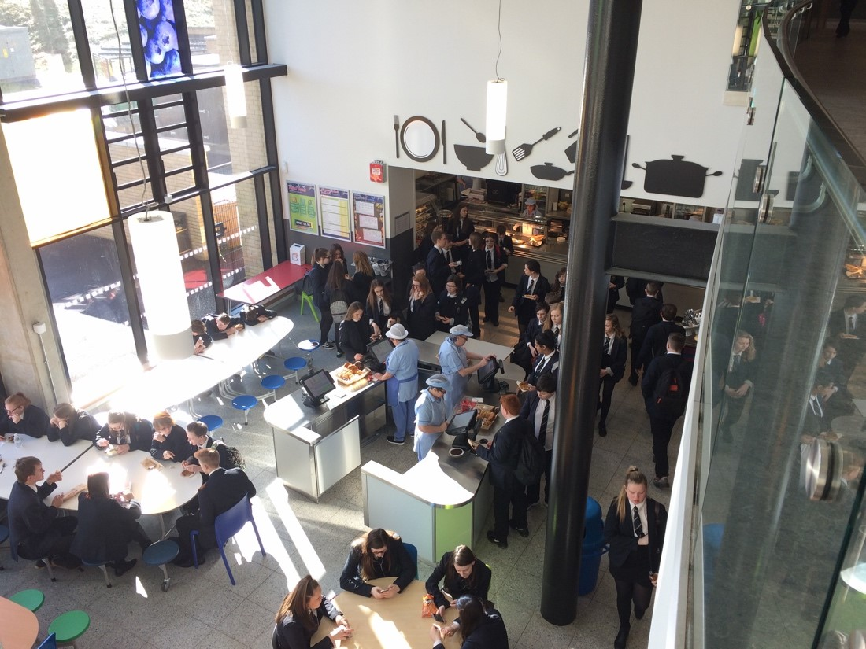

Included, Engaged, Involved

in Clyde Valley High School

A whole school approach to promoting high quality relationships and positive behaviour in Clyde Valley High School

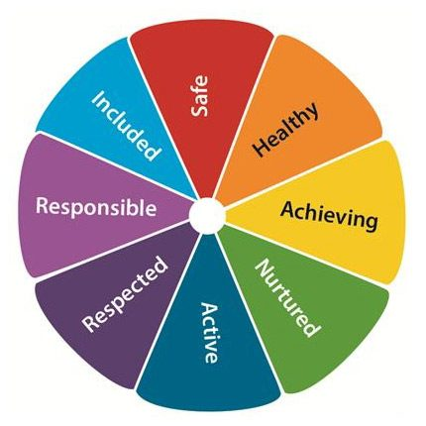

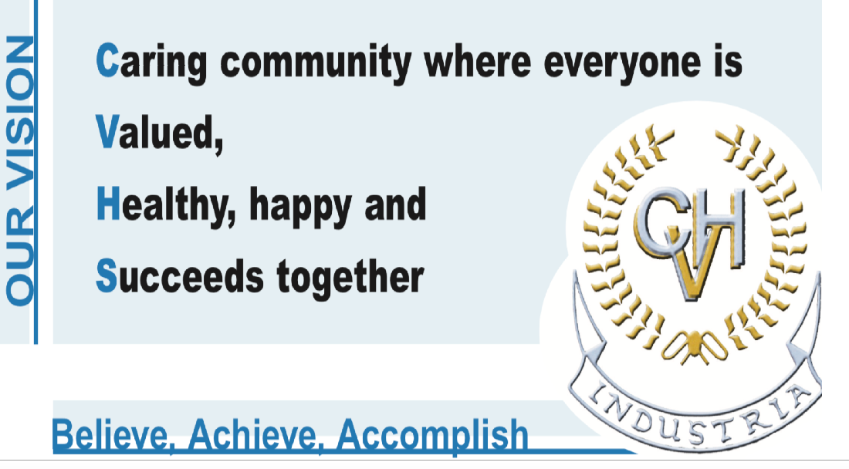

ContentCONs
CONTENTS

- Our vision and values
- Our roles and responsibilities; staff
- Our roles and responsibilities; pupils
- Our roles and responsibilities; parents and carers
- Our framework for learning; strategies, systems & procedures for promoting positive behaviour
- Our school; general expectations

APPENDIX 1
APPENDIX 2

- Our vision and values
Included, Engaged, Involved at Clyde Valley High School aims to promote the high quality relationships, which are at the heart of our pupils feeling safe, happy and supported at school. At CVHS, we recognise that pupils can only reach their potential, when the learning environment is right and this approach aims to ensure that all members of our school community understand that they have a role to play in supporting the culture of inclusion and achievement, central to our vision and values;
- Our roles and responsibilities; staff
Class Teachers will
- Understand that their priority is safeguarding and promoting every pupil’s wellbeing.
- Provide a secure, purposeful, engaging, and inclusive learning environment for all pupils.
- Approach each period as a fresh start for all pupils and a new opportunity to achieve and improve.
- Welcome pupils to their classroom with positivity and enthusiasm.
- Have an awareness and understanding that factors such as poor attendance/trauma/ASN/EAL/health issues/social & emotional issues/LACE status/deprivation can impact on a young person’s ability to learn and make reasonable adjustments on a case-by-case basis.
- Ensure that they know the learning profile of all pupils they teach by accessing pertinent information contained in GIRFme Plans, Confidential Information, Transition Reports and Coordinated Support Plans, using this to plan learning and assessment as appropriate.
- Provide support and help, when required, and understand that all pupils learn at different paces and learn best in different ways.
- Recognise success, effort, improvement and positive attitude through a range of means, verbal feedback, written feedback, Values Merit, reporting.
- Understand that success presents differently for each individual pupil.
- Adopt a consistent approach to classroom management, predicated on fairness, respect and kindness, as per section 5 of this policy, Our Framework for Learning.
- Be fully aware of the Universal Staged Intervention Strategies offered at CVHS (see Appendix 1) and apply these with the clear aim of ensuring that all pupils are included, engaged and involved in the classroom setting, as far as possible.
- Work with staff across the school, to ensure that the needs of all learners are met and that all pupils are appropriately supported.

Please refer to Appendix 3 for Pupil Voice on what makes young people feel included, engaged and involved at Clyde Valley High School.

PTs Curriculum will
- Have an awareness and understanding that factors such as poor attendance/trauma/ASN/EAL/health issues/LACE status/deprivation/social & emotional issues can impact on a young person’s ability to learn and support members of their department in making reasonable adjustments on a case by case basis.
- Support members of their department to meet learners’ needs by facilitating regular discussion around this at departmental meetings.
- Adopt a strategic approach to promoting positive behaviour and high quality relationships in their department, as per section 5 of this policy, Our Framework for Learning.
- Ensure members of their department deploy the Level 1 Staged Intervention Strategies, with the clear aim of ensuring that all pupils are included, engaged and involved in the classroom setting, as far as possible. Have knowledge of, and appropriately deploy, Level 2 Staged intervention strategies, where appropriate.
- Work with staff across the school, to ensure that the needs of all learners are met and that all pupils are appropriately supported.
- Deal with chronic, persistent and/or low to medium level disruption.
PTs Inclusion will
- Take the lead in monitoring pupil wellbeing and updating staff to significant changes in this and coordinating support.
- Take the lead in informing staff about pupils’ learning profiles, coordinating support, initiating and maintaining support plans and updating Confidential Information.
- Have an awareness of those pupils in their caseload, who are at risk of poor outcomes due to any or all of the following factors; poor attendance/trauma/ASN/EAL/health issues/LACE status/deprivation/poor parental engagement/disengagement with learning/social & emotional issues and seek to put suitable interventions and supports in place to mitigate the adverse impact of these.
- Adopt a strategic approach to promoting pupils’ wellbeing, as per section 5 of this policy, Our Framework for Learning.
- Have knowledge of, and appropriately deploy, Level 2-4 Staged Intervention Strategies, with the clear aim of ensuring that all pupils are included, engaged and involved in the life of the school.
- Work with staff across the school, to ensure that the needs of all learners are met and that all pupils are appropriately supported.
- Work with parents/carers towards improved outcomes for pupils.
- Work with partners, both within and out with Education, towards improved outcomes for pupils.
- Deal with chronic, persistent and/or low to medium level disruption.

Senior Leaders will
- Have an overview of pupil wellbeing and work with key staff to promote this.
- Lead The Inclusion Team in the gathering and dissemination of information on learners to staff.
- Lead the Inclusion Team in identifying and targeting interventions to support pupils.
- Coordinate staff training on factors which adversely impact pupil wellbeing and outcomes.
- Ensure that the school has robust strategies in place to support pupils at all levels of Staged Intervention and support staff in deploying these appropriately.
- Adopt a strategic approach to promoting positive behaviour and engagement of all pupils.
- Support staff in promoting positive interactions and developing high quality relationships with pupils, as per section 5 of this policy, Our Framework for Learning.
- Have an overview of pupil wellbeing and engagement and direct interventions as appropriate.
- Deal with serious, dangerous, abusive or violent incidents.
The Inclusion Team will
- Provide a safe, supportive, nurturing space for pupils to access, when they feel they need it or when a member of the teaching staff in consultation with their PT feels that this is appropriate for them.
- Deploy strategies and approaches such as co-regulation, PLACE, Solihull and de-escalation, as appropriate and on a case by case basis.
- Provide targeted support to learners, when they need this.
- Encourage pupils (who are able to) to reflect on their actions and learn from this.
- Help and support pupils develop strategies for managing their own behaviour and reactions.
- Gauge when a pupil is regulated and able to engage in the classroom environment. Recognise that this may take several attempts.
- Communicate learners’ needs to PTs Inclusion, Curriculum and Senior Leaders.
Our roles and responsibilities; pupils
Our pupils will follow their own charter.
Our CVHS Pupil Charter
- Be safe! We will listen to the teacher and follow instructions straight away.
- Be kind! We will treat everyone with respect and value everyone’s contribution.
- Be positive! We will do our best and we will let others do their best.
- Be respectful! We will take care of materials, our surroundings and other people’s belongings.

- Our roles and responsibilities; parents/carers
We ask that parents/carers;
- Be readily contactable and respond to letters, voice mails, text messages or phone calls from the school as appropriate.
- Provide PTs Inclusion with any information which may help the school support their young person.
- If possible attend parent/carer information evenings.
- Attend consultations and meetings.
- Be aware of our expectations of pupils and support this.
- Praise your young person, when they deserve it.

- Our framework for learning; strategies, systems & procedures for promoting positive behaviour

Class Teachers will
- Deploy a range of strategies and techniques for managing their classroom and getting the best out of young people.
- Be clear that the principles of Engaged and Involved apply once pupils are in class and settled.
- Award pupils a Values Merit at the time of reporting periods, in recognition of effort, behaviour, attitude, teamwork and/or success. Understand that how this looks will be different for each pupil.
- Letter parents/carers to communicate concerns around behaviour in class.
Should there be issues with behaviour, which are not addressed in the course of expected classroom management, Class Teachers will;
- Apply Stage 1; Inform pupil clearly which behaviour they need to amend and why. Apply appropriate strategy (Appendix 1). Record Stage 1 Intervention.
- Apply Stage 2; Make it clear to pupil that they need to do further work on amending the behaviour identified in stage 1 and be clear how you will help them. Apply appropriate strategy. Record Stage 2 Intervention.
- Apply Stage 3; If Curriculum PT is available contact PT for advice. Otherwise ask the pupil to go to the Inclusion Base for support. Class Teacher should call the Inclusion Base and inform that a pupil is expected and briefly outline reason. Referral to PT Curriculum to be made on SEEMIS, detailing pupils behaviors and strategies deployed. All referrals from class teachers should go to PT Curriculum, in the first instance.

PTs Curriculum will
- Act on referrals about pupils who are having difficulty managing their behaviour and take appropriate action, as far as possible, before the pupil returns to the department e.g. interview the pupil, facilitate restorative meeting, issue departmental monitoring card, reassign a pupil’s class, work with the pupil themselves for a short period, refer to PT Inclusion, letter parent to notify them of concerns.
- Let faculties and Inclusion base know if they are unavailable at any point in the week to provide support for pupils/classroom staff.
- Forward referrals to PTs Inclusion, once action is taken.
- Have an overview of referrals from their own faculty and respond appropriately to patterns/concerns/issues.

PTs Inclusion will
- Have an overview of referrals and “Stage1,2, intervention records” for pupils in their caseload and take appropriate action to support pupils into better habits, e.g. interview pupil, facilitate restorative meeting, issue behaviour monitoring card or effort card, issue House detention, contact parent/carers, meet with parent/carers, letter parent/carers, discuss with DHT at House Time Meeting

Senior Leaders will
- Ensure that pupils achieving Values Merits are recognised.
- Reinforce expectations of pupils at assemblies and through their daily interactions with them.
- Direct support and interventions for pupils through House Meetings.
- Where necessary, support staff in developing positive relationships with pupils and/or managing their classrooms by offering support, coaching and CLPL opportunities.
- Deal with serious incidents of dangerous, abusive or violent behaviour swiftly and as a priority. In such cases, staff should call the office/Inclusion Base, who will radio for a member of SLT to attend.

- Our school; general expectations

Use of mobile phones
- Phones should be switched off and out of sight when in class, unless the class teacher specifies that they be used as a tool for learning.
- Pupils are free to use phones in the social area or playground at Interval or lunchtimes, but can expect to be told to put their phone away, if it is visible during school time, between classes, etc.
- Should a pupil’s phone be visible during class time, it will be requested by, and given to, the teacher, without issue, and it will kept for the remainder of the period. The phone will then be returned at the end of the period. Failure to comply with this will result in the pupil being sent to a member of SLT, to whom the phone will relinquished for the remainder of the day.

Appendix 1
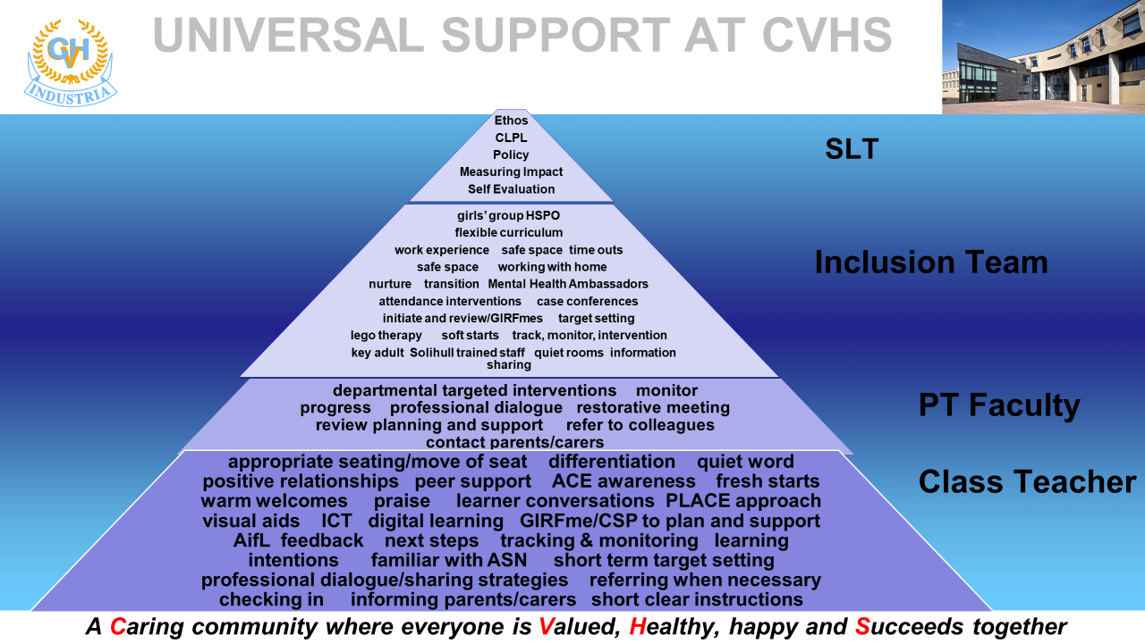

Appendix 2

- Our Award Scheme
- At the time of Tracking and Reporting periods, Class Teachers will award a Values Merit to pupils, who have consistently demonstrated behaviour, effort, and attitude commensurate with our school’s Vision and Values.

- Pupils who receive a “1” rating for behaviour and effort will be awarded a Values Merit.

- Pupils who are awarded with a Values Merit, or number of merits, will have a Praise Letter sent home, to notify parents and carers.

- Pupils achieving a notable number of merits will qualify for end of term rewards

PUPIL PARLIAMENT
Aims of the Pupil Parliament:
- Actively encourage the rights of all pupils to be involved in decisions that affect them and their education.
- Promote equality through UNICEF Articles for the Child.
- Recognise every young person as an equal partner in their school.
- Provide a meaningful way in which pupils can voice their opinions and represent the voices of their peers​.
- Promote Clyde Valley High Schools Vision of being a caring community, where everyone is valued, healthy, happy and succeeds together. ​
- Provide leadership and development opportunities for pupils.
- Cultivate individual and group identities within the school.
- Preserve our school environment, and to hold it in trust for future generations.
- To challenge poverty and discrimination throughout the school.
- To protect freedom of thought, conscience, and assembly; and to encourage discourse.

Structure of Pupil parliament:
- Executive: Head Teacher & School Captains. ​
- ​Legislature: Pupil Voice Committees: pupils will be free to join any committee. ​
- ​Cabinet: 3 members elected from each committee will meet with the executive.

Pupil Parliament: Pupil Voice Committees
- Equalities
- Health and Wellbeing @ CVHS_Parliament
- LGBTIQ+
- Rights Respecting School
- Sustainability

SCHOOL ATTENDANCE …………………………………

Section 30 of the 1980 Education Act lays a duty on every parent of a child of ‘school age’ to ensure that their child attends school regularly. Attendance must be recorded twice a day, morning and afternoon.

Regulation 7 of The Education (School and Placing Information) (Scotland) Amendment, Etc. Regulations 1993 requires each child’s absence from school to be recorded in the school register as authorised, or unauthorised: As defined by the Scottish Government.

Misunderstandings over absences can easily be avoided by careful communication. Parents are asked to inform the school if their child is likely to be absent for some time. On return from all absences, a child is required to produce a note from his/her parent with a reason for the absence(s). This note should specify the date(s) of absence. Where no explanation for absence is provided, or an explanation is doubted, the school will have the absence investigated by the School Attendance Officer. This is done for the well-being of the child and to help both the parents and school to monitor the child’s welfare.

Every effort should be made to avoid family holidays during term time as this both disrupts the child’s education and reduces learning time. Parents/Guardians should inform the school by letter of the dates before going on holiday. Such absence will be authorised only in exceptional circumstances. Such circumstances may include:
A family holiday judged to be important to the wellbeing and cohesion of the family, following serious or terminal illness, bereavement or other traumatic events.

A family holiday classified under the ‘authorised absence’ category will not include such reasons as:

- The availability of cheap holidays
- The availability of desired accommodation
- Poor weather experience during school holidays
- Holidays which overlap the beginning or end of term
- Parental difficulty obtaining leave (except in cases where evidence is provided by the employer that it cannot accommodate leave during school holidays without serious consequences)

Family holidays with the above similar characteristics will be classified as unauthorised absence. Where the head teacher’s prior agreement has not been sought the absence will automatically be classed as unauthorised.

Where most family holidays will be recorded as unauthorised absence (see above) extended leave with parental consent will not be considered the same as a family holiday. Leave in such circumstances will be authorised under circumstances such as:

- Extended overseas educational trips not organised by the school
- Short-term parental placement abroad
- Family returning to its country of origin (to care for a relative, or for cultural reasons)
- Leave in relation to the children of travelling families

Parents may request permission for such leave in writing and the school may authorise such requests under the following circumstances:

- The period immediately after an accident or illness.
- A period of serious or critical illness of a close relative.
- A domestic crisis which causes serious disruption to the family home, causing temporary relocation.

In serious cases of non-attendance, the school is required to take further action. In extreme cases, the parents of non-attenders can be referred for prosecution in the Sheriff Court.

If a child is absent through illness which is likely to extend over a lengthy period of time, the parent should contact the pupil support teacher to arrange for supporting homework to be sent to the child. In the case of prolonged absence, it may be possible for the school to arrange home tuition. In the event, the parents should not hesitate to contact their child’s guidance teacher if they have any cause for concern.

It should also be noted that pupils are expected to arrive punctually at school and may not leave the premises during school hours without prior permission. Appointments with the dentist etc. should be made for times out with school hours whenever possible.

SUPPORTING ATTENDANCE AND COMBATING ABSENTEEISM…………………

We are grateful to the many parents who use Parents Portal and Enquiries Email to notify the school on the first morning of an absence to let us know the reason for that absence.

Each year we will ask you to update your personal details and those of your child for administration purposes. We will ask you to list all your contact telephone numbers in order of preference for direct contact. This can include works numbers, mobile numbers and e-mail addresses.

HEALTH AND MEDICAL CARE……………

The following services are provided in the school by the NHS
Immunisation

- HPV inoculations are given to all S1 boys and girls
- HPV follow-up inoculations to all S2 boys and girl
- Meningitis ACWY booster and DTP booster to all S3 pupils
Continuing Medical Review
Any pupil identified in Primary 7 as having hearing or visual defects will be reviewed during the first year.

Medical Referrals

Some pupils may be referred to the doctor by the school at the request of staff or parents. Before any of the aforementioned services are provided, parental consent is required and consent forms will be provided to parents at the appropriate times.

Special Provisions …………………….

It is very important that parents inform the school of any special provision required for their child: diet in certain conditions.
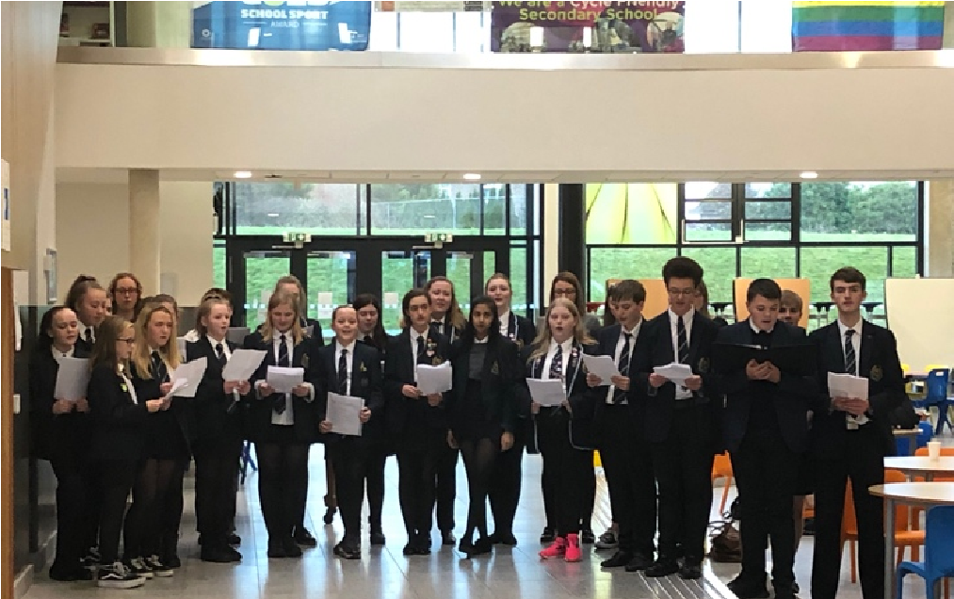
diabetic condition (even if controlled by diet); asthmatic condition;

tablets required to be taken by the child, allergies.

- Prolonged Ill Health

If a pupil is unable to attend as a result of prolonged ill-health. North Lanarkshire Council must make special arrangement for the pupil to receive education elsewhere, other than school.

- Emergency Contact

When a pupil becomes ill or is injured at school the condition of the pupil will be assessed by one of the school’s trained First Aiders. Every effort will be made to contact parents. In this connection it is very important that the school has information for making emergency contact. If it does become necessary to seek proper medical assistance the pupil will be transferred to the nearest hospital under the supervision of a member of staff.

- Medical Appointments

Medical and dental appointments during school hours should be notified in advance to the appropriate member of the Pupil Support Team by presenting an appointment card or a note from the parents.

- Medical Facilities in the School

Please note that there is no school nurse or similarly qualified person on the premises. Parents of pupils who have recently been ill should consider carefully the advisability of sending them back to school unless they are fully recovered. The school carries only the basics of first aid equipment, and in particular we do not, on medical advice, issue painkillers to pupils.

- Medicines

Pupils are not allowed to carry medicines or tablets in school. If a pupil has been prescribed medication which is required to be taken during the school day the following procedures must be followed:

- A parental request form must be completed and returned to the school office along with the prescribed medicine. This authorises school staff to administer the medicine. Unfortunately, verbal instructions from parents cannot be acted upon.

- Pupils will be given permission to report to the school office at the appropriate time during the school day where the correct dosage of their medicine will be issued.

These procedures are designed to ensure that the well-being of all pupils is protected. Medicines will be administered effectively and retained in a secure place in the school.

In North Lanarkshire, children and young people are treated in the paediatric in-patient unit within Wishaw General Hospital. It is not common for children and young people to have extended stays in Wishaw General, and therefore North Lanarkshire Council does not require a dedicated hospital education service. Children and young people resident in North Lanarkshire and in hospital in Glasgow, may access education through the Hospital Education Service (HES). The service is provided by Glasgow City Education Department and Social Work Services.
For further information, please contact the school.

SCHOOL MEALS ……………………………………………………………………………………..

Clyde Valley High School has a modern social area where the School Meals Service operates a self-service cafeteria. A wide variety of snacks, salads, sandwiches and hot meals is available for pupils. As well as providing a lunch time menu, the dining rooms serve breakfast from 8.30 a.m. – 8.55 a.m. and snacks at the mid-morning break from 10.35 a.m. – 10.50 a.m. Monday to Friday.

The availability of special diets.

Diets required as a result of a medical condition (a medically prescribed diet e.g. coeliac disease, diabetes, food allergy or intolerance) can be provided in school. A medically prescribed diet form must be completed by the child’s Registered Dietician or General Practitioner. Procedures and forms can be accessed from the child’s school or dietician, or from North Lanarkshire’s catering service. Occasionally, parents/carers may be asked to supply prescription foods or attend a meeting to discuss the child’s dietary requirements.

Some children with additional support needs may require food to be adapted to an appropriate texture and consistency. In this instance the child’s Registered Dietician or Speech and Language Therapist will liaise with Head Teacher and school catering service to ensure appropriate food provision.

Special diets required for ethical, religious or cultural reasons should be requested in writing to the head teacher, who will liaise with the school catering service.

Children of parents receiving income support or Job Seekers Allowance (income based) and Employment & Support Allowance (income related), universal credit, are entitled to a meal without charge. Students aged between 16 and 18 and who are in receipt any qualifying benefits can apply for free school meals in their own right.

Information and application forms for free school meals may be obtained from schools, first stop shops and Municipal Buildings, Coatbridge. Parents are entitled to receive a clothing grant if they are in receipt of any of the following benefits: Income Support, Job Seekers Allowance (Income based), Employment & Support Allowance (income related), universal credit, housing benefit, council tax rebate.

Free milk is not provided for secondary pupils. Milk may, however, be available for purchase in the school during the lunch period.

Please Note:

Job Seeker’s Allowance (Contribution Based), Council Tax Discount or Council Tax Exemption and Working Families Tax Credit are NOT qualifying benefits.

Family Credit is no longer a qualifying benefit.

The Dining Room is supervised during lunch breaks by the Senior Leadership Team.

SWIPE CARD………………………………………………………………………………………………….

The dining rooms operate on a cashless system, with every pupil having either his or her own swipe card or a unique PIN number. It also avoids pupils entitled to a free meal having to be given a separate dinner ticket.
Cash machines are conveniently situated to enable pupils to top-up the value of their card. Pupils in receipt of a free meal have the cash value of a meal added to their card automatically each day. The system will be explained in full to first year pupils when they visit in June so they are ready for the start of session in August.

Online Payments

Online payments were introduced to CVHS in February 2016 and have now been introduced in all schools across North Lanarkshire to provide parents/carers with more convenient and flexible methods of payments for school expenses. This service will also allow pupils to reduce the amount of cash they carry to school and help reduce administration and cash handling in schools. From August 2016 all trips, uniforms items and school meals can be paid for online.

How do I pay online? For you to use the online payment service, you need to register with MyAccount, the simple and secure sign-in service for accessing online public services in Scotland. It provides people living in Scotland with the ability to set up an online account and use it - using a single user name and password to access a growing range of online public services. Go to www.clydevalleyhighschool.org.uk and select make a payment. If you already have a MyAccount click on the sign-in logo and log in with your MyAccount details. If you do not already have a MyAccount, setting up an online account involves a simple registration process, to do this click on the Register logo. Please contact the school office if you require any assistance.

THE PARENT FORUM ……………………………………………….

As a parent of a child at this school you are automatically a member of the Parent Forum. The Parent Forum is composed of all the parents and carers of children at the school.

As a member of the Parent Forum you can expect to:

- get information about what your child is learning
- get information about events and activities at the school
- get advice/help on how you can support your child’s learning
- be told about opportunities to be involved in the school
- have a say in selecting a Parent Council to work on behalf of all parents at the school
- be invited to identify issues for the Parent Council to work on with the school.

THE PARENT COUNCIL …………………………………………
Parent Councils came into force on 1 August 2007. The Head Teacher is the professional adviser to the Parent Council and as such has a right and duty to attend all meetings of the Parent Council.
Meetings of the Parent Council are open to the public.
The Parent Council’s rights and duties include:

- supporting the work of the school;
- representing the views of parents;
- consulting with parents and reporting back to the Parent Forum on matters of interest; (d) promoting contact between the school, parents, pupils, and the wider community; (e) fundraising;
- taking part in the selection of senior promoted staff;
- receiving reports from the head teacher and education authority;
- receiving an annual budget for administration, training and other expenses; and (i) improving home school partnership and facilitating parental involvement.

Members of Parent Councils, on a voluntary basis, may also have an advisory role in decisions on placing requests by parents in respect of those situations where the number of placing requests for a particular school or for a particular stage in a particular school exceeds the number of places available.

Parent Members 2021 – 2022

Chairperson Mrs Michelle Williams
Vice Chair Mrs Richards
Treasurer Mrs Devanney

Examples of agenda items during session 2021 - 2022 have been:

  - Pupil Attainment
  - Fundraising
  - Campus Improvements
  - School Improvement planning

CATCHMENT AREA…………………………………………………..

The catchment area of Clyde Valley High School includes the districts of Bonkle, Coltness, Craigneuk, Morningside, Muirhouse, Netherton, Newmains, Overtown, Pather, West Crindledyke,
Wishaw and Wishawhill. Pupils are normally drawn from the Partnership Primary Schools which are:

Berryhill PS |  |  | Morningside PS |  | Muirhouse PS
Mrs C Nicol |  |  | Mrs J Gardiner |  | Mrs G Matthews
Hillcrest Avenue |  |  | School Road |  | 66 Barons Road
Wishaw |  |  | Morningside, Wishaw |  | Muirhouse, Motherwell
ML2 7RB |  |  | ML2 9QW |  | ML1 2NB
Tel: 274969 |  |  | Tel: 274938 |  | Tel: 274938
Netherton PS |  |  | Newmains PS |  | Orchard PS
Mrs F Easton |  |  | Mr S Smith |  | Mrs H MacKenzie (Acting)
Netherton Road |  |  | School Road |  | Clyde Valley Campus
Netherton |  |  | Newmains |  | Castlehill Road
Wishaw |  |  | Wishaw |  | Wishaw
ML2 0DD |  |  | ML2 9BE |  | ML2 0LB
Tel: 352520 |  |  | Tel: 274923 |  | Tel: 274984
Thornlie PS |  |  | Wishaw Academy PS
Mr D Hughes |  |  | Miss C Barr
Lomond Drive |  |  | Lochpark
Pather |  |  | Wishaw
Wishaw |  |  | ML2 7PB
ML2 0JR  Tel: 352539 |  |  | Tel: 352579

ENROLMENT OF CHILDREN IN PRIMARY AND SECONDARY SCHOOLS……….
INFORMATION FOR PARENTS

  - Where a parent wishes more information on the actual boundaries of the catchment area for the local school, he/she should enquire at the school where this information will be made available. Names, addresses, telephone numbers and other relevant information relating to other schools in the division are also available at your local school.

  - It is normal practice for children in your local primary school to transfer to Clyde Valley High School. The parents of children who are not so directed may nevertheless apply to have their children admitted to Clyde Valley. This is done by the parent putting forward a placing request which should be done either through the Head Teacher of the primary school in the case of primary children or through the Head Teacher in Clyde Valley in the case of others. Prospective parents are warmly invited to visit Clyde Valley to see the school and to discuss any matters which may arise with the Head Teacher.

  - The Education Authority currently has a policy of providing free transport to all primary pupils who live more than one mile by the recognised shortest safe walking route from their local school and to secondary pupils who live more than two miles by the recognised shortest walking route from their local school. This policy is one which is more generous than that prescribed by statute and is currently under review.

  - The Education Authority does not provide transport for those people in receipt of a placing request other than in exceptional circumstances.

  - In most parts of North Lanarkshire there are Roman Catholic schools which serve a defined area. Parents may enrol their child at a denominational school rather than the nondenominational school if they so wish. In certain rural areas there are few denominational schools and this choice is then not possible.

  - Throughout North Lanarkshire there is a wide variety of provision for children with special educational needs. A list of the schools in your area with a description of the educational provision made in each is available at your local school.

  - You have the right to make a placing request for your child to be educated in a school other than the local school. In December each year, the authority will advertise its arrangements for placing requests. There are sound educational reasons for trying to ensure that the transfer or admission of children to a school takes place at the start of a school session. Other than those who are moving home, to a new area, parents are advised to time any placing requests so that they take effect from the beginning of the new school session. Every effort will be made to try to meet the parental wishes, but you should note that it is not always possible to grant every placing request to a particular school.

  - Once a pupil has reached the school leaving age the pupil, not the pupil’s parents may choose which school to go to.

Placing requests to Primary School does not necessarily ensure that your child will have a direct entry to the associated secondary. Advice on this must be sought from the Primary School Head Teacher. Further information on placing requests and procedures is available from the school or the councils’ website.

Parents and Young People have a right under the Additional Support for Learning Act 2009 to make a placing request for their child or young person to attend a nursery (including partnership nursery), special school or special class managed by the home authority. In the event of a successful placing request the authority are not required to provide transport. The Act also enables parents and young people to make a placing request to attend a school/establishment belonging to another authority.

The Pupil Equity Fund (PEF)………………………
What is it? Pupil Equity Funding is additional funding allocated directly to all schools and targeted at closing the poverty related attainment gap. The Scottish Government has committed to this funding as part of the Scottish Attainment Challenge programme which started in 2017. The Pupil Equity Funding forms part of the £750m Attainment Scotland Fund which will be invested over the current Parliamentary term.
The Main Key Principles Head teachers have access to the full amount of the allocated PEF Funding for their school Pupil Equity Funding enables schools to deliver activities, interventions or resources which are clearly additional to those which are already planned.
- Head teachers work in partnership with each other, and their local authority, to agree the use of the funding. Schools take account of the statutory responsibilities of their authority to deliver educational improvement, secure Best Value, and the authority’s role as employer. Local Guidance from North Lanarkshire Council, Education, Families and Justice sets out more detail on how this will operate.
- The operation of the Pupil Equity Funding articulates closely to existing planning and reporting procedures as possible – e.g. through School Improvement Planning and Standards and Quality reports.
- The operation of the Pupil Equity Funding articulates closely to existing planning and reporting procedures as possible – e.g. through School Improvement Planning and Standards and Quality reports.
- Parents, carers, children, and other key stakeholders are involved in the planning process.
- Funding provides targeted support for children and young people affected by poverty to achieve their full potential.
- Although the Pupil Equity Funding is allocated on the basis of free school meal eligibility, head teachers can and do use their professional judgement to bring additional children in to the targeted interventions and approaches.
- Head teachers develop a clear rationale for use of the funding, based on a clear analysis which identifies the poverty related attainment gap in their schools.
- Schools must have plans in place from the outset to evaluate the impact of the funding. These plans outline clear outcomes to be achieved and how progress towards these, and the impact on closing the poverty related attainment gap, will be measured.
How is the Pupil Equity Funding used in Clyde Valley?
Through consultation with the school community, with young people through the Pupil Council, with parents and carers through the Parent Council and with staff, the school shares its ideas with other schools across North Lanarkshire Council including the associated primary schools.
The school analyses its data on attainment, attendance and engagement in learning with a specific focus on young people who receive Free School Meals Entitlement (FME) and those from deciles 1-3; deciles 1-3 refers to those in the most deprived areas according to the Scottish Index for Multiple Deprivation (SIMD).
Findings from the consultations and analysis of data show:
Young people who attend school regularly, attain better and have more positive outcomes.
Young people who stay on to complete the S4-S6 senior phase attain better and achieve more positive destinations.
Positive relationships with young people and their families support attendance and attainment.
Early interventions (from S1 and even earlier at P6-7 transition) give us the best chance of improving young people’s outcomes.
Targets and support put in place will:
Raise attainment in literacy through the Fresh Start/ Read Write Inc resource programme.
Raise attainment in numeracy through using Number Talks, Sum-dog and Numeracy and Mathematics Workout resources.
Improve attendance, late coming and attainment for young people in deciles 1-3 and/or free school meal entitlement (FME) through Pupil Support Teacher family contact.
Reduce demerits and referrals of young people in deciles 1-3 and/or FME.
Develop positive relationships and supports for challenged young people and their families by using the Extended Support Team, Learning Support, Home School Partnership Officer (HSPO) and the ‘Learning Zone’
Develop early intervention strategies for challenged young people in S1-S3 through securing the services of Action for Children and a trainee Social Worker.

GLOSSARY……………………………………………………………

Catchment Area | The residential area from which a comprehensive school normally draws all pupils, whatever their ability.
Common Course | A course of study prescribed for all pupils of a given age group, irrespective of academic ability.
Comprehensive School | A school which provides courses for the whole range of ability, and normally takes all pupils in residence in a given area.
Continuous Assessment | Assessment as an integral part of the learning process, used to monitor and reinforce progress.
Co-operative Teaching | The simultaneous involvement of more than one teacher with the same class, principally for individual support in a mixed-ability situation.
Mixed-ability Class | Pupils of a wide range of ability taught together as a class; the work of such a group is largely based on individual and group assignments
PEF | Pupil Equity Funding
SQA | Scottish Qualification Authority
Setting | Grouping pupils according to ability in a particular subject, without affecting other subjects.
Standardised Assessment | Assessment of pupils in Literacy and Numeracy by means of Nationally agreed assessment tools.
Streaming | Grouping pupils into totally separate classes for all subjects according to general ability.

IMPORTANT ADDRESSES………………………………………

Des Murray
Executive Director
Education, Youth and Communities
PO Box 14
Civic Centre
Motherwell
ML1 1TW

North Lanarkshire Councillors
Wards | Members | School Buildings in Ward | School Catchments within Ward
Motherwell South  East and Ravenscraig | K Duffy  A Magowan  AL Valentine N Wilson | Berryhill P.S. Muirhouse P.S. | Berryhill P.S.  Muirhouse P.S.  Wishaw Academy P.S.
Murdostoun | R McKendrick  CW McManus  L Roarty  N Shevlin
Wishaw | B Burgess  A Feeney  F Fotheringham  J Hume | Orchard PS  Netherton PS  Thornlie PS  Wishaw Academy PS Clyde Valley HS | Orchard PS  Netherton PS  Thornlie PS  Wishaw Academy PS
S.D.S. - Gail Connelly
Skills Development Scotland
60 Stirling Street
Airdrie
ML6 0AZ Tel: 01236 757400

Community Support Service
Motherwell Area Resource Centre
303 Brandon Street
Motherwell Tel: 01698 259103

Reporter to the Children’s Panel
1st Floor
Hamilton House
Hamilton Business Park
Caird Park
Hamilton
ML3 0QA Tel: Hamilton 543340

Educational Psychological Service
St Brendan’s Primary School
Motherwell Tel: Motherwell 262840

Contacts in relation to Support for Learning,
Help and advice on any matters relating to Additional Support Needs are available from:
Cluster Improvement Integration Leader
Sheila Robertson
Clyde Valley High School
Castelhill Road
Wishaw
ML2 0LS Tel: Wishaw 274950

You can also get more help and advice from:

Enquire – the Scottish advice service for additional support for learning. Operated by Children in Scotland, Enquire offers independent confidential advice and information on additional support for learning. Enquire also provide a range of factsheets.
0345 123 2303 info@enquire.org.uk
www.enquire.org.uk for parents and practitioners
www.enquire.org.uk for children and young people

Resolve
0131 222 2456
(Independent Adjudicator)
Scottish Independent Advocacy Alliance
Melrose House
69a George Street
Edinburgh
EH2 2JG 0131 260 enquiry@siaa.org.uk
www.siaa.org.uk

Reference to Additional Support Needs Tribunal
5th Floor
Highlander House
58 Waterloo Street
Glasgow
G2 7DA
Helpline: 0845 120 2906
Fax: 0141 305 4185
Email: inquiries@asntscotland.gov.uk

NHS Lanarkshire
Wishaw Health Centre
01698 355511

Social Work
Wishaw/Shotts Social Work Department
Kings House
King Street
Wishaw
ML2 8BS 01698 348200

QUALIFYING STATEMENTS ………………………………….
Although this information is accurate at the time of printing, there could be changes affecting any of the matters dealt with in this document –

- before the commencement or during the course of the school year in question.

- in relation to subsequent school years.

Education Authorities are required by law to issue a copy of their school handbook to certain parents in December each year. It details the current policies and practices of both the council and the school.

APPENDIX……………………………………………………………….

EXAMINATION RESULTS: ANALYSIS………………………
The collection of data is now collated and published through the insight benchmarking tool. Information on the latest data can be accessed by visiting the Parent zone Scotland website.

https://education.gov.scot/parentzone
In addition, all Government produced statistics relating to schools including, among other things,
- Leaver Destinations
- School profile statistics (roll etc.) • Attendance / Exclusions data
can be found here:

https://www2.gov.scot/Topics/Statistics/Browse/School-Education

How to contact the school:

Clyde Valley High School,

Clyde Valley Campus

Castlehill Road,

Wishaw.

ML2 0LB

Tel
:

(01698) 274 950

E
-
mail
:

Enquiries-at-clydevalley@northlan.org.uk

Web
:

www.clydevalleyhighschool.org.uk

Follow Us On Twitter
:

@ClydeValleyHS

Education
& Families

