**Parent’s Guide to Number Talks**

**What is Number Talks?**

Number Talks happens daily during a Maths lesson. Children are given calculations and are encouraged to work out the answer using any strategy that makes sense to them (this may be different for several children). The focus is then on talking about the different strategies that were used across the class and discussing the efficiency of them.

**The Key Features!**

1. The teacher provides varied maths problems (sometimes called chilli challenges).
2. The children choose which problem to solve and use a strategy to get to the answer.
3. They show that they have a strategy and an answer using hand signals.
4. Pupils then share their strategies with the rest of the class and the teacher leads a conversations about the strategies used.

**What are the Benefits?**

Through participation in Number Talks, pupils have the opportunity to:

• Explain their own thinking

• Consider other strategies suggested by their peers

• Learn about a range of efficient strategies

• Make decisions about choosing the best strategy for specific problems.

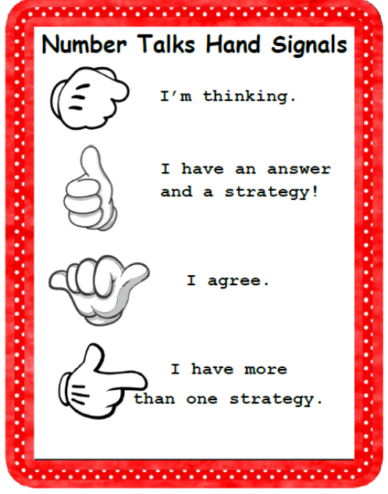



**How Can you Help?**

TALK!

Encourage your child to talk about how they got the answer to a problem!

Remember that there is more than one way to get to an answer…even if it isn’t the same way that you would do it. Ask them to explain it to you.

**Number Sense**

Number Sense is the awareness of numbers and what they are, one to one correspondence and the estimation of number.

**Fluency**

**Subitising**

Children will also develop their fluency of small numbers – knowing how number can be built. E.g. 8 can be made by doing 7+1, 4+4 or 10-2.

The ability to quickly identify the number of items in a small set without counting. E.g. looking at a side of a dice and knowing how many dots there are without counting.

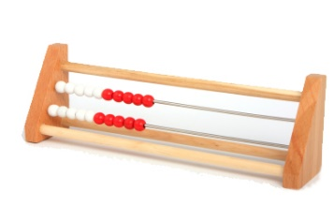

**Rekenreks**

**Ten Frames**

**Dot Patterns**

**Numicon**

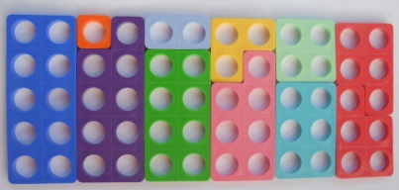

Resources



**Number Lines**