Netherton Family Learning Centre


Handbook

2026/2027

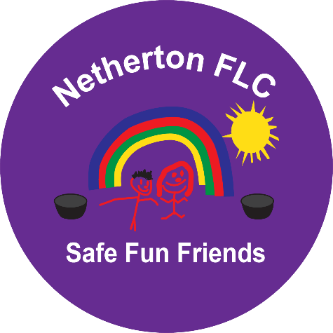

Contact Details

Netherton Family Learning Centre
1 Carbarns
Wishaw ML2 0FQ

Telephone number: 01698 522747

Email: nethertonflc@northlan.org.uk

Follow us on X: CentreNetherton

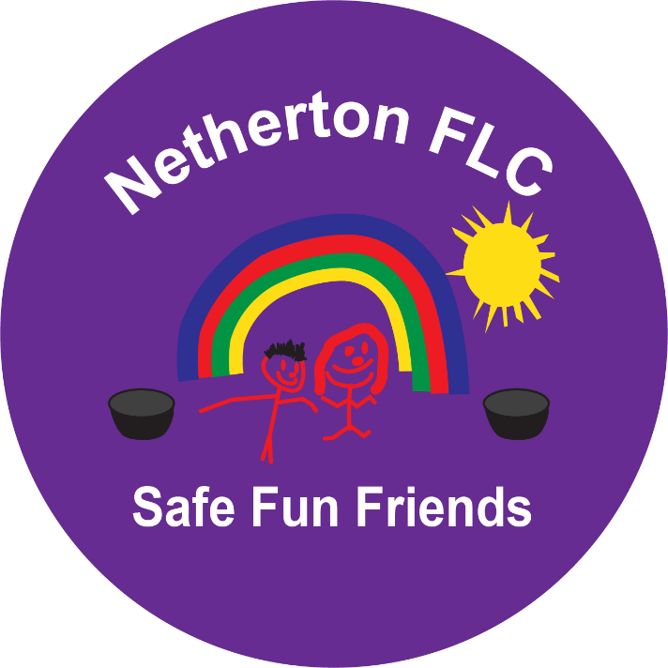

Welcome

We realise that starting nursery is a whole new experience and this may be your child’s first encounter with adults and children outside their own family circle. Therefore, we strive to make Netherton Family Learning Centre a welcoming, happy place for you and your child.

We will build upon the valuable learning that you have been providing for your child at home and like you, we will respect and care for your child as an individual and encourage them to give their very best in all situations.

We hope that the information in this handbook is helpful but if you require any additional information – please do not hesitate to contact a member of staff at any time.

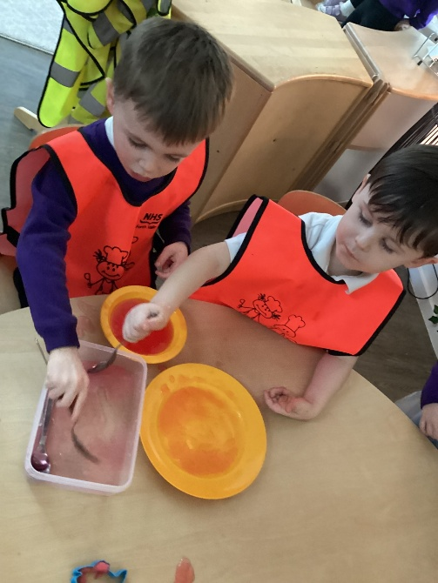

Our Vision, Values and Aims

Our Vision at Netherton Family Learning Centre is for our setting to be a safe, secure and nurturing environment in which children’s unique abilities flourish through play and learning.

We value our place within Netherton community and respect the opinions of our children and families. We promote open communication, valuing the
relationships we have with our families and others who work alongside us. We strive to create an ethos where children are respected and valued in an
environment where they can reach their best potential.

We aim to develop our pedagogical approaches to learning through play-based, holistic pedagogy using Realising the Ambition to compliment the key areas of the curriculum for Excellence, ensuring an inclusive environment where all children’s needs are met. Our committed staff are passionate about their own continuous learning both professionally and personally. We aim to
develop and build a partnership which enables staff to confidently nurture and extend each child to ensure smooth and well supported transitions.

Our core values are Kindness, Trust, Honesty, Respect, Leadership and Equality.

Our Early Learning and Childcare Team

Management Team
Head of Centre: Angie Ross
Depute Head of Centre: Sheryl Ferguson/ Megan Dalgleish

Equity & Excellence Lead: Claire Donald
Lead Practitioner & First Aider: Rhona Douglas

Early Learning & Childcare Keyworkers
Nicole Webster
Kalsoom Begum
Lydia Mooney
Katy Craig (Maternity Leave)

Early Learning & Childcare Support Workers
Michaela Foy
Victoria Mertika

Nursery Support Staff
Clerical Assistant: Rainald Muldoon
Facility Assistants: Maureen Mearns / Laura Kelly

Professional Support Staff
Education Psychologist: Rhiannon Quinn
Speech and Language: Nuala McQuarrie

Our Centre Capacity
3-5 years –29 term time, 11 am/pm children (maximum 40 children per session)
Opening Hours
Our core nursery times for children are:

Morning – 8.00am – 12.45pm (doors open 12.30pm)
Afternoon – 1.15pm – 6.00pm (doors open at 5.30pm)
Term Time Provision – 8.45am -2.45pm (doors open at 2.30pm)

It is important that children are collected promptly at the end of their session. Persistent late collection means our staff are delayed in their duties to clean, prepare and resource the playroom for the new session.

Arriving at Nursery

We will support your child as you leave, it is important for children to know their parents are leaving even if this sometimes can be upsetting for them, this helps support their trust and understanding that their special adult will
return later.

If you are arriving later in the session, please call in advance to let us know

Leaving the Nursery

Your child’s safety is our priority. We ask that you notify staff when leaving the building so that we know your child has left safely.
Should you need to ask a friend or relative to collect your child please ensure we know details and a password has been set. Any person collecting a child from nursery must be over 16 years of age.

Leaving the centre at the end of the day can mean parting from friends and interrupting play, so please arrive with time to support your child with leaving. Children might wish to collect the items they have been working on; this could take some time.

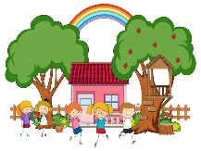

Vertical Transition from home to nursery

Settling into nursery is a big event in a child’s life – some children find it more stressful that others and require a wee bit more support. This can involve staying with your child for a while every day and coming back early to get them, this can support them to build their confidence to stay on their own.
Every child is different, and we appreciate that not every parent can afford the time to stay. Our staff are very experienced in helping children settle quickly and would contact you if your child was upset for a prolonged time.



Vertical Transition from nursery to school
It is important that the child and nursery staff liaise closely at all times, but it is particularly necessary near the time of transition to the next stage of
education. In October we will ask you to confirm your school placement. In January you will be invited to enroll at your child’s catchment school.

Around May/June time Nursery staff and P1 teachers will meet on a formal basis to discuss each child. Time will also be given to the P1 teacher to observe the children within the nursery setting. Your chosen school will also invite you to visit with your child and take part in their transition programme.
Both nursery and school will liaise regularly to ensure a smooth transition for you and your child.

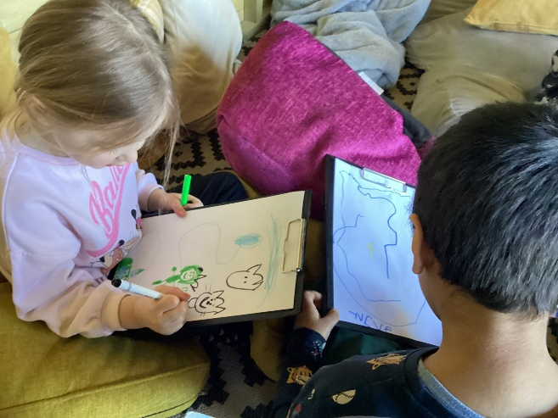

Learning by Play
In making Netherton FLC the best place to learn and grow, our mission is simple; to play. All our little learners will have a wide variety of
experiences, environments and interactions based around our play-based pedagogy in line with the stage and needs of the individual child. High quality interactions are facilitated by highly qualified and experienced practitioners who provide a nurturing and stimulating environment for our children.
Play and learning at home
Learning and relationship building begins even before birth as babies hear rhythms and sounds of the voices around them. Babies, families and homes are their first learning environments and young children learn through the turn-taking and melody of conversations, story reading and songs. Our curriculum approach takes account of every child’s ability and interest. We aim to help parents support their child’s learning in the home through our ongoing discussions about your child’s preferences and interests. These discussions begin at our home visit stage on enrolment and continue across your child’s journey here at Netherton FLC.

Curriculum for Excellence
We follow Curriculum for Excellence – a curriculum for children aged 3-18 and we are informed by Education Scotland’s Pre-Birth to Three national
guidance. Nature and outdoors are at the heart of learning within Netherton Family Learning Centre. All staff take pride in applying nurture principles to their practice and are trained to use the Solihull Approach.

Children have free access to our large garden area and are encouraged to explore and be curious every day.

Getting it Right for Me
At Netherton Family Learning Centre our priority is to Get It Right For Every Child. We will work in very close partnership with other agencies such as our
Educational Psychologist, Speech and Language Therapist and other health professionals. When concerns are raised, relevant assessments are carried out and a team around the child meeting may be convened. Parents will be fully informed throughout this process.

Outdoor Learning
Playing and learning outdoors is fun. When we cast our minds back to childhood, many of our best memories are from outdoor play whether it’s climbing the big tree, building a den for the first time or planting and nurturing a seed. There is a lot of anecdotal evidence that outdoor play-based learning is positive and life enhancing. More importantly however, there is strong and compelling evidence that playing and learning outdoors has many benefits for children. And importantly, it is fun and should be an everyday part of children’s play-based learning
Preparing your child for Nursery

Starting nursery can be an exciting time for children and we hope they settle into their new environment with ease.

On beginning their journey to nursery your child’s photograph will be taken to help them identify their peg, where they can keep their belongings.

Your child will be provided with a Netherton Nursery bag in which a change of clothes, in which the following items are kept:
- nappies/wipes
- socks
- pants
- trousers
- tops
- spare shoes

Naming clothes (labels or use a permanent pen on the clothing label) really helps us to get clothes back to children. In time it also supports children to become familiar with their name.

Children will experience the outdoors in all weathers. It is fine to wear shoes that children can move easily in and outside in, but it’s important to have
Wellies – please bring these every day or leave a set at the centre. When the sun shines, we would ask that children come to nursery with sunscreen already applied and where possible that your child is provided with their own cream and sun hat.

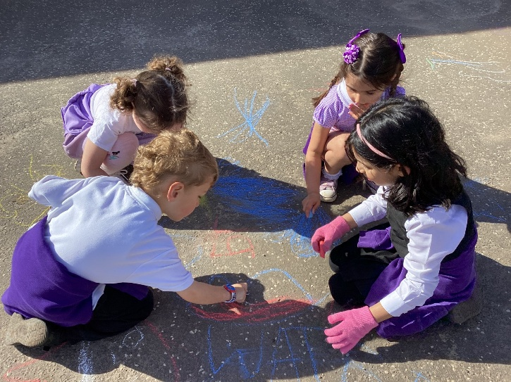

Learning doesn’t stop in the nursery

To continue learning at home you can help your child by:

- Reading to your child every day, talk about the books, read familiar words to them, e.g. labels on food, on signs around them, titles of TV programmes etc.
- Encourage your child to listen to songs, music, stories and rhymes and retell or sing them back to you.
- Talk with your child, answer questions and play remembering games and guessing games such as “I Spy”.
- Encourage them to ask questions.
- Encourage them to count and use numbers in everyday situations and in nursery rhymes.
- Help them to match and sort things e.g. pairing knives and forks, sorting big and little toys.
- Give them the chance to use their fingers and hands e.g. building with bricks, using scissors, helping with baking and food preparations, fastening zips and buttons.
- Encourage them to express their own ideas and feelings through using crayons, pens, pencils, paint, music and play.
- Encourage them to explore their own environment.
- Encourage your child to become more independent by e.g. put on/take off coat. Fasten zips and buttons, putting on shoes, dressing and
undressing, washing hands before meals.
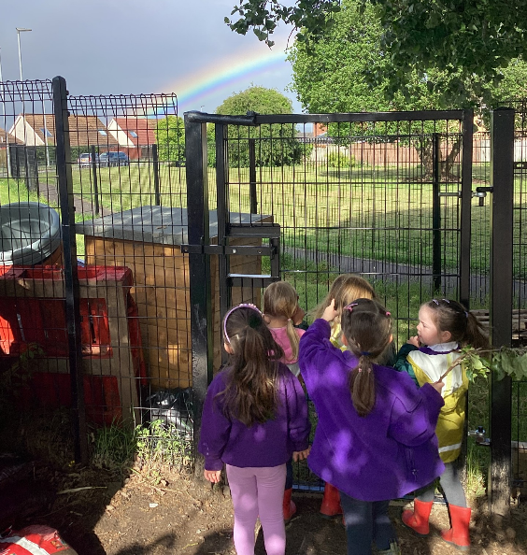

Parental Partnerships

In order to make our nursery a happy and successful learning environment for our children, we need your support. All Nursery activities can be enriched and extended by the involvement of parents. We invite parents and carers into nursery to share time with the children and to become involved in activities such as reading stories, baking, artwork and sharing any special skills.

You will be informed of when these `Stay and Play’ sessions take place throughout the year. Please do let us know if you have any particular skills such as playing a musical instrument, woodwork, storytelling, puppetry etc. which could share with the children in the nursery.

We would also welcome your help with your child `Personal Learning Plan`.
Each term we ask the children what they would like to get better at, and we try to help them to achieve their goals. This is to help prepare them for school when they will regularly be expected to reflect upon their learning. We record this in their `Learning Journal’ along with any evidence or information you give us about their out of nursery achievements. We would also like to regularly share their Learning Journey with you and allow you to comment on their achievements.

We welcome feedback from parents about how we are doing and we aim to provide regular opportunities for this throughout the year. Please feel free to speak to the nursery staff if you have any comments or suggestions.

The platforms we use to communicate with parents are

  - Learning Journals
  - Newsletters
  - Team Around the Child Meetings
  - Family Council Meetings
  - PLP Meetings

Children's Rights at Netherton Family Learning Centre

At Netherton Family Learning Centre, we believe every child has the right to feel safe, happy, respected and included. We are committed to creating a warm, nurturing environment where children are listened to, valued and encouraged to learn, play and reach their full potential.
Children's rights are at the heart of everything we do. Through play, positive relationships and meaningful learning experiences, we help children develop kindness, respect, fairness and confidence while encouraging them to make choices and share their ideas.
We work closely with parents and carers, recognising that they are a child's first and most important educators. By working together, we can ensure every child feels supported, valued and has a strong sense of belonging within our nursery community.

Our Rights Respecting School Award Journey

We are excited to begin our journey towards becoming a UNICEF UK Rights Respecting School. In September, we will submit our application for the Bronze: Rights Committed Award, the first step in embedding children's rights across our nursery. As we progress, children will learn about their rights in fun and age-appropriate ways, while staff continue to develop rights-respecting practice throughout our learning environment.
Families will be invited to take part in our journey because we believe children's rights are best promoted when home and nursery work together.
Looking ahead, we aim to continue beyond Bronze and work towards achieving the Silver: Rights Aware Award, ensuring children's rights remain at the heart of everything we do. We look forward to sharing our progress and celebrating each milestone with our children, families and wider community.

Our Children’s Promise
- To be kind to one another
- To help one another
- To use kind works when playing together
- To celebrate each other’s success and achievements
- To listen
- To have FUN

Our Eco-Garden

Our Eco-Garden is a unique outdoor learning space where children can explore, discover and develop a love of nature. Made possible through a £3,000 Food for Thought grant from Education Scotland, the garden features fruit trees, berry bushes, flowers and wildlife habitats, providing rich opportunities for outdoor learning.

Children are actively involved in planting, growing and harvesting, helping them develop responsibility, teamwork and an understanding of sustainability. Our Mud Kitchen encourages imaginative play using natural materials and fresh produce, while the Zen Garden, bug hotel, compost area and SHANARRI Shack provide spaces for wellbeing, STEM learning and outdoor experiences in all weather.

As our garden grows, we look forward to sharing fresh fruit and vegetables with families through our nursery foyer, celebrating the children's hard work and promoting healthy eating.

Our Eco-Garden continues to develop with the support of our nursery community. We hope to establish a Community Gardening Group and warmly welcome donations of plants, pots, compost and other gardening resources. Children and families will also have the opportunity to help choose a name for our garden and share ideas as we continue to grow this special space together.

Loving Lunches

We know that eating times provide rich opportunities to foster
children’s social wellbeing. In the best ELC settings, snack and
mealtimes are regarded as a rich learning opportunity and skilled
staff plan carefully for these experiences. We also know that the
importance of fostering positive attitudes to healthy eating begin
from a young age.​ Our aim is to ensure all children can enjoy unhurried lunch times in as relaxed an atmosphere as possible. ​ (Health & Social Care Standards, 2017, 1.35)​

All children will be provided with a hot meal for lunch. Our lunch time runs between 11.15am and 12.15pm for our morning and term time children. Our afternoon children will experience lunch as soon as their session begins at 1.15pm.
We ask that all afternoon children are provided with a light snack in the morning, so they are ready to eat upon arrival to nursery.

Treat Fund and Fundraising

We recommend £2.50 per week. You can pay your treat fund in a variety of ways, weekly donation, monthly, termly or yearly.

Please make your donations to Rainald in the office where a receipt will be given.
We would like to thank you in advance for your contribution to the nursery fund.

Below is a list of the things the Nursery Treat Fund is used for: -
Healthy daily snack, arts and craft materials, sensory experiences (play dough, ingredients, shaving foam, pasta, etc), eco resources.
Entertainers/Bouncy Castles, Parties (Christmas, Easter, Graduation), celebrations, baking ingredients, story of the month books and lots, lots
more.

Policies and Procedures

As we continue to review our policies and procedures to further inform you of how we operate. We would especially highlight the confidentiality policy and our child protection policy to you. Be aware that we follow North Lanarkshire Council guidelines relating to Child Protection.
Child Protection issues will always, where necessary, supersede confidentiality.

Nursery Uniform

Our nursery uniform can be purchased online from Gibb Craft, Carluke.

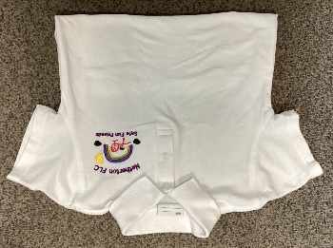
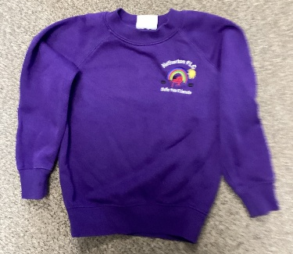

Medication and Illness
You are asked to give details of any medical information relevant to your child on the form completed on enrolment. Any medical or dietary
requirements are noted and all staff are made aware of them.

Please update your child’s keyworker if your child’s medical details change.

Medication - if your child requires medication to be administered, you should discuss his/her requirements with your child’s keyworker. Prescribed medication, inhalers, etc require a permission form which authorises staff to administer the medication to your child.
Forms are available from a member of staff or from the office. Please let us know if you have administered any form of medicine to your child prior to bringing them to nursery.

Asthma Action Plan - If your child suffers from asthma, we require an asthma action plan to be supplied from your G.P. It would also be helpful to let staff know if there are any particular activities or circumstances which might bring on an attack.
If your child suffers from seizures, diabetes etc., please discuss the emergency procedures to be followed and provide a plan of action from a medical professional prior to admission. These are required for insurance purposes. All staff will be made aware of these, in the interests of your child.

If your child becomes unwell, we will contact you or your emergency contact and ask you to collect him/her as soon as possible. Please try to make sure that your emergency contacts are fairly local and you update numbers regularly.

Minor Accidents
Although we do our best to ensure that these are few and far between,
realistically there will be occasions when they do occur. All our staff are highly trained and extremely sympathetic. They will comfort your child and deal with each incident as they see it. Rhona Douglas is our trained first aider and will check anyone who has an accident. Parents are informed of all incidents and accidents with relevant paperwork completed for your signature. These are recorded and filed in our accident folder. Additionally, you will be informed by telephone about any bumps or injuries to the head.

Suggestions or Concerns

We are constantly striving to improve our service and are always interested in the views of children and parents. We may formally ask for your opinions through parent and child questionnaires, but we are always delighted to hear what you think about our service. We have a comments book but feel free to approach our staff at any time. If there is something you feel we could improve upon we would like to hear your views, suggestions and opinions.

Should you wish to comment on or make a complaint about any aspect of provision offered by the establishment, you should contact the Head of Centre in the first instance. Our aim is to resolve as many complaints as possible at the first point of contact. If you remain dissatisfied, leaflets are available outlining our complaints handling procedures and can be found on the local authority website.

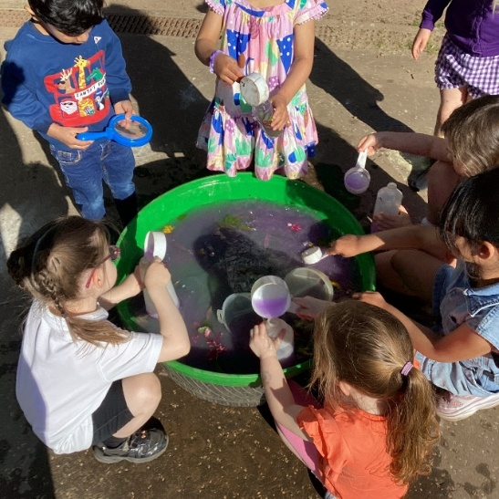

I hope that you find the information in this handbook useful. Please do not hesitate to contact us if you have any questions or suggestions. I wish us a very successful time together in which we establish a nurturing relationship – one which the children will truly enjoy!

Angie Ross
Head of Centre



