Netherton Primary
November Newsletter
Dear Families,
A great deal has happened since our last newsletter so to keep you informed, please see below. The week’s overview is below.
Kind regards,
Fiona Easton
Head Teacher
This week’s overview:
Miss Sum will be working in the following classes on Monday and Tuesday : P.1, 2, 3/2, 6/5 6 and 7 at different times to help class teachers.
Monday
Mrs Bauer will work with P. 2 on Monday from 11.40-3 pm.
Mrs Easton is attending training after school at Wishaw Academy.

Tuesday
Due to a meeting after school, Talking Tuesday is unable to go ahead this week. However, if anyone wishes to speak to Management, please contact the school or email directly and we will arrange a call back.

Wednesday
Mrs Brown is attending training and Mrs Richmond will cover P.1
Mrs Easton is in meetings all day.
Miss Sum will work for part of the day in P.3/2.

Thursday
Mrs Easton is in meetings all day.
Miss Sum is in P.3/2
Friday
We have school photographs today: this is for individual photos and family photographs.
Miss Sum is in P.3/2
Mrs Easton will work with P.5/4 today and also with P.2 at the end of the day.

Staffing
Brian the Janny
We are really saddened to share with you that our janny, Brian, is leaving us after two years to move to another position. He remains with North Lanarkshire but in a different department. This week is his last week but his last day has still to be confirmed (either Thursday or Friday). Brian made a real difference to Netherton Primary. Our grounds have never looked as good. Not only did he carry out his own duties but he also took on board helping the football team, helping with sports activities and always with a smile on his face. He will be a great loss to the school.
We do not know who will replace Brian and I will inform you as soon as possible.
Classes
We continue to have staff absences. These are circumstances beyond our control and I am sorry for any worry that this may cause. If you have any concerns, please contact the school and we can arrange a call back or an appointment. We are trying our very best to ensure as much continuity as possible and we will also do our very best to keep families as informed as quickly and as much as possible. Mrs Lyons will continue to be the main class teacher in P.2 and we have been fortunate that Miss Sum has been able to stay with P.3/2. I have been working with Mr MacNab with P.5/4.

Communication
I wish to apologise for any mix up with communication over the last two weeks. We have looked again at our systems and there should be no further confusion.
If you feel there are any continuing issues, I ask you to contact me directly on nleastonf@northlan.org.uk and that will allow me to discuss this with you and to address concerns directly. This will also allow me to strengthen our practice.
We do not have an answering machine on our phone system. If you are unable to get through, please email enquiries and this will help us get back to you more quickly.

Parking
Please be careful parking near the school. Parents have contacted us with concerns for their children’s safety. We have contacted the relevant Council department and we again ask that the rules of the road are respected and the safety of all our children is considered at all times.

Our Values
We always speak with children about being safe, respected and achieving. We expect everyone in our school community to model this behaviour. If you find that this is not the case, please contact me directly on my email.
Sometimes, children need supported in making positive choices in their behaviour. If this is the case, we will contact you and we will rely on your support, working together for all our pupils.

You Say, We Did:
We want Netherton Primary to be the best and we welcome your views and opinions. We strive to ensure that we listen and act on your suggestions.
Over the next few days, we will send out surveys to seek your views on a number of things and hope to act on them immediately to ensure positive developments.

Netherton Parent Council
Our Parent Council invite everyone to join their Facebook page. Please scan the QR code below. I personally would like to thank our Parent Council for their enthusiasm and commitment to the school. We look forward to working with them in a strategic approach in improvement planning, writing policies and fundraising. Anyone who wishes to volunteer to help with events, please contact the Parent Council or the school.

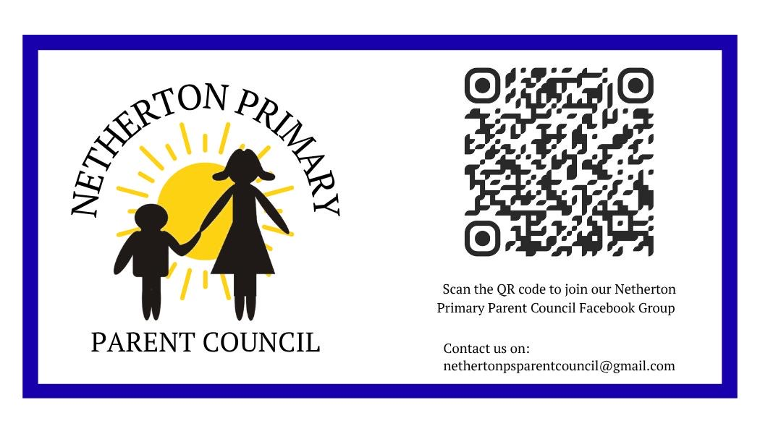
Dates for November:
Monday 17th November: The school is closed to pupils for Inservice Day.

