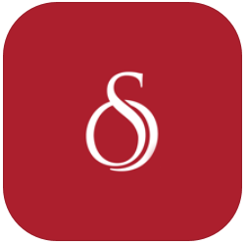
Storyline Online

Apple, YouTube

Free

Similar to BBC Bedtime stories with celebrities reading animated children’s books.

- Scroll to select a book.

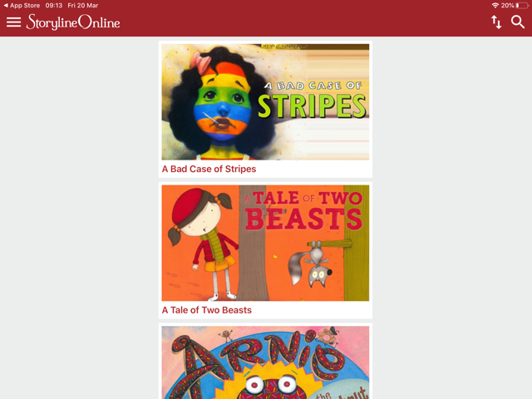

- Tapping the arrows in the top right allows you to sort the stories in different ways.

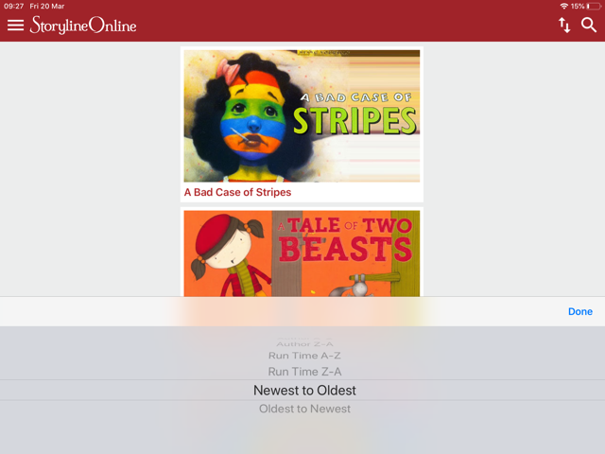
- Once chosen, the app will load a YouTube video of the book being read therefore internet connection is required.

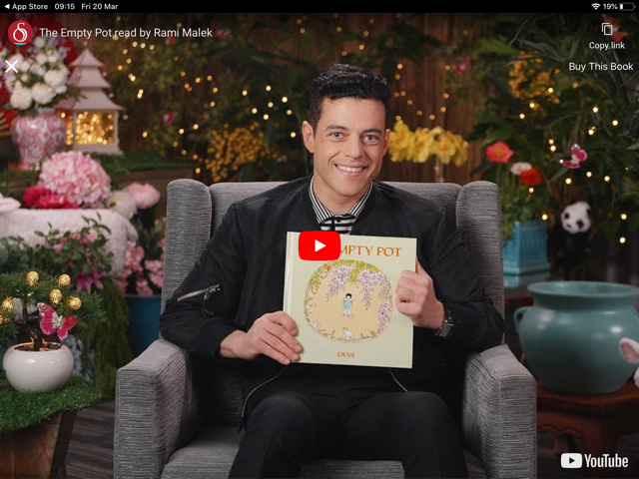

- The videos can also be found on YouTube by searching for ‘Storyline Online’.

