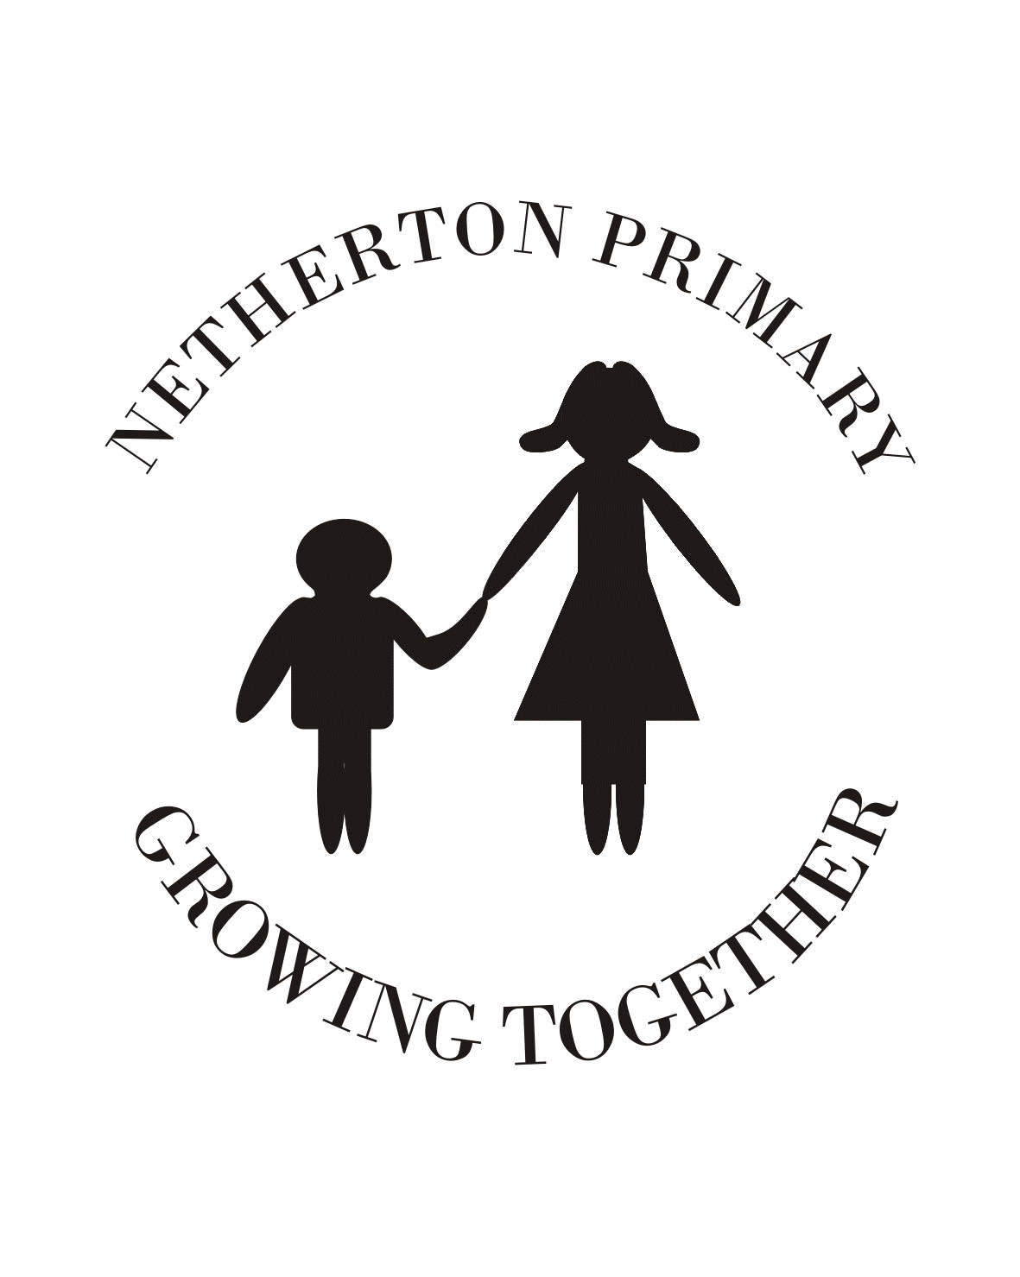
Anti-Bullying, Positive Relationships & Restorative Practices
A Policy for Netherton Primary School

The aims of the policy are:
• To prevent bullying behaviour taking place wherever possible.
• To reduce bullying when it does happen and aim for cessation of bullying
behaviour.
• To provide support for children and their families who have been affected by
bullying.
• To build resilience in children and young people and their capacity to address
bullying.
• To develop organisational capacity to address bullying.
• To provide information on resources for people who have experienced bullying.
• To provide appropriate training for all staff working with children and young
people.

Young people in North Lanarkshire identified the following as forms of bullying:
• Physical - hurting people, negative behaviour, victimisation.

• Verbal - name calling, teasing, being nasty, being hurtful, being unjust, being
unfair, gossiping.

• Material - stealing or damaging property.

• Emotional/mental - intimidation, making people think less of themselves,
excluding people, scaring people, blackmailing, mental and emotional abuse.

• Social - embarrassing someone whether intentionally or not, having awareness
of an incident of bullying behaviour and failing to stop it, humiliation of
another, manipulation of another, isolation of another, exerting peer pressure.

• Cyber - where technology is used to send threatening, offensive or
intimidating messages to another person, sometimes anonymously. People who
do this often make their messages available to a wider audience, for
example, on web blogs, message boards, chat rooms and websites. Other forms
of cyber bullying include filming incidents and distributing them to peer groups, posting filmed incidents of particularly inappropriate events onto video sharing sites such as You-Tube and passing filmed incidents from mobile telephone to mobile telephone.

What North Lanarkshire Council Consider to be Bullying Behaviour
Bullying behaviour can be verbal, physical, emotional or online conduct which is
unwanted and uninvited, and which causes distress and harm to the person experiencing it. It may be intentional or unintentional. This behaviour can produce feelings of helplessness, anger, confusion, disappointment and loss of confidence.

A Closer Look At Types of Bullying Behaviour
Physical
Includes hitting, kicking, pushing, choking. It also involves stealing or damaging someone else’s property.

Verbal
Involves speaking to a person or about a person in a way that is hurtful to that person e.g. rumours, name calling.

Emotional
Includes behaviour that embarrasses another person or upsets and excludes them e.g. exclusion from peer groups, hate notes, rude gestures and rude looks.

Cyber
Involves the misuse of mobile phones, social networking sites, email to communicate degrading information about others or to start rumours. It is often hard to identify the person responsible for this type of bullying behaviour.

Prejudice-based Bullying
• Asylum seekers and refugees
• Body image
• Disabilist - physical and learning disabilities
• Homophobic: because of or focusing on the issue of sexuality or perceived
sexuality
• Looked After Children and Young People
• Racial
• Religious and belief

Many incidents of bullying are based on prejudice.
Examples of this include bullying behaviour towards those who are:
• asylum seekers or refugees;
• looked after children and young people;
• young carers;
• a particular gender;
• a particular race, religion or belief;
• a particular sexuality or perceived sexuality;
• physically disabled or who have learning difficulties;
• a particular body shape.

Homophobic Bullying
This is a specific form of bullying and is motivated by a prejudice against lesbian, gay, bisexual or transgendered people (LGBT) or those perceived to be so. People who are seen to be ‘different’ in some way are also a target, for
example, those not interested in sport or who are intensely shy. This type of bullying uses someone’s own identity to abuse them and homophobic bullying can be experienced by all children and young people, regardless of their sexuality.

Rights and Responsibilities

At Netherton Primary, we believe our pupils have the following rights:
• Everyone has the right to be safe and free from bullying behaviour and
harassment
• Everyone has the right for their property to be safe
• Everyone has the right to learn in a pleasant and healthy environment
• Everyone has the right to be treated with respect and understanding
• Everyone has a right to their own identity; and
• Everyone has the right to report incidences of bullying behaviour through
appropriate channels

We also expect pupils to undertake the following responsibilities:
• Respect all people, personal property, and the rights of others
• Observe safety rules at all times
• Report incidences of bullying behaviour, harassment, theft
• Respect others’ rights to the same happiness and enjoyment as you expect for
yourself
• Avoid unhealthy and dangerous practices that affect you and others in the
community; and
• Treat everyone with respect and understanding
At Netherton Primary school, pupils follow a set of Golden Rules. Our Golden Rules relate to the behaviour we expect from all the children. They are displayed in each class and throughout the school. These rules state the positive actions that we strive to see from all Netherton’s Pupils.
If a Golden Rule is broken, a verbal warning will be given to the child explaining why their actions are not acceptable. If the Golden Rule is broken again, the child will be given a warning card as a further warning. If the behaviour improves significantly for the remainder of the day the child will keep their golden time.
If the behaviour continues and the teacher has to speak to the pupil for the 3rd time, the child will lose 5 minutes Golden Time and the teacher will record this.

Golden Rules
- We are gentle.
We don’t hurt others.
- We are kind and helpful.
We don’t hurt anybody’s feelings.
- We listen.
We don’t interrupt.
- We are honest.
We don’t cover up the truth.
- We work hard.
We don’t waste our own or others’ time.
- We look after property.
We don’t waste or damage things.

Serious Inappropriate Behaviour
In some instances, behaviour which is deemed inappropriate and serious will result in pupils being automatically referred to the Head Teacher. Such behaviours have been collaboratively chosen by both the children and the staff.
The following behaviours are deemed as unacceptable:
- Deliberate physical abuse
- Vandalism of school property
- Misconduct relating to the MPS ICT agreement
- Stealing
- Serious defiance e.g. refusal to leave the room or to follow direct instructions
- Verbal abuse towards others linked to any of the following:
Prejudice against cultures
Racism
Sectarianism
Homophobia
Sexism
Disability
Religion
Swearing
Inappropriate hand gestures

Please note – clear evidence in the form of an adult witness or a confession (Restorative Practice) would be required for staff to refer to the Head Teacher.

Restorative Practices in Netherton Primary School
Restorative Practices was developed to support and help the building and repair of healthy relationships. Netherton Primary School Staff are trained in restorative practices and utilise two sets of restorative questions. The two sets of restorative questions are:

For those who have caused the harm:
1. What happened?
2. What were you thinking at the time?
3. What have you thought about since?
4. Who else has been affected by what you did?
5. In what way?
6. What do you think you need to do to make things right?

For those who have been harmed:
1. What did you think when you realised what had happened?
2. What impact has this incident had on you?
3. What impact has this had on people close to you?
4. What has been the hardest thing for you?
5. What do you think needs to happen to make things right?

Possible Signs of Bullying Behaviour
• Change in attendance at school
• Change in achievement level
• Unexplained injuries
• Change in sleep patterns
• Change in eating patterns
• Withdrawal
• Neglect of appearance
• Mood changes
• Depression
• Suicidal thoughts

When a Child Displays Bulling Behaviour, Parents Can:
• Explain the behaviour is unacceptable and is not a joke
• Provide effective non-violent consequences for your child’s actions
• Help your child to understand the effects of their behaviour on others
• Teach your child to value diversity

Staff in school will engage in restorative discussions with all pupils involved.

What if A Child is Experiencing Bullying Behaviour?

What Pupils Can Do
• Tell the person who is bullying or harassing you to stop, if you feel confident
to do so.
• Tell someone you trust e.g. teacher, parent, friend, relative, pupil support
team. This is not ‘grassing’ - everyone has the right to feel safe; and
• Continue to raise the subject until the problem is resolved.

What Netherton Primary School Staff Will Do
• Take all allegations of bullying behaviour seriously.
• Provide support for all parties involved, the person experiencing the bullying
behaviour and person displaying bullying behaviour.
• Seek to restore damaged relationships and communities through restorative
approaches.
• Adhere to the school’s Positive Relationships policy regarding
isolated, one-off incidences of bullying type behaviour (straight to loss of Golden Time
• Parents/carers will be informed, when appropriate.

What Other Pupils Can Do
• Support the person being bullied.
• Don’t join in.
• Talk to someone you trust who can help.
• Always report bullying.
• Tell the person(s) responsible to stop, if you feel confident to do so.
• Speak up - don’t be a silent witness.

What Parents Can Do
• Listen to them and believe them.
• Assure them it is not their fault.
• Tell them you can work together to solve the problem.
• Report the bullying behaviour to the school or organisation.
• Provide evidence, if possible.
• Identify others who may have witnessed it.
• Help your child feel comfortable about telling.

North Lanarkshire Anti-Bullying Vision
North Lanarkshire Council is committed to the belief that every child has the right to grow up free from bullying. We want children and young people to live, learn, socialise and work in an inclusive North Lanarkshire, where differences between people are valued, people support one another, treat each other with respect, empathy and compassion and refrain from bullying. We are committed to fulfilling the Scottish Government’s commitment to ensuring children and young people become confident individuals, effective communicators, successful learners and responsible citizens. All those who play a daily role in the lives of our learners should be enabled to prevent bullying and respond effectively to incidents of bullying behaviour when they occur.

Other organisations that can help you:
• Respectme www.respectme.org.uk
• Childline 0800 1111
• Kidscape www.kidscape.org.uk
• Bullying Online www.bullying.co.uk
• Lesbian, Gay, Bisexual, Transgender www.lgbtyouth.org.uk

www.northlanarkshire.gov.uk

