Promoting Positive Behaviour through Restorative Practice
Our work towards becoming a Rights Respecting School is reliant on every member of staff being involved in the process, ensuring that it is a whole school approach.
A Parent information sheet will also be sent home at the start of each session.
Reflection time can take place in the classroom, an SMT office or the Rainbow Room where children are invited to reflect on their actions using Restorative questions. We suggest 10 mins for P1-3 and 15- 20 mins for P4-7.
Restorative questions will be displayed in the Rainbow Room and provide a clear structure for the conversation with the child. It is a good idea to have the Restorative questions with you as a reminder throughout the day. Some teachers stick them on the back of their ID badge.
We are focusing on the main rights of Safety, friendships and individuality, opinions and the right to a good education as outlined in our Rights Respecting School Charter, devised by our RRS group. (see attached)
All members of staff have the right to implement a time for reflection. SMT will assist with this process when possible but essentially it is the responsibility of all staff members.
Once a pupil has completed a reflection sheet, it should be copied, with one copy sent home and the other held in the office. A text should be sent to the parent.
If a child is repeatedly spending time in reflection, this indicates that this child requires additional or intensive support which should be planned and documented in a GIRFme plan.

We believe that all members of our school have the following rights:

We all have the right to have a good education
We respect this right by trying our best in our learning

We all have the right to be safe and happy
We respect this right by behave positively towards all members of the school

We all have the right to give our opinions
We respect this right by listening to all adults and the opinions of others

We all have the right to have good friends
We respect this right by talking to them in the right way and treating them fairly

We all have the right to develop our individuality and talents
We respect this right by valuing and respecting all
cultures, religions and languages

Muirhouse Primary School
Our School Charter

Restorative Questions
- What happened?
- What were you thinking about at the time?
3. What have your thoughts been since the incident?
- Who do you think has been affected by your actions?
- In what way were they affected? Which right has been affected?
- What do you need to do now to make things right?
(See child friendly version attached)

There are reflection sheet template in the files on Teams to fill in with the child using the restorative questions and reflecting on the particular right that has not been respected. An infant and nursery version is available too.

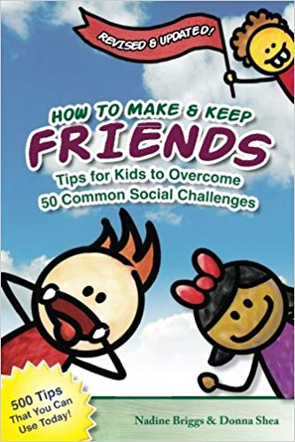

“How to make and keep friends” can be used to illustrate a particular social situation and offers child friendly suggestions on how to overcome these challenges in the future. This will be kept in the Rainbow Room to be used during Reflection Times.

This school practice links with the other RR work that is being done in the classes as well as the Health and Wellbeing lessons. Restorative approaches should be used in all areas of the school; classes, dinner hall, playground etc.

